Detection of mycotoxins :
Most mycotoxins are chemically stable so they tend to survive storage and processing, and even when cooked at quite high temperatures such as those reached during baking bread or breakfast cereal production. Mycotoxins are notoriously difficult to remove and the best method of control is prevention . a variety of testing solutions exist for mycotoxin analysis in food and feed. These solutions range from rapid tests that are easy to conduct, to reference methods that are more time-consuming but yield more detailed results.
The most common methods presently used are :

Thin layer chromatography :
Thin-layer chromatography is a separation technique (e.g. mycotoxin) is trapped by some binding material, known as the Stable phase, which is solidify in a matrix (e.g. silica gel). The method is performed on a plate (e.g. glass or aluminum), coated with a thin layer of adsorbent material. The analysis sample consists of a solvent containing the analyte (the solvent + analyte complex is called the mobile phase). When the mobile phase is applied to the plate, the latter adsorbs it through capillary action. At this point, the substances contained in the mobile phase react with the Stable phase. As different substances ascend the TLC plate at different rates, separation is achieved .
Advantages | disadvantages
Simple, cheap, fast | Separation may not be precise
Multiple samples can be run simultaneously | Does not work for all mycotoxins
Table 1 The advantages and disadvantages of TLC method
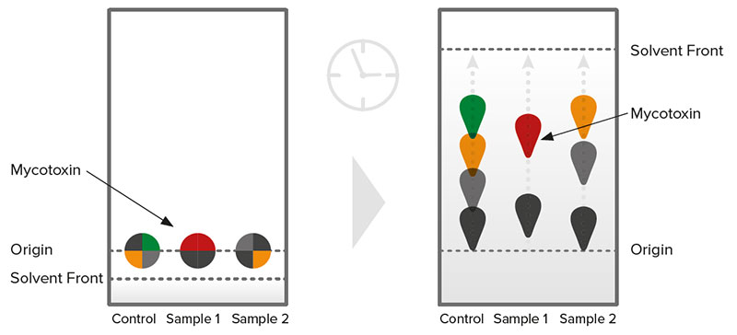
Figure (1) (TLC)
- High-performance liquid chromatography (HPLC) :
This method depend on pumps that spread pressurized liquid solvent containing the sample mixture through a column filled with a solid adsorbent material . These techniques are major methods for descriptive analysis and component quantification. These techniques characterized by accuracy, sensitivity and high efficiency .
Components of the HPLC device:
- An external container: may be a flask or beaker, provided that it is clean in which the solvent ( mobile phase) is placed, and it must be emptied of air and gases.
- The connecting tubes : between the moble phase and the pump, usually made of stainless steel .
- The pump: it pumps the solvent or the mobile phase to the analysis column under high pressure .
- Injection sample: where the sample to be analyzed is injected into the analysis column automatically or manually .
- The analysis column : which is considered the heart of the system in HPLC technology. The analysis columns are usually made of thick glass or stainless steel, anti-corrosion, or polymers in order to withstand the high mobile phase pressure. Also, inside the analysis column is the packed material that forms the Stable phase where injection is carried out. The sample to be analyzed is inside the column, and its components are detected by the detector used .
- The detector : task is to monitor the dissolved substances inside the analysis column when leave it, as it sends electrical or chemical signals commensurate with a certain level of the extracted substance, according to the type of detector used and the characteristics of the sample to be analyzed.
- The recorder or chromatogram: is just connected to the detector, where it receives the signal that the detector sends, analyzes it and outputs it in the form of a graph that appears on the computer screen.

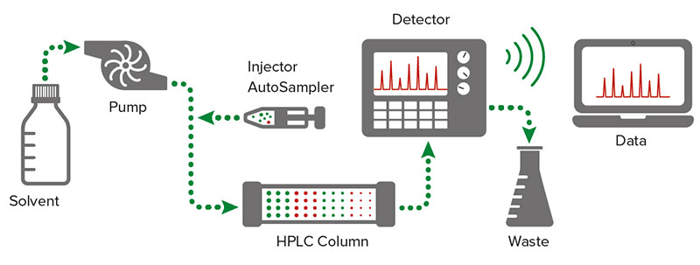
Figure (2) Components of the HPLC device
Advantages | disadvantages
High sensitivity | Time consuming
Only small amounts of sample are needed | Compounds must have UV absorption or fluorescence properties
Applicable to complex matrices | Expensive
Great reliability | Highly skilled technicians needed to carry out the analysis
Highly accurate

Fulfills legal requirements

Table 2 The advantages and disadvantages of HPLC method
- Gas Chromatography (GC) :
This method requires specific equipment and trained technicians. It works as follows: a gas carries the compounds of interest contained in an injected sample (mobile phase). The gas carrying the sample flows through a heated glass column coated with a stationary non-volatile liquid (Stable phase) . Substances will separate according to their ability to cross the Stable phase ( The process of extracting a substance that is adsorbed to another by washing it with a solvent known as elution). Separated compounds coming off the column are detected by a chemical or physical detection system.
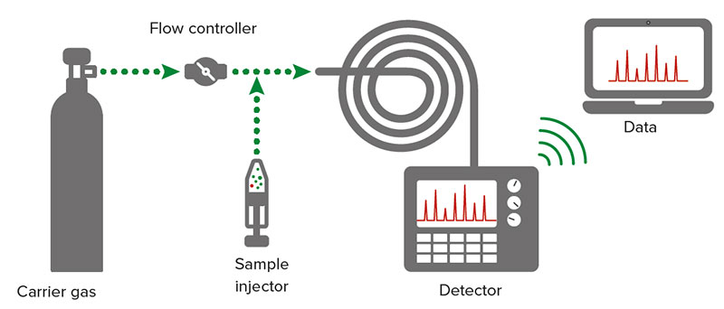
Figure (3) Gas Chromatography (GC)
Advantages | disadvantages
High sensitivity | Data analysis is time-consuming and prone to errors
High specificity (low interference) | Expensive
 | Requires highly skilled technicians to carry out the analysis
Table (3) The advantages and disadvantages of (GC) method
- Liquid Chromatography - Tandem Mass Spectrometry (LC-MS/MS) :
This technique combines the physical separation proprieties of the HPLC with the mass analysis capabilities of the mass spectrometer (MS). The two analytical methods work synergistically. Chromatography separates mixtures with multiple components (e.g. mycotoxins), before the mass spectrometer then provides the structural features of individual components with high sensitivity and specificity. Due to the extreme sensitivity, this method is the reference method of choice in many laboratories and it currently represents state-of-the-art of analytical chemistry.
Advantages | disadvantages
Low detection limits | Expensive
Qualitative and quantitative results | Highly trained personnel required to carry out the analysis
Generate structural information | Time consuming compared to rapid tests
Minimal sample treatment required
Can cover a wide range of analytes
Applicable to complex matrices
Table (4) The advantages and disadvantages of (LC-MS/MS) method
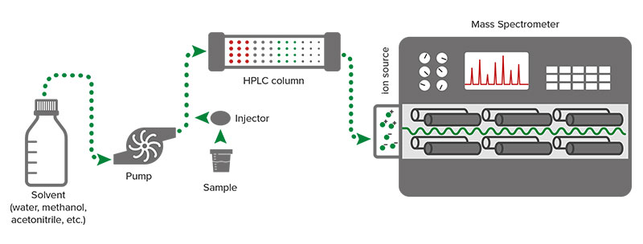
Figure (4) (LC-MS/MS) method
- Enzyme-Linked Immunosorbent Assay (ELISA)
ELISA is one of the most popular immunological- based methods used for the analysis of mycotoxins in foods and feeds. The reaction is carried out in 96-well microtiter plates , The sample reacts with the antibody mixture, placed at the bottom of the wells. The basis of this technique is based on the ability of a specific antibody to distinguish the three-dimensional structure of a specific mycotoxins.
Advantages | disadvantages
Simple sample extraction | Matrix interferences (other substances in the solution that can alter results)
Good sensitivity | Only suitable for validated matrices (mainly raw commodities)
 | Antibodies can react with each other and alter the results (crossreactivity).
Table (5) The advantages and disadvantages of (ELISA) method
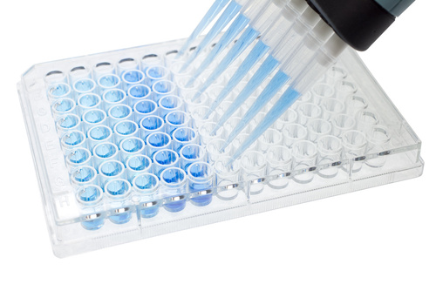
Figure (5) ( ELISA)

