**Lab. Meteorological**

**Data analysis ........ Fourth stage**

**(The second Semester)**

**Department of Atmospheric Sciences**

**2022 – 2023**

**Lecturers :**

**Assist. Prof. Zahra salah , L. Ruaa mazin**

**L. Luma Mahdi , L. Salwa salman, L.Farah haseb**

***Preparing by: L. Ruaa mazin , L. Luma Mahdi***

**(( Seventh Lecture ))**

# Probability

In environmental science and many other subjects, there is certainly no shortage of uncertainty, for example, in our knowledge about whether it will rain or not tomorrow. Uncertainty about such events arises naturally from errors and gaps in measurements, incomplete and incorrect knowledge of the underlying mechanisms, and also from the overall complexity of all the possible interactions in real-world systems. We try to describe this uncertainty qualitatively by using words such as \likely", \probably", \chance", etc.. However, to make progress scenically it is necessary to use a more quantitative definition of uncertainty.

***Probability: to mean a number lying between 0 and 1 that measures the amount of certainty for an event to occur. A probability of 1 means the event is completely certain to occur, whereas a probability of 0 means that the event will certainly never occur.***

***To calculate the probability, apply the following law*:**

Probability = $\frac{The number of ways of achieving success }{The total number of possible outcomes }$

Which:

**Probability = $\frac{Fa}{FE }$**

Where:

P, =probability of outcome

Fa. = absolute frequency of outcome

FE = absolute frequency of all outcomes for event E

***For example***: Suppose a day is classified as wet (w) if measurable precipitation (0.01 inch or more) falls during the 24-hour period. The day is termed dry if measurable precipitation does not occur. By keeping a record of wet and dry days over a 100-day period, precipitation frequencies can be determined and probabilities calculated from the data In this example, 62 days Frequency of Dry are categorized as dry and 38 as wet. ***Solue***:

a) The probability of a wet day occurring (P,) is:

## Probability = >>> p=

b) The probability of a dry day occurring (P,) is:

Probability =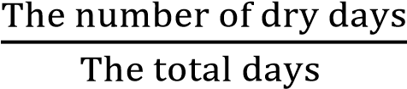 >>>> p=

***For example*** : By recording the temperature data for the Basra station during the three months (June, July and August), the temperatures were classified into two categories, the first category included the temperature between (30 - 40 CO) and the weather was considered hot, and the number of days was 37 days, and the second category of (41 -55 CO) and the number of days was 55 days. The weather is considered very hot. Calculate the probability of temperatures for the two categories identified.

***Solue:***

a) The possibility of hot weather (P,) is:

## Probability = >>> p=

b) The possibility of very hot weather (P,) is:

Probability =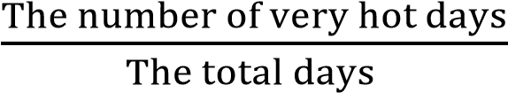 >>>> p=

***Permutation and Combination:***

**Permutation:**

A permutation is an arrangement in a definite order of a number of objects taken some or all at a time. With permutations, every little detail matters. It means the order in which elements are arranged is very important.

***There are two types of permutations:***

**1-Repetition is Allowed**:

**n × n × n** *(*n multiplied 3 times) **n × n × ... *(***r times***)***

**n × n × ... (r times) = nr**

**Example**: in the lock above, there are 10 numbers to choose from (0,1,2,3,4,5,6,7,8,9) and we choose 3 of them:

**10 × 10 × ... (3 times) = 103 = 1,000 permutations**

where ***n*** is the number of things to choose from, and we choose ***r*** of them, repetition is allowed, and order matters.

**2-No Repetition Allowed :**

***P = $\frac{n!}{(n-r)!}$***



where ***n*** is the number of things to choose from, and we choose ***r*** of them, no repetitions, order matters.

Example: How many ways can first and second place be awarded to 10 people?

**P** 

***Combination:***

The combination is a way of selecting elements from a set in a manner that order of selection doesn’t matter. With combination, only choosing elements matter. It means the order in which elements are chosen is not important.

**There are two types of combinations:**

***1-Repetition is Allowed***:

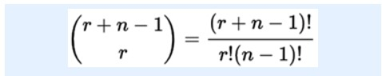

where ***n*** is the number of things to choose from, and we choose ***r*** of them, repetitions allowed , order doesn't matter.

*2*

*.*

***No Repetition Allowed***

*:*

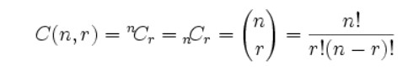

where ***n*** is the number of things to choose from, and we choose ***r*** of them, no repetitions , order doesn't matter.

***For example* : Find the number of permutations and combinations, if n = 15 and**

**r = 3.**

**Solue:**

**permutations** : P = n!/(n – r)! >>>> = 15!/(15 – 3)! = 15!/12! = (15 x 14 x 13 x 12!)/12! = 15 x 14 x 13 **= 2730**

Combination: C = n!/(n – r)!r! >>> = 15!/(15 – 3)!3! = 15!/12!3! = (15 x 14 x 13 x 12! )/12!3! = 15 x 14 x 13/6 = 2730/6 **= 455**

**H.W(1) \\ Find the number of permutations and combinations, if , n = 7 and r = 4.**

**H.W(2)\\ Calculate the following [ 12C3 , 10P3].**