Lec(6) Immunotechnology
Prof. Dr. Ekhlass Noori Ali
MONOCLONAL ANTIBODY
The knowledge that B cells are genetically preprogrammed to synthesize very specific antibody has been used in developing antibodies for diagnostic testing known as monoclonal antibodies. Normally, the response to an antigen is heterogeneous,because even a purified antigen has multiple epitopes that stimulate a variety of B-cell clones. In 1975,Georges Kohler and Cesar Milstein discovered a technique to produce antibody arising from a single B cell, developed a technology to fuse immortal hetero myeloma cells with B lymphocytes,
Q1/ How do PEG play role in monoclonal antibody production?
Answer: using poly ethyl glycol (PEG) to break down cell membranes and allow mixing of the genetic material from both cell types.
The resulting cell type is called a hybridoma. This hybridoma takes on the characteristics of both the lymphocyte and hetero myeloma cell, creating an immortal cell with the ability to produce antibody. which has revolutionized serological testing. For their pioneering research, they were awarded the Nobel Prize in 1984.Kohler and Milstein’s technique fuses an activated B cell with a myeloma cell that can be grown indefinitely in the laboratory. Myeloma cells are cancerous plasma cells .Normally, plasma cells produce antibody,
Q/ Why myeloma cells unable to produce antibody?
So a particular cell line that is not capable of producing antibody is chosen. In addition, this cell line has a deficiency of the enzyme hypoxanthine guanine phosphoribosyl transferase (HGPRT) that renders it incapable of synthesizing nucleotides from hypoxanthine and thymidine, which are needed for DNA synthesis.
Hybridoma Production
A mouse is immunized with a certain antigen, and after a time, spleen cells are harvested. Spleen cells are combined with myeloma cells in the presence of polyethylene glycol(PEG), a surfactant. The PEG brings about fusion of plasma
cells with myeloma cells, producing a hybridoma. Only a small percentage of cells actually fuse, and some of these are like cells—that is, two myeloma cells or two spleen cells.
After fusion, cells are placed in culture using a selective medium containing
Q/ What is the purpose of the use HAT media in monoclonal antibody preparation?
Answer: hypoxanthine, amino pterin, and thymidine (HAT). Culture in this medium is used to separate the hybridoma cells by allowing them to grow selectively .Myeloma cells are normally able to grow indefinitely in tissue culture, but in this case they cannot, because both pathways for the synthesis of nucleotides are blocked. One pathway, which builds DNA from degradation of old nucleic acids, is blocked, because the myeloma cell line employed is deficient in the required enzymes HGPRT and thymidine kinase. The other pathway, which makes DNA from new nucleotides, is blocked by the presence of amino pterin.Consequently, the myeloma cells die out. Normal B cells cannot be maintained continuously in cell culture, so these die out as well. This leaves only the fused hybridoma cells,which have the ability (acquired from the myeloma cell) to reproduce indefinitely in culture and the ability (acquired from the normal B cell) to synthesize nucleotides by the HGPRT and thymidine kinase pathway (Fig. 1).
Selection of Specific Antibody-Producing Clones
The remaining hybridoma cells are diluted out and placed in microliter wells, where they are allowed to grow. Each well, containing one clone, is then screened for the presence of the desired antibody by removing the supernatant.
Once identified, a hybridoma is capable of being maintained in cell culture indefinitely, and it produces a permanent and uniform supply of monoclonal antibody that reacts with a single epitope.

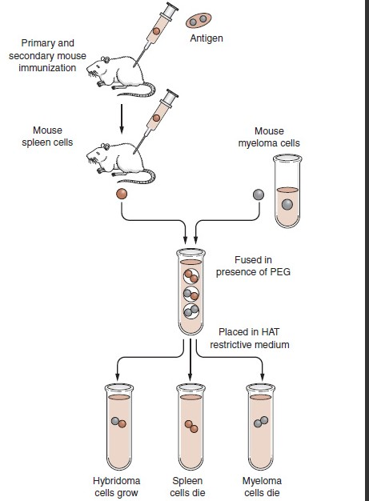
Fig1: Formation of a hybridoma in monoclonal antibody production. A mouse is immunized, and spleen cells are removed. These cells are fused with non secreting myeloma cells and then plated in a restrictive medium. Only the hybridoma cells will grow in this medium,where they synthesize and secrete a monoclonal immunoglobulin specific for a single determinant on an antigen.

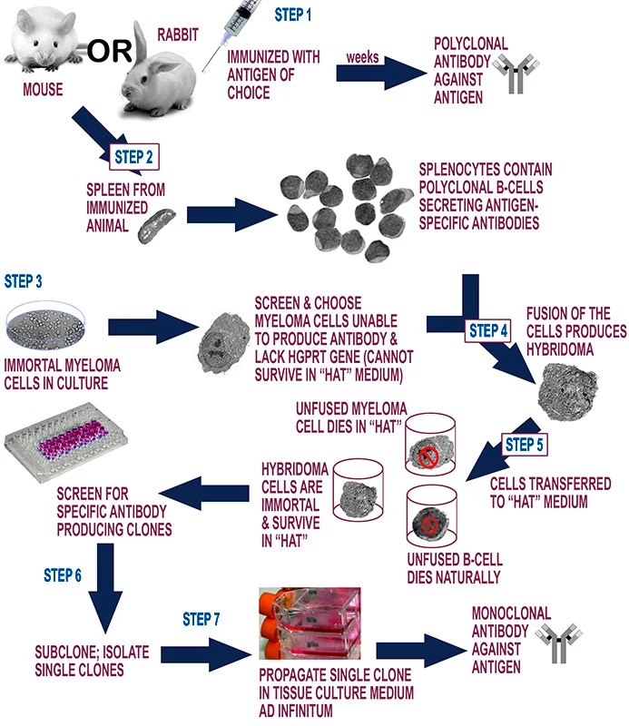
Q/ Describe the method of production of a monoclonal antibody?

Clinical Applications
Monoclonal antibodies were initially used for in vitro diagnostic testing. A familiar example is pregnancy testing, which uses antibody specific for the chain of human chorionic gonadotropin, thereby eliminating many false-positive reactions.
Other examples include detection of tumor antigens and measurement of hormone levels .Recently, however, there has been an emphasis on the use of monoclonal antibodies as therapeutic agents. One of the biggest success stories is in the treatment of two autoimmune diseases: rheumatoid arthritis and Crohn’s disease (a
progressive inflammatory colitis).
Monoclonal antibodies have also been used to treat various types of cancers. In the case of metastatic breast cancer,
Uses of Monoclonal Antibodies
The greatest impact of MAbs in immunology has been on the analysis of cell membrane antigens. Because they have a single specificity rather than the range of antibody molecules present in the serum, MAbs have multiple clinical applications, including the following:
• Identifying and quantifying hormones
• Typing tissue and blood
• Identifying infectious agents
• Identifying clusters of differentiation for the classification of leukemia's and lymphomas and follow-up therapy
• Identifying tumor antigens and autoantibodies
• Delivering immunotherapy.
Polyclonal Antibodies
The immune response to an antigen generally involves the activation of multiple B-cells all of which target a specific epitope on that antigen. As a result a large number of antibodies are produced with different specificities and epitope affinities these are known as polyclonal antibodies.
For production purposes these antibodies are generally purified from the serum of immunised animals were the antigen of interest stimulates the B-lymphocytes to produce a diverse range of immunoglobulin's specific to that antigen.
The aim is to produce high titer, high affinity antibodies. Today these polyclonal antibodies are used extensively for research purposes in many areas of biology, such as immune precipitation, histochemistry, enzyme linked immunosorbent assays (ELISA), diagnosis of disease, immune turbidimetric methods, western blots and Biochip technology. Polyclonal antibodies are ideally suited for use in sandwich assays as second stage antigen detectors.
Polyclonal antibodies | Monoclonal antibodies
Inexpensive to produce | Expensive to produce
Skills required for production are low | Training is required for the technology used
Relatively quick to produce | Hybridomas take a relatively long time to produce​
Generate large amounts of non-specific antibodies | Generate large amounts of specific antibodies
Recognize multiple epitopes on any one antigen | Recognize only one epitope on an antigen
Can have batch-to-batch variability | Once a hybridoma is made, it is a constant and renewable source
 | No or low batch-to-batch variability

IMMUNOTHERAPY
Q/ Enumerate the applications of Immunotherapy
Immunotherapy: the another type for treatment of tumor immunology.
The possibility of stimulating the patient’s own immune system to respond to tumor-associated antigens has long intrigued scientists. Immunotherapeutic methods used can be separated into two types: passive or active immunotherapy.
Passive immunotherapy involves transfer of antibody, cytokines, or cells to patients who may not be able to mount an immune response. With active immunotherapy, patients are treated in a manner that stimulates them to mount immune responses to their tumors.
Passive Immunotherapy
Passive transfer of allogeneic cellular immunity from one person to another to fight cancer has many barriers because of possible recipient rejection of foreign cells, graft-versus host disease (GVHD), and the fragility of live cells, Inducing a patient’s own cellular immunity is far more likely to be successful, However, a form of GVHD called graft versus leukemia has been demonstrated with transfer
of allogeneic T cells and is associated with improved patient prognosis. Therefore, successful passive transfer of anticancer T cells is theoretically possible .Adaptive T-cell therapy has been attempted using several models. For example, T cells from allogeneic donors can be immunized against tumors. After recipients are immunosuppressed to prevent rejection and to eliminate T suppressor mechanisms, they receive the T cells. One strategy in this model to treat GVHD is to genetically engineer the allogeneic T cells
3-Passive transfer of antibody to treat cancer almost always employs monoclonal antibodies. “Naked” monoclonal antibodies
against cancer could induce antibody-dependent cell-mediated cytolysis (ADCC), complement-mediated lysis, or opsonization. If the antibodies are directed toward
particular receptors, they could trigger a desirable action in the cell such as inducing apoptosis or inhibiting growth signals
4. Antibody conjugates, or immunotoxins, are antibodies conjugated to toxins or radioisotopes on the premise that they can kill cancer cells while leaving adjacent cells intact.
Active Immunotherapy
The goal of active immunotherapy is to have the patient develop an immune response that will help eliminate the tumor. Nonspecific stimulation by adjuvants such as Bacillus Calmette Guerin (BCG) was first attempted, and superficial
bladder cancer is still treated with BCG. Improved technology has allowed the production of novel adjuvants and selective use of stimulatory cytokines (TNF-α, IFN-γ,IL-1, IL-2, and so on) in immune competent patients to enhance the natural antitumor response and the artificial vaccine-induced response.
Other attempts at stimulating host immune systems have involved transfection of normal cells or isolated tumor cells with genes for cytokine production and injection of the modified cells into or around the tumor. This has been
done with many cytokines, including TNF-α, interferons,IL-2, and granulocyte monocyte–colony stimulating factor (GM-CSF). Of the cytokines transfected, GM-CSF has shown the most promise.
Cancer vaccines have been of great interest to researchers. When specific viruses are associated with a cancer, vaccine construction is relatively straight forward, since viral antigens are obviously foreign. The vaccine for human papillomavirus
(HPV) to prevent cervical cancer is an excellent example. It is important to note that many viruses have several serotypes ,not all of which may be associated with cancer, so vaccines must be protective against the appropriate epitopes. HPV vaccines, for example, are directed epitopes that prevent initial infection with carcinogenic serotypes but do not help treat established cervical cancer, as these epitopes are down regulated in cancer cells. Therefore, a distinction exists between prophylactic vaccines and therapeutic ones.
These protocols will be important adjuncts to traditional therapies in which tumors will first be de bulked and then the immune system will eradicate residual tumor and micro metastases. The increased understanding of tumor immunology in recent years has made this a field of active study and increased optimism.
Q1/ Compare and contrast passive versus active immunotherapy, describing
common techniques used in each.

