The First Experiment
The Objective of the Experiment:
To give an introduction of some scientific terms, so it would be easy to be familiar to use the thermodynamic diagrams.
Water Vapor in Air:
The amount of water vapor present in a certain quantity of air may be expressed in many different ways as follows:
Humidity
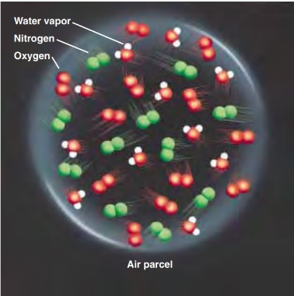
There are several ways to express atmospheric water vapor content because there are several meanings for the concept of humidity.
Fig. 1: Moist air parcel
Imagine, for example, that we enclose a volume of air (about the size of a large balloon) in a thin elastic container—a parcel—as illustrated in Fig. 1. If we extract the water vapor from the parcel, we would specify the humidity in the following ways:

- We could compare the weight (mass) of the water vapor with the volume of air in the parcel and obtain the water vapor density, or absolute humidity.
- We could compare the weight (mass) of the water vapor in the parcel with the total weight (mass) of all the air in the parcel (including vapor) and obtain the specific humidity.
- Or, we could compare the weight (mass) of the water vapor in the parcel with the weight (mass) of the remaining dry air and obtain the actual mixing ratio.
- Or, we could compare the mass of water vapor in a given volume of air that is saturated to the mass of the dry air and obtain the saturation mixing ratio.
- Or, we could also express the humidity of the air in terms of water vapor pressure—the push (force) that the water vapor molecules are exerting against the inside walls of the parcel, thus the Actual Vapor pressure is defined as the partial pressure exerted by the water vapor molecules due to the transformation from the liquid state to the gaseous state, and is accompanied by a high pressure on the water surface, leading to the movement and separation of the particles from each other through their evaporation, and it is proportional to the number of water vapor molecules in the atmosphere.
- And the Saturation vapor pressure which is the pressure that the water vapor molecules would exert if the air were saturated with vapor at a given temperature, or the maximum amount of water vapor necessary to keep moist air in equilibrium with a surface of pure water or ice. It represents the maximum amount of water vapor that the air can hold at any given temperature and pressure.
- And the Relative Humidity which is an indicator of how close the air is to being saturated, and it is defined as the ratio of the amount of water vapor actually in the air to the maximum amount of water vapor required for saturation at that particular temperature (and pressure). It is the ratio of the air’s water vapor content to its capacity.
- And the dew point is the temperature to which air must be cooled at constant pressure for it to become saturated with respect to a plane surface of pure water. In other words, the dew point is the temperature at which the saturation mixing ratio with respect to liquid water becomes equal to the actual mixing ratio.
- The potential temperature of an air parcel is defined as the temperature that the parcel of air would have if it were expanded or compressed adiabatically from its existing pressure and temperature to a standard pressure p₀ (generally taken as 1000 hPa).

Lapse rate
Lapse rate is the rate at which an atmospheric variable (usually temperature) decreases with height. The average (or standard) lapse rate in this region of the lower atmosphere is about 6.5 degrees Celsius (°C) for every 1000 meters (m).
- Adiabatic lapse rate: The rate of decrease in temperature with height via an adiabatic process.
  - Dry-adiabatic lapse rate: represent the rate at which unsaturated air cools (decrease in temperature) as it rises (unsaturated air is air with a relative humidity lower than 100%), the rate equal to 9.8°C/km.
  - Moist-adiabatic lapse rate: the rate at which saturated air cools (lapses) as it rises. When the air is at 100% relative humidity, further cooling causes water vapor to condense. In this condensation process, heat is released which then affects the rate of cooling. Near the surface, as saturated air rises, it expands and begins to cool at a rate of about 4°C/km. As it continues to rise, the cooling rate decreases due to a decreasing amount of water vapor.

The table below summarize all the mentioned terms with their symbols and units.

Variable name | Symbol | units
absolute humidity | ρ_{v} | g/m³
specific humidity | q | g/kg
Relative Humidity | RH | %
actual mixing ratio | r | g/kg
saturation mixing ratio | r_{s} | g/kg
Actual Vapor pressure | e | Pascal
saturation Vapor pressure | e_{s} | Pascal
dew point | T_{d} | Celsius C
potential temperature | θ | Celsius C
Lapse rate |  | C/km
Dry-adiabatic Lapse rate | _{d} | C/km
Moist-adiabatic Lapse rate | _{w} | C/km

