Lab No( 2 )
Turbulent kinetic energy (TKE)

Aims: Calculating TKE.

Tools:
1- Fast response – Anemometer (Sonik)
2- Information output (computer + printer).
3- Timer.
Theoretical Part:
the kinetic energy of An object in motion can be calculated as follow:
$KE=\frac{1}{2}mv^{2}………(1)$
Whereas:
m: body mass
v: body velocity
In the case of air (fluid), it is so difficult to measure the air mass. So the kinetic energy KE will be per unit mass KE/m, then equation (1) will be as follows:
$\frac{KE}{m}=\frac{1}{2}v^{2}………(2)$
The kinetic energy of the total flow can be divided into two main parts: the first part is generated by the wind speed average, the second part is generated by the turbulence wind speed TKE.
For the kinetic energy of average velocity $\overline{X}KE$, it can be calculated as follow:
$\overline{X}KE=\frac{1}{2}\left({\overline{u}}^{2}+{\overline{v}}^{2}+{\overline{w}}^{2}\right)………(3)$
turbulent kinetic energy TKE can be calculated as follows:
$TKE=\frac{1}{2}\left({\grave{u}}^{2}+{\grave{v}}^{2}+{\grave{w}}^{2}\right)………(4)$
To calculate the total turbulent flow energy, it was necessary to average the multiple values of wind speed turbulence, so that we can write the equation of the average turbulent kinetic energy per unit mass more representative of the total flow as follows:
$\overline{e}=\frac{TKE}{m}=\frac{1}{2}\left(\overline{{\grave{u}}^{2}}+\overline{{\grave{v}}^{2}}+\overline{{\grave{w}}^{2}}\right)………(5)$
The importance of calculating turbulent kinetic energy lies in the study of turbulence in the atmospheric boundary layer, where it is possible to assess the state of the atmospheric conditions in the boundary layer (stable, unstable, neutral) as in the figure:

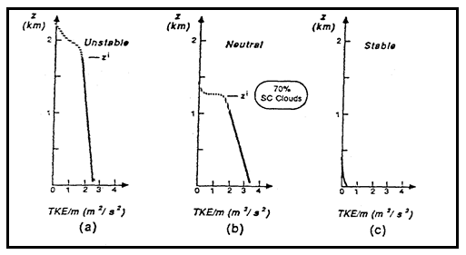.
Figure 1 shows the turbulent kinetic energy per unit mass (TKE/m) of various Boundary layer conditions.

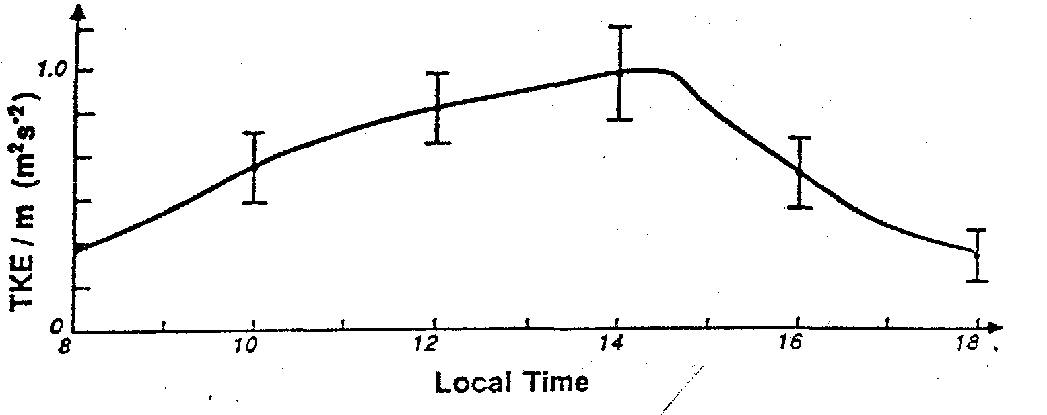
Figure 2 shows the daily cycle of turbulent kinetic energy per unit mass (TKE/m)

Methodology:
1- Two sets of data are recorded by ten recordings, with an interval of one hour.
2- The wind speed turbulence can be calculated for any wind vector, for example, X as follows:
$\grave{x}=x_{i}-\overline{x}$ ……. (6)

3- you must arrange The data as in the table below:

${\grave{w}}^{2}$ | ${\grave{v}}^{2}$ | ${\grave{u}}^{2}$ | $\grave{w}$ | $\grave{v}$ | $\grave{u}$ | w | v | u

3- Using equation No. (5), calculate the avarege of turbulent kinetic energy $\overline{e}$.

