BACILLUS CEREUS

Bacillus cereus is one of over 100 species belonging to the genus Bacillus ,
which contains other foodborne species ( B. anthracis, B. thuringiensis, B. mycoides , and B. pseudomycoides ). B. cereus is usually a gram - positive aerobic spore – forming bacterium that causes two distinct gastrointestinal illnesses, the emetic syndrome and the diarrheal syndrome. B. cereus can become a gram - negative or a facultative anaerobe with age while maintaining toxin – producing properties. In 1955, the fi rst reported cases of B. cereus - induced food poisoning occurred in Scandinavia, when four outbreaks involving over 600 patients were linked to consumption of vanilla sauce contaminated by B. cereus . Although food poisoning from B. cereus is well known, cases are vastly under reported or diagnosed as presumed viral infections, secondary to a short and generally mild course of afebrile gastrointestinal illness that usually resolves spontaneously. Detection of B. cereus during food poisoning episodes requires analysis of stool, vomitus, and food specifically for this bacterium.

EXPOSURE
Bacillus cereus is ubiquitous in water and soil. Uptake of spores and the bacterium by rice plants occurs in rice fields contaminated by B. cereus . Transfer of B. cereus to food occurs not only from soil and fertilizers during
harvesting and post harvest handling, but also from contamination during processing, shipping, and marketing. Although this bacterium frequently contaminates vegetables.
Bacillus cereus can colonize the gastrointestinal tract of some invertebrates (e.g., worms, flying insect larvae), resulting in the exposure of cows to this bacteria. B. cereus spores may contaminate dairy feed and provide a source for the contamination of cow milk by B. cereus . The life cycle of this bacterium may contribute to the occurrence of B. cereus in the milk from cows and goats. Some humans transiently carry B. cereus in the gut
without symptoms (14 – 43%), as a result of the ingestion of nonpathogenic concentrations of the bacterium from food.
Bacillus cereus can contaminate most foods, but the development of Bacillus cereus - induced food poisoning requires high bacterial counts. Foods frequently associated with high B. cereus content include rice (particularly
fried rice), cereals, pasta, corn, cornstarch, beef, poultry, pasteurized dairy products, infant formulas, meats, fish, vegetables, and soups. The diarrheal type is typically associated with vegetables, sauces, soups, meat, and milk products, whereas the emetic type is usually associated with rice, pasta, noodles, and pastry. Bacterial growth is enhanced in proteinaceous environments. The preparation of fried rice provides an ideal milieu for bacterial growth. Rice is typically cooked in advance, and then cooled at room temperature when spores begin to germinate. In vitro studies indicate that quantities of emetic - type toxin sufficient to cause human illness can form at room temperature (20 ° C) within 12 – 16 hours after inoculation of rice with B. cereus . These studies also indicate that the addition of vinegar, mayonnaise, or catsup to foods contaminated with B. cereus inhibits both bacterial proliferation and toxin formation.
Food Processing
Proper refrigeration does not eliminate B. cereus because of the ability of these bacteria to survive low temperatures (i.e., 5 ° C −8 ° C). These psychrotrophic organisms multiply optimally at (20 ° C), but these organisms remain viable at temperatures from (0 ° C −40 ° C). Accordingly, room temperature (22 ° C) provides a favorable environment for B. cereus growth, while refrigeration (2 ° C) and reheating do not always inhibit growth or kill these organisms. The US Department of Agriculture and the European Food Safety Authority do not have specific regulations on B. cereus in foodstuffs. The ability to control B. cereus in commercial food processing is limited by a number of factors including the ubiquity of the organism, the resistances of spores to commercial disinfectant processes, and the lack of easily detectable contamination by smell or sight. Vegetative cells can form films on stainless steel equipment and containers, conferring even higher resistance to disinfectants and heat. Pasteurization is an effective means of killing vegetative cells, but the pasteurization process does not kill all B. cereus spores. Each vegetative cell is capable of producing one spore. The spore core, or protoplast, is surrounded by a cortex and three protein coats that protect the core from environmental stresses, such as heat, radiation, chemical disinfectants, and desiccants. Spores from B. cereus withstand high temperatures during cooking and pasteurization, allowing them to germinate as food cools. Therefore, the storage of precooked food for later serving requires immediate refrigeration after cooking to reduce germination of B. cereus spores. Food should be reheated at high temperatures ( > 60 ° C,) to kill new vegetative cells, and food should be served immediately. Although proper reheating can kill vegetative cells, the spores and preformed toxins can survive normal food preparation methods.Use of separate utensils and containers for cooked and uncooked food may help prevent recontamination of cooked food, and food handlers must practice strict personal hygiene and receive proper food safety training.

TOXINS
Physiochemical Properties
Distinct toxins are responsible for two forms of gastrointestinal illness caused by B. cereus . The emetic - type of illness results from the formation of the dodecadepsipeptide toxin, cereulide, whereas the diarrheal form of
the illness probably involves several enterotoxins.

Emetic Toxin
Cereulide is a preformed, 1165 - Da cyclic dodecadepsipeptide that is heat stable to (126 ° C). The production of cereulide by B. cereus depends on several factors including the type of the food, temperature, pH, preparation methods (e.g., aeration), and the specific strain of B. cereus ,Foods with 10⁶ organisms generally have sufficient toxin to cause illness
. The chemical structure of cereulide includes a ring - shaped structure consisting of three repeats of a four - amino acid sequence (leucine, alanine, valine, valine). Cereulide is resistant to pepsin and stable in the pH range between 2 and 11. This latter property accounts for the ability of cereulide to resist degradation in the human stomach.

Diarrheal Toxin
Bacillus cereus produces at least four heat - labile enterotoxins capable of producing diarrheal illness. These enterotoxins include two protein complexes (hemolysin BL, nonhemolytic enterotoxin) and two enterotoxic
proteins (enterotoxin T, cytotoxin K). Hemolysin BL (HBL), the diarrheal toxin, is a 40 - kDa, three - component protein that is heat labile and pH stable between 4 and 11. A minority of B. cereus strains produce a nonhemolytic enterotoxin (Nhe) that also causes the diarrheal syndrome. The hemolytic notation of HBL refers to the hemolysis induced by this toxin in sheep red blood cells in vitro ; however, there is no direct evidence of a similar effect in humans. Although some B. cereus strains are capable of producing both toxins, only one toxin is usually elaborated in disease states. Some strains of Bacillus species other than B. cereus can produce emetic toxins or enterotoxins including B. subtilis , B. mojavensis , B. pumilus , and B. fusiformis .

Mechanism of Toxicity
- Both spores and vegetative cells are found in many foods. Cooking destroys vegetative cells, but spores survive to germinate when food is cooled to room temperature. Emetic (cereulide) or diarrheal (HBL) enterotoxins are subsequently elaborated when food is improperly stored and reheating fails to destroy these toxins. Following ingestion, these enterotoxins produce either the emetic syndrome or the diarrheal syndrome. The mechanism and site of action of cereulide is .

- Mode of action
- Cereulide is encoded on the plasmid pCER270
- Cereulide is absorbed in the intestine and distributed throughout the body where it can cross the blood–brain barrier or accumulate in the liver, kidneys, fat, and muscle tissue
- Either a direct (at vagal sensory endings) or indirect (stimulates secretion of serotonin to activate 5-HT3) interaction with 5-HT3 receptors of the stomach and intestine that drive gut-to-brain signaling induced emesis (vomiting)
- Cereulide destroyed mitochondrial membrane potential (MMP) and impairs mitochondrial fatty acid metabolism leads to dose-dependent increase of small fatty droplets.
- And induces hepatocyte damage (massive degeneration of hepatocytes).
- Cereluide directly act on the brain; Central Nerve System cause acute encephalopathy

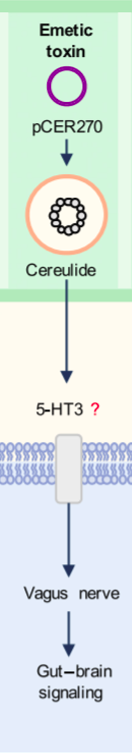

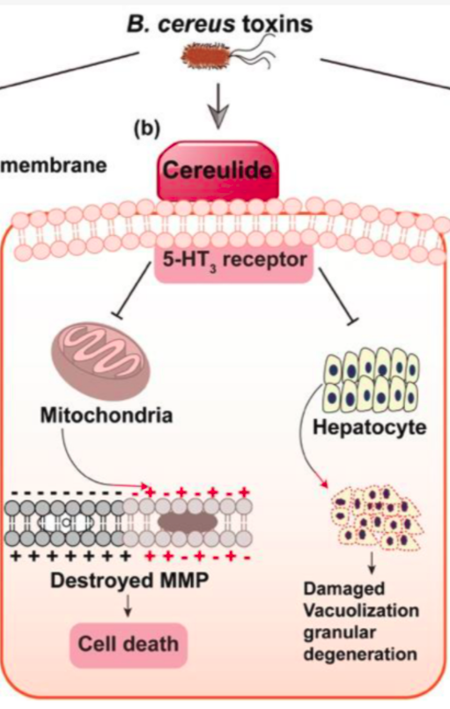

rapid onset of illness and the lack of a diarrheal component suggest that the stomach is the site of action. Animal studies indicate that cereulide disrupts mitochondrial membrane potential and impairs mitochondrial fatty acid metabolism, resulting in a dose - dependent increase of small fatty droplets and massive degeneration of hepatocytes following high doses. Hemolysin BL consists of three polypeptide components: B, L 1 , and L 2 . The B component forms pores in cell membranes of the intestinal mucosa, allowing the L 1 and L 2 components to lyse cells and activate adenylate cyclase, resulting in altered tissue permeability, tissue damage, and fluid secretion. B. cereus also produces a series of phospholipases that have an affinity for phosphatidylcholine and sphingomyeline on intestinal cell membranes. These enzymes play a role in mucosal tissue degradation, and are structurally similar to alpha - toxin produced by Clostridium perfringens .

DOSE RESPONSE
The bacterial dose required for the development of the emetic syndrome has not been established because the number of bacteria required to produce sufficient preformed toxin to cause symptoms is not known. Animal studies suggest 9 – 12.9 µ g/kg of cereulide enterotoxin are required to induce emesis. The bacterial dose for the diarrheal syndrome is accepted as > 10⁵ CFU/g of food substance. This dose is based on epidemiological calculations
of data obtained from confirmed B. cereus outbreaks with diarrheal syndrome (range: 5 × 10⁴ – 10¹¹ CFU/g of food substance).

CLINICAL RESPONSE
Bacillus cereus causes the following two forms of food poisoning: a heat - stable toxin - induced emetic form that is similar to Staphylococcus aureus food poisoning, and heat - labile enterotoxin - induced diarrheal form that
produces symptoms similar to Clostridium perfringens food poisoning. Nausea, abdominal cramping, bloating, and vomiting characterize the emetic syndrome. Symptoms occur 30 minutes to 6 hours after ingestion and
resolve within 6 – 24 hours. Mild diarrhea is occasionally associated with the emetic form of gastrointestinal illness. The diarrheal syndrome is characterized by mild nausea, occasional vomiting, and profuse, nonbloody diarrhea. Symptoms occur 8 – 16 hours after ingestion and persist 12 – 24 hours. Death from either syndrome is extremely rare, and person - to - person spread does not occur. Rarely, case reports document the development of serious extra gastrointestinal infections caused by B. cereus , including meningitis in an immunocompromised patient, sepsis in children with acute leukemia, bacteremia in neonates, and fulminant necrotizing fasciitis in a healthy child following a puncture wound from a tree branch.

TREATMENT
Treatment includes rehydration and bowel rest for both the emetic and the diarrheal syndromes. Oral rehydration is usually sufficient, but intravenous fluid replacement and hospitalization may be necessary in cases of severe dehydration or severe electrolyte abnormalities, particularly in young children or elderly patients. Anti - emetics may alleviate symptoms in the emetic syndrome. The short duration of both syndromes generally limits the necessity of these medications. B. cereus produces beta - lactamases, generating resistance to penicillins and cephalosporins, but B. cereus is usually susceptible to aminoglycosides, sulfonamides, vancomycin, erythromycin, tetracycline, ciprofl oxacin, and clindamycin.

