**University of Al-Mustansiriyah**

**College of Science/ Department of Biology**

**Course : Botany**

**Lecture: 3**

**Tissues**

most plants have three or four major groups of organs—**roots, stems, leaves,** and in some instances, **flowers.** Each of these organs is composed of tissues, which are defined as “groups of cells performing a similar function.” Any plant organ may be composed of several different tissues; each tissue is classified according to its structure, origin, or function.

Three basic tissue patterns occur in roots and stems . The following are major kinds of tissues

found in higher plants.

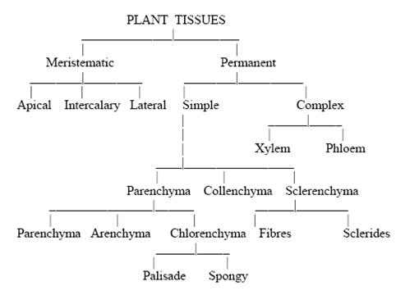

**MERISTEMATIC TISSUES**

Unlike animals, plants have permanent regions of growth called **meristems,** or *meristematic tissues,* where cells actively divide (Fig. 4.1). As new cells are produced, they typically are small, six-sided, boxlike structures, each with a proportionately large nucleus, usually near the center, and with tiny vacuoles or no vacuoles at all. As the cells mature, however, they assume many different shapes and sizes, each related to the cell’s ultimate function; the vacuoles increase in size, often occupying more than 90% of the volume of the cell.

1. **Apical Meristems**

**Apical meristems** are meristematic tissues found at, or near, the tips of roots and shoots, which increase in length as the apical meristems produce new cells. This type of growth is known as *primary growth.* Three *primary meristems,* as well as embryo leaves and buds, develop from apical meristems. These primary meristems are called **protoderm, ground meristem,** and **procambium.** The tissues they produce are called **primary tissues.**

1. **Lateral Meristems**

The *vascular cambium* and *cork cambium,* discussed next, are **lateral meristems,** which produce tissues that increase the girth of roots and stems. Such growth is termed *secondary growth.*

1. ***Vascular Cambium***

The **vascular cambium,** often referred to simply as the **cambium,** produces *secondary tissues* that function primarily in support and conduction. The cambium, which extends throughout the length of roots and stems in perennial and many annual plants, is in the form of a thin cylinder of mostly brick-shaped cells. The cambial cylinder often branches, except at the tips, and the tissues it produces are responsible for most of the increase in a plant’s girth as it grows. The individual remaining cells of the cambium are referred to as *initials,* while their sister cells are called *derivatives.*

1. **Cork Cambium**

The **cork cambium,** like the vascular cambium, is in the form of a thin cylinder that runs the length of roots and stems of woody plants. It lies outside of the vascular cambium, just inside the outer bark, which it produces. The tissues laid down by the vascular cambium and the cork cambium are called *secondary tissues,* since they are produced *after* the primary tissues have matured.

1. **Intercalary Meristems**

Grasses and related plants have neither a vascular cambium nor a cork cambium. They do, however, have apical meristems, and, in the vicinity of **nodes** (leaf attachment areas), they have other meristematic tissues called *intercalary meristems.* The intercalary meristems develop at intervals along stems, where, like the tissues produced by apical meristems, their tissues add to stem length.



**Figure 4.1** A diagram of the longitudinal axis of a plant, showing the location of meristems. Note that in most microscope slides used in botany laboratories, meristems are normally stained green.

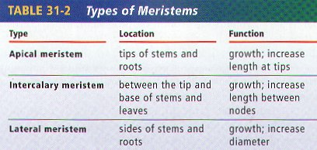

**TISSUES PRODUCED BY MERISTEMS**

After cells are produced by meristems, the cells assume various shapes and sizes related to their functions as they develop and mature. Some tissues consist of only one kind of cell, whereas others may have two to several kinds of cells.

1. **Simple Tissues**
   1. ***Parenchyma***

Parenchyma tissue is composed of parenchyma cells (Fig. 4.2), which are the most abundant of the cell types and are found in almost all major parts of higher plants. They are more or less spherical in shape when they are first produced, but when all the parenchyma cells push up against one another, their thin, pliable walls are flattened at the points of contact. As a result, parenchyma cells assume various shapes and sizes, with the majority having 14 sides. They tend to have large vacuoles . Parenchyma cells have spaces between them; in fact, in water lilies and other aquatic plants, the intercellular spaces are quite extensive and form a network throughout the entire plant. This type of parenchyma tissue with extensive connected air spaces is referred to as **aerenchyma**.

Parenchyma cells containing numerous chloroplasts (as found in leaves) are collectively referred to as **chlorenchyma** tissue. Chlorenchyma tissues function mainly in photosynthesis, while parenchyma tissues without chloroplasts function mostly in food or water storage. Some parenchyma cells develop irregular extensions of the inner wall that greatly increase the surface area of the plasma membrane. Such cells, called transfer cells, are found in nectaries of flowers where they apparently play a role in transferring dissolved substances between adjacent cells. Mature parenchyma cells can divide long after they were produced by a meristem. In fact, when a cutting (segment of stem) is induced to grow, it is parenchyma cells that start dividing and give rise to new roots. When a plant is damaged or wounded, the capacity of parenchyma cells to multiply is especially important in repair of tissues.

**

**Figure 4.2** Parenchyma cells. They are more or less spherical when first formed, but as their walls touch other parenchyma cell walls, the cells end up with an average of 14 sides at maturity. 100.

1. ***Collenchyma***

**Collenchyma** cells (Fig. 4.3), like parenchyma cells, have living cytoplasm and may remain alive a long time. Their walls generally are thicker and more uneven in thickness than those of parenchyma cells. The unevenness is due to extra primary wall in the corners. Collenchyma cells often occur just beneath the epidermis; typically, they are longer than they are wide, and their walls are pliable as well as strong. They provide flexible support for both growing organs and mature organs, such as leaves and floral parts. The “strings” of celery that get stuck in our teeth, for example, are composed of collenchyma cells.



**Figure 4.3** Collenchyma cells. Note the walls are unevenly thickened at the corners. 100.

1. ***Sclerenchyma***

**Sclerenchyma** tissue consists of cells that have thick, tough, secondary walls, normally impregnated with **lignin.** Most sclerenchyma cells are dead at maturity and function in support. Two forms of sclerenchyma occur: **sclereids** and **fibers.** Sclereids (Fig. 4.4) may be randomly distributed in other tissues. For example, the slightly gritty texture of pears is due to the presence of groups of sclereids, or *stone cells,* as they are sometimes called. The hardness of nut shells and the pits of peaches and other stone fruits is due to sclereids. Sclereids tend to be about as long as they are wide and sometimes occur in specific zones (e.g., the margins of camellia leaves) rather than being scattered within other tissues.

1. ***Fibers***

***Fibers***(Fig. 4.5) may be found in association with a number of different tissues in roots, stems, leaves, and fruits. They are usually much longer than they are wide and have a proportionately tiny cavity, or *lumen,* in the center of the cell.



**Figure 4.4** *A.* Sclereids (stone cells) of a pear in cross section.



 

**Figure 4.5** Fibers. *A.* A cross section of a portion of stem tissue from a linden tree (*Tilia* sp.). 1,000. Note the thickness of the walls of the darker fibers.

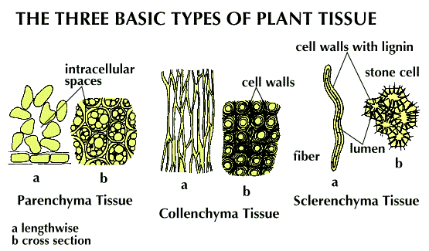

**B-Complex Tissues**

tissues are always composed of two or more kinds of cells and are sometimes referred to as *complex tissues.*

1. ***Xylem***

**Xylem** tissue is an important component of the “plumbing” and storage systems of a plant and is the chief conducting tissue throughout all organs for water and minerals absorbed by the roots. Xylem consists of a combination of parenchyma cells, fibers, *vessels, tracheids,* and *ray cells* (Fig. 4.6). **Vessels** are long tubes composed of individual cells called **vessel elements** that are open at each end. As each vessel element develops, the perforation plate, in some instances, can become barlike strips of wall material that extend across the openings.

However, the flow of fluid through the vessels is not blocked by the strips. **Tracheids,** which, like vessel elements, are dead at maturity and have relatively thick secondary cell walls, are

tapered at each end, the ends overlapping with those of other tracheids. Tracheids have no openings similar to those of vessels, but there are usually pairs of *pits* present wherever two

tracheids are in contact with one another (Fig. 4.7). Pits are areas in which no secondary wall material has been deposited and they allow water to pass from cell to cell.

In cone-bearing trees and certain other non-flowering plants, the xylem is composed almost entirely of tracheids. The walls of many tracheids, as well as vessel elements, have spiral thickenings on them (Fig. 4.9). Most conduction through xylem is upward, but some is lateral (sideways).

1. ***Phloem***

Phloem tissue (Fig. 4.10), which conducts dissolved food materials produced by photosynthesis throughout the plant, is composed mostly of two types of cells without secondary walls. The relatively large, more or less cylindrical **sieve tube** members have narrower, more tapered companion cells closely associated with them. Phloem often includes **fibers, parenchyma, and ray cells**. Sieve tube members, like vessel elements, are laid end to end, forming sieve tubes. Unlike vessel elements, however, the end walls have no large openings; instead, the walls are full of small pores through which the cytoplasm extends from cell to cell. These porous regions of sieve tube members are called **sieve plates**.

Sieve tube members have no nuclei at maturity, even though their cytoplasm is very active in the conduction of food materials in solution throughout the plant. Apparently, the adjacent companion cells form a very close relationship with the sieve tubes next to them and aid in the conduction of the food. Sieve cells, which are found in ferns and cone-bearing trees, are similar to sieve tube members but tend to overlap at their ends rather than form continuous tubes. Like sieve tube members, they have no nuclei at maturity, but they have no adjacent companion cells. They do have adjacent albuminous cells, which are equivalent to companion cells and apparently function in the same manner.



**Figure 4.10** Longitudinal view of part of the phloem of a black locust tree *(Robinia pseudo-acacia).*

1,000.

1. ***Epidermis***

The outermost layer of cells of all young plant organs is called the **epidermis**. Since it is in direct contact with the environment, it is subject to modification by the environment and often includes several different kinds of cells. The epidermis is usually one cell thick, but a few plants produce aerial roots called **velamen roots** (e.g., orchids) in which the epidermis may be several cells thick. Such a multiple-layered epidermis also occurs in the leaves of some tropical figs , where it protects a plant from desiccation. Most epidermal cells secrete a fatty substance called **cutin** within and on the surface of the outer walls. Cutin forms a protective layer called the **cuticle** (Fig. 4.11). The thickness of the cuticle (or, more importantly, wax secreted on top of the cuticle by the epidermis) to a large extent determines how much water is lost through the cell walls by evaporation. The cuticle is also exceptionally resistant to bacteria and other disease organisms .



**Figure 4.11** A portion of a cross section of a kaffir lily (*Clivia*) leaf, showing the thick cuticle secreted by the epidermis. 1,000.