**1-Measurement and Units**

A large part of science is based upon the creation of mathematical models that describe physical phenomena. For example, the subject of Newtonian Mechanics describes how objects will behave when they are subject to forces. However, to relate the mathematical description to the real world requires that there is a mutually agreed upon measurement system. To accomplish this task, we use a mutually agreed upon Currently, there are actually two widely used systems of units in the world, the Metric System (or System International [SI]) and the British systems. The metric system measures the length in meters whereas the British system makes use of the foot, inch, …. The metric system is the most widely used, by international agreement the metric system was formalized in 1971 into the *International System of Units* (SI). Therefore, the metric system (SI) will be used in this course. The three basic quantities Meter, Kilogram, Second, which measure length, mass, and time respectively.

|  |  |
| --- | --- |
| **Quantity** | **SI Unit** |
| Length | Meter |
| Mass | Kilogram |
| Time | Second |
| Temperature | Kelvin |
| Electric Current | Ampere |
| Luminous Intensity | Candela |
| Amount of Substance | mole |

**1-1 The Standard Prefixes used in SI Units**

One nice thing about the SI system is that there is a uniform prefix system that is used across all measured quantities. For example, the prefix kilo means 1000. Thus, a kilogram is 1000 grams or a kilometer is 1000 meters. All of the prefixes are some multiple of 10

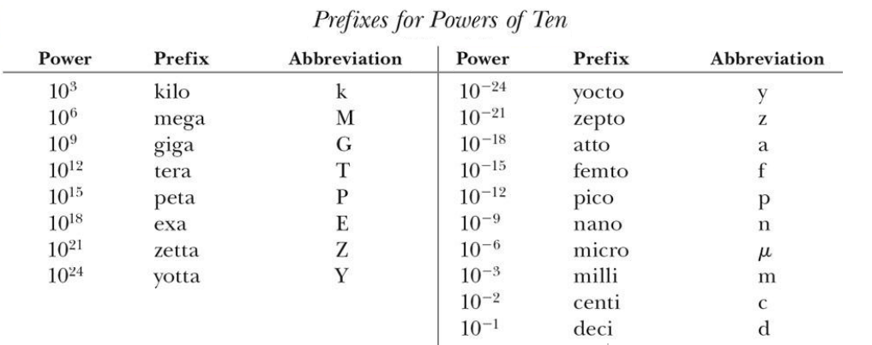

**1-2 Vector and scalar quantities**

All physical quantities (basic or derived) can be divided into two types, the first type scalar quantities and the second type vector quantity**.**

**There are two different quantities in the description of the physical events:**

**1-2-1 Scalars:**

The scalar quantity can be determined by magnitude only, such as saying that the mass of an object is 5kg, the area of a rectangular piece is 30m2, then we have determined the physical quantity. So, Quantities that can be specified completely by a number which have only magnitude are called “scalars”. For example, distance (x), mass (m), time (t), volume (V), density (d), work (W), energy (E)…etc

**1-2-2 Vectors:**

The vector quantity needs to specify its direction in addition to its magnitude, such as the wind speed of 10km/h and its direction to the west. Note here that we needed to specify the magnitude first and then the direction second. Quantities that behave like speed are called “Vectors”. For example, displacement (x), velocity (v), acceleration (a), force (F), moment (M), weight (G)…etc. (Vector means “carrier” in Latin. In Biology the term “vector” means an insect, animal or an agent that carries a cause of disease from one organism to another).

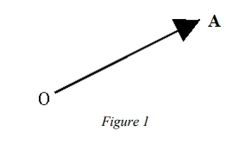Graphically, a vector is represented by an arrow defining the direction. The length of the arrow defines the vector's magnitude. This is shown in Figure 1.

If we denote one end of the arrow by the origin O and the tip of the arrow by A. Then the vector may be represented algebraically by OA

This is often simplified to just or Ā**.** The line and arrow above the A are there to indicate that the symbol represents a vector. Another notation is boldface type as: **A**.

Note, that since a direction is implied, OA **≠** AO. Even though their lengths are identical, their directions are exactly opposite, in fact OA = -AO.

The magnitude of a vector is denoted by absolute value signs around the vector symbol: magnitude of A = |A|.

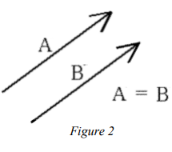

**#1** Two vectors, A and B are equal if they have the same magnitude and direction, regardless of whether they have the same initial points, as shown in Figure 2.

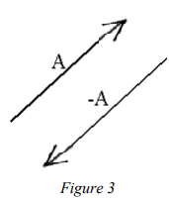

#2 A vector having the same magnitude as A but in the opposite direction to A is denoted by - A, as shown in Figure 3.

**1-2-3 Properties of Vector: Vector addition**

**A- Graphical Method**

Vectors that express similar physical quantities can be combined, such as the collection of two force vectors, but we cannot combine a force vector with a velocity vector. For example, by combining vector A with vector B, the resultant vector is C

A + B = C

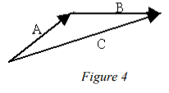We can now define vector addition. The sum of two vectors, A and B, is a vector C, which is obtained by placing the initial point of B on the final point of A, and then drawing a line from the initial point of A to the final point of B, as illustrated in Figure 4. This is sometimes referred to as the "Tip-to-Tail" method.

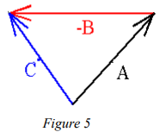

Vector subtraction is defined in the following way. The difference of two vectors, A - B, is a vector C that is, C = A - B or C = A + (-B). Thus, vector subtraction can be represented as a vector addition.

As we mentioned above, any quantity that has a magnitude but no direction associated with it is called a "scalar". Speed, mass and temperature are scalars, for example. The product of a scalar, p say, times a vector A , is another vector, B, where B has the same direction as A but the magnitude is changed, that is, |B| = m|A|

 Many of the laws of ordinary algebra hold also for vector algebra. These laws are:

* **Commutative Law for Addition**: A + B = B + A
* **Associative Law for Addition**: A + (B + C) = (A + B) + C

The verification of the Associative law is shown in Figure 6.

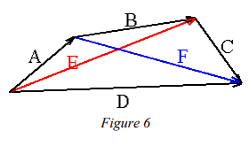If we add **A** and **B**, we get a vector **E**.

And

similarly, if **B** and **C**, we get **F.**

Now **D** = **E** + **C** = **A** + **F**

Replacing **E** with (**A** + **B**) and **F** with (**B** + **C**),

we get (**A** +**B**) + **C** = **A** + (**B** **+ C**) and we see that the law is verified. Stop now and make sure that you follow the above proof.

* **Commutative Law for Multiplication**: pA = Ap
* **Associative Law for Multiplication**: (p + n) A = pA + nA, where p and n are two different scalars.

Distributive Law: p(A + B) = pA + pB

**1-3 The unit vector:**

A unit vector is known as a vector of unit length and is used to express the direction of any vector physical quantity.

Unit vectors (i, j, k) of the Cartesian rectangular coordinate system x, y, z can be represented as in figure 7.

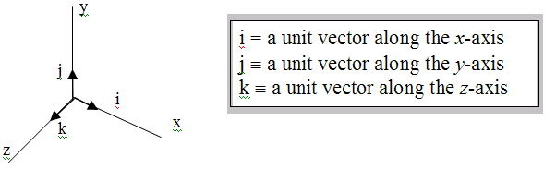

*figure 7. Unit vectors (i, j, k) of the Cartesian coordinate system x, y, z*

