Dimorphic Systemic Mycoses
These infections result from inhalation of the spores of dimorphic fungi that have their mold forms in the soil. the infection had happened by spreading of spores from soil then is inhaled to reach respiratory system then spore germinate in lung to form yeast cells to cause Asymptomatic infection or primary pulmonary infection then transform this infection to systematic infection with chronic ulcerative lesions
- 1- Histoplasmosis
Histoplasma capsulatum causes histoplasmosis. H. capsulatum is a dimorphic fungus that exists as a mold in soil and as a yeast in tissue.
It forms two types of asexual spores
1- tuberculate macroconidia, with typical thick walls and fingerlike projections that are important in laboratory identification,
2- microconidia, which are smaller, thin, smoothwalled spores that, if inhaled, transmit the infection.

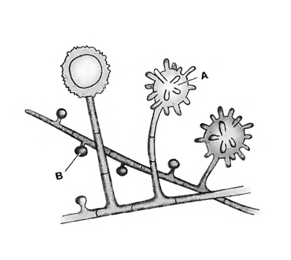
This fungus occurs in many parts of the world.
In the United States it is endemic in central and eastern states, especially in the Ohio and Mississippi River valleys.
Clinical manifestations:
Histoplasmosis may be divided into the following types:
Primary pulmonary histoplasmosis
Progressive disseminated histoplasmosis
Primary cutaneous histoplasmosis

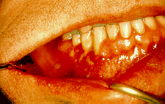
Histoplasmosis of the lower jaw showing ulcer around base of the teeth.
Disease mechanism
H. capsulatum grows in soil and material contaminated with bird or bat droppings.The fungus has been found in poultry house litter, caves, areas harboring bats, and in bird roosts (particularly those of starlings). The fungus is thermally dimorphic: in the environment it grows as a brownish mycelium, and at body temperature (37 °C in humans) it morphs into a yeast. Histoplasmosis is not contagious, but is contracted by inhalation of the spores from disturbed soil. The inoculum is represented principally by microconidia. These are inhaled and reach the alveoli. In the alveoli, macrophages ingest these microconidia. They survive inside the phagosome. As the fungus is thermally dimorphic, these microconidia are transformed into yeast. They grow and multiply inside the phagosome. The macrophages travel in lymphatic circulation and spread the disease to different organs.
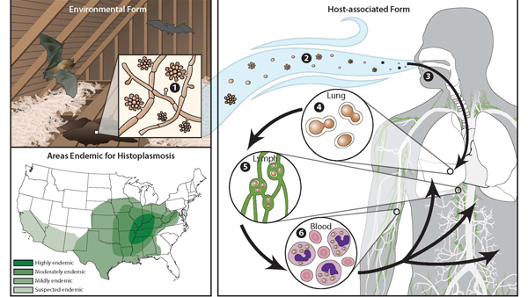
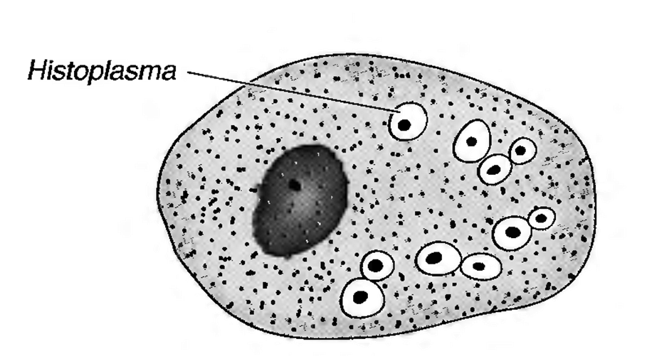
In tissues, H. capsulatum occurs as an oval budding yeast inside macrophages

Laboratory diagnosis:
. 1-Clinical material: Skin scrapings, sputum and bronchial washings, cerebrospinal fluid, pleural fluid and blood, bone marrow, urine and tissue biopsies from various visceral organs.
. 2-Direct Microscopy: (a) Skin scrapings should be examined using 10% KOH and Parker ink or calcofluor white mounts; (b) Exudates and body fluids should be centrifuged and the sediment examined using either 10% KOH and Parker ink or calcofluor white mounts, (c) Tissue sections should be stained using PAS digest, Grocott's methenamine silver (GMS) or Gram stain.
Histopathology is especially useful and is one of the most important ways of alerting the laboratory that they may be dealing with a potential pathogen.
.
. 3-Culture: Clinical specimens should be inoculated onto primary isolation media, like Sabouraud's dextrose agar and Brain heart infusion agar supplemented with 5% sheep blood..
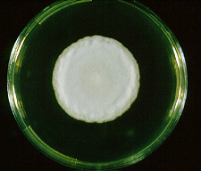
Culture of Histoplasma capsulatum.
4. -Serology: Immunodiffusion and/or complement fixation tests for the detection of antibody have proven to be useful in the diagnosis of Histoplasmosis, especially in immunocompetent patients. However, detection of antibodies in immunosuppressed patients is often difficult, with between 20-50% of patients testing negative.
Causative agents Histoplasma capsulatum
Treatment Typical treatment of severe disease first involves treatment with amphotericin B, followed by oral itraconazole.Treatment with itraconazole will need to continue for at least a year in severe cases.while in acute pulmonary histoplasmosis, 6 to 12 weeks treatment is sufficient..
2-Blastomycosis
Blastomycosis dermatitidis causes blastomycosis, known as North American blastomycosis.
B. dermariridis is a dimorphic fungus that exists as a mold in soil and as a yeast in tissue.The yeast is round with a doubly refractive wall and a single broad-based bud

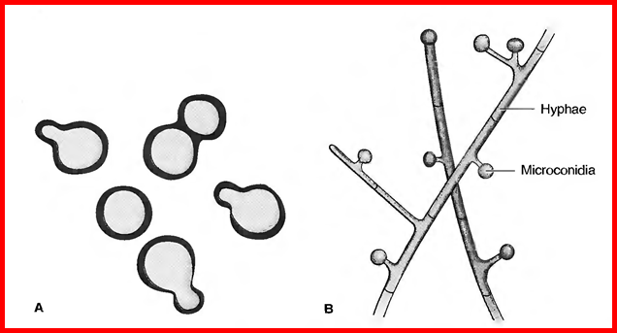
It grows in moist soil rich in organic material, forming hyphae with small pear-shaped conidia.
Inhalation of the conidia causes human infection.
Infection occurs mainly via the respiratory tract. Asymptomatic or mild cases are rarely recognized. Dissemination may result in ulcerated granulomas of skin, bone, or other sites.

Clinical manifestations: blastomycosis presents as a cutaneous or a respiratory disease
Pulmonary blastomycosis: In most individuals pulmonary lesions are asymptomatic and are not detected until the infection has spread to other organs. Others develop symptoms after an incubation period of 3-15 weeks. In most cases blastomycosis is indolent in onset and patients present with chronic symptoms such as cough, fever, and malaise and weight loss. The lesions become more extensive, with continued suppuration and eventual necrosis and cavitation.
Cutaneous blastomycosis: Haematogenous spread gives rise to cutaneous lesions in over 70% of patients. These tend to be painless and present either as raised verrucous lesions with irregular ulcers. The face, upper limbs, neck and scalp are the most frequent sites involved.
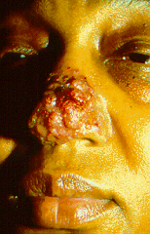
Skin lesions resulting from the dissemination of
the fungus from the lung
Laboratory diagnosis:
. 1-Clinical material: Skin scrapings, sputum and bronchial washings, cerebrospinal fluid, pleural fluid and blood, bone marrow, urine and tissue biopsies from various visceral organs.
2 . -Direct Microscopy: (a) Skin scrapings should be examined using 10% KOH and Parker ink or calcofluor white mounts; (b) Exudates and body fluids should be centrifuged and the sediment examined using either 10% KOH and Parker ink or calcofluor white mounts, (c) Tissue sections should be stained using PAS digest, Grocott's methenamine silver (GMS) or Gram stain.
In tissue biopsy specimens, thick-walled yeast cells with single broad-based buds are seen microscopically.
The skin test lacks specificity and has little value.
3-Culture: Clinical specimens should be inoculated onto primary isolation media, like Sabouraud's dextrose agar and Brain heart infusion agar supplemented with 5% sheep blood. Hyphae with small pear-shaped conidia are visible on culture.
. 4-Serology: Serological tests are of limited value in the diagnosis of Blastomycosis.
Treatment
Itraconazole is the drug of choice for most patients
Amphotericin B should be used to treat severe disease.
Surgical excision may be helpful.
There are no means of prevention.

