Phaeohyphomycosis
A mycotic infection of humans and lower animals caused by a number of dematiaceous (brown-pigmented) fungi where the tissue morphology of the causative organism is mycelial. This separates it from other clinical types of disease involving brown-pigmented fungi where the tissue morphology of the organism is a grain (mycotic mycetoma) or sclerotic body (chromoblastomycosis). The etiological agents include various dematiaceous hyphomycetes especially species of Exophiala, Phialophora, Cladophialophora ,Phaeoannellomyces, Aureobasidium, Cladosporium, Curvularia and Alternaria

Clinical manifestations:
Clinical forms of phaeohyphomycosis range from localized superficial infections of the stratum corneum (tinea nigra) to subcutaneous cysts (phaeomycotic cyst) to invasion of the brain.

1. Subcutaneous phaeohyphomycosis:
Subcutaneous infections occur worldwide, usually following the traumatic implantation of fungal elements from contaminated soil, thorns or wood splinters. Exophiala jeanselmei and Wangiella dermatitidisare the most common agents and cystic lesions occur most often in adults. Occasionally, overlying verrucous lesions are formed, especially in the immunosuppressed patient.
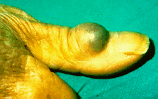
Subcutaneous phaeohyphomycosis caused by Exophiala jeanselmei.

2. Paranasal sinus phaeohyphomycosis: 3. Cerebral phaeohyphomycosis:

Laboratory diagnosis:
1. Clinical material: Skin scrapings and/or biopsy; sputum and bronchial washings; cerebrospinal fluid, pleural fluid and blood; tissue biopsies from various visceral organs and indwelling catheter tips.
2. Direct Microscopy: (a) Skin scrapings, sputum, bronchial washings and aspirates should be examined using 10% KOH and Parker ink or calcofluor white mounts; (b) Exudates and body fluids should be centrifuged and the sediment examined using either 10% KOH and Parker ink or calcofluor white mounts, (c) Tissue sections should be stained using H&E, PAS digest, and Grocott'smethenamine silver (GMS).
3. Culture: Clinical specimens inoculated onto primary isolation media, like Sabouraud's dextrose agar..
4. Serology: There are currently no commercially available serological procedures for the diagnosis of any of the infections classified under the term phaeohyphomycosis..
Treatment :1- surgery 2-antifungal agent are used 100-400mg/day of Amphotericin B,Itraconazol

Sporotrichosis (Rose Gardeners disease)
Sporotrichosis is primarily a chronic mycotic infection of the cutaneous or subcutaneous tissues and adjacent lymphatics characterized by nodular lesions which may suppurate and ulcerate. Infections are caused by the traumatic implantation of the fungus into the skin, or very rarely, by inhalation into the lungs. Secondary spread to articular surfaces, bone and muscle is not infrequent, and the infection may also occasionally involve the central nervous system, lungs . Sporothrix schenckii common agents of Sporotrichosis.

Clinical manifestations:

Cutaneous or skin sporotrichosis
Fixed cutaneous sporotrichosis: Primary lesions develop at the site of implantation of the fungus, usually at more exposed sites mainly the limbs, hands and fingers. Lesions often start out as a painless nodule which soon become palpable and ulcerate often discharging a serous or purulent fluid. Importantly, lesions remain localised around the initial site of implantation and do not spread along the lymphangitic channels.
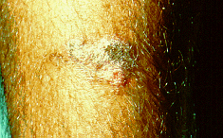
Fixed cutaneous sporotrichosis showing an ulcerating lesion on the leg.
Lymphocutaneous sporotrichosis: Primary lesions develop at the site of implantation of the fungus, but secondary lesions also appear along the lymphangitic channels which follow the same indolent course as the primary lesion ie they start out as painless nodules which soon become palpable and ulcerate. No systemic symptoms are present.
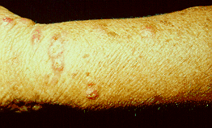
Lymphocutaneous sporotrichosis showing typical elevated subcutaneous nodules developing along the regional lymphatics of the forearm..

Pulmonary sporotrichosis

This rare form of the disease occur when S. schenckii spores are inhaled. Symptoms of pulmonary sporotrichosis include productive coughing, nodules and cavitations of the lungs, fibrosis, Patients with this form of sporotrichosis are susceptible to developing tuberculosis and pneumonia

Disseminated sporotrichosis

When the infection spreads from the primary site to secondary sites in the body, the disease develops into a rare and critical form called disseminated sporotrichosis. The infection can spread to joints and bones (called osteoarticular sporotrichosis) as well as the central nervous system and the brain (called sporotrichosis meningitis)..

The symptoms of disseminated sporotrichosis include weight loss, anorexia, and appearance of bony lesions

Laboratory diagnosis:
1. Clinical material: A tissue biopsy is the best specimen.
2. Direct Microscopy: Tissue sections should be stained using PAS digest, Grocott's methenamine silver (GMS) or Gram stain.
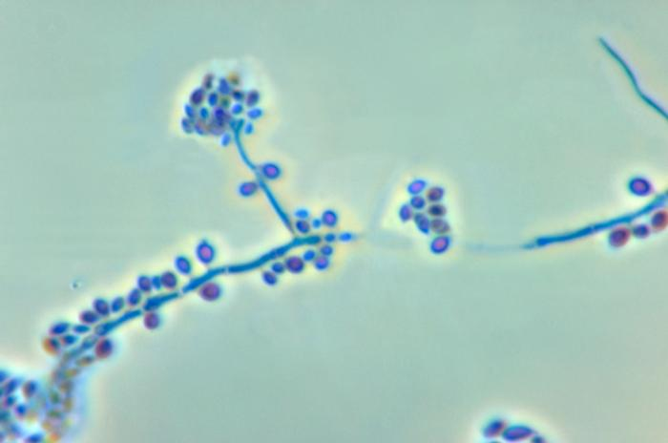
Conidiophores and conidia of the fungus Sporothrix schenckii

3. Culture: Clinical specimens should be inoculated onto primary isolation media, like Sabouraud's dextrose agar and Brain heart infusion agar supplemented with 5% sheep blood.
4. Serology: Serological tests are of limited value in the diagnosis of Sporotrichosis.

Treatment
Site of infection | Treatment
Skin | - Traditionally treated with saturated potassium iodide solution given orally 3 times per day for 3-6 months until all lesions have gone.  - ■Itraconazole orally for up to 6 months.  - ■Oral terbinafine
Bones and joints | - Difficult to treat and rarely respond to potassium iodide.  - Itraconazole orally for months or even up to a year.  - Amphotericin IV if oral therapy ineffective.  - Surgery to remove infected bone.
Lungs | - Potassium iodide, itraconazole and amphotericin used with varying degrees of success.  - Infected areas of lung may need to be surgically removed.
Disseminated (e.g. brain infection) | - Itraconazole may be tried  - Amphotericin plus 5-fluorocytosine is generally recommended.

*surgical excision
Zygomycosis
The term zygomycosis describes in the broadest sense any infection due to a member of the Zygomycetes. These are primitive, fast growing, Medically important orders and genera include:
1. Mucorales, causing subcutaneous and systemic zygomycosis (Mucormycosis) - Rhizopus, Mycocladus (Absidia), Rhizomucor, Mucor, Cunninghamella ..etc
2. Entomophthorales, causing subcutaneous zygomycosis (Entomophthoromycosis) - Conidiobolus and Basidiobolus .

Clinical manifestations:

1. Rhinocerebralzygomycosis: 2. Pulmonary zygomycosis:

3. Gastrointestinal zygomycosis:4. Cutaneous zygomycosis:

5. Disseminated zygomycosis: 6. Central Nervous System alone:

7. Infections caused by entomophthoraceous fungi:
Zygomycosis due to entomophthoraceous fungi is caused by species of two genera, Basidiobolus and Conidiobolus. Zygomycosis caused by B. ranarum is a chronic inflammatory or granulomatous disease generally restricted to the subcutaneous tissue of the limbs, chest, primarily occurring in children and with a predominance in males. Initially, lesions appear as subcutaneous nodules which develop into massive, firm, , painless swellings which are freely movable over the underlying muscle, but are attached to the skin which may become hyperpigmented but not ulcerated.
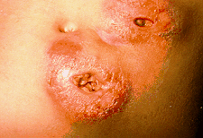
Zygomycosis caused by B. ranarum. Zygomycosis caused by Conidiobolus
Zygomycosis caused byConidiobolus sp. is a chronic inflammatory or granulomatous disease that is typically restricted to the nasal submucosa and characterised by polyps or palpable restricted subcutaneous masses. Clinical variants, including pulmonary and systemic infections have also been described. Human infections occur mainly in adults with a predominance in males (80% of cases). Infections usually begin with unilateral involvement of the nasal mucosa. Symptoms include nasal obstruction, drainage and sinus pain. Subcutaneous nodules develop in the nasal and perinasal regions and progressive generalized facial swelling may occur. Infections also occur in horses.

Laboratory diagnosis:
1. Clinical Material: Skin scrapings from cutaneous lesions; sputum and needle biopsies from pulmonary lesions; nasal discharges, scrapings and aspirates from sinuses in patients with rhinocerebral lesions; and biopsy tissue from patients with gastrointestinal and/or disseminated disease.
2. Direct Microscopy: (a) Scrapings, sputum and exudates should be examined using 10% KOH & Parker ink or Calcofluor mounts; and (b) Tissue sections should be stained with H&E and GMS. Examine specimens for broad, infrequently septate, thin-walled hyphae, which often show focal bulbous dilations and irregular branching..
3. Culture: Inoculate specimens onto primary isolation media, like Sabouraud's dextrose agar. Most zygomycetes are sensitive to cycloheximide (actidione) and this agent should not be used in culture media. Look for fast growing, white to grey or brownish, downy colonies.
4. Serology: There are currently no commercially available serological procedures for the diagnosis of zygomycosis. Although some laboratories have developed ELISA tests for the detection of antibodies to Zygomycetes. Treatment: 1-surgical therapy 2-use potassium Iodine 3-Antifungal like Amphotericin B

