Subcutaneous mycoses
Subcutaneous mycoses include a heterogeneous group of fungal infections that develop at the site of transcutaneous trauma. The main subcutaneous fungal infections include sporotrichosis, chromoblastomycosis, mycetoma, lobomycosis, phaeohyphomycosis, subcutaneous zygomycosis
Chromoblastomycosis (Verrucous dermatitis)
Aetiological agents include various dematiaceous hyphomycetes associated with soil, especially Phialophora verrucosa,

Clinical manifestations:
Lesions of chromoblastomycosis are most often found on exposed parts of the body and usually start a small scaly papules or nodules which are painless but may be itchy. lesions may gradually arise and as the disease develops rash-like areas enlarge and become raised irregular plaques that are often scaly or verrucose. In long standing infections, lesions may become tumorous and even cauliflower-like in appearance. Other prominent features include epithelial hyperplasia, fibrosis and microabscess formation in the epidermis..

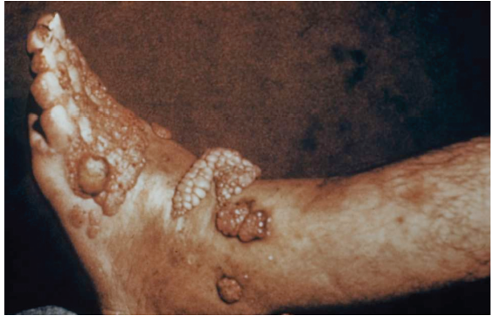
Chromoblastomycosis presenting on the toes, foot

Laboratory diagnosis:
1. Clinical Material: Skin scrapings and/or biopsy.
2. Direct Microscopy: (a) Skin scrapings should be examined using 10% KOH and Parker ink or calcofluor white mounts; (b) Tissue sections should be stained using H&E, PAS digest, and Grocott's methenamine silver (GMS).
Skin scrapings from a patient with chromoblastomycosis mounted in 10% KOH and Parker ink solution showing characteristic brown pigmented, planate-dividing, rounde sclerotic bodies(Medlar bodies)

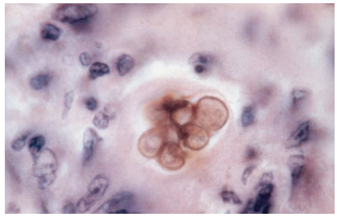
Chromoblastomycosis. Histological sample stained with hematoxylin and eosin showing the brown-pigmented Medlar bodies

3. Culture: Clinical specimens should be inoculated onto primary isolation media, like Sabouraud's dextrose agar

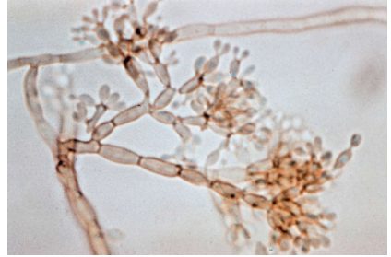.
Chromoblastomycosis. Culture stained with 10% KOH revealing the Medlar bodies, muriform bodies or sclerotic cells with round, brown, thick-walled and multi-septate cells

4. Serology: There are currently no commercially available serological procedures for the diagnosis of chromoblastomycosis

Management:
The treatment of chromoblastomycosis has been exceedingly difficult. Successful surgical excision requires the removal of a margin of uninfected tissue to prevent local dissemination. both itraconazole [400 mg/day] and terbinafine [500 mg/ day] for 6 to 12 months have been used successfully for the treatment of chromoblastomycosis

Lobomycosis(Lacaziosis)
Aetiological agents Lacazia loboi. The disease has been found in humans and dolphins

Clinical manifestations:
The initial infection is thought to be caused by traumatic implantation such as an arthropod sting, snake bite, or wound acquired while cutting vegetation. The lesions begin as small, hard nodules and may spread slowly in the dermis and continue to develop over a period of many years. Older lesions become verrucoid and may ulcerate. The disease may be transfered to other areas of of the skin by further trauma or autoinoculation. Lesions are usually found on the arms, legs, face or ears.
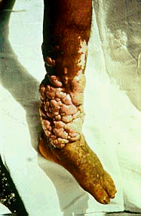
Lobomycosis showing extensive verrucoid lesions on the legs.
The lesions affect mainly exposed areas such as upper and lower limbs and are typically presented as keloid-like lesions

Laboratory diagnosis:
1. Clinical material: Tissue sample obtained by curettage or surgical biopsy.
2. Direct Microscopy: (a) Tissue can be macerated and mounted in 10% KOH and Parker ink or calcofluor white mounts or (b) Tissue sections should be stained using PAS digest, Grocott's methenamine silver (GMS) or Gram stains.
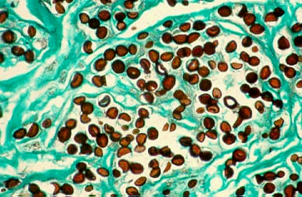 GMS stained tissue specimen showing numerous darkly pigmented yeast-like cells, often in chains, 9-1 µm in size.
3. Culture: The aetiologic agent known as "Loboa loboi" remains to be cultured.
4. Serology: There are currently no serological tests available.

Management:
The most successful treatment is for wide surgical excision of the affected area, however care must be taken to prevent contamination of surgical wounds, as relapse is common. Clofazimine at 100-200 mg/day has been used with varying results

Mycetoma(maduromycosis)
A mycotic infection of humans and animals Mycetoma are caused by 2 totally different groups of organisms: the first are moulds, and the second are filamentous bacteria in the order Actinomycetales. In the first case they are referred to as eumycetomas, in the second as actinomycetomas characterized by draining sinuses, granules and tumefaction..Aetiological agents include Madurella, Fusarium, Aspergillus etc.

Clinical manifestations:
Mycetoma is more common in men than women, particularly those aged 20 to 50. It generally presents as a single lesion on an exposed site and may persist for years. Two thirds arise on the foot.
- It starts as a small hard painless lump under the skin.
- It grows slowly but eventually involves underlying muscles and bones.
- The middle of the lesion caves in, ulcerates and discharges pus, which contains grains.
- granules which vary in size, colour and degree of hardness, depending on the aetiologic species. These grains are the hallmark of mycetoma.
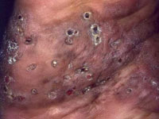 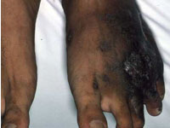.
Sinuses from Nocardia

Laboratory diagnosis:
1. Clinical Material: Tissue biopsy or excised sinus, fluid containing the granules which vary in size, colour and degree of hardness, depending on the aetiologic species.
2. Direct Microscopy: fluid containing the granules should be examined using either 10% KOH and Parker ink or calcofluor white mounts, and tissue sections should be stained using H&E, PAS digest, and Grocott'smethenamine silver (GMS). The colour of the grains may suggest the likely diagnosis; black grains suggest a fungal infection,
Microscopy using potassium hydroxide (KOH) confirms the diagnosis and type of mycetoma.
- Actinomycotic grains contain very fine filaments.
- Fungal grains contain short hyphae (branched filaments) that are often swollen
3. Culture: Clinical specimens should be inoculated onto primary isolation media, like Sabouraud's dextrose agar. Several agar plates are cultured at 25-30 degrees celcius and 37 degrees celcius for up to six weeks. Fungi grow more quickly than actinomycetes.
4. Serology: There are currently no commercially available serological procedures for the diagnosis of mycetoma.

Treatment of mycetoma
Actinomycetoma ….Streptomycin injections
- Amikacin , rifampicin, tetracycline
. Eumycetoma is more difficult to treat.
Itraconazole
ketoconazole

- Surgery to remove the affected tissue completely. These may mean amputation if bone is involved

