2-Tinea nigra (Phaeoannellomyces werneckii)
World-wide distribution, but more common in tropical regions of Central and South America, Africa, South-East Asia and Australia. An etiological agent is (Phaeoannellomyces werneckii) a common saprophytic fungus lived in soil, compost, and on wood in humid tropical and sub-tropical regions.
Clinical manifestations:
Skin lesions are characterized by brown to black macules which usually occur on the palmar aspects of hands and occasionally the plantar and other surfaces of the skin. Lesions are non-inflammatory and non-scaling.
Laboratory diagnosis:
1. Clinical Material: Skin scrapings.
2. Direct Microscopy: Skin scrapings should be examined using 10% KOH and Parker ink or calcofluor white mounts.
3. Culture: Clinical specimens should be inoculated onto primary isolation media, like Sabouraud's dextrose agar.
4. Serology: Not required for diagnosis.
Treatment: whitfild ointment, topical imidazole in a solution
3-Black piedra (e)
Black piedra is a superficial fungal infection of the hair shaft caused by Piedra hortae, an ascomycetous .It is common in Central and South America and South-East Asia.
Clinical manifestations:
Infections are usually localized to the scalp but may also be seen on hairs of the beard, moustache and pubic hair. Black piedra mostly affects young adults and epidemics in families have been reported following the sharing of combs and hairbrushes. Infected hairs generally have a number of hard black nodules on the shaft.
Laboratory diagnosis:
1. Clinical Material: Epilated hairs with hard black nodules present on the shaft.
2. Direct Microscopy: Hairs should be examined using 10% KOH and Parker ink or calcofluor white. Look for darkly pigmented nodules that may partially or completely surround the hair shaft. Nodules are made up of a mass of pigmented with a stroma-like centre containing asci.
3. Culture: Hair fragments should be implanted onto primary isolation media, like Sabouraud's dextrose agar. Colonies of Piedra hortae are dark, brown-black and take about 2-3 weeks to appear.
4. Serology: Not required for diagnosis.

4-White piedra (Trichosporon spp)
White piedra is a superficial cosmetic fungal infection of the hair shaft caused by Trichosporon spp . White piedra is found worldwide, but is most common in tropical or subtropical regions.
Clinical manifestations:
Infections are usually localised to the axilla or scalp but may also be seen on facial hairs and sometimes pubic hair. White piedra is common in young adults. The presence of irregular, soft, white or light brown nodules, 1.0-1.5 mm in length, firmly adhering to the hairs is characteristic of white piedra.
Laboratory diagnosis:
1. Clinical Material: Epilated hairs with white soft nodules present on the shaft.
2. Direct Microscopy: Hairs should be examined using 10% KOH and Parker ink or calcofluor white mounts. Look for irregular, soft, white or light brown nodules, 1.0-1.5 mm in length, firmly adhering to the hairs.
3. Culture: Hair fragments should be implanted onto primary isolation media, like Sabouraud's dextrose agar. Colonies of Trichosporon beigelii are white or yellowish to deep cream colored, smooth, wrinkled, velvety, dull colonies with a mycelial fringe.
4. Serology: Not required for diagnosis.
Treatment for black and white piedra :the hair shoud be shaved , use ointment from imidazole ,selenium sulfide 2%.chlorhexidine solution
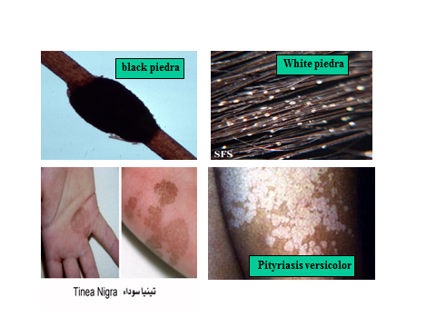
Secondly -Cutaneous Mycoses
Involves deep epidermis and keratinized body areas (skin, hair, nails).classified
A. Dermatophytoses (caused by the genera Epidermophyton, Microsporum and Trichophyton)
Dermatophytosis (tinea or ringworm) of the scalp, glabrous skin, and nails is caused by a closely related group of fungi known as dermatophytes which have the ability to utilize keratin as a nutrient source ,they have a unique enzymatic capacity [keratinase].
B. Dermatomycoses(the most common of which are Candida spp.)

The Dermatophytoses are characterized by an anatomic site-specificity .According to genera for example

1-Trichophyton species (19 species (
These infect skin, hair and nails. They rarely cause subcutaneous infections, in immuno-compromised individuals. Trichophyton species take 2 to 3 weeks to grow in culture. The conidia are large (macroconidia), smooth, thin-wall, septate (0-10 septa), and pencil-shaped; colonies are a loose aerial mycelium that grow in a variety of colors. Identification requires special biochemical and morphological techniques ,
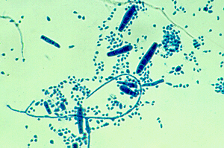

Fig -1- Microconidia, macroconidia, in T. mentagrophytes

2-Microsporum species (13 species).
These may infect skin and hair, rarely nails. The prevalence of infection has decreased significantly in recent years. The loose, cottony mycelia produce macroconidia which are thick-walled, spindle-shaped, multicellular, and spiny . Microsporum canis is one of the most common dermatophyte species infecting humans.

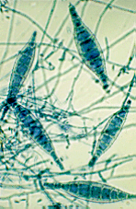

3- Epidermophyton floccosum.
These infect skin and nails and rarely hair. They form yellow-colored, cottony cultures and are usually readily identified by the thick, bifurcated or divided hyphae with multiple smooth, club-shaped macroconidia .

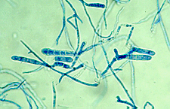
ECOLOGY
The dermatophytes (which means skin plants) causing human infections may have different natural sources and modes of transmission:
anthropophilic - These are usually associated with humans only; transmission from man to man is by close contact or through contaminated objects.
zoophilic - These are usually associated with animals; transmission to man is by close contact with animals (cats, dogs, cows) or with contaminated products.
geophilic - These are usually found in the soil and are transmitted to man by direct exposure.

Laboratory diagnosis
1-Clinical Material
Skin Scrapings, nail scrapings and epilated hairs.
2-Direct Microscopy
Skin Scrapings, nail scrapings and epilated hairs should be examined using 10% KOH and Parker ink or calcofluor white mounts.
3-Culture
Specimens should be inoculated onto primary isolation media, like Sabouraud's dextrose agar containing cycloheximide (actidione) and incubated at 26-28C for 4 weeks.
4-Serology Not required for diagnosis

