Lec(9)
Prof. Dr.Ekhlass N. Ali
Hypersensitivity
The term hypersensitivity is used to describe immune responses which are damaging rather than helpful to the host. Nearly 40 years ago Gell and Coombs proposed a classification scheme which defined 4 types of hypersensitivity reactions. The first 3 are mediated by antibody, the fourth by T cells.

Type I Hypersensitivity
This will be familiar to most people and describes the rapid ('Immediate') allergic reaction. The symptoms produced by exposure of a sensitized person to antigen depend upon the site of contact. Hay fever (allergic rhinitis), eczema, asthma and urticarial all result from type I hypersensitivity. It is caused upon contact with antigen against which the host has pre-existing IgE antibody. IgE is present in very low levels in serum in most people (see on) - c.50ng (ie 5 × 10⁸gm) per ml. Its' half life in serum is only 2-3 days but much of the IgE in the body is bound to high affinity receptors (The cells are activated by the cross-linking of the Fc epsilonRI receptors via antigen binding to the bound IgE molecules.
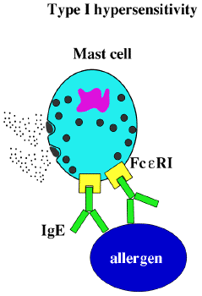
Such cross-linking leads to rapid degranulation (60-300 secs) of the mast cells and the release of primary inflammatory mediators called histamin stored in the granules. These mediators cause all the normal consequences of an acute inflammatory reaction - increased vascular permeability, smooth muscle contraction, granulocyte chaemotaxis and extravasation etc.

Systemic anaphylaxis
While we are probably all familiar with the consequences of a localized type I reaction (anaphylaxis) which are unpleasant and annoying, the consequences of a generalized reaction are potentially fatal. Ingestion of nuts or seafood, insect bites (venom), and drug injection may all cause life-threatening reactions in highly sensitized individuals. Death in such cases is due to systemic release of vasoactive mediators leading to general vasodilation and smooth muscle contraction resulting in sudden loss of blood pressure, massive oedema and severe bronchiole constriction (systemic anaphylaxis).

Type II Hypersensitivity(Cytotoxicity)
The second class of damaging reactions is caused by specific antibody binding to cells or tissue antigens. The antibodies are of the IgM or IgG classes and cause cell destruction by Fc dependent mechanisms either directly or by recruiting complement via the classical pathway. Except where the reaction is autoimmune, the target cells are foreign to the host. this means type II hypersensitivity reactions are usually only seen in blood transfusion recipients and patients with certain autoimmune diseases. The classic ABO incompatibility reaction is a type II, with IgM antibodies causing complement lysis of erythrocytes. Rhesus disease (or haemolytic disease of the newborn HDN) is a special example since the IgG antibodies which cause destruction of fetal red blood cells by antibody dependent cellular cytotoxicity (ADCC) are passively acquired by the host via the placenta .
Type III 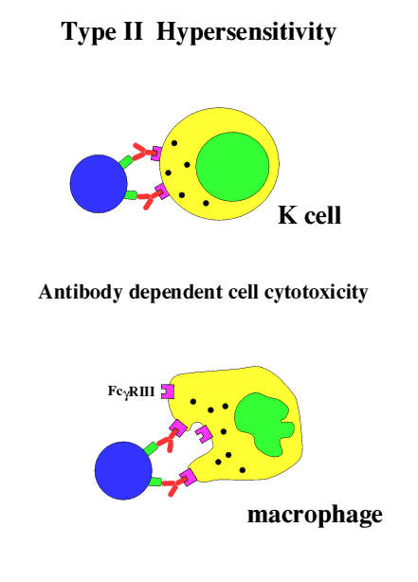

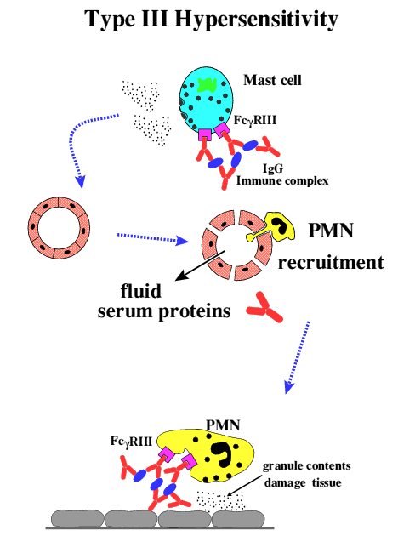
Type III Hypersensitivity:
Type III hypersensitivity is mediated by immune complexes essentially of IgG antibodies with soluble antigens. mast cells, so that only preformed complexes can bind to the low affinity Fc gamma RIII.

The Arthus reaction:
The Arthus reaction is the name given to a local type III hypersensitivity reaction. It is easy to demonstrate experimentally by subcutaneous injection of any soluble antigen for which the host has a significant IgG titre. Because the Fc gamma RIII is a low affinity receptor ,typically maximal at 4-8hrs,

Generalized or systemic reactions:
The presence of sufficient quantities of soluble antigen in circulation to produce a condition of antigen excess leads to the formation of small antigen-antibody complexes which are soluble and poorly cleared. In the normal animal these complexes fix complement but experiments in animals genetically deficient in C3 or C4 have shown that complement is not required for pathology to be observed following antibody-antigen complex challenge. The major pathology is due to complex deposition which seems to be exacerbated by increased vascular permeability caused by mast cell activation via Fc gamma RIII as above. The deposited immune complexes trigger neutrophils to discharge their granule contents with consequent damage to the surrounding endothelium and basement membranes. The complexes may be deposited in a variety of sites such as skin, kidney and joints. Common examples of generalized type III reactions are post-infection complications such as arthritis and glomerulonephritis.

Type IV Hypersensitivity
This is the only class of hypersensitive reactions to be triggered by antigen-specific T cells. were originally termed T_{DTH} for this reaction - delayed type hypersensitivity.
Delayed type hypersensitivity results when an antigen presenting cell, typically a tissue dendritic cell which has picked up antigen, processed it and displayed appropriate peptide fragments bound to class II MHC The resulting activation of the T cell produces cytokines such as chemokines for macrophages, other T cells and, to a lesser extent, neutrophils as well as TNFbeta and IFNgamma. The consequences are a cellular infiltrate in which mononuclear cells (T cells and macrophages) tend to predominate. It is usually maximal in 48-72 hours.
The classical example of delayed type hypersensitivity is in tuberculosis

Summary of Hypersensitivity classification( very important)

TYPE | DESCRIPTIVE | Ab |  | INITIATION | MECHANISM | EXAMPLES
 | NAME | mediated |  | TIME
I | IgE-mediated hypersensitivity |  | IgE | 2-30 mins | Ag induces cross-linking of IgE bound to mast cells with release of vasoactive mediators | Systemic anaphylaxis, Local anaphylaxis, Hay fever, Asthma, Eczema
II | Antibody-mediated cytotoxic hypersensitivity |  | IgM  IgG | 5-8hrs | Ab directed against cell-surface antigens mediates cell destruction via ADCC or complement | Blood transfusion reactions, Haemolytic disease of the newborn, Autoimmune Haemolytic anaemia
III | Immune-complex mediated hypersensitivity |  | IgG | 2-8hrs | Ag-Ab complexes deposited at various sites induces mast cell degranulation via FcgammaRIII, PMN degranulation damages tissue | Arthus reaction (Localized); Systemic reactions disseminated rash, arthritis, glomerulonephritis
IV | cell-mediated hypersensitivity |  | ^{T}DTH  CD4+ | 24-72hrs | Memory TH1 cells release cytokines that recruit and activate macrophages | Contact dermatitis, Tubercular lesions

