Lab Eight:.
Sensitivity Test Antifungal
A diffusion method for determining the sensitivity of pathogenic fungi to therapeutic agents is described using tablets containing the following antibiotics: amphotericin B, clotrimazole, econazole, fluorocytosine, and miconazole. The composition of the media used, standardization of inocula, incubation time, and temperature are detailed.
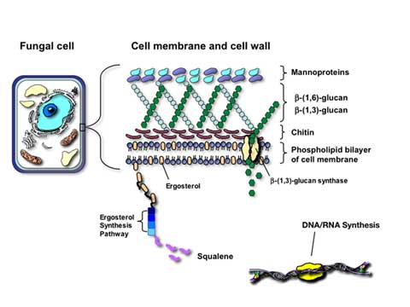
The establishment of a standardized broth reference method for antifungal susceptibility testing of yeasts has opened the door to a number of interesting and useful developments. In addition, the availability of reference methods provides a useful touchstone for the development of commercial products that promise to be more user friendly and to further improvement of test standardization.
Incorporation of antifungal susceptibility testing methods into the clinical trials of new antifungal agents will facilitate the establishment of clinical correlates and further enhance the clinical utility of antifungal susceptibility testing.
Do we have any methods for Sensitivity Test Antifungal?
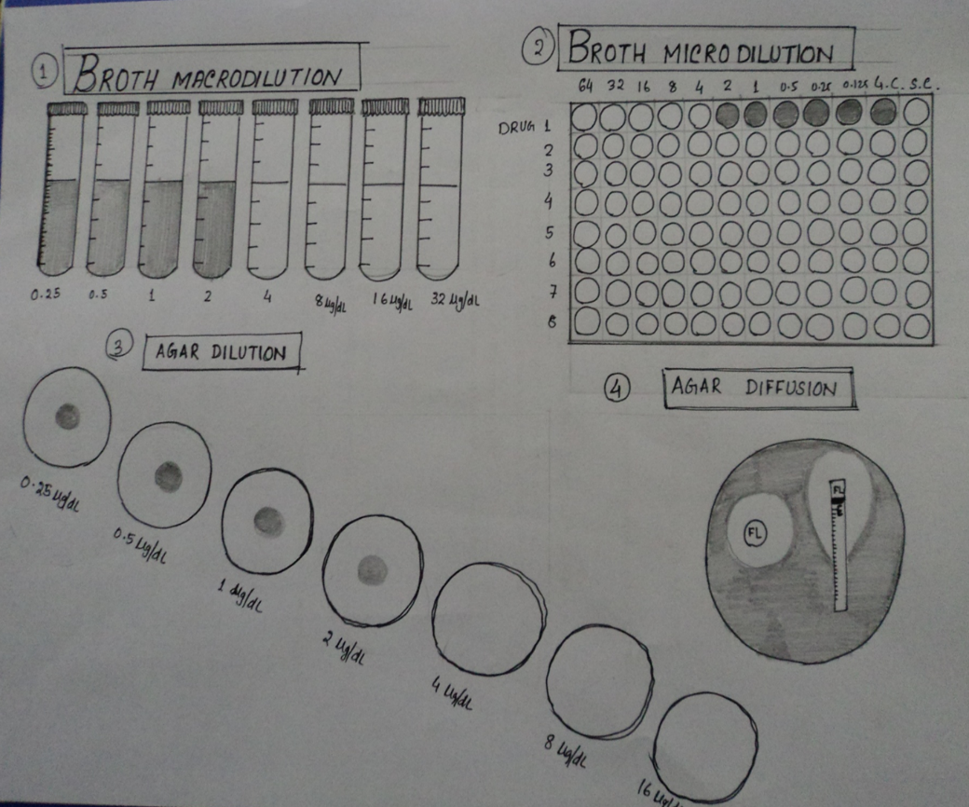
- Macro-dilution method.
- Micro-dilution method.
- Disk diffusion method.
- Agar dilution method.

Antifungal:
Voriconazole, Fungus | Caspofungin, Fungus
Miconazole, Fungus | Itraconazole, Fungus
Fluconazole, Fungus | Ketoconazole, Fungus
Nystatin, Fungus | 5-Fluorocytosine, Fungus
Natamycin, Fungus | Grisiofulvin, Fungus
Terbinafine, Fungus | Terconazole, Fungus
Clotrimazole, Fungus

Procedure:
Firstly, you should to prepare the following materials:
- Disc diffusion susceptibility testing.
- Candida species.
- Good correlation with microdilution method.
- Antifungal agents: Fluconazole, Itraconazole, Voriconazole
- Test medium: Muller- Hinton agar
Glucose (2%)
Methylene blue (0.5µg/ml)
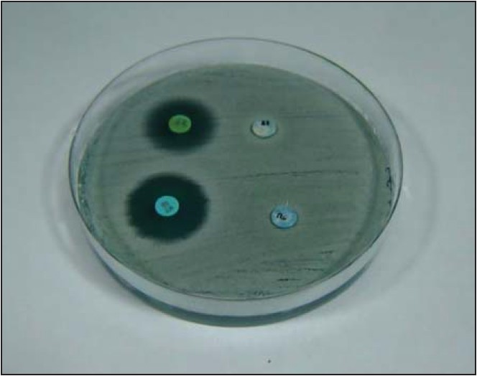
When supplemented with glucose to a final concentration of 2%, it provides for suitable fungal growth. The addition of methylene blue dye to a final concentration of 0.5 μg/mL enhances zone edge definition.
- Inoculum preparation : SDA (24-hr old culture)
- Test medium : stock inoculum suspension
0.5 McFarland standard
1Х10⁶ to 5Х10⁶ CFU/ml
The medium can be prepared and poured as the complete media with supplements (A1) or the
supplements can be added to commercially prepared Mueller-Hinton agar plates (A2). Using the latter technique enables the use of routine Mueller-Hinton agar plates from the bacteriology laboratory.
A1. Preparation of Supplemented Mueller-Hinton Agar:
(1) Mueller-Hinton agar should be prepared from a commercially available dehydrated Mueller-Hinton agar base according to the manufacturer’s instructions.
(2) Dissolve 0.1 gram of methylene blue dye in 20 mL of distilled water and warm gently to dissolve. Do not overheat. Add 100 μL of this solution per liter of agar suspension.
(3) Add 20 grams of glucose per liter of agar suspension.
(4) Autoclave as directed by manufacturer’s instructions.
(5) Immediately after autoclaving, allow the agar solution to cool in a 45 to 50 °C water bath.
(6) Pour the freshly prepared and cooled medium into plastic, flat-bottomed petri dishes on a level, horizontal surface to give a uniform depth of approximately 4 mm. This corresponds to 67 to 70 mL of medium for plates with diameters of 150 mm and 28 to 30 mL for plates with a diameter of 100 mm.
(7) The agar medium should be allowed to cool to room temperature and, unless the plate is used on the same day of preparation, stored at refrigerator temperature (2 to 8 °C). The agar medium should have a pH between 7.2 and 7.4 at room temperature. Plates should be used within seven days after preparation unless adequate precautions such as wrapping in plastic have been taken to minimize drying of the agar.
(9) A representative sample of each batch of plates should be examined for sterility by incubating at 30 to 35 °C for 24 hours or longer. Plates should undergo quality control testing.
A2. Glucose-Methylene Blue (GMB) Supplementation of Commercially Prepared Mueller-Hinton
Agar:
(1) Commercially prepared Mueller-Hinton agar plates can be obtained from several manufacturers. These are the same plates utilized by the bacteriology laboratory for performing Kirby-Bauer disk diffusion tests on bacteria.
(2) Dissolve 0.1 gram of methylene blue dye to 20 mL of distilled water and warm gently to dissolve. Do not overheat. Add 100 μL of this solution per liter of agar suspension.
(3) Prepare a 0.4 g/mL stock solution of glucose by dissolving 40 grams of glucose in 100 mL of distilled water. Heat gently and mix to dissolve.

