Lab (2)
Kingdom: Protista
Subkingdom: Protozoa
Phylum: Sarcomastigophora
1-Subphylum: Sarcodina
Genus: 1-Entamoeba histolytica (pathogenic ameba)
2-Entamoeba coli (non-pathogenic ameba)
3-Endolimax nana (non-pathogenic ameba)
4-Iodamoeba butschlii (non-pathogenic ameba)
5-Entamoeba gingivalis (non-pathogenic ameba)
1-Entamoeba histolytica
Disease name: Amebic dysentery or Amebiasis
Site of infection: Large intestine
Entamoeba histolytica: Pathogenic ameba has two stages: Trophozoite (vegetative and diagnostic stage) and Cyst (infective and diagnostic stage).
Morphology of trophozoite
Trophozoite of E. histolytica is ranging from (15-30) micrometer in diameter, has asingle nucleus with a small centrally placed karyosome. The nuclear chromatin is evenly distributed along the periphery of the nucleus. The fine granular endoplasm may contain ingested RBCs
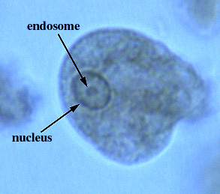
Entamoeba histolytica (trophozoite)

Morphology of cyst
Cyst of E. histolytica is ranging from (10-15) micrometer in diameter and contain one to four nuclei. Chromatoid bodies are usually present in young cysts as elongated bars with bluntly rounded ends. Glycogen is usually diffuse, but in young cysts it is often present as a concentrated mass, staining reddish brown with iodine.
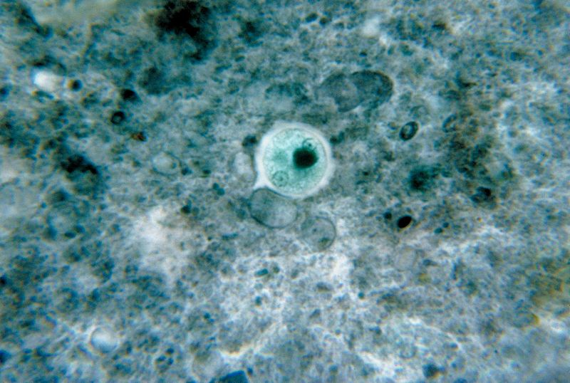
Entamoeba histolytica (cyst)

Life cycle of Entamoeba histolytica:
Infection occurs by ingestion of cysts on focally contaminated food or hands. The cyst is resistant to the gastric environment and passes into small intestine where it decysts. The metacyst divides into four and then eight amoebae which move to the large intestine. The majority of the organisms are passed out of the body with the feces but with chronic infection some amoeba invaded the mucosal tissue forming flask-shaped lesions. The organisms encyst for mitosis and are passed through with feces. (there are no intermediate or reservoir host).
Symptoms: including diarrhea with blood and mucus, fever and dehydration.
Laboratory diagnosis:
1-Laboratory diagnosis by finding the characteristic cysts in iodine stained or formol- ether concentration method or a permanent stained preparation. Direct microscopy should be done by mixing a small amount of the specimen in 0.9% sodium chloride solution
2- The tests of indirect fluorescent antibody test (IFAT) or (ELISA).

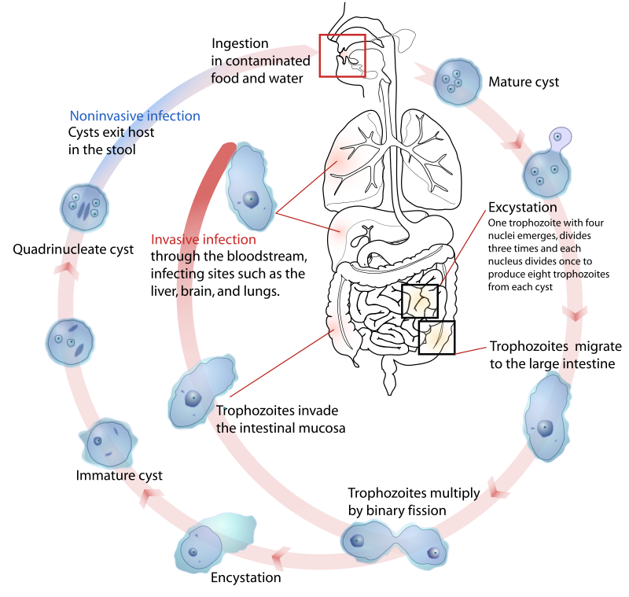
Life cycle of Entamoeba histolytica

2-Entamoeba coli
Entamoeba coli are a non-pathogenic ameba with worldwide distribution. Its life cycle is similar to that of E. histolytica but it does not have an invasive stage and does not ingest red blood cells.
Morphology of trophozoite
Trophozoite is larger than of E. histolytica is ranging from (15-50) micrometer in diameter. It exhibits blunt pseudopodia with sluggish movement. A permanently stained preparation shows a nucleus with a moderately large eccentric karyosome with the chromatin clumped on the nuclear membrane. The cytoplasm appears granular containing vacuoles with ingested bacteria and other food particles.
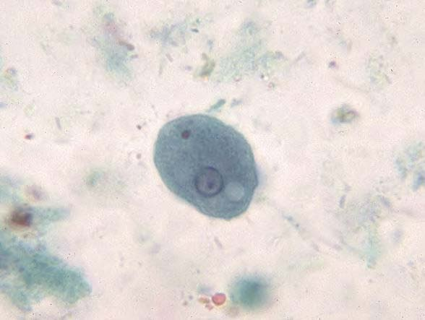
Entamoeba coli (trophozoite)
Morphology of cyst
Cyst of E. coli is ranging from (15-30) micrometer in diameter and contain (1-8) nuclei with irregular peripheral chromatin, karyosomes not central. Chromatoid bodies are not frequently seen but when present they are usually splinter-like with pointed ends. Glycogen is usually diffuse but in young cyst is occasionally found as a well-defined mass, which stains reddish brown with iodine.
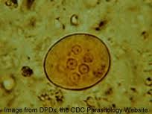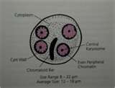
Entamoeba coli (cyst)

3-Endolimax nana
Morphology of trophozoite
Trophozoite of E. nana is ranging from (6-12) micrometer in diameter. Motility is sluggish with blunt hyaline pseudopodia. In a permanently stained preparation, the nucleus exhibits a large karyosome with no peripheral chromatin on the nuclear membrane.

Morphology of cyst
Cyst of E.nana is ranging from (6-9) micrometer in diameter. They can be spherical or ovoid in shape and contain (4) pinpoint nuclei, which are highlighted by the addition of iodine. Chromatoid bodies are not found and glycogen is diffuse.
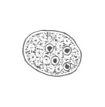

4-Iodamoeba butschlii
Morphology of trophozoite
Trophozoite of Iodamoeba butschlii is ranging from (8-20) micrometer in diameter, it's actively motile. On a permanently stained fecal smear, a nucleus with a large karyosome is evident. Chromatoid bodies form striations around the karyosome. The cytoplasm appears granular containing vacuoles with ingested bacteria and debris.
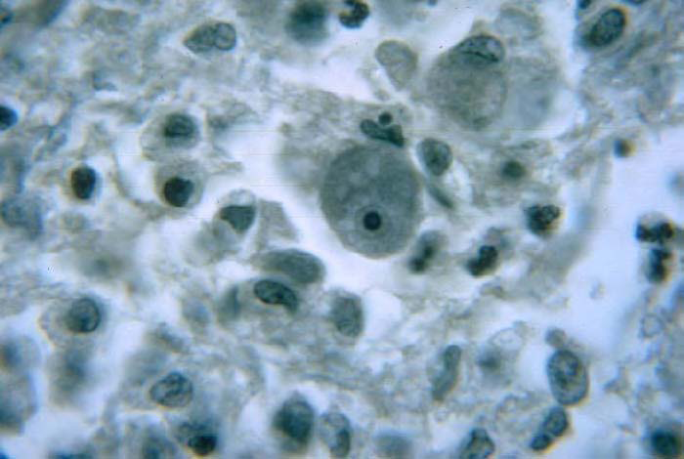
Iodamoeba butschlii (trophozoite)
Morphology of cyst
Cyst of Iodamoeba butschlii is ranging from (9-15) micrometer in diameter and have one nucleus in mature cysts usually eccentrically placed. Chromatoid bodies are not present and glycogen is present as a compact well defined mass staining dark brown with iodine.
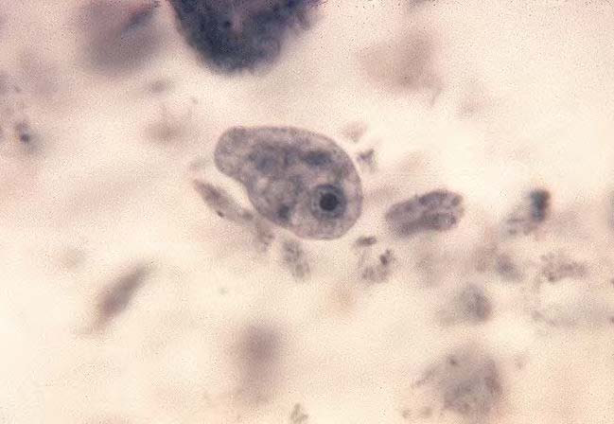
Iodamoeba butschlii (cyst)

5-Entamoeba gingivalis
Entamoeba gingivalis is found in mouth near the base of the teeth. It has only trophozoite.
Morphology of trophozoite
Trophozoite of E. gingivalis is ranging from (5-30) micrometer in diameter, contain single small spherical nucleus, contains irregular distributed small masses of chromatin, central or eccentric karyosome. They are several food vacuoles in endoplasm contain largely dark bodies.

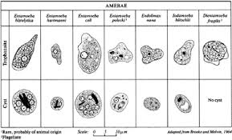
Types of amebae

