Lab(3)
Kingdom: Protista
Subkingdom: Protozoa
Phylum: Sarcomastigophora
2-Subphylum: Ciliophora
Class: Ciliata
Order: Euciliata
Genus: Balantidium coli
3- Subphylum: Mastigophora (Flagellates)
Class:Zoomastigophora
Order: Diplomonadida
Genus: Giardia lamblia , Trichomonas vaginalis
Balantidium coli
Disease name: Balantidiasis , Balantidil dysentery
Site of infection: Large intestine, cecum and terminal ileum

Morphology of trophozoite
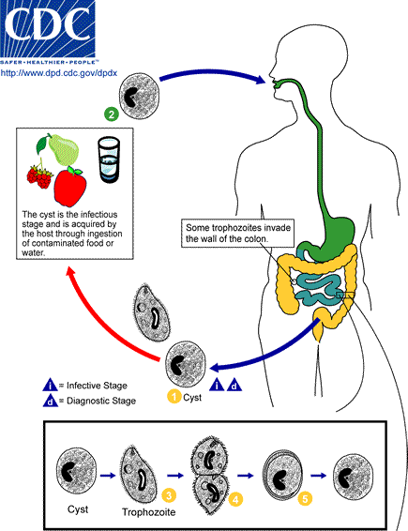

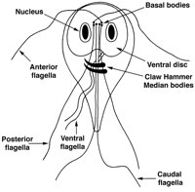
Giardia lambilia trophozoite
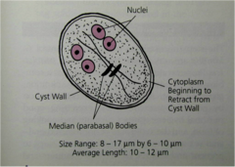
cyst Giardia lambilia
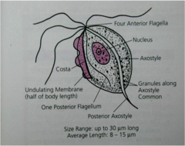
Trichomonas vaginalis trophozoite

