Lab (4)
Blood and Tissue flagellates: it include flagellated protozoa that contain
1-flagella 2-nuclues 3-kinetoplast
Morphology of tissue and blood flagellates
1-Amastigote 2-Promastigote 3-Epimastigote 4-Trypomastigote
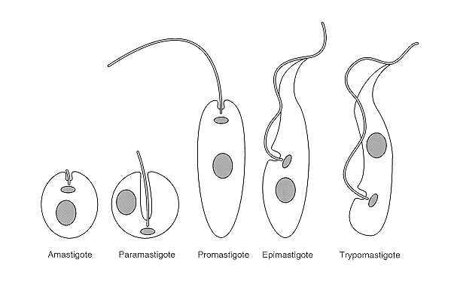

Kingdom: Protista
Subkingdom: Protozoa
Phylum: Sarcomastigophora
Class: Zoomastigophora
Order: Kinetoplastida
Family: Trypanosomatidae
Genus: 1-Leishmania spp.
2-Trypanosoma spp.

Leishmania spp.
1-Leishmania tropica
2-Leishmania donovani
3-Leishmania braziliensis
Disease name:
- Leishmania tropica causes Baghdad boil (cutaneous leshmaniasis).
-Leishmania donovani causes kalazar or black fever (visceral leshmaniasis).
-Leishmania braziliensis causes subcutaneous (mucocutaneous leshmaniasis).
Site of infection:
-Leishmania tropica (skin)
-Leishmania donovani (liver, spleen, lymph node, bone marrow)
-Leishmania braziliensis (mucocutaneous tissue of skin, nose, mouth)
Definitive host: human
Intermediate host (vector): Phlebotomus female (sand fly)
Morphology:
Leishmania exist as flagellated extracellular Promastigotes in the sand fly vector and as a flagellar obligate intracellular Amastigotes within mononuclear phagocytes of their vertebrate hosts. The various species are not distinguishable morphologically from one another. When stained with Giemsa stain, amastigotes appear as round or oval bodies ranging from (2-3) micrometer in diameter with a well-defined nucleus and kinetoplast, a rod shaped specialized mitochondrial structure. The flagellated Promastigote form is spindle shaped, measuring (10-20) micrometer in length, not including the length of the flagellum. As in the Amastigote form a nucleus and kinetoplast are clearly visible.

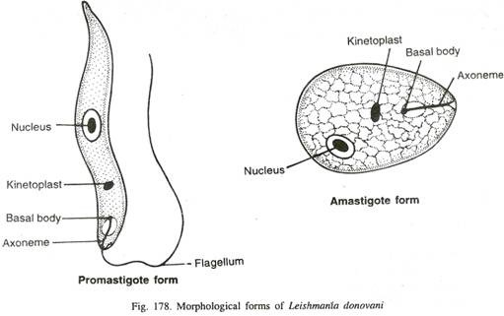

Life cycle:
All forms of infection start when a female sandfly (Phlebotomus sp.) takes a blood meal from an infected host. Small amounts of blood, lymph, and macrophages infected with Leishmania amastigotes are ingested. Once ingested the amastigotes transform to promastigotes in the sandfly, the non-infective promastigotes divide and develop into infective promastigotes. These are formed in the midgut of the sandfly and migrate to the proboscis. When the sandfly bites, the extracellular promastigotes at the site of the bite are Phagocytosed by macrophages. After phagocytosis, transformation to dividing amastigotes occurs within 24 hours. Reproduction at all stages of the lifecycle is believed to occur by binary fission. No sexual stage has been identified.

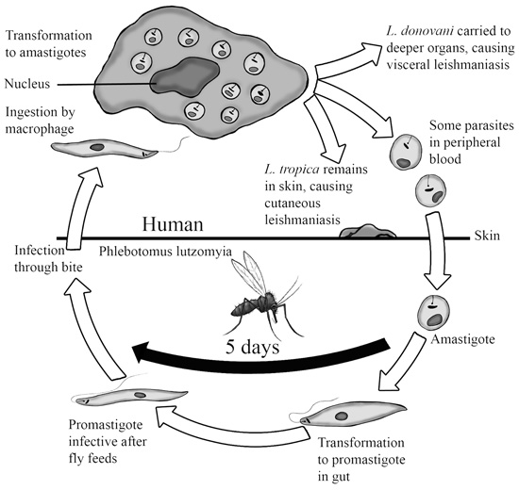

Diagnosis:
1- Direct smear of blood and lymph.
2- Serology.
3- Culturing in N.N.N. (Nove Mac Neal-Nicole).
4- Biopsy from liver, Spleen and bone marrow.

