**LAB (8)**

Kingdom: Animalia

Phylum: Platyhelminthes

Class: Trematoda

Order: Prostomata

1-Family: Opisthorchiidae

**Genus: Clonorichis sinensis**

2-Family: Faschiolidae

**Genus: Faschiola hepatica**

3-Family: Troglotremagotidae

**Genus: Paragonimus westermani**

The Trematodes (or Flukes) are leaf shaped with an outer cover called the tegument which may be smooth or spiny. There are two suckers or attachment organs, an anterior oral sucker and a posterior ventral sucker.

**1- *Clonorichis sinensis***

Common name: Chinese liver fluke

Definitive host: Man

Intermediate hosts: Water snails and Fish

Site of infection: the biliary duct in humans who become infected by eating raw or undercooked fish.

Reservoir hosts: Dogs and Cats

**Morphology**

**The adult** flukes measure 11–20μm by 3–4.5μm and are lanceolate in shape, translucent and brownish in color, Hermaphroditic. It has two suckers, the oral sucker is larger than ventral sucker.

**The ova** of *Clonorchis sinensis* small ovoidal or elongated with broad rounded posterior end and a convex opercular resting on shoulders (flask shaped egg), contains mature miracidium.

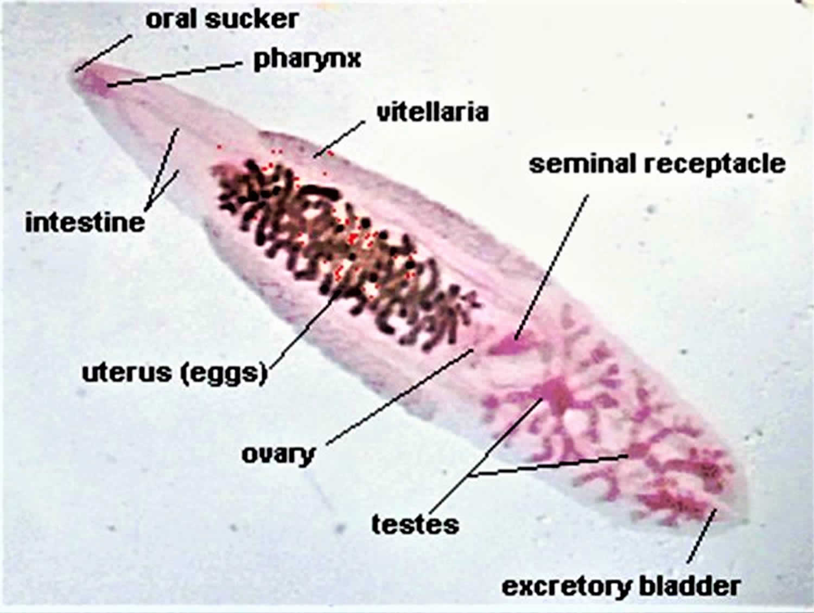

**(The adult of *Clonorchis sinensis*)**

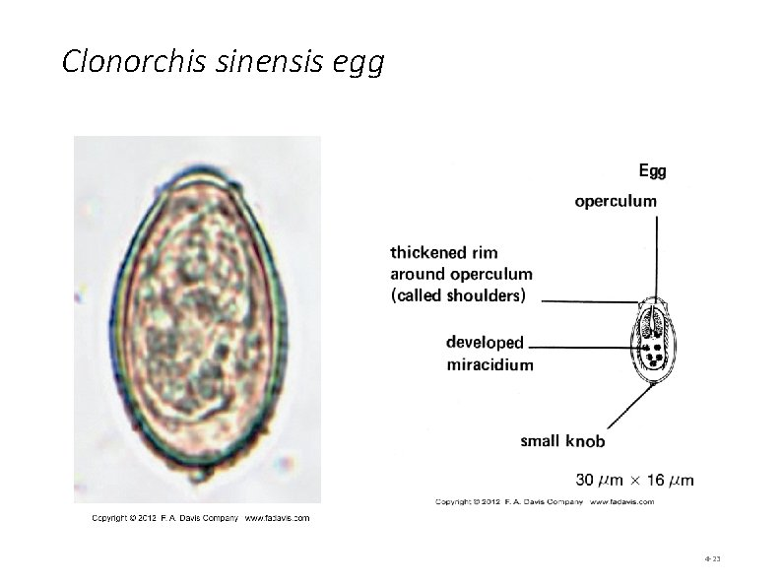

**(The ova of *Clonorchis sinensis***)

**Life cycle:**



**Symptoms:**

The pathology is related to the number of parasites present. Light infections of up to 50 eggs or more are usually asymptomatic. A heavy infection of 500 or more eggs may cause serious illness.

Acute infections may be characterized by fever, diarrhea, epigastric pain, enlargement and tenderness of liver and sometimes jaundice. The invasion by these worms in the gall bladder may cause cholecystitis, due to flukes becoming impacted in the common bile duct.

**Laboratory Diagnosis:**

Microscopic identification of eggs in feces following iodine stained,

Formal-ether concentration method of the feces or from duodenal

aspirates when there is complete obstructive jaundice

**2-*Fasciola hepatica***

Common name: sheep liver fluke

The eating of unwashed watercress (freshwater plants) appears to be the source of infection,

Definitive host: sheep (herbivorus) and some time human.

Intermediate host: snails

site of infection: liver or bile ducts

**Morphology**

**The adult** flukes are large leaf-shaped parasites about 2–3cm long. There

are two suckers, an anterior oral sucker surrounding the mouth and a

ventral sucker on the ventral surface, oral sucker is smaller than ventral

sucker

The outer tegument is covered in tiny spines which face backwards

enabling them to attach themselves along with their suckers to the tissues.

**The egg**: Ellipsoidal, thin shell, small indistinct operculum, unembryonated.

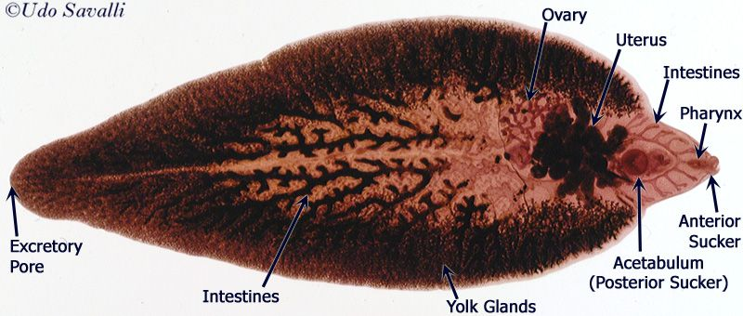

The adult of ***Fasciola hepatica***

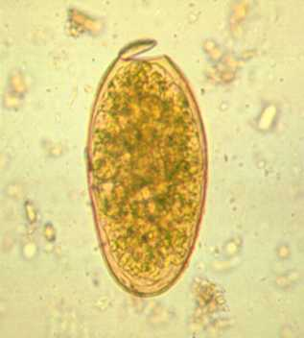 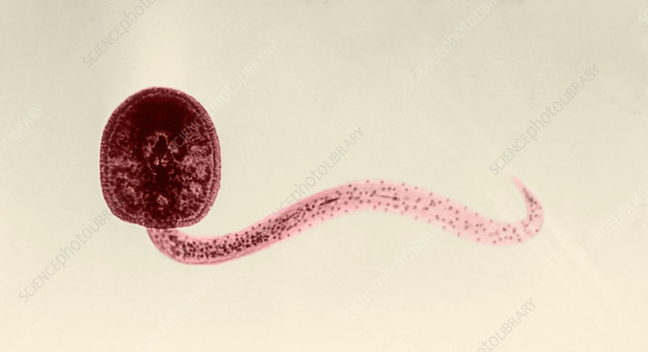

The egg and cercaria of ***Fasciola hepatica***

**Life cycle**

Infective stage: Metacercaria

Diagnostic stage: Egg



**Symptoms:**

Light infections due to *Fasciola hepatica* may be asymptomatic.

However, they may produce hepatic colic with coughing and vomiting; generalized abdominal rigidity, headache and sweating, irregular fever, diarrhea and anemia.

**Laboratory Diagnosis:**

-Microscopic identification of eggs in feces

-Serological techniques

***3-Paragonimus westermani***

Common name: Oriental lung fluke

Site of infection: lungs, liver and spleen

**Morphology:**

**The adults** are ovoid, reddish brown fluke 12μm long and are found in capsules in the lung. Oral and ventral suckers are equal in size.

**The eggs** are ovoid, brownish yellow, thick shelled and operculated,

Unembryonated

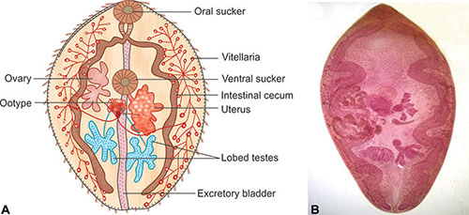

The adult of ***Paragonimus westermani***

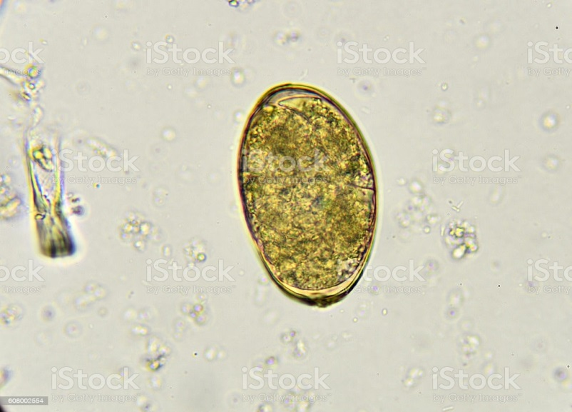

The egg of ***Paragonimus westermani***

**Life cycle:**

Definitive host: Human

Intermediate host: snail, crab or crayfish

Reservoir host : pigs, dogs and variety of feline species



**Symptoms:**

As the parasites grow in the lung cyst, inflammatory reaction and fever occurs. The cyst ruptures and a cough develops resulting in an increase in sputum. The sputum is frequently blood tinged and may contain numerous dark brown eggs.

Hemoptisis may occur after paroxysms of coughing. Dyspnea and bronchitis develop with time. The disease resembles pulmonary tuberculosis. Cerebral calcification may also occur.

**Laboratory Diagnosis:**

-Diagnosis is based on finding the characteristic eggs in brown sputum.

The eggs can also be found in the feces due to swallowing sputum.

-A chest x-ray may show cystic shadows and calcification.

-Serological tests, in particular, the ELISA method, are useful diagnostic

tests.