Lab Five :.
Chromosomal DNA extraction from plants
Of course, the DNA in the cell is not allowed to use directly, but it should extract from living cell, purify and then store in a laboratory environment suitable for future use. In all cases, the DNA in the cell located inside the cell nucleus, , and the process of extracting DNA from the cell requires using many of chemicals to analyze the membranes surrounding DNA without damaging the DNA itself. Perhaps extracting DNA from cells as a whole is a very interesting, but the process is a bit tricky for plants because the cells have the cellular solid wall distinctive mainly composed of cellulose.
Isolation DNA from onion:
This is an important way to extract large amounts of DNA from onion or animal sources or other vegetable, as it is in this way using Isopropanol instead of alcohol, and the use of sodium citrate rather than salt, and use of SDS instead of shampoo.
Procedure:
- Chopped the onion into small pieces and place inside the blender container.
- Measure about 200 mL (1 cup) of the water, pour this into a glass and add one level teaspoon of salt, and cooling the salty water to be ready for use.
- Add enough of the salty water to just cover the onion.
- Blend the mixture for about 10 seconds.
- Pour the onion-salt-water mixture through the strainer and collect the liquid in a glass. The DNA from the onion is in this liquid.
- Measure out 50 mL (1/4 cup) of the onion liquid and pour it into a glass.
- Add 2 teaspoons of dishwashing detergent to the glass containing the 50 mL (1/4 cup) of onion liquid. Stir very gently.
- Measure out 100 mL (1/2 cup) of Isopropanol. Slowly add the Isopropanol to the glass containing the onion-detergent mixture.
- Now wait for the DNA to appear! The DNA is white, rising up from the bottom of the glass. Be patient as it may take a few minutes to appear.

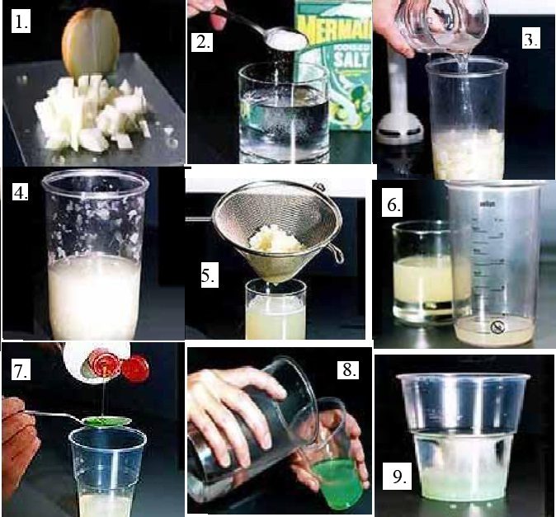

Steps of extraction DNA from onion

See DNA is present in the form of cotton material!! These are thousands of nucleic acids, which is completely ready for storage.
10 – Pull the DNA by placing wood stick and recycle promises one way to gather the DNA around it.
11 – Place the DNA in Eppendrof tubes and add a TE buffer solution and kept in the Deep freezing.
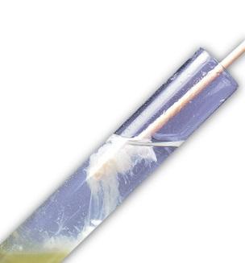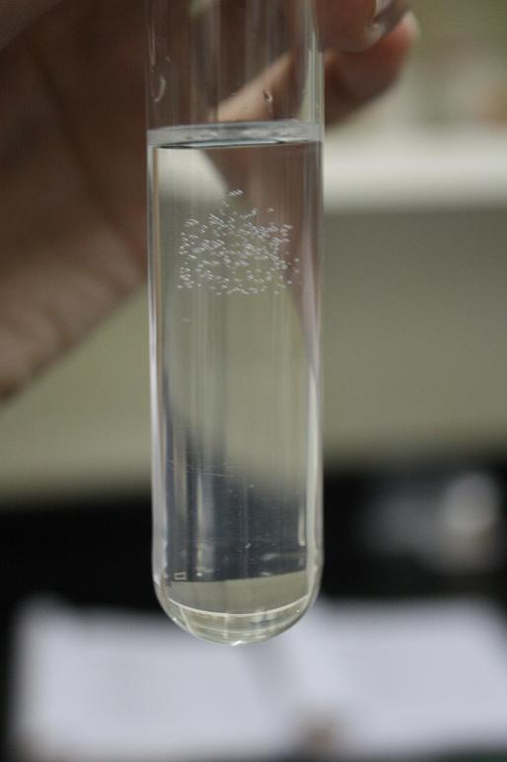
DNA rising from the bottom of the cup to the top.

What is the importance of salt in the set-up? Why do you have to suspend the cells in cold salt solution?
The importance of salt in the set-up is to make proteins and carbohydrates precipitate while making the DNA remained in solution. Suspending cells in cold salt solution will provide the DNA with favorable environment since salt contributes atoms that neutralize the normal negative charge of DNA. Negatively charged phosphates on DNA causes the cells to repel each other. The NaCl Solution provides Na ions that will block charge from phosphates on DNA. The Na ions will form an ionic bond with negatively charges and allow DNA molecules to come together.
Note: DNA is extracted above manner is completely pure because it contains proteins the Histones and the presence of RNA is connected to it, and therefore must use analyzed for proteases (proteolytic enzymes) and enzymes of the analyst RNA (RNase) within the action steps. And if there is no analyst enzymes of protein in the laboratory, it is possible to use several drops of concentrated pineapple juice which rich set of enzymes analyst protein into amino acids called Bromelain.
H.W.
1- If you need to extract the DNA from a baby. Which cells would you like to use and why?

