Lab Three:.
instruments and equipments in molecular lab
Biosafety cabinet (BSC): is an enclosed, ventilated laboratory workspace for safely working with materials contaminated with (or potentially contaminated with) pathogens requiring a define biosafety level. it found three classes of BSC depending on (providing safety to person, environment and samples)
class I: provide safety to person and environment only.
class II: provide safety to person, environment and samples.
class III: provide safety to person, environment and samples, generally only installed in maximum containment laboratories, is specifically designed for work with more dangerous pathogen like viruses .
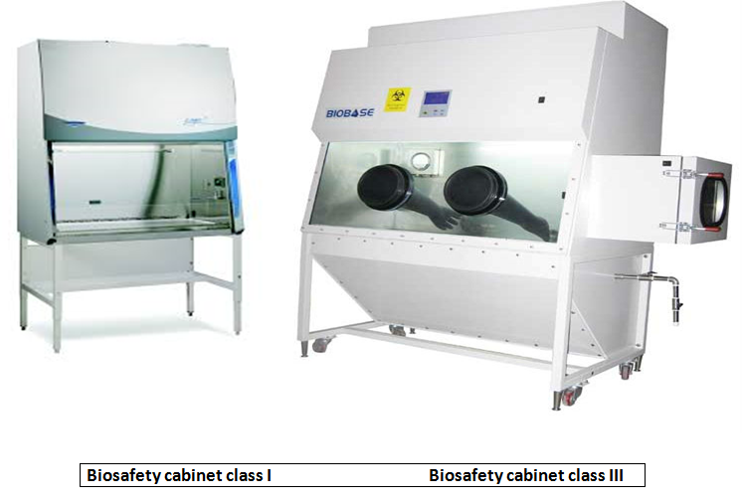

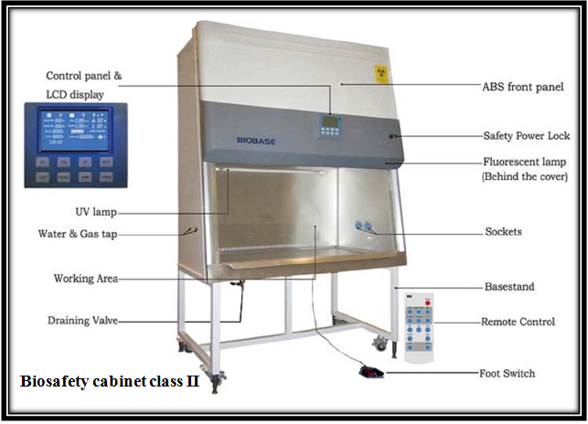
Picture | description | Instrument
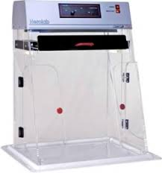 | enclosed, sterilized space work. | PCR work station
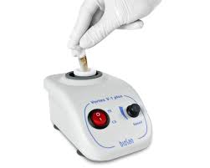 | To mix the reaction continent | Vortex shaker
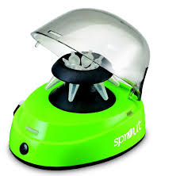 | To participate cell continent | Cool centrifuge
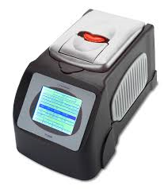 | To amplified DNA molecules (quality identification) | Conventional PCR
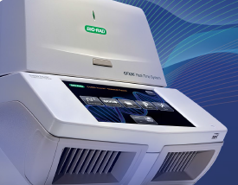 | To amplified DNA molecules and measuring gene expression(quality and quantity identification) | Real-time PCR
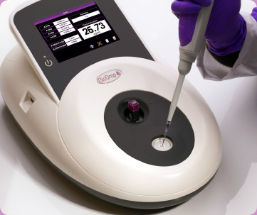 | To measuring nucleic acid concentration and purity | Nanodrop
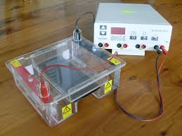 | To separate nucleic acid and protein with molecular weigh less than 10000 bp | Gel electrophoresis
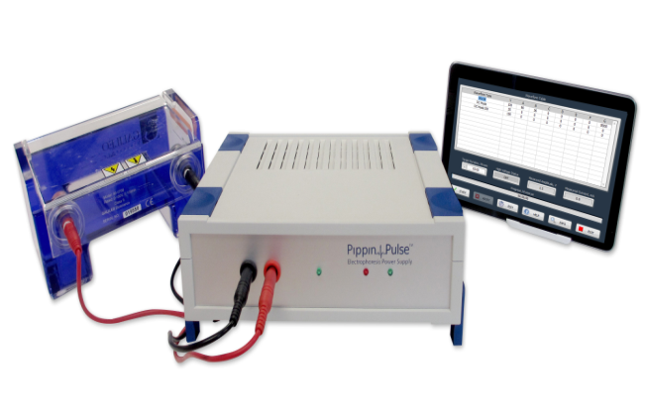 | To separate nucleic acid and protein with molecular weigh more than 10000 bp | Pulse gel electrophoresis
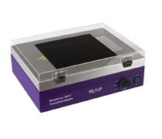 | To detect nucleic acid and protein were separated in gel electrophoresis run | UV-Transilluminator
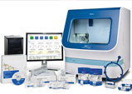 | To determine sequence of nucleotide in DNA strand | DNA sequencer
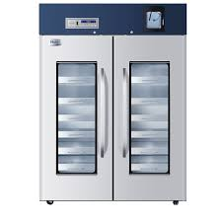 | To keep biological material in low temperature | Deep freeze
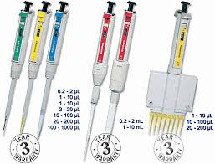 | To transfer the appropriate amount of volumes | Micropipettes in different size
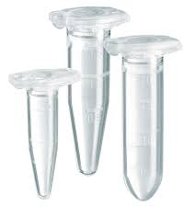 | To keep and holder samples in experiment | Different size of eppendorf tubes

