The Sixth Experiment
The Objective of the experiment:
Using the skew-T/log-P thermodynamic diagram to find the equivalent temperature (T_{e}) for some observational stations.

Materials:
Skew-T/log-P thermodynamic diagram, and upper air data for temperature and pressure as provided in table (1).

Introduction:
The equivalent temperature (T_{e}) is the temperature at a level that a sample of air would have if all its moisture were condensed out by a pseudo-adiabatic process (whereby all the condensed moisture is immediately removed from the air sample). The latent heat of condensation then heats the air sample. This equivalent temperature is sometimes termed the "adiabatic equivalent temperature" because the parcel undergo the following process: dry-adiabatic expansion until saturated; pseudoadiabatic expansion until all moisture is precipitated out; dry- adiabatic compression to the initial pressure.
The adjective ‘equivalent’ implies the sum of the latent and sensible heat contained inside an air parcel.
The equivalent temperature as read from a thermodynamic chart can be calculated from the following equation:

$T_{e}$=T exp$\frac{L w}{c_{p}T}$
Where T the temperature, w the mixing ratio, L the latent heat of vaporization per unit mass of water and it is equal to 22.6*10⁵J/kg, and c_{p} the specific heat of air at constant pressure and it is equal to 1005 J/kg K.

The Procedure:
- Prepare the temperature and dewpoint Data for each pressure level.
- Using a pencil, find and make a point mark for the temperature and dewpoint values at the corresponding pressure level on the Skew-T/log-P diagram, and then connect the points to make a vertical profile for temperature and dewpoint temperature.
- From the dewpoint at the given pressure, draw a line upward parallel to the saturation mixing-ratio lines. Also, from the T curve at the given pressure, draw a line upward along a dry adiabat until it intersects the line drawn from the dewpoint. Recall that this level is the LCL.
- From the LCL, follow a saturation adiabat upward to a pressure where the saturation adiabat parallels the dry adiabat. This is the pressure level where all the moisture has been condensed out of the sample.
- From this pressure, follow a dry adiabat back to the original pressure. The isotherm value at this point is equal to the equivalent temperature (T_{e}).

Example:
To find the equivalent temperature (T_{e}) at 900-hPa:
- From the 900-hPa temperature, draw a line upward along a dry adiabat.
- From the 900-hPa dewpoint, draw a line upward along a saturation mixing ratio line.
- From the intersection of these two lines, draw a line upward along a saturation adiabat to a level where this adiabat is parallel to a dry adiabat.
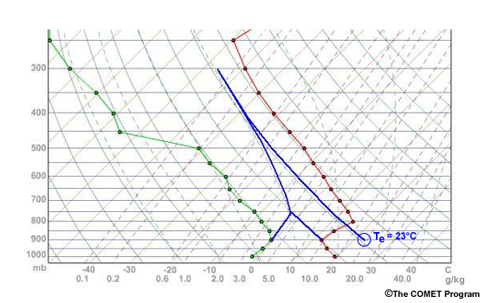
- From this level, draw a line downward along a dry adiabat to 900 hPa, the value of the temperature where this line intersects the 900 hPa isobar is 23°C = T_{e}.
Exercise:
According to the available Data in table (1) below, find the equivalent temperature (T_{e}) for each level.
Pressure | Temp. | Dewpoint | Z_{LCL} | P_{LCL} | T_{LCL} | T_{e}
hPa | C | C | m | hPa | C | C
975 | 5.5 | 2.3 | 0.8 | 915 | 2
950 | 5.2 | -0.3 | 1.1 | 890 | 0
900 | 0.3 | -0.9 | 1.2 | 880 | -1.5
850 | -2.4 | -4.4 | 1.6 | 840 | -4
810 | -4.6 | -7.7 | 2.3 | 760 | -9

Discussion:
- Compare between the values of the temperature (T) and the equivalent temperature (T_{e}) for each level, which one is higher and why?
- Draw a graphical relationship between Z_{LCL} on the x-axis and P_{LCL} on the y-axis and discuss the relation, what do you conclude?

