The Third Experiment
The Objective of the experiment:
Using the skew-T/log-P thermodynamic diagram to determine the dewpoint depression (DD) from Radiosonde Observation (RAOB).
Materials:
- Skew-T/log-P thermodynamic diagram.
- Upper air data for pressure, temperature and dew point as provided in table (1).
- A pencil.
- Graph paper.

Introduction:
The dewpoint depression is the difference between the temperature and the dewpoint temperature at a particular pressure level, and the dewpoint is the temperature to which a parcel of air at a constant pressure becomes saturated without any addition of water vapor. For instance, at ground level this is the temperature at which dew would be expected to form. Saturated conditions have a dewpoint depression of zero, while dry conditions have a large dewpoint depression (30°C or more).
Thus, dewpoint depression can be calculated as follows

DD = T - T_{d} …………(1)

The sounding data is available in two main levels:
The mandatory levels are: Surface, 1000-mb, 850-mb, 700-mb, 500-mb, 400- mb, 300-mb, 250-mb, 200-mb, 150-mb, 100-mb, 70-mb, 50-mb, 30-mb, 20-mb, 10-mb, 7-mb, 5-mb, 3-mb, 2-mb, 1-mb.
Significant levels are levels other than the mandatory levels which are required for the reasonable accurate reproduction of a pressure, temperature, or dew-point profile. Usually, it represents a change in the slope of the profile.
The Procedure:
To create temperature and dewpoint curves on a skew-T, first plot the temperature and dewpoint at each individual pressure level in the sounding. All mandatory and significant level sounding data should be plotted.

- Use the data in Table (1) for Mafraq station/Jordan with the following information (Station: OJMF, Date: 00Z 24 MAR 2022, WMO ident: 40265, Latitude: 32.37, Longitude:36.25, Elevation: 687 m), enter the station index number (or location identifier), station name, time (UTC), and date in the identification box.
- Plot the temperature to the nearest tenths of degree Celsius. Each temperature point is represented by a small dot located at the proper temperature - pressure intersection. A small circle, no more than one-eighth inch in diameter, should be drawn around each dot plotted. A sample curve is shown in figure 1.
- After plotting all levels for which data was given, connect each point to the next with a solid line (often using red for temperature). Use a straight edge when drawing the connecting lines between the plotted points. Where there is a region of missing data, terminate the connecting line at the lower boundary of the missing data region, and start the line again at the upper boundary of the missing data region. Enter the symbol MISDA in the middle of the region of missing data in the same colour as is used for plotting the connecting line.
- Plot the dewpoint to the nearest tenths of degree Celsius. Each dewpoint point is represented by a small dot located at the proper dewpoint - pressure intersection. A small circle, no more than one-eighth inch in diameter, should be drawn around each dot plotted. A sample curve is shown in figure 1.
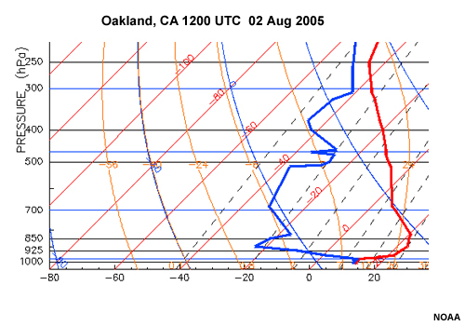
- After plotting all levels for which data was given, connect each point to the next with a solid line (often using green or blue for dewpoint temperature). Use a straight edge when drawing the connecting lines between the plotted points. Where there is a region of missing data, terminate the connecting line at the lower boundary of the missing data region, and start the line again at the upper boundary of the missing data region. Enter the symbol MISDA in the middle of the region of missing data in the same colour as is used for plotting the connecting line.
Figure (1)

Pressure | Hight | Temp. | Dewpoint | Dewpoint Depression
hPa | m | C | C | C
1000 | 153 | - | -
937 | 687 | 3.6 | 2.1
925 | 791 | 5.6 | -0.4
882 | 1179 | 4.2 | -4.8
874 | 1253 | 3.6 | -4.4
850 | 1478 | 1.8 | -6.2
828 | 1689 | 0 | -7
700 | 3006 | -11.3 | -13.3
627 | 3842 | -15.7 | -22.7
600 | 4172 | -18.1 | -28.1
550 | 4818 | -20.5 | -36.5
524 | 5176 | -21.3 | -50.3
500 | 5520 | -22.9 | -46.9
413 | 6895 | -33.5 | -53.5
400 | 7120 | -33.9 | -58.9
351 | 8023 | -39.1 | -74.1
300 | 9090 | -41.5 | -75.5
278 | 9609 | -41.5 | -75.5
265 | 9934 | -41.7 | -75.7
250 | 10330 | -41.9 | -75.9
Discussion:
- From the plotted curves, find the dewpoint depression for the following pressure levels on this sounding (900, 650, 450) hPa.
- Determine dewpoint depression by using equation (1) and write down your results in the table.
- Discuss the results using the plotted curves and the dewpoint depression, when do you think there is a humid or dry conditions? And why?

