The Fifth Experiment
The Objective of the experiment:
Using the skew-T/log-P thermodynamic diagram to predict the lifting condensation level (LCL)from Radiosonde Observation (RAOB).
Materials:
- Skew-T/log-P thermodynamic diagram.
- Upper air data for pressure, temperature and dew point as provided in table (1).
- A pencil.
- Graph paper.

Introduction:
The lifting condensation level (LCL):
The height at which a parcel of air becomes saturated when it is lifted dry
adiabatically is the Lifting Condensation Level. When a parcel of air is forced upward, as by being forced upward across land, a mountain, or over a layer of colder air, the air cools dry adiabatically. This is called mechanical lifting. If the air is lifted high enough, and cools enough, the parcel is saturated and any further cooling will result in condensation of moisture. This is the Lifting Condensation Level. The LCL is located on a sounding at the intersection of the saturation mixing-ratio line that passes through the surface dewpoint temperature with the dry adiabat that passes through the surface temperature.
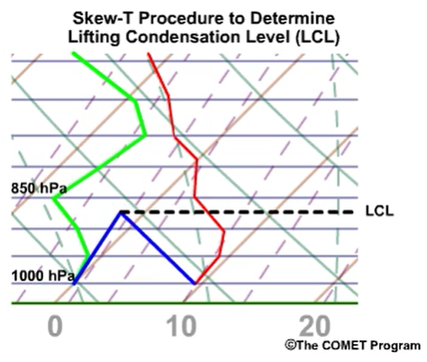
Example:
Air at the surface with T=9°C and T_{d}=0°C will become saturated if lifted dry-adiabatically to 870 hPa, which is the lifting condensation level.
Note: When the moisture content in the near-surface layers varies significantly, an average moisture value of the lower layer may be used in place of the surface-parcel moisture value to compute the LCL.

The Procedure:
- Create temperature and dewpoint curves on a skew-T as shown in experiment 3 according to the sounding data in Table (1) for Mafraq station/Jordan with the following information (Station: OJMF, Date: 00Z 24 MAR 2022, WMO ident: 40265, Latitude: 32.37, Longitude:36.25, Elevation: 687 m), enter the station index number (or location identifier), station name, time (UTC), and date in the identification box.
- From the dew-point temperature of the level for which the LCL is desired to be determined (i.e., 937hPa), draw a line upward parallel to the saturation mixing ratio lines.
- From the temperature value of the level for which the LCL is desired (i.e., 937hPa), draw a line upward parallel to the dry adiabat lines. The level where these two lines intersect is the LCL.

Pressure | Hight | Temp. | Dewpoint
hPa | m | C | C
1000 | 153 | - | -
937 | 687 | 3.6 | 2.1
925 | 791 | 5.6 | -0.4
882 | 1179 | 4.2 | -4.8
874 | 1253 | 3.6 | -4.4
850 | 1478 | 1.8 | -6.2
828 | 1689 | 0 | -7
700 | 3006 | -11.3 | -13.3
627 | 3842 | -15.7 | -22.7
600 | 4172 | -18.1 | -28.1
550 | 4818 | -20.5 | -36.5
524 | 5176 | -21.3 | -50.3
500 | 5520 | -22.9 | -46.9
413 | 6895 | -33.5 | -53.5
400 | 7120 | -33.9 | -58.9
351 | 8023 | -39.1 | -74.1
300 | 9090 | -41.5 | -75.5
278 | 9609 | -41.5 | -75.5
265 | 9934 | -41.7 | -75.7
250 | 10330 | -41.9 | -75.9

- Determine the temperature and the height of LCL level.
Homework:
According to the data in the table below, find the required information for the LCL level.
Pressure P(hPa) | 975 | 950 | 900 | 850 | 810
Temperature T(C°) | 5.5 | 5.2 | 0.3 | -4.4 | -7.7
Dewpoint Temperature Td (C°) | 2.3 | -0.3 | -0.9 | -2.4 | -4.6
Z_{LCL} (m)
P_{LCL}(hPa)
T_{LCL} (C°)

Discussion:
- Draw a graphic relationship between T(°C) on the x-axis and Z_{LCL} (m) on the y-axis.
- Draw a graphic relationship between T_{d}(°C) on the x-axis and Z_{LCL} (m) on the y-axis.

