The Sixth Experiment
Determining the stability of the atmosphere and its impact on pollution
The Objective of the experiment:
Use vertical atmospheric monitoring to determine the stability of the air layers.
The Theoretical Part:
Atmospheric stability is a means of analyzing air tilt to show vertical movement. During one annual cycle, the form of atmospheric stability depends mostly on temperature, that is, the stability in the atmosphere depends on the vertical sections of the temperature and humidity of the surrounding air [11]. Warm air has a lower density than cold air and therefore is lighter. The same situation occurs for moist air, which has a lower density than dry air, and therefore it is lighter. It follows that the volume of air that is warmer or more humid than the surrounding air is unstable and will rise into the atmosphere. In contrast, the volume of air that is colder or drier than ocean air is stable and descends into the atmosphere until it reaches a state of equilibrium. Atmospheric stability conditions correlate with the ability of the atmosphere to mix and diffuse pollutants out. These conditions also determine the turbulent conditions in the atmosphere and the formation of clouds. Air pollution is caused by harmful gases in the atmosphere that pollute the air. There are four main factors that play a major role in determining how pollutants spread, which are emission, transformation, sedimentation rate and dilution. The general concept known in pollution publications is that air pollution is based on atmospheric stability, because in stable conditions, atmospheric mixing is low, and accordingly, concentrations of ground-level pollutants become high.
In general, the stability of the atmosphere depends on the environmental lapse rate and the humidity in the air. Temperature decreases with altitude at the rate of temperature gradient The value of this rate in dry air is 9.8 °C/km is called the dry lapse rate and is symbolized by (γ_d), while the wet lapse rate (γ_m) is approximately 6 °C/km [12] In the case of an increase in temperature with altitude, it is called a temperature inversion, which has the effect of causing an increase in the amount of pollutants in the atmosphere, in addition to the redness of the sky at sunset and the flatness of clouds and their spread on the horizon, as in the figure(3-3)
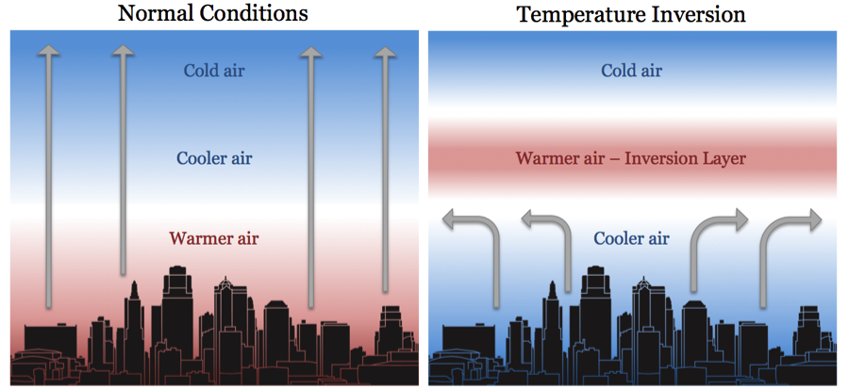
Figure 3-3: Thermal inversion and normal Conditions without inversion in the atmosphere, vertical arrows, air flow.

TheMaterials and Tools used

1. The Skew T-lnP or T-ϕ graph shown in Figure 3-4.
2. Scientific numbers calculator.
3. Measurements of air temperatures and dew point degrees for different pressure levels are listed in Table (2-3).

The Method of Work

- I use the table (2-3) above and transfer the vertical pressure, temperature and altitude data to the following table:
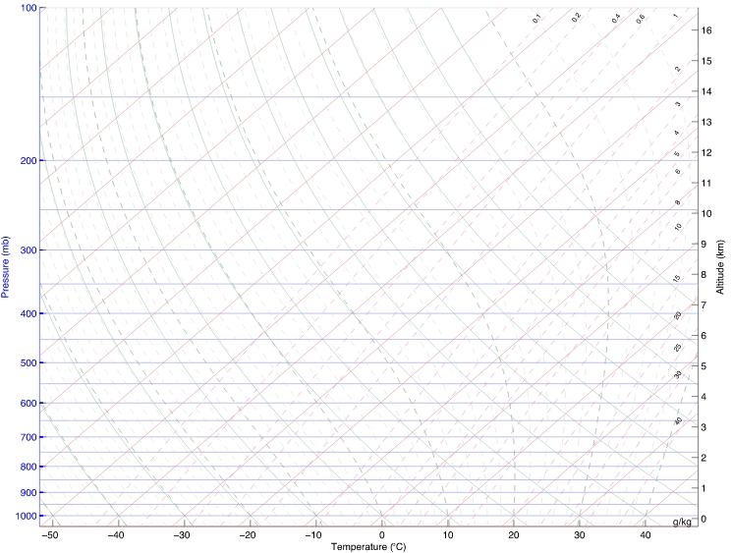

Figure 3-4: Skew T-lnP Diagram Blank Left Slashes Potential Temperature

Table (2-3): Radiosonde data recorded at Baghdad station (Baghdad International Airport) for upper monitoring.
Dew point (°C ) | Temperature (°C ) | Height (m) | Pressure (mb) | Levels
18.3 | 20.0 | 14 | 1011 | SFC
16.9 | 20.2 | 32 | 1009 | 1
17.6 | 19.4 | 112 | 1000 | 2
16.7 | 17.2 | 330 | 975 | 3
14.3 | 14.8 | 779 | 925 | 4
12.1 | 12.6 | 1375 | 862 | 5
9.7 | 12.4 | 1493 | 850 | 6
3.2 | 9.2 | 2232 | 778 | 7
2.6 | 3.8 | 3100 | 700 | 8
-5.4 | 0.6 | 3673 | 652 | 9
-10.5 | -1.5 | 4284 | 604 | 10
-20.1 | -10.1 | 5502 | 517 | 11
-34.7 | -9.7 | 5638 | 508 | 12
-41.1 | -10.1 | 5760 | 500 | 13

P₁  (hPa) | P₂  (hPa) | T₁  (°C) | T₂  (°C) | h₁  (m) | h₂  (m) | $$γ$$  (°C/km) | Stability | Saturated
1011 | 1009
1009 | 1000
1000 | 975
975 | 925
925 | 862
862 | 850
850 | 778
778 | 700
700 | 652
652 | 604
604 | 517
517 | 508
508 | 500

- Start from the second value of pressure and fill in the second column of the above table.
- Calculate the value of the regression rate from the difference between the temperatures of the two adjacent levels divided by the height difference, that is:
$=\frac{T_{2}-T_{1}}{h_{2}-h_{1}}$ (3-3)

- Calculate the values of γ for the rest of the levels, recording your results in the table of calculations above.
- Determine the type of stability for each layer according to the following criteria
The word "Absolutely" here indicates that the stability criterion holds for any type of sample (saturated or unsaturated). While the term conditionally unstable means that the layer is stable to the displacement of unsaturated samples and unstable to saturated samples, as in Figure (3-4) and Table (3-3).
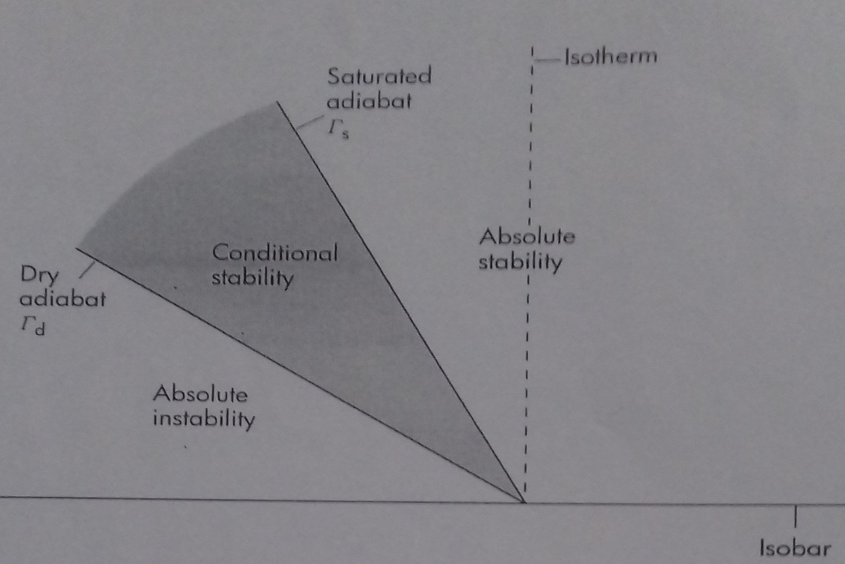
.

Figure 3-4: The relative location of the baselines and areas of stability.

Table (3-3): Ranges of the vertical regression rate and the quality of stability
au (absolutely unstable) | $$γ>γ_{d }and γ>γ_{m }$$
D (dry neutral) | $$γ=γ_{d }$$
cu (conditionally unstable) | $$γ<γ_{d }and γ>γ_{m }$$
M(moist neutral) | $$γ=γ_{m}$$
as (absolutely stable) | $$γ<γ_{d }and γ<γ_{m }$$

- Determine whether the atmospheric layers are saturated or dry. Use the criteria below for which air can be considered saturated.

- T-T_{d}$≤$ 2 ⁰C when T>0⁰ C
- T-T_{d}$≤$ 2 ⁰C when -10 ⁰C <T<0 ⁰C
- T-T_{d}$≤$ 2 ⁰C when T $≤$ -10 °C
If the air layer is conditionally unstable and saturated, it is considered unstable.
7. Repeat steps 5 and 6 to determine the type of stability and for all other levels.

Discussion
Q1: Which of the computed layers in the results table is conditional unstable?
Q2: Is the rising air in your opinion saturated or unsaturated, and what must be done to make it saturated?
Q3: Mention the most important weather phenomena that arise from atmospheric instability?
Q4: Mention the most important causes or origins of instability of the air?
Q5: Compare the average value of α with its reality value in Table (1-3)? Find the error rate?

Good Luck
L.wedyan ghalib

