Lec(1) Advanced Serology MSC of Zoology
Prof. Dr. Ekhlass N. Ali

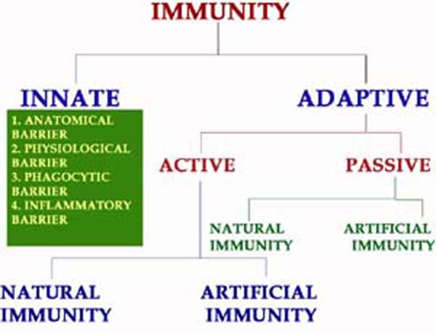
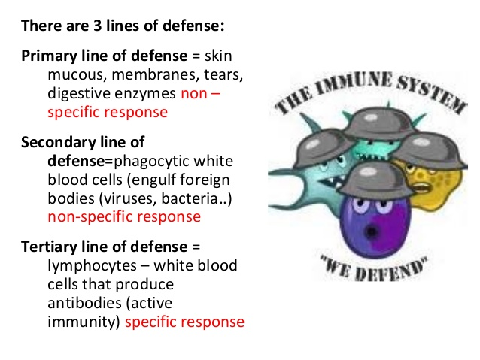

S.N. | Characteristics | Innate Immunity | Adaptive immunity
1. | Presence | Innate immunity is something already present in the body. | Adaptive immunity is created in response to exposure to a foreign substance.
2. | Specificity | Non-Specific | Specific
3. | Response | Fights any foreign invader | Fight only specific infection
4. | Response | Rapid | Slow (1-2 weeks)
5. | Potency | Limited and Lower potency | High potency
6. | Time span | Once activated against a specific type of antigen, the immunity remains throughout the life. | The span of developed immunity can be lifelong or short.
7. | Inheritance | Innate type of immunity is generally inherited from parents and passed to offspring. | Adaptive immunity is not passed from the parents to offspring, hence it cannot be inherited.
8. | Memory | Cannot react with equal potency upon repeated exposure to the same pathogen. | Adaptive system can remember the specific pathogens which have encountered before.
9. | Presence | Present at birth | Develops during a person’s lifetime and can be short-lived.
10. | Allergic Reaction | None | Immediate and Delay hypersensitivity
11. | Used Against | For microbes | Microbes and non-microbial substances called antigens
12. | Memory | No memory | Long term memory
13. | Diversity | Limited | High
14. | Speed | Faster response | Slower response
15. | Complement system activation | Alternative and lectin pathways | Classical pathway
16. | Anatomic and physiological barriers | Skin, Mucous membranes, Temp, pH, chemicals, etc. | Lymph nodes, spleen, mucosal associated lymphoid tissue.
17. | Composition | The innate immune system is composed of physical and chemical barriers, phagocytic leukocytes, dendritic cells, natural killer cells, and plasma proteins. | Adaptive immune system is composed of B cells and T cells.
18. | Development | Evolutionary, older and is found in both vertebrates and invertebrates. | Adaptive immunity system has been developed recently and is found only in the vertebrates.
19. | Example | White blood cells fighting bacteria, causing redness and swelling, when you have a cut. | Chickenpox vaccination so that we don’t get chickenpox because adaptive immunity system has remembered the foreign body.
Specific immunity is developed as a result of exposure to a variety of agents capable of inducing an immune response (immunogens) such as:
1- Vaccines.
2- Microbes that colonize the body.
3- Macromolecules in the diet.
Specific Immune responses:
I- Antibody mediated (Humoral) immune responses:
a. Primary immune response.
b. Secondary immune response.
S.N. | Primary immune response | Secondary immune response
1. | This occurs as a result of primary contact with an antigen. | This occurs as a result of second and subsequent exposure of the same antigen
2 | Responding cell is naïve B-cell and T-cell. | Responding cell is memory cell.
3 | Lag phase is often longer (4-7 days), sometimes as long as weeks or months. | Lag phase is shorter (1-4 days) due to the presence of memory cell.
4 | Level of antibody reaches peak in 7 to 10 days. | Level of antibody reaches peak in 3 to 5 days.
5 | It takes longer time to establish immunity. | Takes shorter time to establish immunity.
6 | First antibody produced is mainly IgM. Although small amount of IgG are also produced. | Mainly IgG antibody is produced. Although sometimes small amount of IgM are produced. Other immunoglobulins such as IgA and in the case of allergy IgE are produced.
7 | Amount of antibody produced depends on nature of antigen. Usually produced in low amount. | Usually 100-1000 times more antibodies are produced.
8 | Antibody level declines rapidly. | Antibody level remain high for longer period.
9. | Affinity of antibody is lower for its antigen. | Antibodies have greater affinity for antigen.
10 | Primary response appears mainly in the lymph nodes and spleen. | Secondary response appears mainly in the bone marrow, followed by the spleen and lymph nodes.
11 | Both Thymus dependent and Thymus independent antigen gives primary immune response. | Only Thymus-dependent antigen gives secondary immune response.

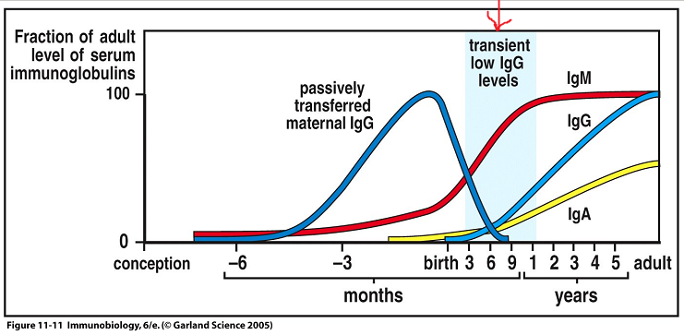
In the graph above the darker blue line refers to the antibodies the baby receives from the mother in utero.
As you can see, the red line indicates that babies begin to produce low levels of their own antibodies between 3 and 6 months before birth. However, these are IgM antibodies, immature 'rough draft' versions. These have much lower affinity for antigens then their mature IgG counterparts which are the classically thought of antibody.
Levels of an infant's own IgG start to rise after birth, however don't reach a reasonable level until after the child is roughly 1 year old. Maternal antibodies start to tail off at around 3 months leaving a period highlighted in blue on the graph where infants are particularly prone to getting infections.
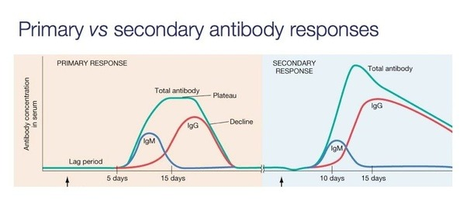
The primary immune response occurs when an antigen comes in contact to the immune system for the first time. During this time the immune system has to learn to recognize antigen and how to make antibody against it and eventually produce memory lymphocytes.
- Following the first exposure to a foreign antigen, a lag phase occurs in which no antibody is produced, but activated B cells are differentiating into plasma cells. The lag phase can be as short as 2-3 days, but often is longer, sometimes as long as weeks or months.
- The amount of antibody produced is usually relatively low.
- Over time, antibody level declines to the point where it may be undetectable.
- The first antibody produced is manily IgM (although small amounts of IgG are usually also produced).
- No detectable antibodies for several days (long lag period).
- Antibodies become detectable after one week, they climb for 10-14 days.
- Antibodies decline and disappear within a few weeks.
- Amount of antibodies formed and amount of protection is relatively small.
- Memory cells are formed.

The secondary immune response occurs when the second time (3rd, 4th, etc.) the person is exposed to the same antigen. At this point immunological memory has been established and the immune system can start making antibodies immediately.
- If a second dose of the same antigen is given Antibodies may be detectable for months or years after the second injection, an accelerated the secondary immune response occurs. This lag phase is usually very short (e.g. 3 or 4 days) due to the presence of memory cells.
- The amount of antibody produced rises to a high level before declining slowly. And Antibody level tends to remain high for longer.
- Continuous injection does not lead to an indefinitely greater immune response. A third dose (injection) of the antigen elicits an immune response with an even shorter lag period and higher and more
- Antibody-forming system posses the ability to remember previous exposure to an antigen.
- The main type of antibody produced is IgG (although small amounts of IgM are sometimes produced).

Active immunity: is protection that is produced by the person’s own immune system. This type of immunity is usually permanent. prolonged antibody response. This forms the basis of all current vaccination techniques. but the Secondary immune response is specific; it can be provoked only by an antigen identical to that given first, and can be provoked many months and years after the first injection of the antigen.
Passive immunity: is protection by products produced by an animal or human and transferred to another human, usually by injection. Passive immunity often provides effective protection, but this protection wanes (disappears) with time, usually within a few weeks or months.
IMMUNOGLOBULIN VARIANTS
An antigenic determinant is the specific chemical determinant group or molecular configuration against which the immune response is directed. Because they are proteins, immunoglobulins themselves can function as effective antigens when used to immunize mammals of a different species. When the resulting antiimmunoglobulins or antiglobulins are analyzed, three principal
categories of antigenic determinants can be recognized—isotype, allotype, and idiotype.
Isotype Determinants
The isotypic class of antigenic determinants is the dominant type found on the immunoglobulins of all animals of a species. The heavy-chain, constant region structures associated with the different classes and subclasses are termed isotypic variants.Genes for isotypic variants are present in all healthy members
of a species. Determinants in this category include those specific for each Ig class, such as gamma (γ) for IgG, mu (μ) forIgM, and alpha (α) for IgA, as well as the subclass-specific determinants κ and λ.
Allotype Determinants
The second principal group of determinants is found on the immunoglobulins of some, but not all, animals of a species.Antibodies to these allotypes (alloantibodies) may be produced by injecting the immunoglobulins of one animal into another member of the same species. The allotypic determinants
are genetically determined variations representing the presence of allelic genes at a single locus within a species. Typical allotypes in humans are the Gm specificities on IgG (Gm isa marker on IgG). In humans, five sets of allotypic markers have been found—Gm, Km, Mm, Am, and Hv.
Idiotype Determinants
A result of the unique structures on light and heavy chains,individual determinants characteristic of each antibody are called idiotypes. The idiotypic determinants are located in the variable part of the antibody associated with the hypervariable regions that form the antigen-combining site.
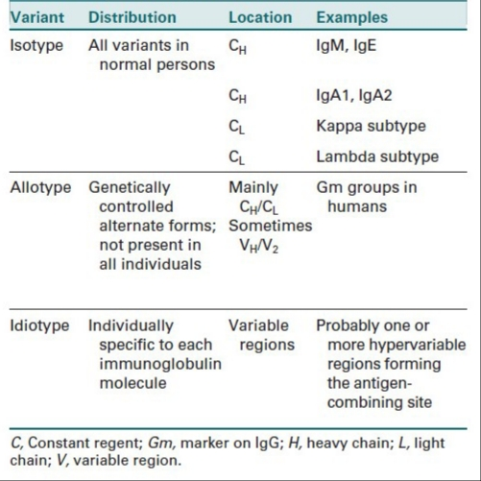
Fig: Immunoglobulins variants.

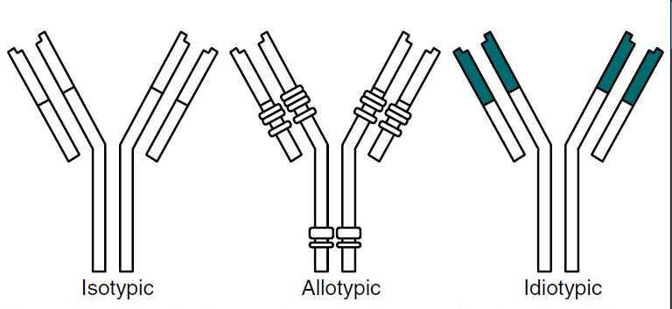
Fig: Variants of antibodies—antigenic determinants.(Adapted from Turgeon ML: Fundamentals of immunohematology, ed 2, Baltimore,1995, Williams & Wilkins.)

ANTIBODY SYNTHESIS
When an antigen is initially encountered, the cells of the immune system recognize the antigen as nonself and elicit an immune response or become tolerant of it, depending on the circumstances. An immune reaction can take the form of cell-mediated immunity (immunity dependent on T cells and macrophages) or may involve the production. antibodies (B lymphocytes and plasma cells) directed against the antigen.Production of antibodies is induced when the host’s lymphocytes come into contact with a foreign antigenic substance that binds to its receptor. This triggers activation and
proliferation, or clonal selection. Clonal expansion of lymphocytes
in response to infection is necessary for an effective immune response. However, it requires 3 to 5 days for a sufficient number of clones to be produced and to differentiate into antibody-producing cells. This allows time for
most pathogens to damage host tissues and cells. Whether a cell-mediated response or an antibody response takes place depends on how the antigen is presented to the lymphocytes; many immune reactions display both types of responses. The antigenicity of a foreign substance is also related to the route of entry. Intravenous and intraperitoneal routes are stronger stimuli than subcutaneous and intramuscular routes.Subsequent exposure to the same antigen produces a memory response, or anamnestic response, and reflects the outcome of the initial challenge. In the case of antibody production,the quantity of IgM-IgG varies.
FUNCTIONS OF ANTIBODIES
The principal function of an antibody is to bind antigen, but antibodies may also exhibit secondary effector functions and behave as antigens. The significant secondary effector functions of antibodies are complement fixation and placental transfer The activation of complement is one of most important effector mechanisms of IgG1 and IgG3 molecules. IgG2 seems to be less effective in activating complement; IgG4, IgA, IgD, and IgE are ineffective in terms
of complement activation. IgG-4 related disease is a newly recognized inflammatory condition characterized by often but not always elevated serum IgG4 concentrations.In humans, most IgG subclass molecules are capable of
crossing the placental barrier; no consensus exists on whether IgG2 crosses the placenta. Passage of antibodies across the placental barrier is important in the etiology of hemolytic disease of the fetus and newborn and in conferring passive immunity to the newborn during the first few months of life.
ANTIGEN-ANTIBODY INTERACTION:
SPECIFICITY AND CROSS-REACTIVITY
The ability of a particular antibody to combine with a particular antigen is referred to as its specificity. This property resides in the portion of the Fab molecule called the combining site, a cleft formed largely by the hypervariable regions of heavy and light chains. Evidence indicates that an antigen may bind to larger, or even separate, parts of the variable region. The closer the fit between this site and the antigen determinant, the stronger are the noncovalent forces (e.g., hydrophobic or electrostatic bonds) between them, and the higher is the affinity between the antigen and antibody. Binding depends on a close
three-dimensional fit, allowing weak intermolecular forces to overcome the normal repulsion between molecules. When more than one combining site interacts with the same antigen ,the bond has greatly increased strength. Antigen-antibody reactions can show a high level of specificity. Specificity exists when the binding sites of antibodies directed against determinants of one antigen are not complementary to determinants of another dissimilar antigen.When some of the determinants of an antigen are shared by similar antigenic determinants on the surface of apparently unrelated molecules, a proportion of the antibodies
directed against one type of antigen will also react with the other type of antigen; this is called cross-reactivity. Antibodies directed against a protein in one species may also react in a detectable manner with the homologous protein in another species.
Cross-reactivity occurs between bacteria that possess the same cell wall polysaccharides as mammalian erythrocytes. Intestinal bacteria, as well as other substances found in the environment, possess A-like or B-like antigens similar to the A and B erythrocyte antigens. If A or B antigens are foreign to an
individual, production of anti-A or anti-B occurs, despite lack of previous exposure to these erythrocyte antigens. Cross-reacting antibodies of this type are termed heterophile antibodies.
Antibody Affinity
Affinity is the initial force of attraction that exists between a single Fab site on an antibody molecule and a single epitope o determinant site on the corresponding antigen. The antigen is univalent and is usually a hapten. Several types of moncovalent bonds hold an epitope and binding site close together “Type of Bonding”).

Antibody Avidity
Each four-polypeptide–chain antibody unit has two antigen binding sites, which allows them to be potentially multivalent in their reaction with an antigen. The functional combining strength of an antibody with its antigen is called avidity,
in contrast to affinity, the binding strength between an antigenic determinant (epitope) and an antibody-combining site When a multivalent antigen combines with more than one of an antibody’s combining sites, the strength of the bonding is significantly increased. For the antigen and antibody to dissociate, all the antigen-antibody bonds must be broken simultaneously .Decreased avidity can result when an antigen (e.g., hapten) has only one antigenic determinant (monovalent).
Table 2-

