1-3 SOFTWARE AND HARDWARE
Software is the stuff that makes your computer do things for you. The computer without software would be like a home entertainment system with no tapes, CD is, or movies - you have the machine, but there is nothing to play on it. Software is continually developed. Each time the software maker (Microsoft, Adobe, Corel, etc) develops a new version of their software they assign it a version number. Before Microsoft Word 7, there was Microsoft Word 6.0.1, and before that Word 6.0. The larger the developments made to the software, the larger the version number changes. Usually, a large change will result in a whole number upgrade; a small change may `result in a tenth of a decimal place.
Hardware is the term given to the physical components of a computer: e.g., keyboard, monitor, system box or floppy disk drive. Software, on the other hand, is electronic information: files, operating system, graphics, computer programs are all example of software. The difference between hardware and software reflects the duality between the physical and mental worlds: for example, your brain is hardware, whereas your mind is software.
Hardware are those components or physical pieces (things you can touch) that make up the computer. The different pieces of the computer’s hardware are monitor, speakers, mouse, CDROM, floppy drive, hard drive, keyboard, CPU, RAM, Processor, etc. Each piece plays a role in the operation of a computer.
3-2 DIFFERENT PARTS OF A COMPUTER AND THEIR USES
The standard computer consists of a monitor, a keyboard, a mouse and the system unit. One can attach accessories such as printers and scanners by means of ports. Increasingly in the workplace, computers are connected to printers and other computers by means of a network.
3-2-1The monitor
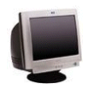 This is the Visual Display Unit (VDU). There are various technologies for the display unit, cathode ray tube (CRT) or Liquid Crystal Display (LCD) or electro luminescent screens or the projector. The monitor or screen displays your work. Facing it down reduces reflected glare from room lights. This reflection may affect your sight. Monitors come in different sizes. The (most important) size of the monitor is measured diagonally on the screen (in inches). Based on this, the monitors range in sizes of 12", 14", 15", 17", 19", 21", 29", etc. Monitors are also characterized by the flatness of their screen. The flatter and the wider screens are usually the better.

3-2-2 The system box or computer console
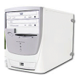 The system box is where all the computations that the computer performs take place. Inside are the CPU processor, the motherboard, the hard disk, any network or sound cards, memory chips (RAM), printer ports (at the back) and the drive bays for floppy disks, Zip disks or CDs. Outside the casings are the power buttons (ON/OFF and Restart) with some additional facilities like the casing USB ports, Webcams, etc.

3-2-3 The system box or computer console
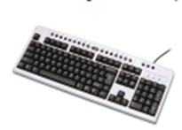The system box is where all the computations that the computer performs take place. Inside are the CPU processor, the motherboard, the hard disk, any network or sound cards, memory chips (RAM), printer ports (at the back) and the drive bays for floppy disks, Zip disks or CDs. Outside the casings are the power buttons (ON/OFF and Restart) with some additional facilities like the casing USB ports, Webcams, etc.
- Character Keys: These comprise of letters, numbers and the symbols. They are used to insert/display readable characters on the screen which is equivalent to the keystroke pressed.
Letters a, b, c, d, e, f, g, h, i, j, k, l, m, n, o, p, q, r, s, t, u, v, w, x, y, z
Numbers 0, 1, 2, 3, 4, 5, 6, 7, 8,

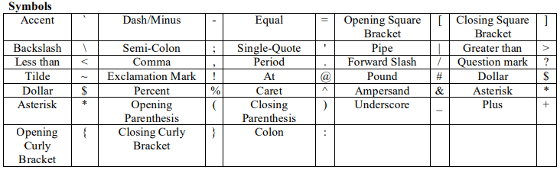

- Action Keys: These are not used to type anything, instead they cause an action. Escape, Tab, Caps Lock, Shift, Control, Alt, Backspace, Enter, Windows, Win Menu, Print Screen, Scroll Lock, Pause Break, Number Lock, Insert, Home, Page Up, Delete, End, Page Down, Power, Sleep, wake up, Up Arrow, Left Arrow, Right Arrow, Down Arrow, and Space Bar.
- Application-Dependant Keys: These are called function keys. They are F1, F2, F3, F4, F5, F6, F7, F8, F9, F10, F11, and F12. Although the F1 key is usually used to get help while working in Microsoft Windows, the use of the other keys varies from one application to another. Eventually, the application you use will give you instructions on what to do and how to use the function keys.
- Key Combinations
Some keys can be combined to produce uppercase letters or to access the upper symbols of some keys (i.e., the Shift and Control keys). Keys are also combined for many other reasons. In some situations, you have to press keys simultaneously, which means that you may be expected to press two or more keys at the same time, or almost at the same time. In some other situations, you may have to press and release one key, followed by another.

- Shortcuts
A shortcut is a quick action you ask a program to perform when you press one particular key or a combination of keys. Some shortcuts are universal or almost, that is, the computer responds regardless of what application is running. Some other shortcuts depend on what you have on your screen. Some shortcuts are already known to the computer (as part of the operating system). Most other shortcuts are set by the programmer of the particular application you are using. Yet some applications allow you to create your own shortcuts. Some shortcuts are readily obvious and can be seen from the main menu of the application. Some other shortcuts are either part of Microsoft Windows (and can be applied in your program) or are not easily displayed, you might have to search the Help documentation of the program you are using.

3-2-4 The Mouse (Clicking and Dragging)
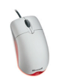This is another input device used to move a small white arrow pointer-the Cursor (but the shape will change depending on the context in which the mouse is being used) on the screen. By pointing and clicking you can carry out commands. The computer may ask you to verify that you are sure to rename a file, by clicking on the (Ok) button. A mouse is primarily made of three parts: the buttons, the handling area, and the sensor (rolling object or light). There are either one, two or three mouse buttons. By default, a mouse has two buttons: left and right. Most mice nowadays are also equipped with a wheel on top of the middle button called the Scroll Button. To use the mouse, the first decision you make is to know which of your two hands you will be using to handle the mouse. By default, the mouse is configured to work for the right hand. If you are left-handed, the settings can be changed to suit your needs: Start → Control Panel →Double-click Mouse →on the Buttons Tab, Check the Switch Primary and Secondary Buttons check box.

3-2-5 The Peripherals
All the parts we have reviewed so far are usually required for the computer to function. Some other parts, not required, can also be connected to the computer to complement it. A peripheral is an object attached to the computer to help it perform some necessary assignments none of the other parts can handle. In most scenarios, no peripheral is required but nowadays, it is unusual for a computer not to have any peripheral at all. The most used peripherals are the printer, a digital camera, a scanner, a projector, an external drive (such as an external CD burner for an old computer), etc.

