Magnetotactic bacteria (or MTB) Dr.Neihaya Heikmat
Magnetic Bacteria are known to synthesize fine crystalline particles of magnetite (Fe₃O₄) or greigite (Fe₃S₄) known as bacterial magnetic particles (BMPs). These naturally synthesized BMPs are enveloped by a thin lipid bilayer and are uniform in shape and size ranging from 50 to 100 nm in diameter.
The first description of magnetotactic bacteria appeared in 1963 by Lowenstam and hence called them "magnetosensitive bacteria". The first peer-reviewed article on magnetotactic bacteria appeared in a 1975 by Blakemore, who had similarly observed bacteria capable of orienting themselves in a certain direction: Blakemore realized that these microorganisms were following the direction of Earth's magnetic field, from south to north.
To perform this task, these bacteria have organelles called magnetosomes that contain magnetic crystals. The biological phenomenon of microorganisms tending to move in response to the environment's magnetic characteristics known as magnetotaxis. In contrast to the magnetoception of animals, the bacteria contain fixed magnets that force the bacteria into alignment- even dead cells align, just like a compass needle. The alignment is believed to aid these organisms in reaching regions of optimal oxygen concentration.

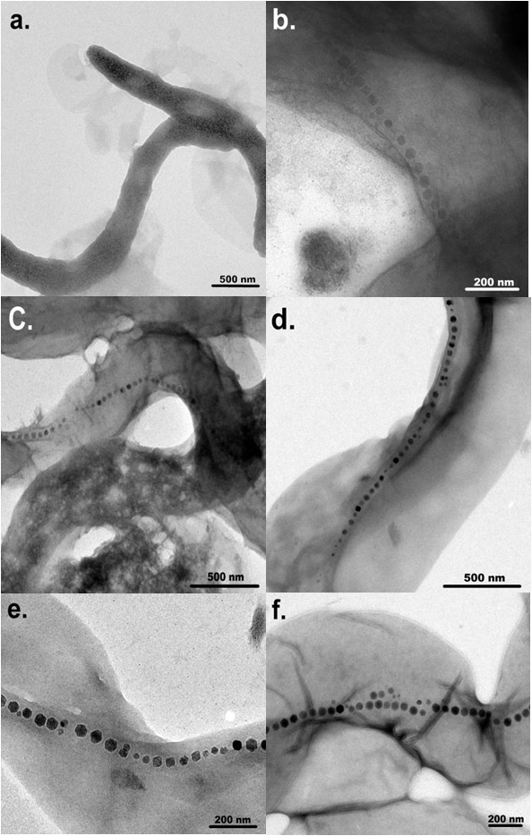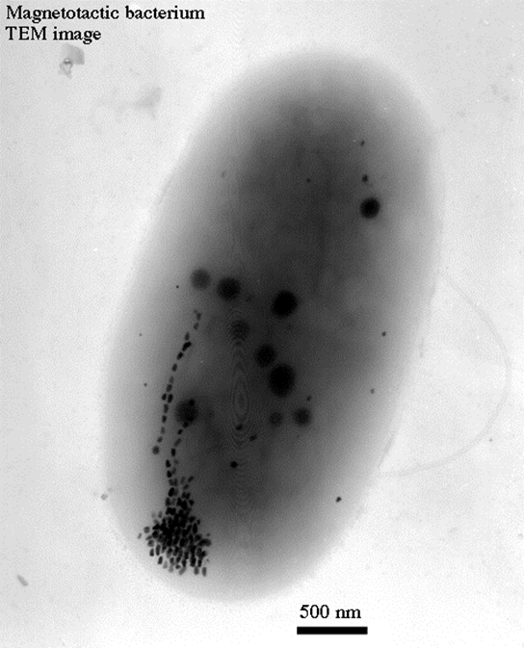
Types of Magnetotatic bacteria

The sensitivity of magnetotactic bacteria to the Earth's magnetic field arises from the fact these bacteria precipitate chains of crystals of magnetic minerals within their cells; to date, all magnetotactic bacteria are reported to precipitate either magnetite or greigite.
Biology of MTB
MTB- a polyphyletic group of bacteria exhibited several different morphologies (shapes) of MTB exist, differing in number, layout and pattern of the bacterial magnetic particles (BMPs) they contain. The MTBs can subdivided into two categories, according to whether they produce particles of magnetite (Fe₃O₄) or of greigite (Fe₃S₄), although some species are capable of producing both. Magnetite possesses a magnetic moment three times that of greigite.
Characteristics of MTB: Various morphological types exist, Gram-negative prokaryote, Magnetic nanoparticles present in magnetosomes, Found in sediments in diverse aquatic environment. All are either obligate microaerophiles, or strict anaerobes. Motile, aquatic bacteria. Direction of motility is affected by the Earth’s geomagnetic field. Strains are either north- or south-seeking depending upon oxic conditions
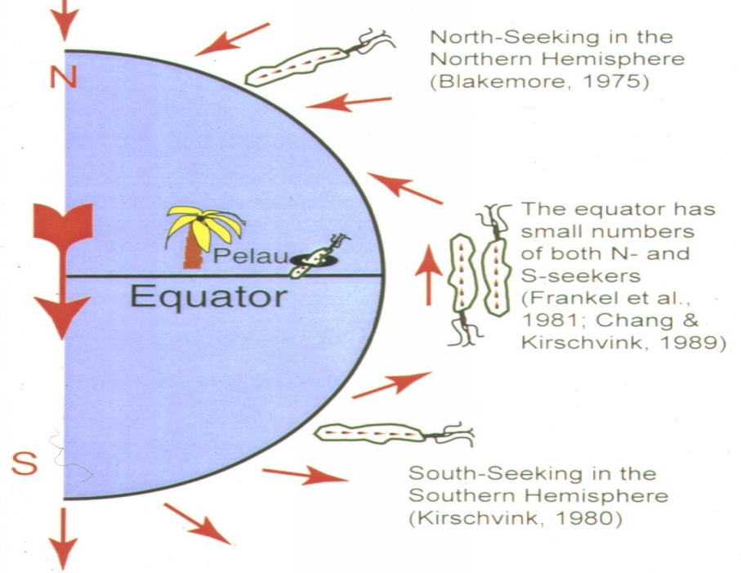
Current hypothesis states that these bacteria use the geomagnetic field to locate lower O₂ or anaerobic habitats. Magnetite-producing magnetotactic bacteria are usually found in an oxic-anoxic transition zone (OATZ), the transition zone between oxygen-rich and oxygen-starved water or sediment. Many MTB are able to survive only in environments with very limited oxygen, and some can exist only in completely anaerobic environments. Some types of magnetotactic bacteria can produce magnetite even in anaerobic conditions, using nitric oxide, nitrate, or sulfate as a final acceptor for electrons. The greigite mineralizing MTBs are usually strictly anaerobic.
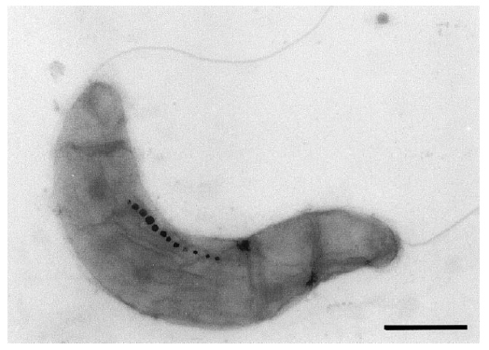
Magnetotactic bacteria
The diversity of MTB reflected by the high number of different morphotypes found in environmental samples of water or sediment. Commonly observed morphotypes include spherical or ovoid cells (cocci), rod-shaped (bacilli), curved bacteria (vibrio) and helical (spirillum) of various dimensions. One of the more distinctive morphotypes is an apparently multicellular bacterium referred to as the many-celled magnetotactic prokaryote (MMP). Regardless of their morphology, all MTB studied so far are motile by means of flagella, the arrangement of flagella differs and can be polar, bipolar, or in tufts. they are Gram-negative bacteria of various phyla: Despite the majority of known species' being proteobacteria, e.g. Magnetospirillum magneticum an alphaproteo- bacterium.
Magnetospirillum is a Gram-negative, microaerophilic genus of magnetotactic bacterium, first isolated from pond water by Blakemore in 1975. It is characterized by a spirilla, or helical, morphology. It is also a motile bacterium owing to the presence of a polar flagellum at each end. Four species have been described: Magnetospirillum magnetotacticum strain MS- (originally classified as Aquaspirillum magnetotacticum;) Magnetospirillum magneticum strain AMB-1; Magnetospirillum gryphiswaldense; and Magnetospirillum bellicus.

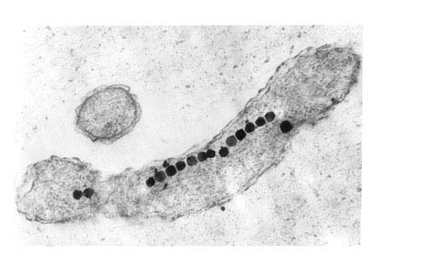
The typical habitat of Magnetospirillum consists of shallow fresh water and sediments, characterized by low concentrations of oxygen for growth (microaerophilic) where it lives in the upper portion of the sediment (oxic/anoxic interface). It prefers an oxygen gradient of approximately 1-3%. Magnetospirillum also resorts to aerotaxis, in order to remain in favorable O₂ concentration conditions. When the bacteria ingest iron, proteins inside their bodies interact with it to produce tiny crystals of the mineral magnetite, the most magnetic mineral on Earth. Due to the high quality of the single-domain magnetic crystals there is also a commercial interest in the bacteria. The crystals are thought to have the potential to produce magnetic tapes and magnetic target drugs.
The MTB polarity model
Various experiments have clearly shown that magnetotaxis and aerotaxis work in conjunction in the magnetotactic bacteria. Aerotaxis is the response by which bacteria migrate to an optimal oxygen concentration in an oxygen gradient. The behavior that has been observed in these bacterial strains has been referred to as magneto-aerotaxis.
Two different magneto-aerotactic mechanisms — known as polar and axial — are found in different MTB strains.

Magnetosomes

It has linear dimensions of 40 to 50 nm and are separated from adjacent particles in the chain by approximately 4 to 10 nm, and the particles are well crystallized with truncated octahedral morphology. The number of magnetosomes per cell is variable within a population, but the average number is typically 10 to 20 magnetosomes per cell, and the average number of magnetosomes also varies with culture conditions, especially chelated iron concentration and dissolved oxygen tension.

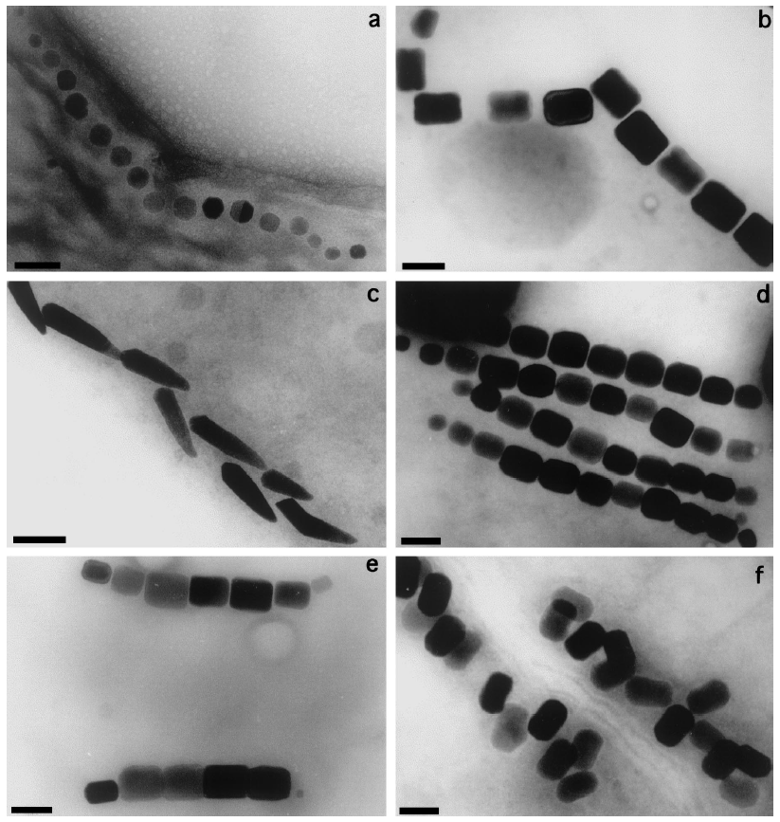

Another trait that shows considerable diversity is the arrangement of magnetosomes inside the bacterial cell. In the majority of MTB, the magnetosomes are aligned in chains of various lengths and numbers along the cell's long axis, which is magnetically the most efficient orientation.

Three general crystal morphologies appeared: roughly cuboidal, elongated prismatic, and tooth-bullet shaped. However, dispersed aggregates or clusters of magnetosomes occur in some MTB, usually at one side of the cell, which often corresponds to the site of flagellar insertion.

Membrane and proteins of Magnetosomes
The biomineralization of the magnetite is brought about by the regulating mechanisms of the concentration of iron, by the nucleation of crystal, of the potential redox and of the pH. The compartmentalization in magnetosomes permits the biochemical control of such processes. After the sequencing of the genome of certain species of MTB, a comparative analysis of the proteins involved in the formation of BMP became possible. These proteins of the magnetosome membrane (MM) beyond the serine proteases domain contain PDZ domains. Other MM proteins contain TPR domains (Tetratric Peptide Repeat).
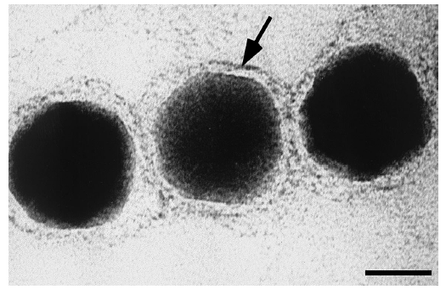
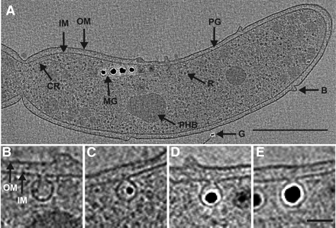

Formation of the magnetosome
The formation of the magnetosome requires at least three steps.
1. The invagination of the magnetosome membrane (MM)
2. The entrance of magnetite precursors into the newly formed vesicle.
3. The nucleation and growth of the magnetite crystal.
During the first formation of an invagination in the cytoplasmic membrane is triggered by a GTPase. It is supposed this process can take place amongst eukaryotes, as well.
The second step requires the entrance of ferric ions into the newly formed vesicles from the external environment. Even when cultured in a Fe³⁺ deficient medium, MTB succeed at accumulating high intracellular concentrations of this ion. It has been suggested that they accomplish this by secreting, upon need, a siderophore, a low-molecular-weight ligand displaying an elevated affinity for Fe³⁺ ions. The "Fe³⁺-siderophore" complex is subsequently moved in the cytoplasm, where it is cleaved. The ferric ions must then be converted into the ferrous form (Fe²⁺), to be accumulated within the BMP; this is achieved by means of a transmembrane transporter, which exhibits sequence homology with a Na⁺/H⁺ antiporter. Furthermore, the complex is a H⁺/Fe²⁺ antiporter, which transports ions via the proton gradient. These transmembrane transporters are localized both in the cytoplasmic membrane and in the MM, but in an inverted orientation; this configuration allows them to generate an efflux of Fe²⁺ ions at the cytoplasmic membrane, and an influx of this same ion at the MM.
During the final stage of the process, the magnetite crystal nucleation is by action of transmembrane proteins with acidic and basic domains. One of these proteins, called Mms6, has also been employed for the artificial synthesis of magnetite, where its presence allows the production of crystals homogeneous in shape and size.
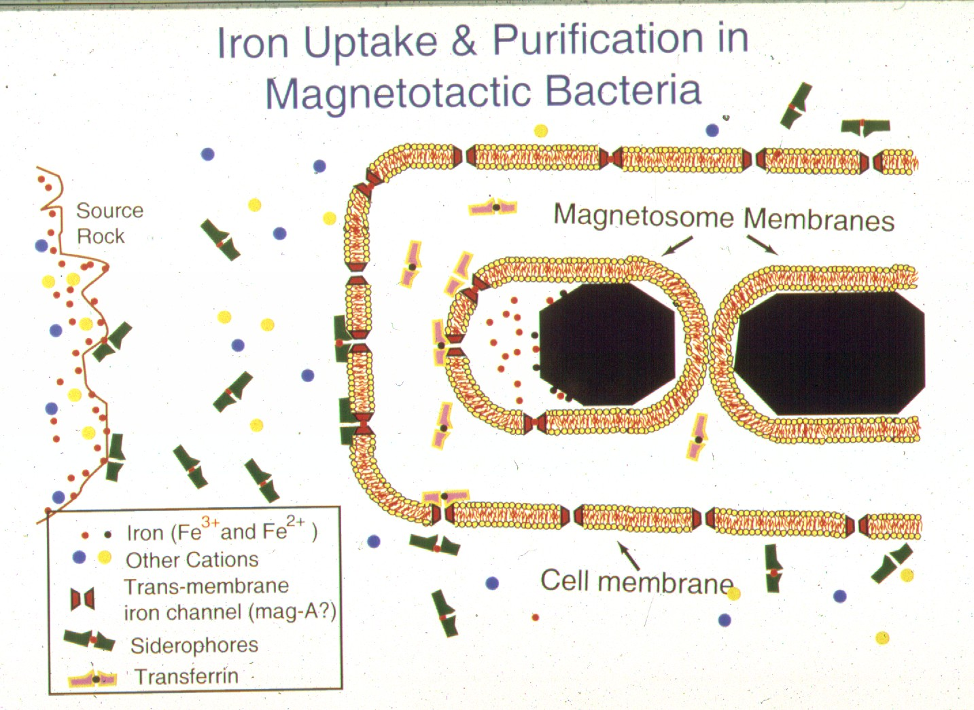

Biomineralization
Several clues led to the hypothesis that different genetic sets exist for the biomineralisation of magnetite and greigite. In cultures of Magnetospirillum magnetotacticum, iron cannot be replaced with other transition metals (Ti, Cr, Co, Cu, Ni, Hg, Pb) commonly found in the soil. In a similar manner, oxygen and sulfur are not interchangeable as nonmetallic substances of the magnetosome within the same species.
From a thermodynamic point of view, in the presence of a neutral pH and a low redox potential, the inorganic synthesis of magnetite is favored when compared to those of other iron oxides. It would thus appear microaerophilic or anaerobic conditions create a suitable potential for the formation of BMPs. Moreover, all iron absorbed by the bacteria is rapidly converted into magnetite, indicating the formation of crystals is not preceded by the accumulation of intermediate iron compounds; this also suggests the structures and the enzymes necessary for biomineralization are already present within the bacteria.
Fe³⁺→Fe²⁺→ amorphous ferrous oxyhydroxide (ferrihydrite?) → oxidise [2Fe³⁺Fe²⁺(O)_{x}(OH)_{y}]^{n+} →Fe₃O₄ + H⁺ + H₂O
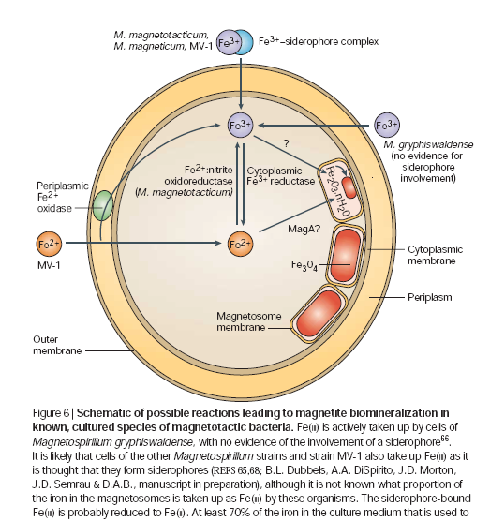

Biotechnology applications
In certain types of applications, bacterial magnetite offers several advantages compared to chemically synthesized magnetite. Bacterial magnetosome particles, unlike those produced chemically, have a consistent shape, a narrow size distribution within the single magnetic domain range, and a membrane coating consisting of lipids and proteins. The magnetosome envelope allows for easy couplings of bioactive substances to its surface, a characteristic important for many applications.
Magnetotactic bacterial cells have been used to determine south magnetic poles in meteorites and rocks containing fine-grained magnetic minerals and for the separation of cells after the introduction of magnetotactic bacterial cells in to granulocytes and monocytes by phagocytosis. Magnetotactic bacterial magnetite crystals have been used in studies of magnetic domain analysis and in many commercial applications including: the immobilization of enzymes; the formation of magnetic antibodies, and the quantification of IgG; the detection and removal of Escherichia coli cells with a fluorescein isothiocyanate conjugated monoclonal antibody immobilized on magneto-tactic bacterial magnetite particles; and the introduction of genes into cells, a technology in which magnetosomes are coated with DNA and "shot" using a particle gun into cells that are difficult to transform using more standard methods.
Using this special characteristic, a sandwich chemiluminescence enzyme immunoassay using antibody-conjugated to BMPs permits the development of highly sensitive assays for insulin, HbA1c, glycated albumin and IgG. In addition, the development of a competitive chemiluminescence enzyme immunoassay allows us to detect small molecules, such as environmental pollutants, hormone and toxic detergents.
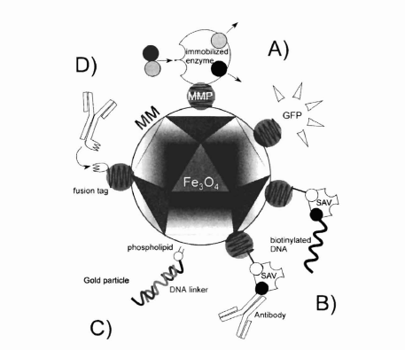
Biological applications
- a potential biomarker for geobiologists
- an ideal system for studying biomineralization
- magnetosomes have been also used for the generation of magnetic antibodies as components of medically important biosensors e.x. Brain tumor sensing
- were also used as carriers for the introduction of DNA into cell as contrast agents for magnetic resonance imaging and tumor-specific drug carriers based on intratumorally enrichment
- Treatment of AIDS
Environmental chemistry and technology
- Waste water and potable water purification using magnetite microparticles to the removal of heavy metals and radionuclides from it.
- Magnetically modified microbial cells for xenobiotics removal.
- Magnetically modified enzymes for the detection of their inhibitors (heavy metals, pesticides etc…)
- the used Microbial magnetometer” .

