Bacterial taxonomy Lec .10 Phylum Actinobacteria
Suborder Corynebacterineae
Genus Mycobacterium
Scientific classification
Domain Bacteria
Phylum Actinobacteria
Class Actinobacteria
Order Actinomycetales
Family Mycobacteriaceae
Genus Mycobacterium
Species M.tuberculosis
- Straight or slightly curved rods that sometimes branch or form filaments
- Aerobic and catalase positive
- Filaments readily fragment into rods and coccoid bodies
- Very slow growing on culture media.
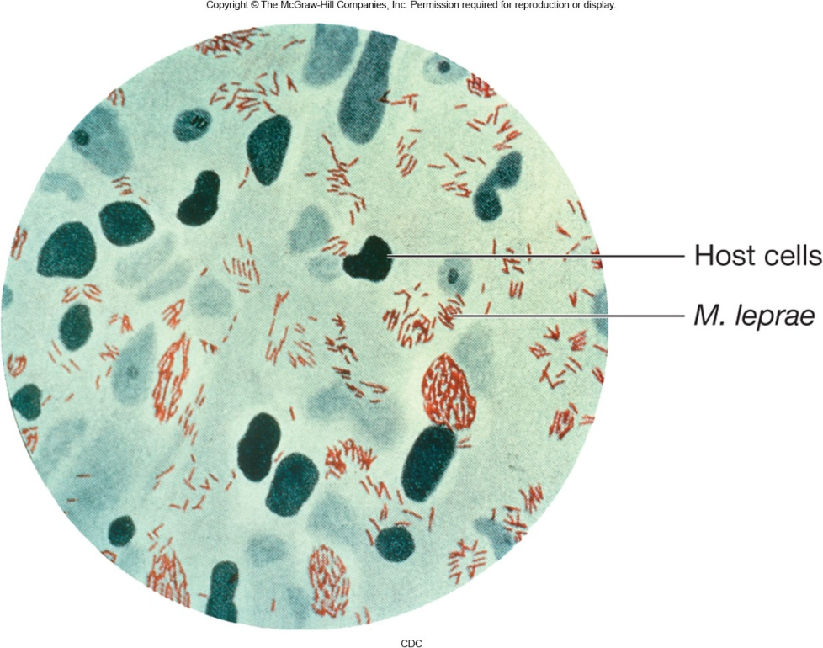
Fig.1 Mycobacterium stained with acid fast stain
Mycobacterial Cell Walls
- Contain waxes with 60 to 90 carbon mycolic acids
- Cell wall surface contains the glycolipid trehalose dimycolate
- cell wall very hydrophobic
- impenetrable by antibiotics
- acid-fast
- basic fuchsin dye not removed by acid alcohol treatment.
Important Species of Mycobacterium
- M. bovis causes tuberculosis in cattle, humans
- M. tuberculosis causes tuberculosis in humans
- M. avium complex (MAC) causes various diseases
- M. leprae causes Leprosy.

Genus Nocardia
- Along with genus Rhodococcus make up the family Nocardiaceae.
- Develop a substrate mycelium that readily breaks into rods and coccoid elements.
- Some also form an aerial mycelium and conidia(fig.2).
Figure.2 Nocardia 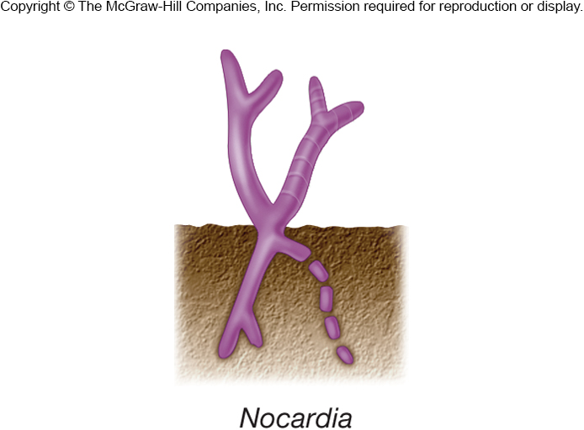

Impact of Nocardia
- Most are free-living saprophytes.
- Can degrade many molecules.
- e.g., petroleum hydrocarbons, detergents, benzene
- Involved in biodegradation of rubber joints in water and sewage pipes.
- Some are opportunistic pathogens causing nocardiosis
- usually infect lungs; can infect central nervous system

Suborder Micromonosporineae

- Only one family, Micromonosporaceae
- extensive substrate mycelia
- lack or have rudimentary aerial mycelia
- sporangiospores motile or nonmotile
- found in soil and aquatic habitats (especially freshwater).

Genus Propionibacterium
- Found on skin and in digestive tract of animals
- also in dairy products such as cheese
- used in production of Swiss cheese
Most important genus P. acne which involved in development of body odor and acne vulgaris.

Suborder Streptomycineae
- One family, three genera
- Aerial hyphae that divide in single plane to form chains of 3–50 nonmotile spores
- All have type I cell wall
- G+C DNA content is 69–78%
- Filaments grow by tip extension (fig.3).
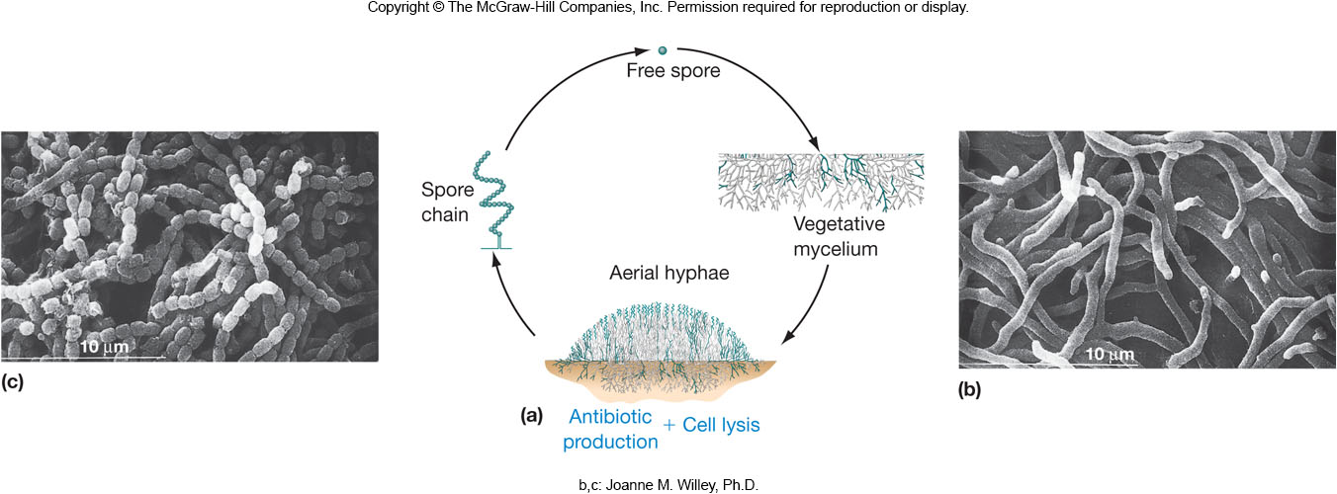
Figure .3 Life cycle and cell morphology of Streptomycineae
Genus Streptomyces
Scientific classification
Domain Bacteria
Phylum Actinobacteria
Class Actinobacteria
Order Actinomycetales
Family Streptomycetaceae
Genus Streptomyces
- Are 1 to 20% of culturable soil microbiota.
- Produce geosmin.
- volatile substance that is source of moist earth odor
- Important in mineralization process.
- Aerobically degrade many resistant substances (e.g., pectin, lignin, and chitin).
- Produce vast array of antibiotics, other bioactive compounds, and antibiotic resistance genes.
- Most are nonpathogenic saprophytes.

Table 1 Some products of Streptomycetes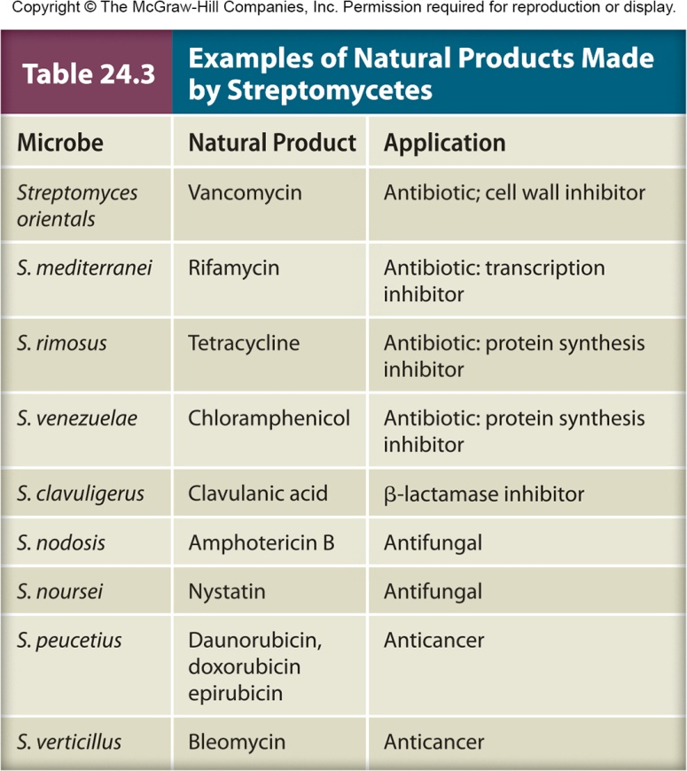

Pathogenic Streptomycetes
- usually infect lungs as well as can infect central nervous system.
- Streptomyces somaliensis causes actinomycetoma infection of subcutaneous tissues in humans leads to swelling, abscesses, and bone destruction.

Order Bifidobacteriales
One family and ten genera
Most important genera are; Gardnerella which found in human genitourinary tract and thought to be major cause of vaginitis and Bifidobacterium nonsporing rods that found in mouth and intestinal tract of warm-blooded animals, in sewage, and in insects.

Bifidobacterium bifidus
Scientific classification
Domain Bacteria
Phylum Actinobacteria
Class Actinobacteria
Order Bifidobacteriales
Family Bifidobacteriaceae
Genus Bifidobacterium
Species B.bifidum
- Pioneer colonizer of human intestinal tract
- Does not appear to be major cause of disease
- Probiotic agent.

