Lecture two

Radiation laws
2.1 Blackbody Radiation Laws
The laws of blackbody radiation are basic to an understanding of the absorption and emission processes. A blackbody is a basic concept in physics and can be visualized by considering a cavity with a small entrance hole, as shown in Fig. 2.1. Most of the radiant flux entering this hole from the outside will be trapped within the cavity, regardless of the material and surface characteristics of the wall. Repeated internal reflections occur until all the fluxes are absorbed by the wall. The probability that any of the entering flux will escape back through the hole is so small that the interior appears dark. The term blackbody is used for a configuration of material where absorption is complete. Emission by a blackbody is the converse of absorption. The flux emitted by any small area of the wall is repeatedly reflected and at each encounter with the wall, the flux is weakened by absorption and strengthened by new emission.

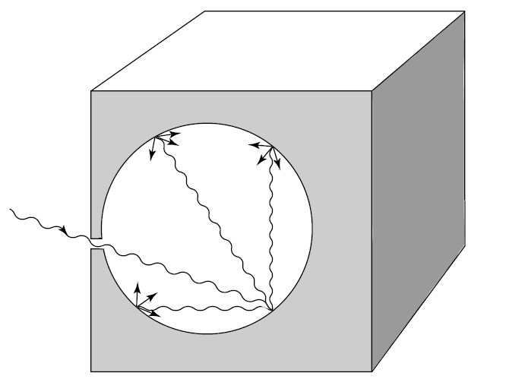
Figure 2.1 A blackbody radiation cavity to illustrate that absorption is complete.

After numerous encounters, emission and absorption reach an equilibrium condition with respect to the wall temperature. In the following, we present four fundamental laws that govern blackbody radiation, beginning with Planck’s law.

2.2 Planck’s Law
In his detection of a theoretical explanation for cavity radiation, Planck (1901) assumed that the atoms that make up the wall behave like tiny electromagnetic oscillators, each with a characteristic frequency of oscillation. The oscillators emit energy into the cavity and absorb energy from it. In his analysis, Planck was led to make two assumptions about the atomic oscillators.
First, Planck postulated that an oscillator can only have energy given by:

$E=nh\tilde{v }………………………………………..2.1a$

Where $\tilde{v }$the oscillator frequency, h is is Planck’s constant, and n is called the quantum number and can take on only integral values. Equation (2.1) states that the oscillator energy is quantized. Although later developments revealed that the correct formula for a harmonic oscillator is
$E = \left(n +\frac{1}{2}\right)h \tilde{ν}………………………………..2.1b$
The change introduces no difference to Planck’s conclusions.
Secondly, Planck postulated that the oscillators do not radiate energy continuously, but only in jumps, or in quanta. These quanta of energy are emitted when an oscillator changes from one to another of its quantized energy states. Hence, if the quantum number changes by one unit, the amount of radiated energy is given by $= nh \tilde{ν} = h \tilde{ν}$ . Determination of the emitted energy requires knowing the total number of oscillators with frequency $\tilde{ν}$ for all possible states in accord with Boltzmann statistics, following the two preceding postulations and normalization of the average emitted energy per oscillator, the Planck function in units of energy/area/time/sr/frequency is given by:
$$B_{\tilde{v}}\left(T\right)=\frac{2h{\tilde{v}}^{3}}{c^{2}( e^{\frac{h\tilde{v}}{KT}}-1)} …………………………….(2.3)$$
Where K is Boltzmann’s constant, c is the velocity of light, and T is the absolute temperature. The Planck and Boltzmann constants have been determined through Experimentation and are h = 6.626 × 10⁻³⁴ J sec and K = 1.3806 × 10⁻²³ J deg⁻¹.The Planck function relates the emitted monochromatic intensity to the frequency and the temperature of the emitting substance. By utilizing the relation between frequency and wavelength shown in Eq. (2.4): c=λ*$\tilde{v}$
$$I_{\tilde{v}}=-\left(\frac{{}^{2}}{c}\right)I_{}…………………………………….(2.4)$$
Eq. (2.3) can be rewritten as follows in eq. 2.5:
$$B_{λ}\left(T\right)=\frac{2hc^{2}}{{}^{5}( e^{\frac{hc}{KT}}-1)} =\left(\frac{C_{1}{}^{-5}}{π(e^{\frac{C_{2}}{T}}- 1}\right) ……………………………(2.5)$$

Where $C_{1}$ = 2πhc² and $C_{2}$= hc/K are known as the first and second radiation constants, respectively. Figure 2.2 shows curves of B_{λ}(T) versus wavelength for a number of emitting temperatures. It is evident that the blackbody radiant intensity increases with temperature and that the wavelength of the maximum intensity decreases with increasing temperature. The Planck function behaves very differently when λ→∞, referred to as the Rayleigh–Jeans distribution, and when λ → 0, referred to as the Wien distribution.
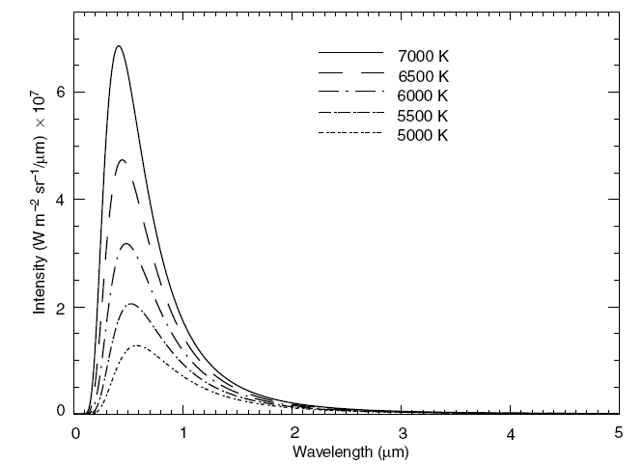
Figure 2.2 Blackbody intensity (Planck function) as a function of wavelength for a number of emitting temperatures.
2.3 Stefan–Boltzmann Law
The total radiant intensity of a blackbody can be derived by integrating the Planck
Function over the entire wavelength domain from 0 to ∞. Hence,
$$B\left(T\right)=\int_{0}^{-∞}{B_{}\left(T\right)d= \int_{0}^{-∞}{\left(\frac{2hc^{2}{}^{-5}}{( e^{\frac{hc}{KT}}-1)}\right)} }d ……….(2.6)$$
On introducing a new variable $x = hc/kλT$ , Eq. (2.5) becomes
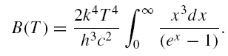……………………………(2.7)

The integral term in Eq. (2.7) is equal to π⁴/15. Thus, defining
$$b = \frac{2π^{4}K^{4}}{(15c^{2}h^{3})}…………………………………………(2.8)$$
We then have:
$$B\left(T\right)=bT^{4} ……………………….\left(2.9\right)$$
Since blackbody radiation is isotropic,
………………………………..(2.10)
The flux density emitted by a blackbody is Therefore:
$$F= πB\left(T\right)= σ T^{4}………………………………(2.11)$$
Where σ is the Stefan–Boltzmann constant and is equal to 5.67 × 10⁻⁸ J m⁻² sec⁻¹ deg⁻⁴. Equation (2.11) states that the flux density emitted by a blackbody is proportional to the fourth power of the absolute temperature. This is the Stefan– Boltzmann law, fundamental to the analysis of broadband infrared radiative transfer.

2.4 Wien’s Displacement Law
Wien’s displacement law states that the wavelength of the maximum intensity of blackbody radiation is inversely proportional to the temperature. By differentiating the Planck function with respect to wavelength, and by setting the result equal to zero, i.e.,
$$\frac{∂B_{}(T)}{∂}=0…………………………………….(2.12)$$

We obtain the wavelength of the maximum:
$$λ_{m} =\frac{a}{T}……………………………………(2.13)$$
Where a = 2.897 × 10⁻³ m deg. From this relationship, we can determine the temperature of a blackbody from the measurement of the maximum monochromatic intensity. The dependence of the position of the maximum intensity on temperature is evident from the blackbody curves displayed in Fig. 2.2.

2.5 Kirchhoff’s Law
The preceding three fundamental laws are concerned with the radiant intensity emitted by a blackbody, which is dependent on the emitting wavelength and the temperature of the medium. A medium may absorb radiation of a particular wavelength, and at the same time also emit radiation of the same wavelength. The rate at which emission takes place is a function of temperature and wavelength. This is the fundamental property of a medium under the condition of thermodynamic equilibrium. The physical statement regarding absorption and emission was first proposed by Kirchhoff (1860).
To understand the physical meaning of Kirchhoff’s law, we consider a perfectly insulated enclosure having black walls. Assume that this system has reached the state of thermodynamic equilibrium characterized by uniform temperature and isotropic radiation. Because the walls are black, radiation emitted by the system to the walls is absorbed. Moreover, because there is an equilibrium, the same amount of radiation absorbed by the walls is also emitted. Since the blackbody absorbs the maximum possible radiation, it has to emit that same amount of radiation. If it emitted more, equilibrium would not be possible, and this would violate the second law of thermodynamics.
Radiation within the system is referred to as blackbody radiation as noted earlier, and the amount of radiant intensity is a function of temperature and wavelength. On the basis of the preceding discussion, the emissivity of a given wavelength, ε_{λ} (defined as the ratio of the emitting intensity to the Planck function), of a medium is equal to the absorptivity, A_{λ} (defined as the ratio of the absorbed intensity to the Planck function), of that medium under thermodynamic equilibrium. Hence, we may write
$$ε_{λ} = A_{λ}………………………………………2.14$$
A medium with an absorptivity A_{λ} absorbs only A_{λ} times the blackbody radiant intensity B_{λ}(T ) and therefore emits ε_{λ} times the blackbody radiant intensity. For a blackbody, absorption is a maximum and so is emission. Thus, we have
$$A_{λ} = ε_{λ} = 1…………………….…………2.15$$
For all wavelengths. A gray body is characterized by incomplete absorption and emission and may be described by
$$A_{λ} ={ ε}_{λ} < 1. …………………………………2.16$$
Kirchhoff’s law requires the condition of thermodynamic equilibrium, such that uniform temperature and isotropic radiation are achieved. Obviously, the radiation field of the earth’s atmosphere as a whole is not isotropic and its temperatures are not uniform. However, in a localized volume below about 60–70 km, to a good approximation, it may be considered to be isotropic with a uniform temperature in which energy transitions are governed by molecular collisions. It is in the context of this local thermodynamic equilibrium (LTE) that Kirchhoff’s law is applicable to the atmosphere.

