Lab 3
(Dogfish) Shark

Phylum: Chordata
Sub phylum : Vertebrata
Super class : Piesces
Class : Chondrichthyes
Sub class : Elasmobranchii
Order : Selachii
Genus : Squalus acanthias

The Dogfish or shark is belong to phylum Chordata meaning it has a notochord. It is a jawed vertebra in the class chondrichthyes; meaning it has a flexible skeleton made of cartilage. The shark has a graceful and streamlined body shape built for fast, long distance swimming. The body is divided into the head, trunk, and tail. Placoid scales (dermal denticles) are covering the skin of sharks. The snout is at the anterior end. The opening to the mouth of sharks is always on the underside. The external nostrils are located on each side of the head and leads to larger internal nostrils. Eyes are large in sharks and are located at both sides of head. The shark's body is dark gray above and almost white below. Sharks have 5-7 pairs of gill slits located on the sides of their heads. Unlike bony fish, they do not have gill covers. Some sharks have spiracles, which are special gill slits appear like small openings located just behind the eyes. These openings allow water to pass through the gills even when the shark’s mouth is closed.

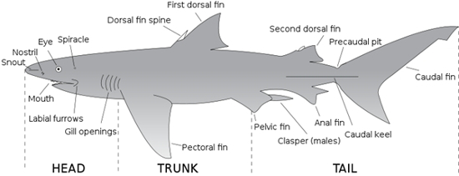

Shark's fins
Most sharks have five different types of fins, while some sharks only have four. These types of fins include:
- Pectoral Fins
At the front of the shark behind its head, are the pectoral fins. Sharks use these fins to lift and steer them while they swim.
- Pelvic Fins
Behind the pectoral fins, are the pelvic fins, also found on either side of the cloaca. In male sharks, the posterior parts of pelvic fins are modified into tube-like copulatory organs called claspers which are necessary for the reproduction process.
- Dorsal Fins
Dorsal fins are the ones that most people are familiar with; these fins are often seen when a shark is at the water’s surface. Anterior dorsal fin is larger than the posterior dorsal fin. There are two spines, one immediately in front of each dorsal fin. The spines carry poisons secreted by glands at their base and are mainly used in defense.
- Anal Fins
For some sharks, these fins are not enough to completely stabilize them. Therefore, the anal fin is present to provide additional stability to the sharks that possess them. The anal fin is located between the pelvic and caudal fins on the bottom, or ventral, part of the shark.
- Caudal Fins
The shark having the ability to propel itself through the water, they utilize what is called the caudal fin. This fin, also known as the tail fin. The caudal fin is divided into two lobes: a larger dorsal lobe and a smaller ventral lobe. This type of tail is known as a heterocercal tail.
Shark's senses
- Smell
Sharks have an acute sense of smell. Paired external nostrils with internal and external openings lead to ventral olfactory organs. Sharks have ability to detect minute quantities of substances such as blood in the water; also can detect a concentration as low as one part per billion of some chemicals.
- Hearing
Shark external ears are hard to see, they are just two small openings behind and above the eyes. The ears may be small, but they’re powerful. Inside, there are cells that can sense even the tiniest vibration in the surrounding water. Sharks may track sounds over many miles.
- Eyesight
Sharks have good eyesight for being in the water, so they can see well during the day or the night. Upper and lower eyelids also protect the eye. Sharks that live deeper in the oceans usually have larger eyes than those that live nearer the surface.
- Taste
Many sharks rely heavily on their sense of taste. Before these sharks eat something, they will give it a "test bite" first. The sensitive taste buds clustered in the mouth analyze the potential meal to see if it's palatable. Sharks will often reject prey that is outside their ordinary diet, after this first bite.
- Lateral line
The lateral line system is a series of fluid-filled canals just below the skin of the head and along the sides of the body. The canal is open to the surrounding water through tiny pores. The lateral line canals contain a number of sensory cells called neuromasts. Tiny hair-like structures on the neuromasts project out into the canal. Water movement created by turbulence, currents, or vibrations displaces these hair-like projections and stimulates the neuromasts. This stimulation triggers a nerve impulse to the brain. The lateral line senses low-frequency vibrations. It functions mainly in distance perception and detecting low-frequency vibrations and directional water flow.

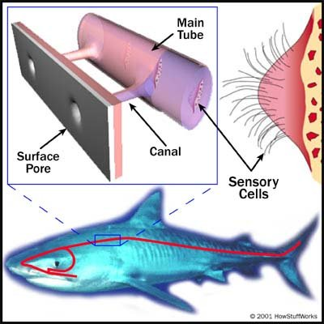
Lateral line

- Ampullae of Lorenzini
The ampullae of Lorenzini form a complex and extensive sensory system around a shark's head. External pores cover the surface of a shark's head. Each pore leads to a jelly-filled canal that leads to a membranous sac called an ampulla.
In the wall of the ampulla are sensory cells innervated by several nerve fibers. The ampullae detect weak electrical fields at short ranges. All living organisms produce electrical fields. ampullae of Lorenzini may also detect temperature, changes in water pressure, mechanical stimuli, and magnetic fields.

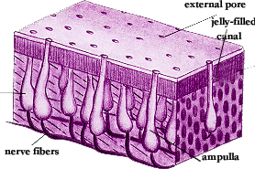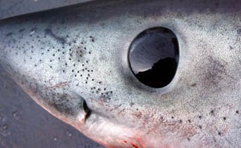
Ampullae of Lorenzini
The digestive system
The digestive tract is begins at the mouth behind which is the oral Cavity, and ends either at a cloaca or anus. In mouth on the jaws there are many sharp teeth which are similar in shape. Sharks have many rows of sharp teeth and its shape depends on the shark’s diet. The teeth are actually modified placoid scales, and are replaced regularly.
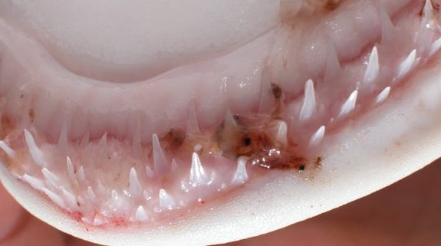

On the floor of the mouth is the immovable tongue, Posterior to the mouth is the pharynx, which connect the oral cavity to the esophagus, the posterior end of the pharynx is the esophagus, a short tube lined by many papillae. The esophagus leads into the "J"-shaped stomach. The upper portion, the cardiac region, lining with numerous glands which produce acids and enzymes that digest food. The shark does not chew its food, but swallows large pieces, which may remain in the stomach for some time. The caudal section of the stomach is the pyloric region that breaks the food down further. This ends in a muscular pyloric valve, which regulates the passage of food into the intestine.
The small intestine is beginning at the pyloric valve. The first portion of the intestine is the short duodenum.

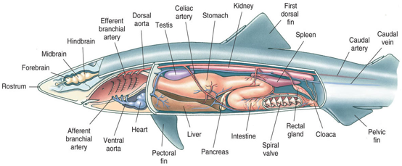
The larger and longer portion is the ileum. Opening the ileum reveals the spiral valve, a unique adaptation of sharks that greatly increases the surface area available for absorption of nutrients. The large intestine or colon is very short; the rectal gland is a slender, blind-ended, finger-like structure with duct into the colon. It excretes salt (NaCI) in high concentrations; to regulate the shark's salt balance. Colon connects with the short rectum, which leads to the cloaca. The cloaca is the common chamber for the digestive, excretory, and reproductive systems. The cloacal opening is the common opening for these systems.

Glandular organs in digestive system
1- The liver
Is the largest organ in the abdominal cavity, it is composed of three lobes. The right and left lobes are large; the medial lobe is much smaller. The gall bladder is located within the smaller lobe. Gall bladder is small sac stores bile and releases it into the small intestine through the common bile duct.
- The pancreas
The pancreas has two lobes located on the duodenum and the lower stomach. The secretions of the pancreas enter the duodenum by way of the pancreatic duct.
Respiratory system
Sharks have 5-7 pairs of gill slits located on the sides of their heads. There is also a modified slit, called the spiracle, which lies immediately behind the eye on the shark’s head. Unlike bony fish, they do not have gill covers, water must continually flow across these slits in order for the shark to breathe. . Each gill is supported by a gill arch and protected by gill rakers, which filter the respiratory water and direct food toward the esophagus. Each gill arch supports one set of paired gill filaments, which help increase their surface area for oxygen exchange. Water enters through the mouth and the spiracle, into the pharynx, over the gills and exits through the gill slits. Respiratory gas exchange takes place on the surface of the gill filaments as the water passes over and out the gills.
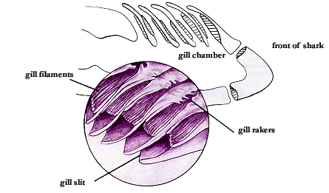
Urogenital system
The kidneys are flattened, ribbon-like, darkly colored structures lying dorsally on either side of the midline. Small collecting tubules from the kidneys collect and transport urine from the kidneys lead into the accessory urinary ducts along their lengths then open into cloaca. The kidneys of the male are the same as those of the female, the posterior portion is involved in the manufacture and transport of urine, the main difference lies in the anterior portion of the kidney, which in females is degenerate and functionless, but in males is an active part of the reproductive system.

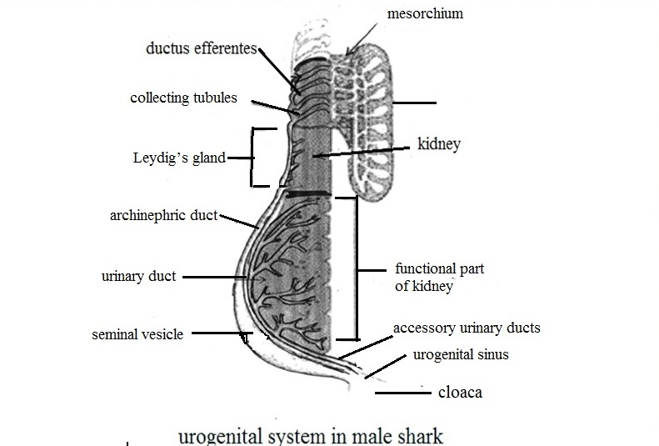
The male testes are suspended in the cavity by the mesorchium. In the mesorchium, several small tubules called the ductus efferentes carry the sperms from the testes to the archinephric duct. The archinephric duct is a highly coiled tube that carries sperm to the seminal vesicle. The Leydig’s gland, secretes fluid into the archinephric duct to protect the sperm. The posterior portion of the archinephric duct enlarges and forms the seminal vesicle, the posterior ends of the seminal vesicles transform to sperm sac. The joining of sperm sac end and the accessory urinary duct produce the urogenital sinus which open into cloaca. The male also have external structures called claspers. The claspers are rod like copulatory organs present on the inner borders of the pelvic fins. Each clasper has a groove on its dorsal side. The groove is opened at both the ends. The male deposits his sperm into the female's cloaca via claspers’ grooves.

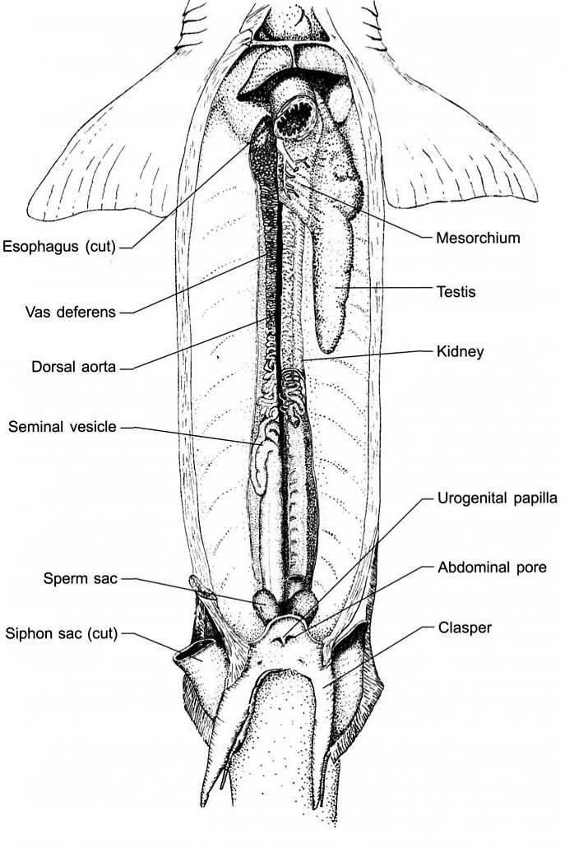

The female ovaries are suspended by a mesovarium, which contains eggs in different stages of maturity. Once the eggs reach maturity, they are released from the ovary and mesovarium and travel to the oviducts. Oviduct is elongated tubes that lay dorsal and lateral along the body cavity .At the beginning of oviduct there is shell duct. This gland secretes a thin shell around a group of eggs and is a reservoir for sperm storage. Eggs are fertilized in this gland as they pass through.at the end of ovidut the uterus.
Uterus is enlarged caudal end of the oviduct; it is here that eggs develop. The two oviducts join in the dorsal portion of the cloaca.
Fertilization is internal, usually taking place within the shell gland of the oviduct. The fertilized eggs continue to move posteriorly to the uterus.

