**Staining of Slides-2021-2022**

**Staining** is a technique used in microscopy to enhance contrast in the microscopic image in biology and medicine to highlight structures in cell populations or organelles within individual cells.

**The term stain and dye are not the same.**

**A dye** is a coloring agent that is used for general purposes.

**A stain** is one that is used for biological purposes.

**Dyes and Stains Structure**

Dyes are colored organic compounds that can selectively bind to tissues. Most modern dyes are synthesized from simpler organic molecules, usually benzene or one of its derivatives.

Most simple organic compounds such as alkanes, benzene and alcohols are colorless to the human eye but will absorb light outside the visible spectrum. Benzene, for example, absorbs strongly in the UV region of the spectrum but appears water-white to the human eye. Any group that makes an organic compound colored is called a **chromophore**. Benzene can be made to absorb visible light by adding a suitable chromophore.

**The Staining Process**

The actual staining process may involve immersing the sample (before or after fixation and mounting) in dye solution, followed by rinsing and observation. Many dyes, however, require the use of a mordant (a chemical compound that reacts with the stain to form an insoluble, colored precipitate). When excess dye solution is washed away, the mordant stain remains. Stains are generally prepared largely as aqueous solutions. However in some cases stock solutions are prepared in alcohol, and are diluted with water as needed. Since alcohol removes the stains, pure alcoholic solutions should not be used. Staining solutions are prepared to contain low concentrations of stains rarely exceeding 1%.A very dilute staining solution activity for a long period of time will produce much better results than more concentrated solution acting for a shorter interval.

**Classification of Days (Stains)** Based on their chemical behavior, the dyes are classified as acidic, basic and neutral.

An **acid** (or anionic) dye has a negative charge. eg., Eosin, Rose Bengal and Acid fuchsine. Since they are negatively charged, bind to positively charged cell structures. The anionic dyes stain better under acidic conditions, where the proteins and many other molecules carry a positive charge.

· A **basic** dye (or cationic) carries a positive charge. eg., Methylene Blue, basic fuchsine, crystal violet, malachite green, safranin. Basic dyes bind to negatively charged molecules like nucleic acid and many proteins. Since the bacterial cells surfaces are negatively charged, basic dyes are most often used in Bacteriology. Basic dyes are normally available as chloride salts.

· A **neutral** dye is a complex salt of a dye acid with a dye base.

**The dyes used in bacteriology have two features in common**

1- They have chromophore groups, groups with double bonds that give the dye its color

2- They can bind with cells by ionic, covalent or hydrophobic bonding.

Most of the dyes commonly used in microscopy are available as **certified stains**.

**Names of common dyes**

Dye manufacturers usually give the dyes they produce common names such as eosin or Congo red rather than their full chemical name.

**Example:**

The full chemical name of **Congo red**is:

3,3′-((biphenyl)-4,4′-diylbis(azo))-bis(4-amino-1-naphthalenesulphonicacid) disodium salt, whilst its common name is **Congo red**.

More of a problem is the fact that different dyes can be produce by different manufacturers under the same name. For example, a dye called **light green** is usually considered an acid dye in histology and used for staining connective tissue, but the term light green is also used by some manufacturers for some basic dyes that will stain the nucleus and not the connective tissues.

Buying the wrong dye can totally alter the results of a staining method.

***In vivo* staining and*In vitro* staining**

***In vivo* staining** ( Intra Vital Staining ) is the process of dyeing living tissues*in vivo* means "in life" .By causing certain cells or structures to take on contrasting color(s), their form (morphology) or position within a cell or tissue can be readily seen and studied.

***In vitro* staining** involves coloring cells or structures that have been removed from their biological context. Certain stains are often combined to reveal more details and features than a single stain alone. Those stains excluded by the living cells but taken up by the already dead cells are called vital stains (e.g. trypan blue or propidium iodide for eukaryotic cells). Those that enter and stain living cells are called supravital stains (e.g. New Methylene Blue and Brilliant Cresyl Blue for reticulocyte staining). However, these stains are eventually toxic to the organism, some more so than others. Partly due to their toxic interaction inside a living cell, when supravital stains enter a living cell, they might produce a characteristic pattern of staining different from the staining of an already fixed cell .To achieve desired effects, the stains are used in very dilute solutions ranging from 1:5000 to 1:500000. Note that many stains may be used in both living and fixed cells.

**Common biological stain**

There are many types of staining techniques, all of these dyes may be used with fixed cells and tissues

1. 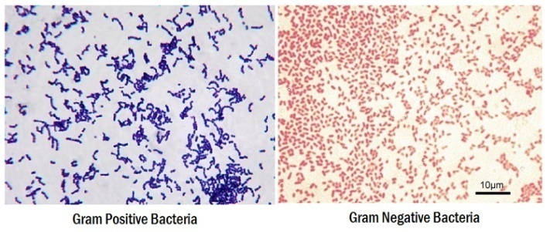**Gram staining**

Gram staining is used to determine gram status to classify bacteria broadly. It is based on the composition of theircell wall. Gram staining uses crystal violet to stain cell walls, iodine as a mordant, and a fuchsine or safranin counter stain to mark all bacteria. Gram status is important in medicine; the presence or absence of a cell wall changes the bacterium's susceptibility to some antibiotics.

Gram-positive bacteria stain dark blue or violet. Their cell wall is typically rich with peptidoglycan and lacks the secondary membrane and lipopolysaccharide layer found in Gram-negative bacteria.

On most Gram-stained preparations, Gram-negative organisms appear **red or pink** because they are counterstained.

Because of presence of higher lipid content, after alcohol-treatment, the porosity of the cell wall increases, hence the CVI complex (crystal violet – iodine) can pass through.

Thus, the primary stain is not retained. Also, in contrast to most Gram-positive bacteria, Gram-negative bacteria have only a few layers of peptidoglycan and a secondary membrane(lipopolysaccharide layer).

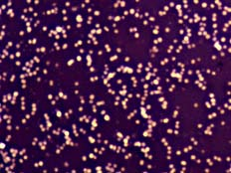**2- Negative staining**

A simple staining method for bacteria that is usually successful, even when the "positive staining" methods detailed below fail, is to use a negative stain. This can be achieved by smearing the sample onto the slide and then applying nigrosin (a black synthetic dye) or Indian ink (an aqueous suspension of carbon particles). After drying, the microorganisms may be viewed in bright field microscopy as lighter inclusions well-contrasted against the dark environment surrounding them. Note: negative staining is a mild technique that may not destroy the microorganisms, and is therefore unsuitable for studying pathogens.

**3- Ziehl-Neelsen stain**

Ziehl-Neelsen staining is used to stain species of *Mycobacterium tuberculosis* that do not stain with the standard laboratory staining procedures like Gram staining. The stains used are the red colored Carbol fuchsine that stains the bacteria and a counter stain like Methylene blue.

**4- Haematoxylin and Eosin (H&E) staining**

Haematoxylin and eosin staining protocol is used frequently in histology to examine thin sections of tissue (procedures in histology). **Haematoxylin stains** cell nuclei, while **Eosin** stains cytoplasm, connective tissue and other extracellular substances. **Hematoxylin** stains the cell nucleus and other acidic structures (such as RNA-rich portions of the cytoplasm and the matrix of hyaline cartilage). In contrast, Eosin stains the cytoplasm and collagen.

Eosin is most often used as **a counter** stain to haematoxylin, imparting a pink or red color to cytoplasmic material, cell membranes, and some extracellular structures. It also imparts a strong red color to red blood cells. Eosin may also be used as a counter stain in some variants of Gram staining, and in many other protocols.

Haematoxylin (hematoxylin in North America) is a nuclear stain. Used with a mordant, haematoxylin stains nuclei blue-violet or brown.



Microscopic view of a histological specimen of human lung tissue stained with hematoxylin and eosin.

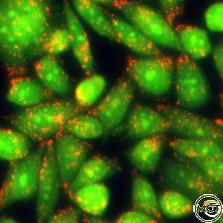**5- Acridine orange**

Acridine orange (AO) is a nucleic acid selective fluorescent cationic dye useful for cell cycle determination. It is cell-permeable, and interacts with DNA and RNA by intercalation or electrostatic attractions.

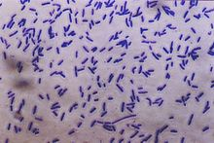**6- Crystal violet**

Crystal violet, when combined with a suitable mordant, stains cell walls purple. It isis an important component in Gram staining.

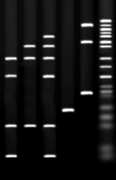**7- Ethidium bromide**

Ethidium bromide intercalates and stains DNA, providing a fluorescent red-orange stain. Although it will not stain healthy cells, it can be used to identify cells that are in the final stages of apoptosis – such cells have much more permeable membranes. Consequently, ethidium bromide is often used as a marker for apoptosis in cells populations and to locate bands of DNA in gel electrophoresis. The stain may also be used in conjunction with acridine orange (AO) in viable cell counting. This EB/AO combined stain causes live cells to fluoresce green whilst apoptotic cells retain the distinctive red-orange fluorescence.

**8- Acid fuchsine**

Acid fuchsine may be used to stain collagen, smooth muscle, or mitochondria. Acid fuchsine is used as the nuclear and cytoplasmic stain in Mallory's trichrome method. Acid fuchsine stains cytoplasm in some variants of Masson's trichrome. Acid fuchsine imparts its red color to collagen fibers. Acid fuchsine is also a traditional stain for mitochondria by Altmann's technique.

**9- Iodine**

Iodine is used in chemistry as an indicator for starch. When starch is mixed with iodine in solution, an intensely dark blue color develops, representing a starch/iodine complex. Starch is a substance common to most A-and so a weak iodine solution will stain starch present in the cells. Lugol's solution or Lugol's iodine (IKI) is a brown solution that turns black in the presence of starches and can be used as a cell stain, making the cell nuclei more visible. Iodine is also used as a mordant in Gram's staining (is one component in the staining technique, used in microbiology) it enhances dye to enter through the pore present in the cell wall/membrane.

**10- Malachite green**

Malachite green (also known as diamond green B or victoria green B) can be used as a blue-green counter stain to safranin in the Gimenez staining technique for bacteria. It also can be used to directly stain spores.

**11- Methylene blue**

Methylene blue is used to stain animal cells, such as human cheek cells, to make their nuclei more observable. Also used to stain the blood film and used in cytology.

**12- Neutral red**

Neutral red (or toluylene red) stains Nissl substance red. It is usually used as a counter stain in combination with other dyes.

**13- Safranin**

Safranin (or Safranin O) is a nuclear stain. It produces red nuclei, and is used primarily as a counter stain. Safranin may also be used to give a yellow color to collagen.

**Electron microscopy Stains**

As in light microscopy, stains can be used to enhance contrast in electron microscopy. Electron-dense compounds of heavy metals are typically used:

1-**Phosphotungstic acid:** Phosphotungstic acid is a common negative stain for viruses, nerves, polysaccharides, and other biological tissue materials.

**2-Osmium tetroxide:** Osmium tetroxide is used in optical microscopy to stain lipids. It dissolves in fats, and is reduced by organic materials to elemental osmium, an easily visible black substance. Because it is a heavy metal that absorbs electrons, it is perhaps the most common stain used for morphology in biological electron microscopy. It is also used for the staining of various polymers for the study of their morphology by TEM.

Other chemicals used in electron microscopy staining include: ammonium molybdate, cadmium iodide, carbohydrazide, ferric chloride, hexamine, indium trichloride, lanthanum nitrate, lead acetate, lead citrate, lead(II) nitrate, periodic acid, phosphomolybdic acid, potassium ferricyanide, potassium ferrocyanide, ruthenium red, silver nitrate, silver proteinate, sodium chloroaurate, thallium nitrate, thiosemicarbazide, uranyl acetate, uranyl nitrate, and vanadyl sulfate.