The Third Experiment
The installation of the pollutant rose

The Objective of the experiment:
- Finding the pollutant rose for a specific air pollutant according to wind directions, and then finding the prevailing direction in which the concentration of a particular pollutant is high.
- Comparison of a manually operated wind rose with that made using ready-made software.

The Theoretical Part:
Knowing the direction of the wind is important in the construction of factories and buildings, by determining the direction of the spread of pollutants to agricultural areas or residential complexes. The vertical change of wind speed and direction is one of the causes of swirling movement that leads to the dispersal of pollutants, while direction is the main factor that determines the areas to which pollutants are transmitted. As the air quality depends on the direction of the wind, and generally there are two reasons for finding the direction of the pollutants diagram [1]:
- Determining the air quality prevailing in each direction, either as an average concentration of this pollutant or as a frequency of time during which pollution levels exceed the specified critical value.
- To indicate or infer the distribution or strength of the emission sources around the specified station.

TheMaterials and Tools used

- Data of pollutants from the environmental air stations of the Ministry of Environment, such as Al-Waziriyah station, Al-Andalus station, or Al-Alawi station (which are stations to monitor and monitor air quality).
- A specific month is taken from this data, which contains in addition to the concentrations of pollutants such as CO, CO2, SO2, NO, NOX, NO2, PM₁₀ on weather factors such as wind speed, direction, temperatures and others.
- Sometimes we need to use ready-made electronic programs to extract the wind rose, such as Windgrapher, Windrose, Origin, and others.

The Method of Work

- We divide the circle surrounding a point that represents the monitoring station, which is the city of Baghdad. It can be (Waziriya station, Al-Alawi, ....) into 16 directional segments and the angle between each of the segments is 22.5°
- We calculate the frequency of pollutants according to the wind direction and write them down in the following table:

 | direction (°) |  | Repetitions according to the extent of pollutant concentrations
 |  |  | 0-0.2 |  | 0.2-0.4 |  | 0.4-0.8 |  | …….
0-22.5
22.5-45
45-67.5
……
……
Total

And that Determine repetitions for ranges of pollutant values.
- Find the sum of the frequencies by extent of the pollutants and the sum of the frequencies by direction
- Draw a circle 3600 divided into 16 segments, where the diagonal axis shows the concentrations of pollutants according to the divided ranges, while the segments represent the direction to which the specific pollutants are blowing or spreading. According to the following table:
direction (°) | focus range | mid range focus | Repetitions
0-22.5 | 0-0.2 | 0.1
22.5-45 | 0.2-0.4 | 0.3
45-67.5 | 0.4-0.8 | 0.6
….

- A comparison can be made between the values or shapes of the pollutant rose that was made manually with those that can be done using ready-made programs. Figure (1-3) shows the wind rose (which is very similar to the pollutant rose, where the wind is replaced by the observed pollutant) that was made Using the Origin9 program and those that were done manually and using accounts.
The student is taught how the wind rose works using these ready-made programs using the computer and using the same previous data.

Discussion

Q1/ What is the wind rose and for what purpose is it used?
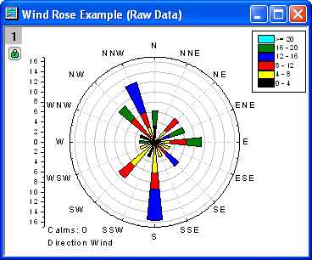

Figure (1-3): Models of the wind rose (right) and the pollutant rose (left).

Q2/ Do they depend on Repetition Or on pollutant values by direction and how?
Q3/ What is the effect of topography on the pollutant rose?
Q4/ Where can a factory or power plant be located relative to a particular city? The prevailing direction is north, and why?
Q5/ What is the similarity between the wind rose and the pollutant rose, and what is the difference?

