Q-1- What is the weight for the indium sample if you know that the percentage for the indium that precipitate in the form of In₂O₃ is ( 34.5%) , the gravimetric factor for the indium is( 0.82) and the weight of the precipitate is (1g)? A.wt for In =114.8 , O=16.

Wt of In = G.F × Wt of In₂O₃

A.Wt of In 2 114.8× 2
= × × 1 g = =0.82 g
M.wt of In₂O₃ 1 114.8 ×2 + 16×3

Wt of In 0.82
% In = × 100 34.5 / 100 =
Wt of Sample Wt of sample

Wt of Sample = 2.3 g
Q-2- If the weight of the lead sample is (3 g) was precipitated in the form of the PbSO4 and the weight of the precipitate is (2 g) ,what is the percentage for the precipitated substance in form of PbSO4 ? If you know that the atomic weights of Pb= 207.2, S = 32 And O = 16
Wt of Pb = G.F × Wt of Pb SO₄
A.Wt of Pb Wt of Pb
= × 2 g = 1.36 g , %Pb = × 100
M.Wt of PbSO₄ Wt of Sample
1.36
% Pb = ×100 = 45.5 %
3

Q-3- What is the gravimetric factor for the substance that have a weight (0.37 g) if you know that the weight of the precipitate is (0.5) grams?

Wt of Substance = G.F × Wt of precipitate

0.37 = G.F × 0.5 G.F = 0.74

Q-4- Calculate the weight of the chloride ion that was precipitated on the form of the silver chloride if you know that the weight of the precipitate is (0.53 g) ,atomic weights of the silver (108) and the chlorine (35.5)?

Wt of Cl = G.F × Wt of AgCl

A.Wt of Cl
= × 0.53g
M.Wt of AgCl

= 0.13 g

Q-5- A sample of non-pure sulfate salt 4 g was precipitated in the form of barium sulphate after it was dissolved in (100 ml) of distilled water and added the precipitated agent.Calculate the molarity of the sulfate ion in the non -pure salt ,If you know that the weight of the precipitate is (2.5 g), Atomic weights for S= 32, O= 16 and Ba= 137.3?

Wt of SO4 = G.F × Wt of BaSO4

M.Wt of SO4
= × 2.5 g 1.02 g
M.Wt of BaSO4

Wt SO4 1000
M for SO4 = ×
M.Wt SO4 V(Ml)
= 0.10

اذا كانت النسبة المئوية الوزنية الحجمية هي 1% فما هو قيمتها بالجزء بالمليون

نموذج وزنه 0.2 غم يحتوي على الكبريت تم ترسيبه ع هيئة كبريتات الباريوم وزنها 0.5 غم احسب النسبة المئوية للكبريت

كم يتطلب من الوزن لتحضير محلول مائي من كلوريد النحاس المائي تركيزه ppm30 الوزن الجزيئي له هو 170.5 في حجم 50 مل وكم هو التركيز المولاري

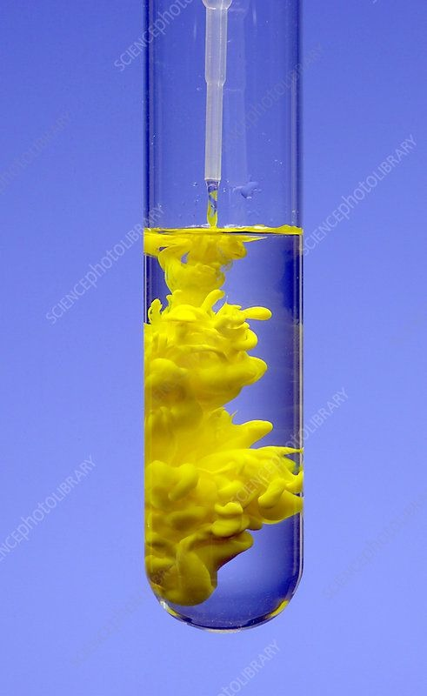
عملية اضافة العامل المرسب وتكوين راسب اصفر اللون

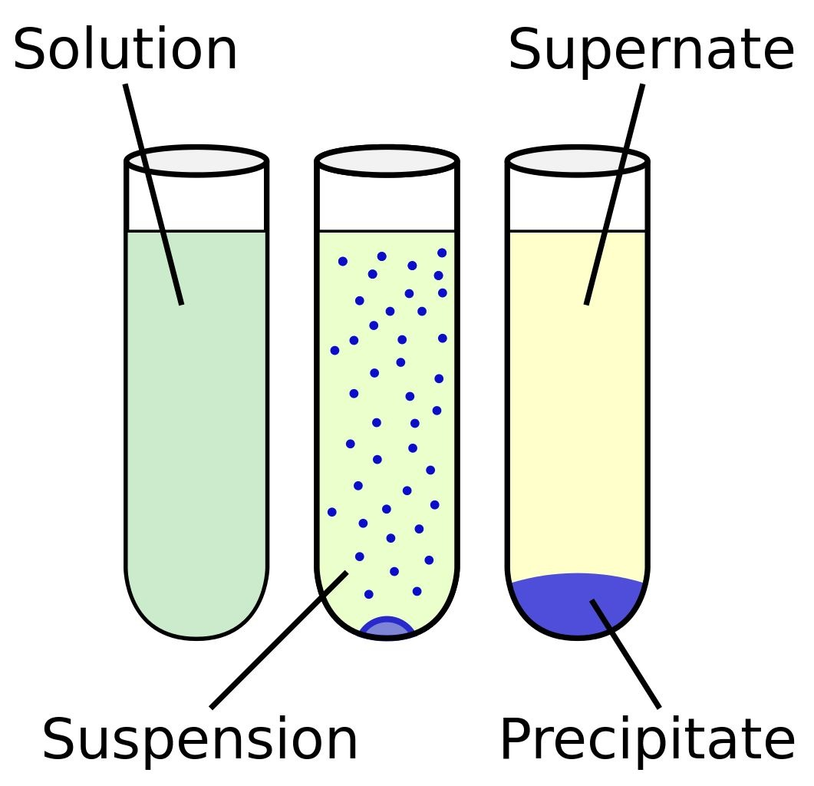
مراحل ركود الراسب

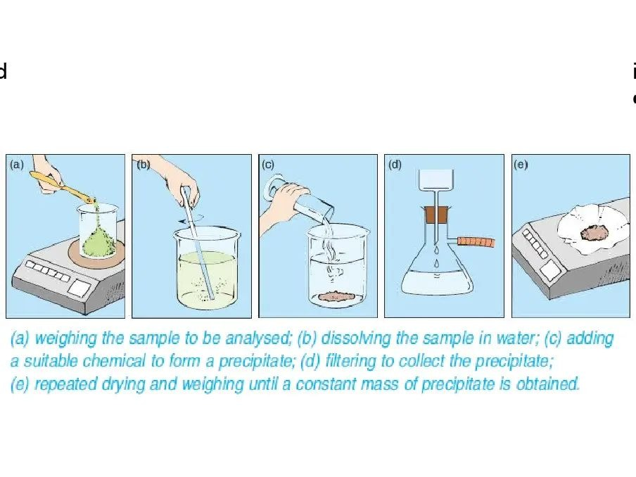
خطوات تكوين الراسب بطريقة التحليل الكمي الوزني

