The Fifth Experiment

THERMOCOUPLE SCALING & ITS USE AS A THERMOMETER

The Objective of the experiment:
- Scaling of Thermocouple, and using it as a thermometer.
- Finding the thermoelectric power.

The Used Equipments:
- Thermocouple (copper - Constantine).
- Voltage amplifier.
- Voltmeter.
- Heater.
- Thermometer.
- Sand.

The Theoretical Part:

A thermocouple is a device for measuring temperature, it consists of two dissimilar metallic wires made of different metals (A, B) connected to each other at two points or junctions (C1, C2). When the junction is heated or cooled, a small voltage is generated in the electrical circuit of the thermocouple which can be measured, and this corresponds to temperature, and a thermoelectric power (E) is generated in this thermocouple as a result of the differences in junctions temperatures as shown in figure (1).
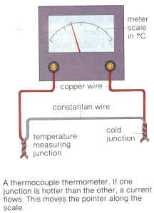
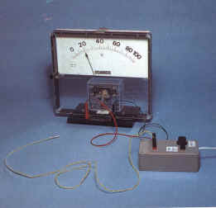
A
C1
B
C2

Figure (1) Thermocouple
The Seebeck coefficient (also known as thermopower, thermoelectric power, and thermoelectric sensitivity) of a material is a measure of the magnitude of an induced thermoelectric voltage in response to a temperature difference across that material, as induced by the Seebeck effect. This effect does not change if other devices are connected to the electrical circuit, provided that the terminals of these devices remain at the same temperature, which is easy to achieve by making the connecting wires and circuit gauges all at laboratory temperature. The scientist (Seebeek) studied the thermoelectric properties of a large number of metals and ordered them in the table of thermoelectric series.

If a thermocouple is formed from two metals in the thermoelectric series, the thermoelectric power is larger when the two metals are farther from each other in the series; in addition, the direction of the current is at the junction passing from the metal that falls at the beginning of the series to the metal that falls after it.
The following is the order of some metals in the thermoelectric series: (Bismuth - Nickel - Cobalt - Platinum - Copper - Manganese - Mercury - Lead - Tin - Gold - Silver - Cadmium - Iron - Arsenic – Antimony).

For example, if the thermocouple is composed of copper and iron, the direction of current at the junction is from copper to iron, and the thermocouple consisting of bismuth and antimony is given the largest thermoelectric power (E) , and does not stop for certain metals, nor at the two temperatures of the two junctions.

If one of the two junctions is made at zero degrees Celsius, the thermoelectric power is given by the following relationship:
E= a t + bt²…………………(1)
where (b), (a) are constants, and t is the junction temperature (° C).
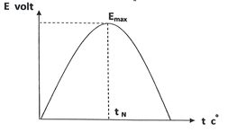
The graph between E_{t} on the y-axis and t on the x-axis represents a parabola as shown in Figure (2).
Figure (2)

Where (t_{N}) represents the Neutral Temperature, which is the temperature at which the thermoelectric power is at its maximum, E_{max}.
In the case of a thermocouple (iron-copper), the value of the neutral temperature is (270 °C), while it is more than that in the thermocouple of other pure metals.

In the case of thermocouple made of alloys, the relationship between (E_{t},t) is linear in a wide range of temperatures as in Figure (3).
Figure (3)
The thermoelectric power is given by the following equation:

E=a+ b t……………………(2)

To find the values of the constants b, a, we draw a graph between E (volt) on the y-axis and t (°C) on the x-axis as shown in the figure.

Slope= b = $\frac{AB}{CB}$
And by substituting the values of b and a in equation 2, we get the value of (E).

The Procedure:

- Put the thermocouple junction point (Copper-Constantine) in a bowl of sand and the other point in a bowl of ice. Then heat the bowl of sand and watch the deflection of the voltmeter.
- Continue heating to higher temperatures (200°C) and each time watch the deviation of the voltmeter.

t (⁰C ) | V volt
50
200
Measurements and calculations:

- Arrange the readings as in the following table:
- Draw a graph between E on the y-axis and t on the x-axis, as shown in Figure (3). Then find (b), (a).
- Find the value of (E) from equation (2) in the theoretical part.

Example:

From the following data, find the thermoelectric power.

V (volt) | t(⁰C )
0.1 | 22
0.2 | 33
0.3 | 43
0.4 | 53
0.5 | 63
0.6 | 70
0.7 | 96
Solution:
E = a+bt
a= -0.15
b=Slope = 0.01
t = 96
E= -0.15+(0.01*96) = 0.81 Volt

