**The Experiments of Weather Instruments & Observations lab.**

**(First Semester)**

**ASD / 2nd Stage**

**2021 - 2022**

Preparing by: L. Nagham T. Ibraheem, L. Ruaa M. Ibraheem

**The Wind**

The moves of air masses in the horizontal direction, and it moves as a result of the gradient in atmospheric pressure.

**Wind measured Instruments:**

1. Wind speed measuring devices (Anemometers).

2. Wind direction measuring devices (wind vane).

wind vane 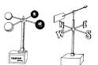 Anemometer

Nddff **←**

Amount of clouds and winds group:

|  |  |
| --- | --- |
| N | Amount of clouds (0-9) |

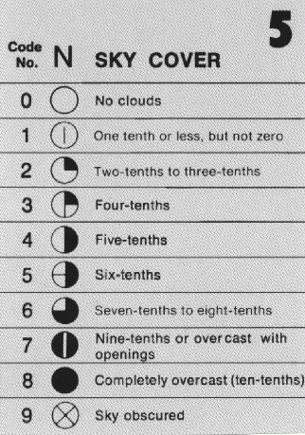

|  |  |
| --- | --- |
| dd | Wind direction (01-36) |

To set the correct direction we add a zero to the right and draw the direction from outside towards to the station.

360

270 90

180

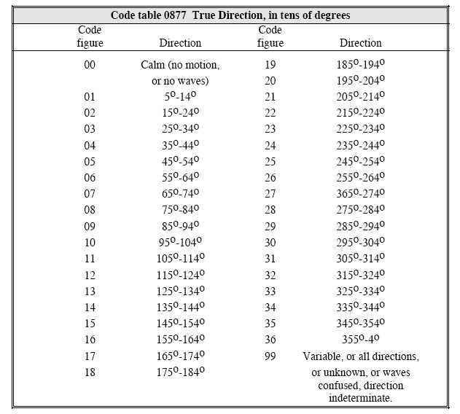

|  |  |
| --- | --- |
| ff | Wind speed is plotted clockwise from the direction line |

50 10 5

N dd ff

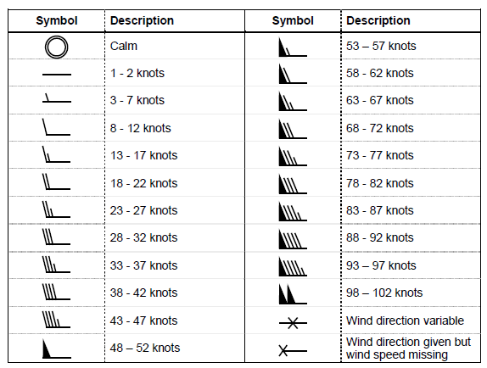

1. In the event that the wind direction is variable, it is drawn in the most frequent direction, as shown in Figure

2. If the wind direction is lost, we do not draw the wind information.

3. If the wind speed information is lost, the diagram will be as follows

4. If the wind is calm or calm, the drawing will be as follows 

5. The drawing is in knot units, but if it is in m/s units, it is multiplied by 2 to convert to knots.

6. If the wind speed exceeds (100kt.), we write instead of ff the number 99 and add a new group (00fff) and write the value of the real wind speed in three places after 00.

For example if the wind is south at a speed of 125 kt. The clouds cover half of the sky, so the code is as follows: 41899 00125

**X**

**X**