Lec2: Cell disruption

Cell disruption is the process of obtaining intracellular fluid via methods that open the cell wall.

The overall goal in cell disruption is to obtain the intracellular fluid without disrupting any of its components

The method used may vary depending on the type of cell and its cell wall composition. Irrespective of the method used, the main aim is that the disruption must be effective and the method should not be too harsh so that the product recovered remains in its active form.

There are two types of cell disruption method which are following:

1- Mechanical methods

2- Non Mechanical methods

Mechanical methods are those methods which required some sort of force to separate out intracellular protein without adding chemical or enzyme, these methods including:

a- Mortar & Pestle/ grinding

It is also possible to achieve cell disruption by grinding via a mortar and pestle. This method is often used with plant samples that have been frozen in liquid nitrogen. Once the cell wall has been disrupted, solvents are added to extract the biological molecules.

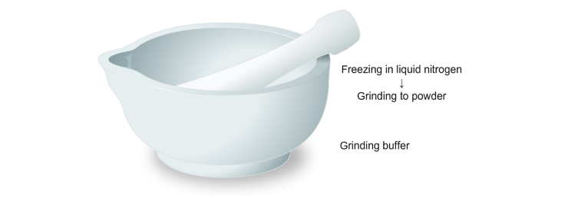

b- Blenders

- The use of blenders (high speed) can be used to disrupt cell walls.
- This is the same process used by centrifugation, which separates or concentrates materials suspended in a liquid medium

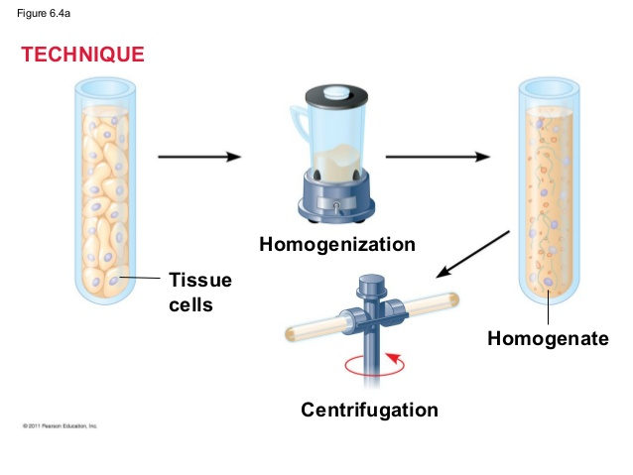

c- Bead beating
- Glass or ceramic beads are used to crack open cells
- but this kind of mechanical shear is gentle enough to keep organelles intact.
- It can be used with all kinds of cells, just add beads to an equal amount of cell suspension and vortex

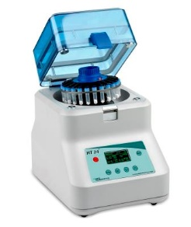

d- Ultra sonication
- Ultrasonic homogenizers work by inducing vibration in a titanium probe that is immersed in the cell solution.
- A process called cavitations occurs, in which tiny bubbles are formed and explode, producing a local shockwave and disrupting cell walls by pressure change.
- This method is very popular for plant, bacterial and fungal cells but comes at a disadvantage: It’s very loud and has to be performed in an extra room.

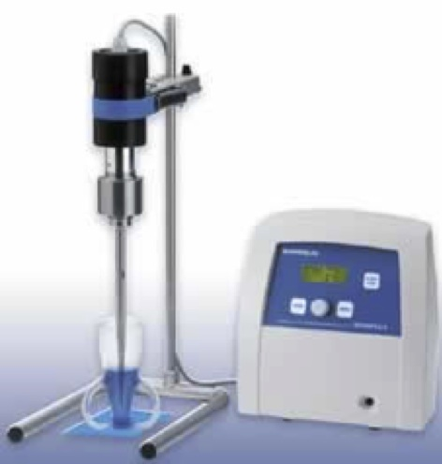

e- Homogenization
- Liquid-based homogenization is the most widely used cell disruption technique for small volumes and cultured cells.
- Cells are lysed by forcing the cell or tissue suspension through a narrow space
- Homogenizers use shearing forces on the cell similar to the bead method. Homogenization can be performed by squeezing cells through a tube that is slightly smaller than beads beating.

2- Non mechanical methods:

are further divided into three class which are following:

a- Physical methods

1- Freeze thaw
- This method used when working with soft plant material and algae.
- freezing is used to achieve cell disruption via a series of freezing and thawing cycles.
- Freezing forms ice crystals, which expand upon thawing, and this ultimately causes the cell wall to rupture.

2- Microwave/ Thermolysis

Microwave (along with autoclave and other high temperature methods) are used to disrupt the bonds within cell walls, and also to denature proteins. This is a somewhat risky method, as the excess heat can quickly damage the rest of the cell.

3- Osmatic shock
- Through the process of osmosis, water can be moved into the cell causing its volume to increase to the point that it bursts.
- Note that this method can only work with animal cells and protozoa, since they do not have cell walls.

4- Electric discharges
- It is also possible to achieve cell disruption via electrical discharges in mammalian cells.
- Cells that are bounded by plasma membranes, unlike plant cells, have no cell membrane.
- This method allows researchers to examine secretion by exocytosis, which is a process during which the membrane-bounded sphere (intracellular vesicle) shifts to and fuses with the plasma membrane

b- Chemical Method
- Often used with plant cells (and sometimes in combination with shearing), organic solvents such as toluene, ether, benzene, methanol, surfactants, and phenyl ethyl alcohol DMSO can be used to permeate cell walls.
- EDTA (ethylene diamine tetraacetic acid) is a chelating agent can be used specifically to disrupt the cell walls of gram negative bacteria, whose cell walls contain lipopolysaccharides that are stabilized by cations like Mg²⁺ and Ca²⁺. EDTA will chelate the cations leaving holes in the cell walls.
- Surfactants (commonly called detergents) disrupt the distinct interface between hydrophobic and hydrophilic systems. Detergents are used in cell lyses buffers and they help to solubilize membrane proteins and lipids thereby causing the cell to lyse and release its contents. Widely used detergents include Triton X – 100, sodium dodecyl sulfate (SDS), Tween 20, and 80 and CHAPS
- Chaotropic agents, such as urea and guanidine, are also used for cell lysis. They are capable of bringing some hydrophobic compounds into aqueous solutions. They do this by disrupting the structure of water and making it a less hydrophilic environment, and weakening the hydrophobic interactions among solute molecules.

c- Enzymatic methods
- Lysozyme, Chitinase, Pectinase as enzymatic methods are easy and fast but cost for these methods are also high. Lysozymes are used for Bacterial cell lysis and Chitinase for Yeast cell lysis. Pectinases are used for the lysis of plant cell walls.
- Enzymes such as beta(1-6) and beta(1-3) glycanases, proteases and mannase can be used to disrupt the cell wall.
- This method is particularly useful for isolating the cell without the wall (protoplast).
Applications of Cell-disruption
- Isolating intracellular Proteins.
- Downstream Processing.
- Isolating intracellular organelles.
- Nucleic acid isolation.
Disadvantages
1- Whole cell contents are released out which makes it difficult to separate out product of interest from the mixture.
2- Cell lysis increases viscosity of the solution making it difficult to process in the further steps.
3- Product released into harsh environment causing the product to lose stability or activity
4- Might cause filtration membranes to foul during the filtration process.
5- Enzymatic cell-disruption in large scale can be expensive

