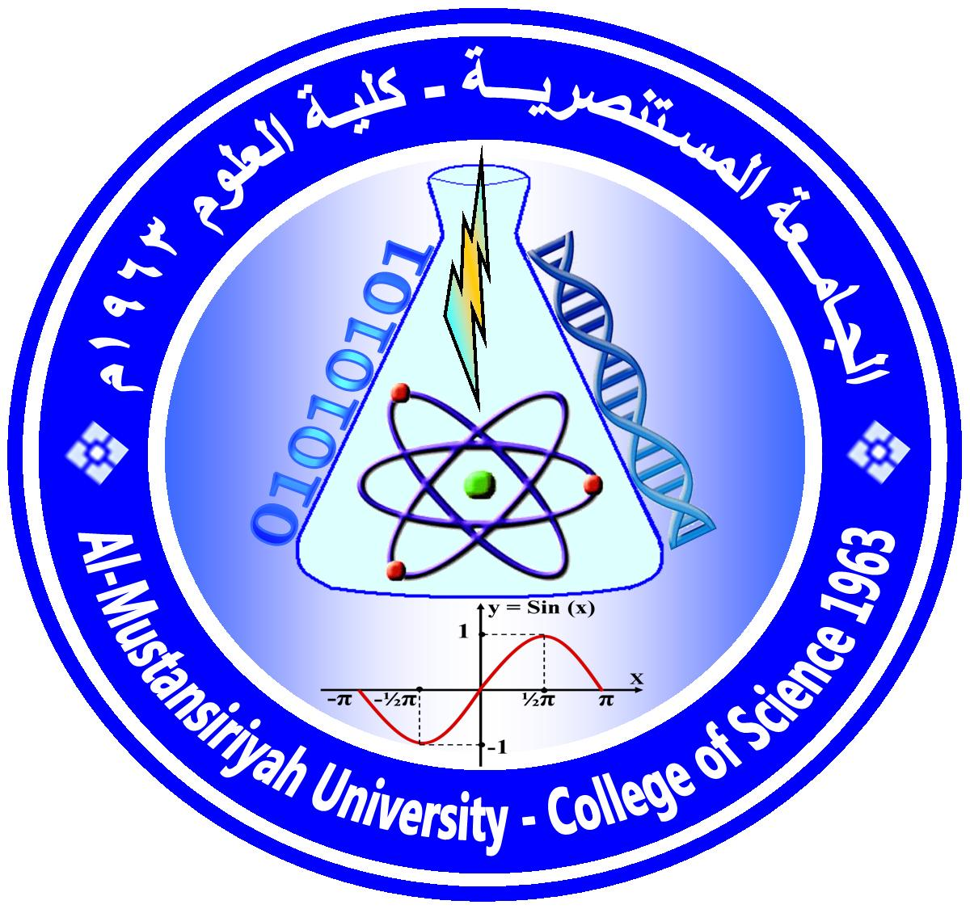
Ministry of Higher Education and Scientific Research
Mustansiriyah University / College of Science / Department of Chemistry
(الخطة الدراسية للمساق)
Course Plan

Time Division: 2hrs Theoretical
Course Name: Petroleum Chemistry For 4th year students
Semester & Year: First, 2018 / 2019

Course Description:
The course describes the formation, chemistry and the chemical constituents of petroleum oil. The various methods of evaluations of petroleum and the manufacture of petroleum products such as Gasoline, Kerosene, Aviation fuels and lubricating oils.
Course Intended Outcomes:

Course Outline:

Week | Description depends on the Timing table (Theoretical)
1 | Historical background and theories of petroleum oil formation
2 | Chemical constituents of petroleum oil
3 | Chemical constituents of petroleum oil
4 | Physical properties of petroleum oil and pretreatment processes
5 | Manufacture of petroleum products and petroleum operations
6 | Manufacture of petroleum products and petroleum operations
7 | 1st test
8 | Thermal cracking and catalytic cracking processes
9 | Thermal cracking and catalytic cracking processes
10 | Test methods of petroleum and petroleum products
11 | Test methods of petroleum and petroleum products
12 | Manufacture of lubricating oils
13 | Manufacture of lubricating oils
14 | Chemistry of lubricating oil additives
15 | 2nd test

Textbooks:
[1] The chemistry and technology of petroleum, 4th ed., James G. Speight.
[2] Handbook of petroleum refining processes, 3rd. ed., Robert A. Meyers.

