Lab:3
Cell shape

- Squamous shape / Irregular – shaped cell forming a continuous surface with small nuclei.
[ ex. Squamous epithelial tissue in Skin , mouth ].

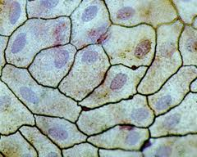
2- Cuboidal shape / The cells appear square & the nuclei is in the middle of cell .
[ ex. Cuboidal epithelial tissue in c.s in Kidney , Urinary bladder & pancreas ].

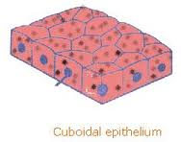
3- Columnar shape / is similar to Cuboidal epithelialium except that the cell are taller & appear columnar in section, the nuclei may be located towards the base .
[ ex. Columnor epithelial tissue in Stomach , Trachea ]

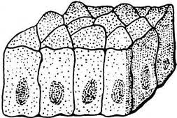
4- Spindle cell / The cell elongated spindle shaped with pointed end .
[ ex. Smooth muscle ]
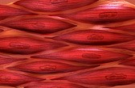
5- Stellate ( Asteriodal shape ) [ ex. Neuron ]
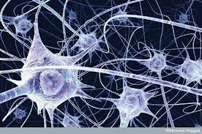

6- Circular (Discoid shape )
[ ex. Red blood cell(R.B.C) in Human blood ]

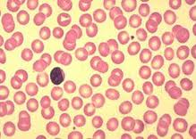
7- Sperm shape [ ex. Rabbit sperm ]

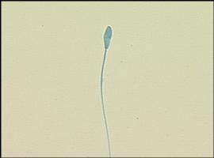

8- Amoeboid shape [ ex. Amoeba ]
