**Mutation**

A mutation is a heritable change in the base sequence of the nucleic acid in the genome of an organism. strain carrying such a change is called a mutant. A mutant by definition differs from its parental strain in genotype, the nucleotide sequence of the genome.. Some mutations have benefit (new or enhanced activity ,this drives evolution). Some mutations harmful (cause decreased activity or loss of activity).

Although some of these mutations are lethal or cause serious disease, many have minor effects as they do not result in residue changes that have significant effect on the structure and function of the [proteins](https://en.wikipedia.org/wiki/Protein). Many mutations are [silent mutations](https://en.wikipedia.org/wiki/Silent_mutation), causing no visible effects at all, either because they occur in non-coding or non-functional sequences, or they do not change the [amino-acid](https://en.wikipedia.org/wiki/Amino-acid) sequence due to the [redundancy](https://en.wikipedia.org/wiki/Redundancy_%28information_theory%29) of [codons](https://en.wikipedia.org/wiki/Codon).

**Mutagens**

Mutagen is a **physical** or **chemical** or **biological** origin agent that changes the genetic material, usually [DNA](https://en.wikipedia.org/wiki/DNA), of an [organism](https://en.wikipedia.org/wiki/Organism) and thus increases the frequency of [mutations](https://en.wikipedia.org/wiki/Mutation) above the natural background level. As many mutations can cause [cancer](https://en.wikipedia.org/wiki/Cancer), mutagens are therefore also likely to be [**carcinogens**](https://en.wikipedia.org/wiki/Carcinogen). Not all mutations are caused by mutagens: so-called "spontaneous mutations" occur due to spontaneous [hydrolysis](https://en.wikipedia.org/wiki/Hydrolysis), [errors](https://en.wikipedia.org/wiki/DNA_error) in [DNA replication](https://en.wikipedia.org/wiki/DNA_replication), repair and [recombination](https://en.wikipedia.org/wiki/Genetic_recombination).

Mutagens cause changes to the DNA that can affect the transcription and replication of the DNA, which in severe cases can lead to cell death. The mutagen produces mutations in the DNA, and deleterious mutation can result in aberrant, impaired or loss of function for a particular gene, and accumulation of mutations may lead to cancer.

Mutagens may act directly on the DNA, causing direct damage to the DNA, and most often result in replication error. Some however may act on the replication mechanism and chromosomal partition. Many mutagens are not mutagenic by themselves, but can form mutagenic metabolites through cellular processes. Such mutagens are called [**promutagens**](https://en.wikipedia.org/w/index.php?title=Promutagens&action=edit&redlink=1).

## Types of mutagens

### Physical mutagens:

* [**Ionizing radiations**](https://en.wikipedia.org/wiki/Ionizing_radiation)such as [X-rays](https://en.wikipedia.org/wiki/X-rays), [gamma rays](https://en.wikipedia.org/wiki/Gamma_ray) and [alpha particles](https://en.wikipedia.org/wiki/Alpha_particle) create ions and free radicals that break molecular bonds and damages DNA **Nonionizing radiation (**[Ultraviolet](https://en.wikipedia.org/wiki/Ultraviolet) radiations) with wavelength above 260 nm are absorbed strongly by bases, producing [pyrimidine dimers](https://en.wikipedia.org/wiki/Pyrimidine_dimers), which can cause error in replication if left uncorrected.
* [**Radioactive decay**](https://en.wikipedia.org/wiki/Radioactive_decay)**,** such as [14C](https://en.wikipedia.org/wiki/Carbon-14) in DNA which decays into [nitrogen](https://en.wikipedia.org/wiki/Nitrogen).

### Chemical mutagens

**A large number of chemicals may interact directly with DNA.**

* [Reactive oxygen species](https://en.wikipedia.org/wiki/Reactive_oxygen_species) (ROS) – These may be [superoxide](https://en.wikipedia.org/wiki/Superoxide), [hydroxyl radicals](https://en.wikipedia.org/wiki/Hydroxyl_radicals) and [hydrogen peroxide](https://en.wikipedia.org/wiki/Hydrogen_peroxide),
* [Deaminating](https://en.wikipedia.org/wiki/Deamination) agents, for example [nitrous acid](https://en.wikipedia.org/wiki/Nitrous_acid) which can cause transition mutations by converting [cytosine](https://en.wikipedia.org/wiki/Cytosine) to [uracil](https://en.wikipedia.org/wiki/Uracil).
* [Polycyclic aromatic hydrocarbon](https://en.wikipedia.org/wiki/Polycyclic_aromatic_hydrocarbon) (PAH), when activated to diol-epoxides can bind to DNA and form adducts.
* [Alkylating](https://en.wikipedia.org/wiki/Alkylation) agents such as [ethylnitrosourea](https://en.wikipedia.org/wiki/Ethylnitrosourea). The compounds transfer methyl or ethyl group to bases or the backbone phosphate groups. Guanine when alkylated may be mispaired with thymine. Some may cause DNA crosslinking and breakages. [Nitrosamines](https://en.wikipedia.org/wiki/Nitrosamine) are an important group of mutagens found in tobacco, and may also be formed in smoked meats and fish via the interaction of amines in food with nitrites added as preservatives. Other alkylating agents include mustard gas and [vinyl chloride](https://en.wikipedia.org/wiki/Vinyl_chloride).
* [Aromatic amines](https://en.wikipedia.org/wiki/Aromatic_amines) and amides have been associated with carcinogenesis since 1895 .
* [Alkaloid](https://en.wikipedia.org/wiki/Alkaloid) from plants, such as those from [Vinca](https://en.wikipedia.org/wiki/Vinca) speciesmay be converted by metabolic processes into the active mutagen or carcinogen.
* [Bromine](https://en.wikipedia.org/wiki/Bromine) and some compounds that contain bromine in their chemical structure.
* [Sodium azide](https://en.wikipedia.org/wiki/Sodium_azide), an azide salt that is a common reagent in organic synthesis and a component in many car airbag systems
* [Psoralen](https://en.wikipedia.org/wiki/Psoralen) combined with ultraviolet radiation causes DNA cross-linking and hence chromosome breakage.
* [Benzene](https://en.wikipedia.org/wiki/Benzene), an industrial solvent and precursor in the production of drugs, plastics, synthetic rubber and dyes.

### Base analogs

* [Base analog](https://en.wikipedia.org/wiki/Base_analog), which are in structur with similar bases and bonded to DNA by error between thymine and adenine which can substitute for DNA bases during replication and cause transition mutations.

### Intercalating agents

* [Intercalating agents](https://en.wikipedia.org/wiki/Intercalation_%28chemistry%29), such as [ethidium bromide](https://en.wikipedia.org/wiki/Ethidium_bromide) and [proflavine](https://en.wikipedia.org/wiki/Proflavine), are molecules that may insert between bases in DNA, causing [frameshift mutation](https://en.wikipedia.org/wiki/Frameshift_mutation) during replication. Some such as [daunorubicin](https://en.wikipedia.org/wiki/Daunorubicin) may block transcription and replication, making them highly toxic to proliferating cells.

### Metals

Many metals, such as [arsenic](https://en.wikipedia.org/wiki/Arsenic), [cadmium](https://en.wikipedia.org/wiki/Cadmium), [chromium](https://en.wikipedia.org/wiki/Chromium), [nickel](https://en.wikipedia.org/wiki/Nickel) and their compounds may be mutagenic, they may however act via a number of different mechanisms.

### Biological agents

* [**Transposon**](https://en.wikipedia.org/wiki/Transposon), a section of DNA that undergoes autonomous fragment relocation/multiplication. Its insertion into chromosomal DNA disrupt functional elements of the genes. Transposons have the ability to move (transpose) from one site to another.

Elements known as **Insertion Sequences** (IS) have a specific ability to insert into other DNA sequences, thus generating insertion mutations. A substantial proportion of spontaneous mutations may be due to inactivation of genes by insertion of a copy of an IS element rather than by replication errors.

* [**Virus**](https://en.wikipedia.org/wiki/Virus) **,** Virus DNA may be inserted into the genome and disrupts genetic function. Infectious agents have been suggested to cause cancer as early as 1908 by Vilhelm Ellermann and Oluf Bang.

**Mutagens can be divided into Three classes based on the ways they cause mutation:**

**1-** **Base analogs**. Examples: ( 2-aminopurine, ) (5-bromouracil.) These base analogs are incorporated into DNA where they mispair with other bases. 5BU can pair with adenine and guanine. These result in transition mutations.

**2-** **Base modifications** **causing mispairs** Examples: ethyl methane sulfonate (EMS). These mutagens modify bases on DNA such that they mispair. EMS alkylate the O6 of guanine, which is highly mutagenic and causes mispairing with thymine ,and show preference for GC to AT transitions. However, they also alkylate bases at many positions with other effects. Nitrous acid and hydroxylamine deaminate cytosine to yield uracil (see deamination above) resulting in transition mutations.

**3-** **Base modifications which destroy pairing**: SOS-dependent mutagens. Examples: UV light, benzo(a)pyrene, aflatoxin B1 (i.e. most carcinogens) These mutagens or their metabolites modify DNA so that no specific pairing is possible; replication cannot proceed past the lesion. Unrepaired AP sites also elicit this response.

**Types of Mutations**

Mutations can be either **spontaneous** (occur without the known intervention of mutation-causing agents or occur due to spontaneous [hydrolysis](https://en.wikipedia.org/wiki/Hydrolysis), [errors](https://en.wikipedia.org/wiki/DNA_error) in [DNA replication](https://en.wikipedia.org/wiki/DNA_replication), repair and [recombination](https://en.wikipedia.org/wiki/Genetic_recombination). ) or **induced** mutations

The most common mutation is a ***point mutation*** or ***base substitution*,** in which a single base in DNA is replaced with a different one. Such a substitution can to result in the incorporation of an incorrect amino acid in the synthesized protein, a result known as a ***missense mutation*** (Figure 1)**.**



**Figure 1: Nucleotide –pair substitution : missense (**still code for an amino acid, but not the correct amino acid) [Pearson Education inc, 2011].

Some errors may create a stop codon, which stops protein synthesis before completion, resulting in type of mutation called a ***nonsense mutation*** (Figure 2)**.**

The other type of point mutation is **Silent mutations** (Figure 3)have no effect on the amino acid produced by a codon because of redundancy in the genetic code.

Deletion or addition of base pairs results in other type of mutation which called a ***frameshift mutation*.** In this mutation, there is a shift in the “translational reading frame” (the three-by-three grouping of nucleotides), and a long stretch of missense and an inactive protein product result (Figure 4). All chemicals and radiation bring about mutations are called ***mutagens*.**



**Figure 2: Nucleotide –pair substitution : Nucleotide –pair substitution : nonsense (**change an amino acid codon into a stop codon, nearly always leading to a nonfunctional protein) [Pearson Education inc, 2011].



**Figure 3**: **Nucleotide –pair substitution : silent** [Pearson Education inc,2011].

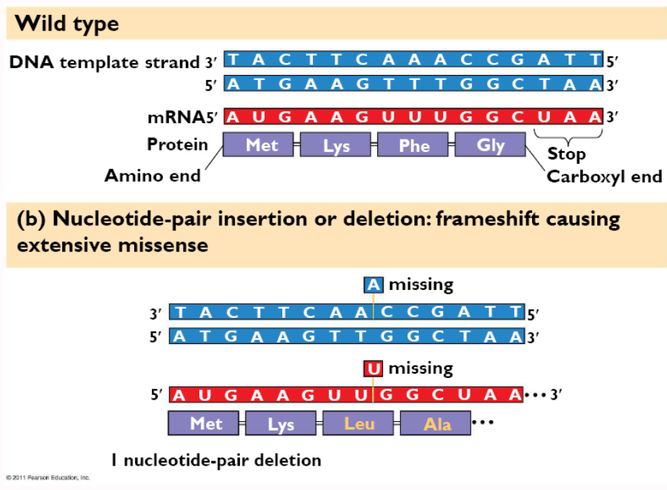

**Figure 4: Nucleotide –pair insertion or deletion: extensive missense** [Pearson Education inc,2011].

**DNA modification repair pathways**

Repair pathways that remove DNA modifications have Three basic mechanisms: direct repair, base-excision repair and nucleotide-excision repair.

**A. Direct chemical reversal.**

1. Photolyase, AKA photo-reactivation: UV light induces the formation of pyrimidine dimers between adjacent C or T bases in DNA. The photolyase enzyme break the cyclobutane dipyrimidine bond. To do so, the enzyme must absorb visible light, hence the name photo-reactivation. *E. coli* and the yeast *Saccharomyces cerevisiae* have such an enzyme.

2. Methyltransferase: The methyl groups from mutagenic O6-methylguanine (O6-MeG is particularly mutagenic) and O4-methylthymine can be removed directly by this enzyme.

**B** Glycosylase + AP endonuclease: Many modified bases are recognized by specific N-glycosylases that cleave the modified base. The resulting AP site is repaired by AP endonucleases. Examples in *E. coli*: hypoxanthine-DNA glycosylase, 3-methyladenine glycosylase . formamidopyrimidine glycosylase, hydroxymethyl glycosylase.

**C. Nucleotide excision repair**: In this form of DNA repair, the damaged bases are removed from DNA as an oligonucleotide and the resulting gap is repaired by resynthesis. This pathway is used to remove many bulky adducts in DNA, including cross-links and UV-induced pyrimidine dimers.



**Figure 5: Nucleotide excision repair = enzymes that function to cut out and replace DNA damage** [Pearson Education inc,2004]

**Rate of Mutation**

The ***mutation*** is a probability that gene will mutate when cell divides. DNA replication is very faithful, and only about once in 1 billion base pair replications does an error occur by Spontaneous mutation (If it was harmful, organism dies. If beneficial, organism thrives and passes mutation to offspring (This allows organisms to balance the need for genetic stability with that for evolutionary improvement). Mutagen play a role for increasing the rate of such errors from 10 to 1000 times.

The fact that organisms as phylogenetically disparate as hyper thermophilic Archaea and *Escherichia coli* have about the same mutation rate might make one believe that evolutionary pressure has selected for organisms with the lowest possible mutation rates. However, this is not so. The mutation rate in an organismis subject to change. For example, mutants of some organisms have been selected in the laboratory that are hyperaccurate in DNA replication and repair.

However, in these strains, the improved proofreading repair mechanisms has a significant metabolic cost; thus, a hyperaccurate mutant might actually be at a disadvantage in its natural environment. On the other hand, some organisms seem to benefit from a hyperaccurate phenotype that enables them to occupy particular niches in nature. A good example is the bacterium

*Deinococcus radiodurans* . This organism is 20 times more resistant to UV radiation and 200 times more resistant to ionizing radiation than *E. coli.*

**Identifying Mutants**

With bacteria mutants can be identified more easily, because bacteria produce very large populations very quickly. ***Positive* (*direct*) *selection*** involves the selection of mutant cells and rejection of non mutant cells. For example: plating out bacteria on a medium containing penicillin. Survivors, which are penicillin - resistant mutants, can be isolated. ***replica plating***(Figure 6) is used for ***negative* (*indirect*) *selection***to detect, for example, ***auxotrophs*** that have nutritional requirements not possessed by the parent (non mutant) cell. To isolate auxotrophs, colonies growing on a master plate containing a complete medium can be transferred by a sterile velvet pad is pressed onto the master plate, and the colonies are transferred simultaneously to a ***minimal medium****,* which lacks essential nutrients such as the required amino acid. An auxotrophic mutant will fail to appear on the minimal medium.

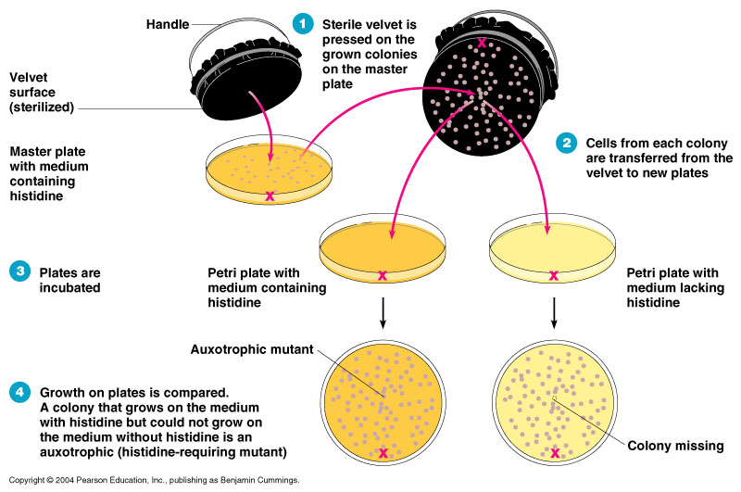

**Figure 6:** Replica plating process for detection the Auxotrophic mutation

#### Identifying Chemical Carcinogens

For identifying possible ***chemical carcinogens***, the ***Ames*** test is used as a relatively inexpensive and rapid test. is based on the ability of a mutated cell to mutate again and to revert to its original form. An auxotroph of *Salmonella,* which has lost the ability to synthesize the amino acid histidine, is plated out on a minimal medium without histidine. together with a rich source of activation enzymes found in rat liver extract called the test chemical ( is placed on this plate also). Rat Mutations of the *Salmonella* to the normal histidine-synthesizing form are indicated by colonies growth near the chemical test. High mutation rates are indicate the effects of carcinogens (Figure 7).

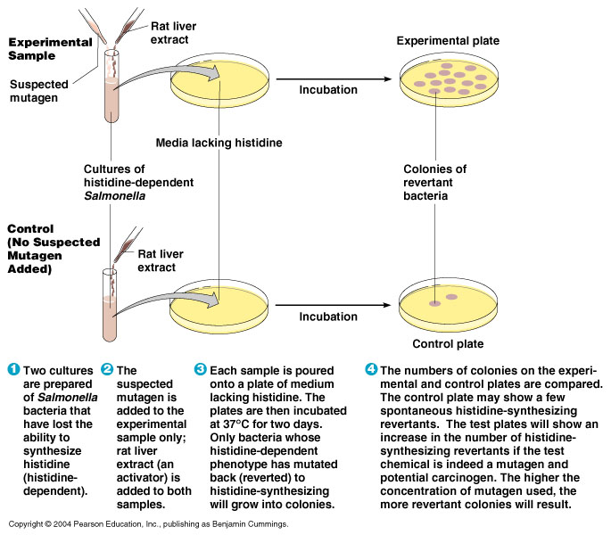

**Figure 7**: Ames test to identify chemical carcinogens.