Laboratory Diagnosis of Cerebrospinal Fluid (CSF) infections
Examination of cerebrospinal fluid (CSF) is an essential step in the diagnosis of bacterial and fungal meningitis and CSF must always be considered as a priority specimen that requires prompt attention by the laboratory staff.
Normal CSF is sterile, clear, colorless liquid found in your brain and spinal cord and usually contains three leukocytes or fewer per mm3 and no erythrocytes. The chemical and cytological composition of CSF is modified by meningeal or cerebral inflammation, i.e. meningitis or encephalitis.

A CSF analysis may include tests to diagnose:
- Infectious diseases of the brain and spinal cord: Including meningitis and encephalitis. CSF tests for infections look at white blood cells, bacteria, and other substances in the cerebrospinal fluid
- Autoimmune disorders: such as multiple sclerosis (MS). CSF tests for these disorder look for high levels of certain proteins in the cerebrospinal fluid. These tests are called albumin protein and IgG/albumin.
- Bleeding in the brain
- Brain tumors

Symptoms of a brain or spinal cord infection include:
- Fever
- Severe headache
- Stiff neck
- Nausea and vomiting
- Sensitivity to light
- Double vision
- Changes in behavior
- Confusion

Collection and transportation of specimens
Approximately 5–10 ml of CSF should be collected in two sterile tubes by lumbar puncture performed by a physician. Part of the CSF specimen will be used for cytological and chemical examination, and the remainder for the microbiological examination.
The specimen should be delivered to the laboratory at once, and processed immediately, since cells disintegrate rapidly. Any delay may produce a cell count that does not reflect the clinical situation of the patient.

Common causes of bacterial and fungal meningitis
In neonates (from birth to 2 months):-
Escherichia coli, Listeria monocytogenes, Streptococcus agalactiae, Other Enterobacteriaceae, Salmonella spp. and Citrobacter spp.

In all other age groups:-
Haemophilus influenza, Neisseria meningitides, Streptococcus pneumonia, Mycobacterium tuberculosis, Listeria monocytogenes, Staphylococci and Cryptococcus neoformans.
- Haemophilus influenza the main cause meningitis in children.
- Neisseria meningitides and Streptococcus pneumoniathe main cause meningitis in adult.

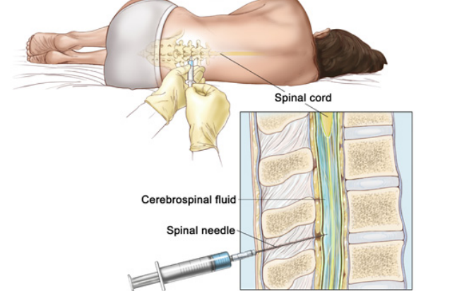

Microscopic examination
Preparation of specimen
If the CSF is purulent (very cloudy), it can be examined immediately without centrifugation. In all other cases, the CSF should be centrifuged in a sterile tube. Remove the supernatant and transfer it to another tube for chemical and/or serological tests. Use the sediment for further microbiological tests.

Direct microscopy
Examine one drop of the sediment microscopically for:
— leukocytes (polymorphonuclear neutrophils or lymphocytes)
— erythrocytes
— bacteria
— yeasts.

If the yeast-like fungus Cryptococcus neoformansis suspected, mix a loopful of the sediment with a loopful of India ink on a slide, place a coverslip on top,and examine microscopically for the typical, encapsulated, spherical, budding yeast forms.
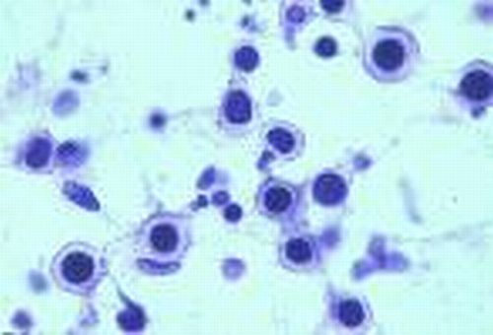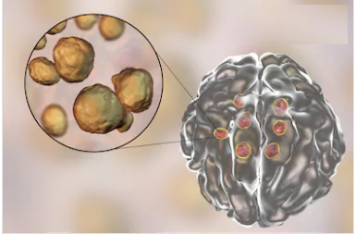

A rare and generally fatal type of meningitis is caused by free-living amoebae found in water (Naegleria fowleri) which enter through the nose and penetrate the central nervous system. They may be seen in the direct wet preparation as active motile amoebae.

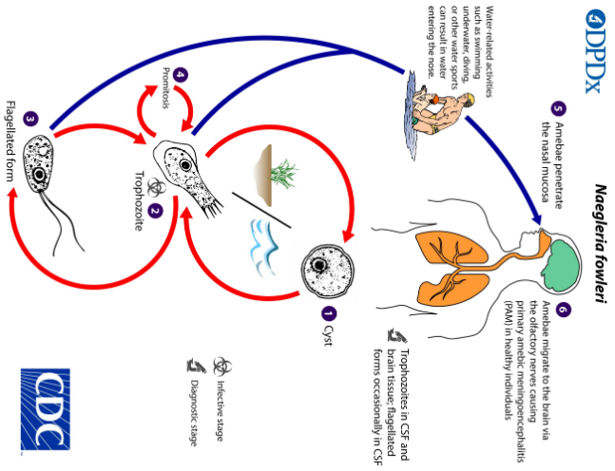

Gram-stained smears
As the causative agent of bacterial meningitis may often be observed in a Gram-stained smear, this examination is extremely important.

Acid-fast stain (Ziehl–Neelsen)
Examination of an acid-fast-stained preparation of the sediment or of the fibrin web is indicated when tuberculous meningitis is suspected by the physician.
Measure protein (Lower limit15mg/dL and Upper limit40–45mg/dL)
Measure glucose (Lower limit50mg/dL and Upper limit 80 mg/dL)

Culture
- The CSF cultures are performed by streaking a loopful on Blood agar, chocolate agar and MacConkey agar, then incubated at 35 -37 C in an atmosphere enriched with carbon dioxide. All media should be incubated for 3 days, with daily inspections.
- When tuberculous meningitis is suspected by Mycobacterium tuberculosis, at least three tubes of Löwenstein– Jensen medium should be inoculated with a drop of the sediment and incubated for 6 weeks.
When Cryptococcus neoformansis suspected, either from the India ink preparation or on clinical grounds, the sediment should be inoculated on two tubes of Sabouraud dextrose agar, and incubated at 35 C for up to 1 month. C. neoformans also grows on the blood agar plate, which should be incubated at 35C for 1 week.

VITEK 2 System for Rapid Identification of Clinical Isolates
The fully automated VITEK 2 system (bioMérieux) can provide identification results for microbial identification (bacteria and yeast identification) rapidly, accurately and reliable species-level identification in a few hours. It improved microbial identification and antibiotic susceptibility testing (AST) for all microbial isolates which isolated from different clinical specimens (blood, CSF, urine, stool, wound, burns, and others…).
The VITEK 2 system can:
- Reduce time to microbial identification and antibiotic susceptibility testing results
- Reduce waste with a miniaturized card-format that measures 10 cm x 6 cm x 0.5 cm and weighs only 16 grams
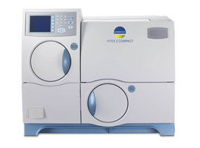
- Meet the needs of any size laboratory
- Offer an extensive identification and
susceptibility menu.

