LECTURE 7 (2021)

The Serological Tests
Serology blood test is performed to detect and measure the levels of antibodies as a result of exposure to a particular bacteria or viruses (antigens), the immune system produces specific antibodies against these organism. Antibody levels (antibody titer) help physicians determine whether an infection occurred recently (Acute) or years ago (chronic).

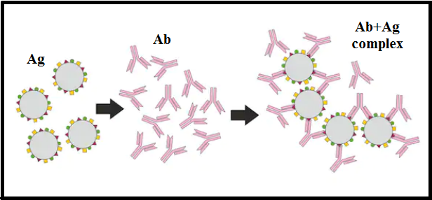

Antigens are substances that provoke a response from the immune system. They can enter the human body through the mouth, broken skin, or through the nasal passages. Antigens that commonly affect people include the following:
- Bacteria
- Fungi
- Viruses
- parasites
-Serological testing is particularly helpful in the diagnosis of rickettsia and viral diseases such as Rocky Mountain spotted fever, influenza, measles, poliomyelitis, and yellow fever, as well as rheumatoid arthritis and syphilis.
-Sometimes the body mistakes its own healthy tissue for outside invaders and produces unnecessary antibodies. This is known as an autoimmune disorder. Serological tests can detect these antibodies and help the doctors in diagnose the autoimmune disorder.

Submitting specimens
- Whole blood: Refrigerated specimens must be received within 24 hours of the time of collection.
- Serum separated from clot: Refrigerated specimens must be received within 48 hours of the time of collection. Frozen specimens must be received within six months of collection.
- CSF: Refrigerated specimens must be received within 48 hours from the time of collection. Frozen specimens must be received within six months of collection.

Rose Bengal plate test (RBT) for Brucella
-The Rose Bengal test (RBT) is a simple, rapid slide-type agglutination assay performed with a stained Brucella abortus suspension at pH 3.6–3.7 and plain serum.

-Although the overall sensitivity reported for RBT varies widely, with the use of good quality antigens made by experienced or reference laboratories, the sensitivity of RBT can increased.
-It is often used as a screening test in human brucellosis and would be optimal for small laboratories with limited means. False-negative reactions occur especially in the early stages of acute infection.

Procedure of Rose Bengal Plate Test:
• Test Serum (0.03 ml) is mixed with an
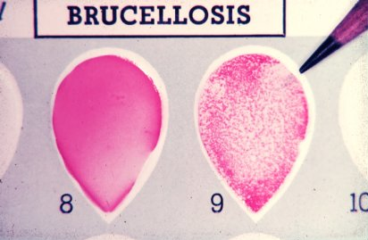
equal volume of antigen on a white tile
or enamel plate to produce a zone
approximately 2 cm in diameter.
• The mixture is agitated gently for
four minutes at room temperature,
and then observed for agglutination.
• Any visible reaction is considered to
be positive.

Widal Test
- Widal test is an agglutination test which detects the presence of serum agglutinins (H and O) in patient's serum with typhoid and paratyphoid fever.
- When facilities for culturing are not available, the Widal test is the reliable and can be of value in the diagnosis of typhoid fevers in endemic areas.
- It was developed by Georges Ferdinand Widal in 1896.
- The patient’s serum is tested for O and H antibodies (agglutinins) against the following antigen (Usually stained suspentions).
S. Typhi 0 antigen suspension
S. Typhi H antigen suspension
S. Paratyphi A 0 antigen suspension
S. Paratyphi A H antigen suspension
S. Paratyphi B 0 antigen suspension
S. Paratyphi B H antigen suspension
S. Paratyphi C 0 antigen suspension
S.Paratyphi C H antigen suspension

- Salmonella antibody starts appearing in serum at the end of first week and rise sharply during the 3rd week of endemic fever. In acute typhoid fever, O agglutinins can usually be detected 6–8 days after the onset of fever and H agglutinins after 10–12 days.
- It is preferable to test two specimens of sera at an interval of 7 to 10 days to demonstrate a rising antibody titer.
- Salmonella antigen suspensions can be used as slide and tube techniques.

Principle of Widal Test
Bacterial suspension which carry antigen will agglutinate on exposure to antibodies to Salmonella organisms. Patients’ suffering from enteric fever would possess antibodies in their sera which can react and agglutinate serial doubling dilutions of killed, coloured Salmonella antigens in an agglutination test. The main principle of widal test is that if homologous antibody is present in patients serum, it will react with respective antigen in the reagent and gives visible clumping on the test card and agglutination in the tube. The antigens used in the test are “H” and “O” antigens of Salmonella typhi and “H” antigen of S. paratyphi. The paratyphoid “O” antigen are not employed as they cross react with typhoid “O” antigen “O” antigen is a somatic antigen and “H” antigen is flagellar antigen.

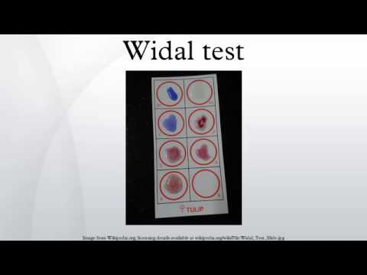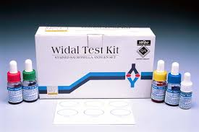

Typhoid Strip Test

Also there is rapid test for the qualitative detection of IgG and IgM antibodies to Salmonella typhi (S. typhi) in human blood (serum), is Typhoid strip test.

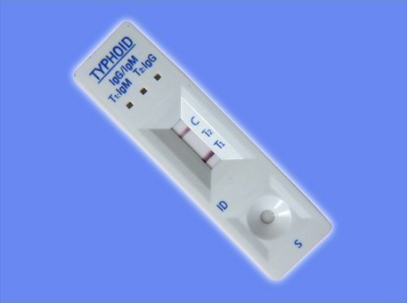

VDRL Test

What is a VDRL Test?
The venereal disease research laboratory (VDRL) test is designed to assess whether or not you have syphilis, a sexually transmitted infection (STI). Syphilis is caused by the bacteria Treponema pallidum. The bacteria infect by penetrating into the lining of the mouth or genital area.The VDRL test doesn’t look for the bacteria that cause syphilis. Instead, it checks for the antibodies your body makes in response to antigens produced by cells damaged by the bacteria. Testing for these antibodies can let doctors know whether you have syphilis, because it checks for antibodies produced as a result of a syphilis infection, the VDRL test can be used whether or not have any symptoms.
VDRL test may also be performed on CSF samples in the diagnosis of Neurosyphilis.
VDRL Performing the test:
– 0.05 mL of serum added to circle on ceramic slide and spread.
– Add one calibrated drop of antigen to each circle.
– Rotate for 4 minutes
– Observe for microscopically flocculation at 100x and grade reaction if positive.
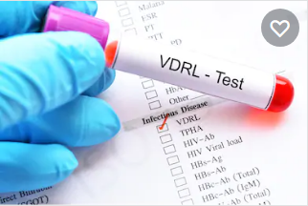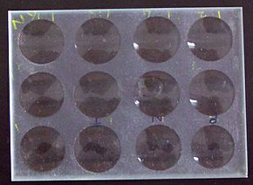
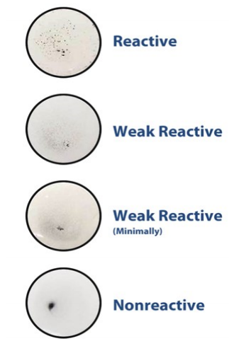
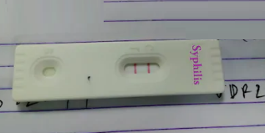
Rapid Syphilis strip test
Also Rapid Syphilis strip is a rapid test
for the qualitative detection of antibodies
(IgG and IgM) to Treponema Pallidum in
blood to aid in the diagnosis of Syphilis.
The VDRL test isn’t always accurate. For example, it may give false-negative results if syphilis test was done less than three months, as the body might take this long time to make antibodies. The test is also unreliable in late-stage syphilis.On the other hand, the following can cause false-positive results:
- HIV
- Lyme disease
- malaria
- pneumonia (certain types only)
- systemic lupus erythematosus
- IV drug use
- Tubercul
- 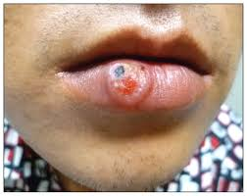

Rheumatoid arthritis

Rheumatoid arthritis can be difficult to diagnose because many conditions cause joint stiffness and inflammation and there is no definitive test for the condition.
There is no singular test for diagnosing rheumatoid arthritis. The diagnosis is based on the clinical presentation.
Ultimately, rheumatoid arthritis is diagnosed based on a combination of the presentation of the joints involved, characteristic joint swelling and stiffness in the morning, the presence of blood rheumatoid factor and citrulline antibody, as well as findings of rheumatoid nodules and radiographic changes (X-ray testing). It is important to understand that there are many forms of joint disease that can mimic rheumatoid arthritis.
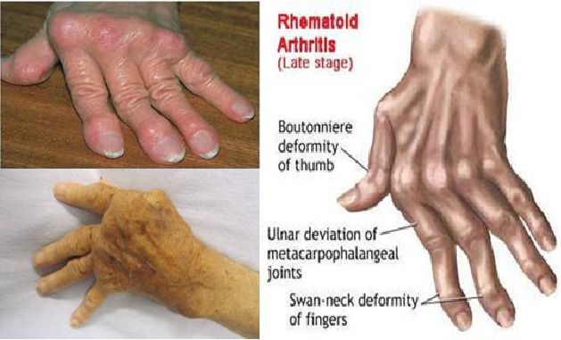
Abnormal antibodies can be found in the blood of people with rheumatoid arthritis with simple blood testing. An antibody called "rheumatoid factor" (RF) can be found in 80% of patients with rheumatoid arthritis. Patients who are felt to have rheumatoid arthritis and do not have positive rheumatoid factor testing is referred to as having "seronegative rheumatoid arthritis.
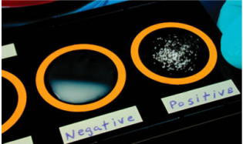
The procedure of this test is same for
Rose Bengal test.
Agglutination of latex particles is considered a
positive reaction.
No agglutination of the latex particles
suspension within two minutes (-ve).

C-Reactive Protein Test
C-reactive protein (CRP) is a substance produced by the liver in response to inflammation. Other names for CRP are high-sensitivity C-reactive protein (HS-CRP), or ultra-sensitive C-reactive protein (US-CRP).
A high level of CRP in the blood is a sign that there may be an inflammatory process occurring in the body. Inflammation itself isn’t typically a problem, but it can indicate a host of other health concerns, including infection, arthritis, kidney failure, and pancreatitis. High CRP levels may put patients at increased risk for coronary artery disease, which can cause a heart attack.
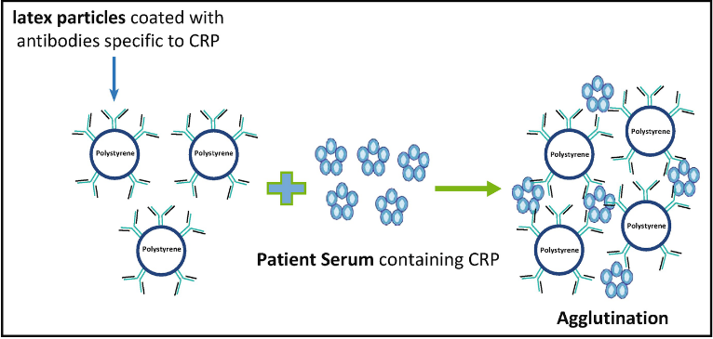

A CRP test is a blood test designed to measure the amount of CRP in the blood. A CRP test only needs a blood sample.
Usually, doctors order the test to determine a person’s risk for heart disease or stroke. Doctors may also order a CRP test after surgery to check for signs of postsurgical infection. They also might use it to monitor inflammatory diseases, including:
- pelvic inflammatory disease
- inflammatory bowel disease
- arthritis
- autoimmune diseases, such as lupus
C-reactive protein is measured in milligrams of CRP per liter of blood (mg/L). In general, a low C-reactive protein level is better than a high one, because it indicates less inflammation in the body.
A reading of less than 1 mg/L indicates you’re at low risk of cardiovascular disease. A reading between 1 and 2.9 mg/L means you’re at intermediate risk. A reading greater than 3 mg/L means you’re at high risk for cardiovascular disease. A reading above 10 mg/L may indicate a need for further testing to determine the cause of severe inflammation in your body.
An especially high CRP reading (greater than 10 mg/L) may indicate:
- a bone infection, or osteomyelitis
- an arthritis flare-up
- inflammatory bowel disease
- tuberculosis
- lupus or another connective tissue disease or autoimmune disease
- cancer, especially lymphoma
- pneumonia

Hepatitis

What is hepatitis?
Hepatitis is an inflammation of the liver that is most commonly caused by viruses but may also be due to chemicals, drugs, alcohol, inherited diseases, or autoimmune disease. The inflammation can be acute, flaring up and then resolving within a few weeks to months, or chronic, enduring over many years. Chronic hepatitis may persist for 20 years or more before causing significant symptoms related to progressive liver damage such as cirrhosis, liver cancer, or death.
The liver is a vital organ located in the upper right-hand side of the abdomen. It performs many functions in the body, including processing the body's nutrients, manufacturing bile to help digest fats, synthesizing many important proteins, regulating blood clotting, and breaking down potentially toxic substances into harmless ones that the body can use or excrete. Inflammation may (in severe cases) interfere with these processes and allow potentially toxic substances to accumulate.

Signs and Symptoms
The signs and symptoms of hepatitis are the same, regardless of the cause, but vary from person to person and may vary over time. Most people with chronic hepatitis have no symptoms at all. Some people with acute hepatitis have not symptoms, but many have mild and/or vague symptoms that may be mistaken for the flu. Some of the more common signs and symptoms include:
- Fatigue
- Nausea
- Abdominal pain
- Joint aches
- Itching
- Yellowing of the eyes and skin (jaundice, the one symptom strongly suggesting liver damage as the cause of other symptoms).
-Hepatitis B serologic testing involves measurement of several hepatitis B virus (HBV)-specific antigens and antibodies. Different serologic “markers” or combinations of markers are used to identify different phases of HBV infection and to determine whether a patient has acute or chronic HBV infection, is immune to HBV as a result of prior infection or vaccination, or is susceptible to infection.

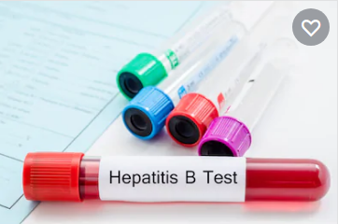

Coronavirus disease (COVID-19):

Serology testing for SARS-CoV-2 is at increased demand in order to better quantify the number of cases of COVID-19, including those that may be asymptomatic or have recovered. Serology tests are blood-based tests that can be used to identify whether people have been exposed to a particular pathogen by looking at their immune response.
A COVID-19 antibody strip test, also known as a serology test, is a blood test that can detect if a person has antibodies to SARS-CoV-2, the virus that causes COVID-19. COVID-19 antibody tests can help identify people who may have been infected with the SARS-CoV-2 virus or have recovered from the COVID-19 infection.
Rapid diagnostic strip tests for COVID-19 viruses are often similar to pregnancy tests, in that the test shows the user colored lines to indicate positive or negative results. These tests most frequently test for patient antibodies (IgG and IgM).

