Lecture 6 (2021)

Common blood tests

Blood tests are performed to determine the biochemical and physiological state of the blood, which can determine if a patient is ill, if there is an imbalance in a mineral, if drugs are working or present, or if organs are functioning properly.

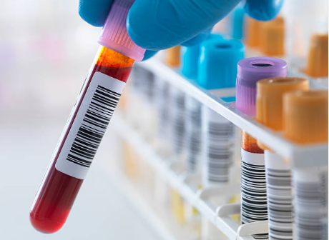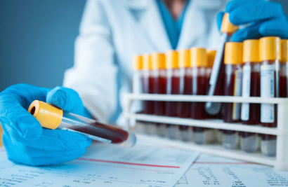

1-Complete Blood Count (CBC)
2-Chemistry Panel :measures
A- Blood glucose
Blood glucose tests are also sometimes called blood sugar done as:
- Fasting blood suger test:
*Oral glucose tolerance test
Abbreviated as OGTT or GTT, for this test patient fast, then have a blood sample taken, then drink glucose, and then have a number of samples taken over a few hours. They are usually used to check for or monitor diabetes.
The standard blood glucose tests measure blood sugar level at a particular time. The OGTT measures respond to glucose.
Pregnant women can develop a particular type of diabetes called gestational diabetes, and might be asked to have an OGTT around 28 weeks of pregnancy. Gestational diabetes usually goes away after the baby is born.
*HbA1c test
HbA1c is a blood test that is used to help diagnose and monitor people with diabetes. It is also sometimes called a haemoglobin A1c, glycated haemoglobin or glycosylated haemoglobin.HbA1c refers to glucose and haemoglobin joined together (the haemoglobin is ’glycated’). Haemoglobin is the protein in red blood cells that carries oxygen throughout the body. The amount of HbA1c formed is directly related to the amount of glucose in blood.
Red blood cells live for up to 4 months, so HbA1c gives an indication of how much sugar in blood over the past few months. It’s different to the blood glucose test, which measures how much sugar in blood at that moment.
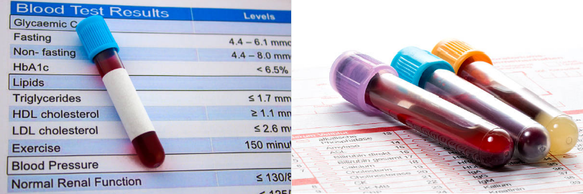
It can used to diagnose diabetes and indicates how well diabetes has been controlled over the last few months. Higher of HbA1c, mean greater risk of developing complications such as problems with eyes and kidneys.

B- Kidney function tests
Kidney tests are very important for people who have diabetes, high blood pressure or heart disease.
The most important tests:
Creatinine and urea in blood & Electrolytes in blood – usually sodium, potassium, chloride or bicarbonate.

- Liver function tests
Liver function tests (also called LFTs) are blood tests that can provide information about liver working. They test the levels of a number of proteins and enzymes that are either produced by liver cells or released into the blood when liver cells are damaged

- Cardiac enzymes
Cardiac enzyme tests can check whether the heart muscle is damaged, and indicate if a person has had a heart attack.The most common test is troponin. This test has replaced other cardiac enzyme tests previously done (total cholesterol, HDL (high-density lipoprotein), LDL (low-density lipo-protein), triglycerides, and the total cholesterol/HDL ratio, as it is more accurate.

Troponin is a protein found in the heart muscle. When the heart muscle is injured, troponin is released into the bloodstream and the level that can be detected goes up. This can happen during and after a heart attack. Often the test will be done more than once to monitor for damage.

Common Blood Test Codes
Blood Test Code | Definition
CBC: Complete Blood Count | This is one of the most common tests administered, which measures the cell count in the blood and the ratios and weights of blood components by comparing white and red blood cell counts, hemoglobin, hematocrit, and corpuscular volume.. It helps doctors determine if a patient is affected by infection, anemia, blood cancers, immunity issues, or platelet problems.
BMP: Basic Metabolic Panel | This series of tests is used to measure chemicals present in the blood. The test is administered on the plasma and measures electrolyte levels, glucose, calcium, and other chemicals. It is used to determine a patient’s overall health and if there are any underlying imbalances causes various health problems.
CK: Creatine Kinase Tests | This measures an enzyme in your body that is produced when the heart is injured. This test is used when a patient has a heart attack. It indicates the severity of the heart attack.
LDL and HDL | This tests measures the amount of bad (LDL) and good (HDL) cholesterol in the blood. If results are out of the norm, your doctor will likely suggest dietary changes and potentially cholesterol medication.
CRP: C-Reactive Protein Test | This test measures how much protein in the blood which indicates if a patient has inflammation and is at risk for a heart attack. Result can be used to encourage a patient to make lifestyle changes to reduce his or her risk.
TSH: Thyroid Stimulating Hormone Test | This test is used to diagnose thyroid disorders, such as when the thyroid is underactive or there is a problem with fertility.
AST: Asparate Aminotransferase | This measures an enzyme found in the blood that rises when an injury occurs in the body’s tissue or an organ. It helps a doctor determine if there are internal injuries.

Other Blood Test Codes
The following are codes for less common blood tests:
Codes | Common Names | Test For
25 Hydroxy Vitamin D | Vitamin D | Levels of Vitamin D
ALT | Alanine Transaminase | Liver Function
ANA | Antinuclear antibody | Autoimmune disease
BAC | Blood Alcohol Concentration | Blood alcohol
BNP | Beta natriuretic peptide | Congestive heart failure
BUN | Blood Urea Nitrogen | Kidney Function
Ca | Calcium | Levels of Blood Calcium
CBL | Cobalamin (Vitamin B12) | Levels of Vitamin B12
CMP | Comprehensive Metabolic Panel | Refer to a group of tests
CPK | Creatine phosphokinase | Muscle Damage
Cr | Creatinine | Kidney Function
ESR | Erythrocyte Sedimentation Rate | 'sed rate'. Test for inflammation
Hct | Hematocrit | Part of the CBC Blood Test
Hgb | Hemoglobin | Part of the CBC Blood Test
INR | International Normalized Ratio | A test of blood clotting
K | Potassium | Measures potassium level in blood
MCV | Mean Corpuscle Volume | One of the CBC
Mg | Magnesium | Measures magnesium level in blood
Na | Sodium | Measures sodium level of the blood
Platelets | Platelets | One of the CBC
PSA | Prostate Specific Antigen | Prostate Cancer
PT | Prothrombin Time | Blood clotting
PTT | Partial Thromboplastin Time | Blood clotting
RBC | Red Blood Cell Count | One of the CBC
TPO | Thyroid Peroxidase Antibodies | Measurement of antibodies to the thyroid
Trig | Triglygerides | Cholesterol
WBC | White Blood Cell Count | One of the CBC

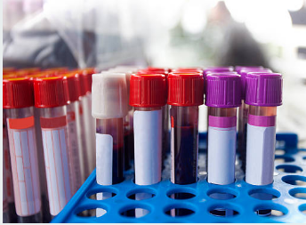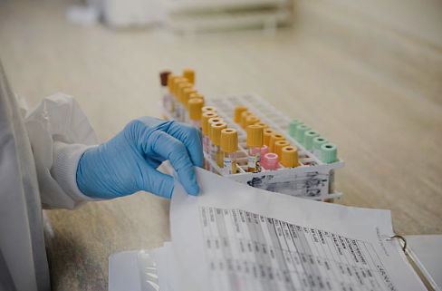

Blood Test Reference Range
1. Complete Blood Count
Test Items | Normal Results
Red blood cell | 5 to 6 million cells/mcL (male)
 | 4 to 5 million cells/mcL (female)
White blood cell | 4,500 to 10,000 cells/mcL
Platelets | 140,000 to 450,000 cells/mcL
Hemoglobin | 14 to 17 gm/dL (male)
 | 12 to 15 gm/dL (female)
Hematocrit | 41% to 50% (male)
 | 36% to 44% (female)
Mean corpuscular volume | 80 to 95 femtoliter

2. Blood Glucose
Plasma Glucose (mg/dL) | Results
<99 | Normal
100 - 125 | Prediabetes
>126 | Diabetes

3. Lipoprotein Panel
Total Cholesterol (mg/dL) | Diagnosis
<200 | Optimal
200–239 | Borderline High
>240 | High

LDL Cholesterol (mg/dL) | Diagnosis
<100 | Desirable
100–129 | Near Desirable
130–159 | Borderline High
160–189 | High
>190 | Very High

HDL Cholesterol (mg/dL) | Diagnosis
<40 | Risk of heart disease
40–59 | Better to be higher
>60 | Protect against heart disease
