Lecture 4- Serology and Vaccination for Biotechnology 4th stage2021
Prf. Dr. Rajwa Hasen Essa Prf.Dr. Alia Essam Mahmood
Precaution and Contraindication الاحتياطات وموانع
1- The injection of vaccines may causes general anaphylactic reactions therefore 1:1000 epinephrine should always be readily available.
2- When a child is not good health or is suffering from acute febrile illness, routine vaccines should be postponed until recovery.
3- Treatment with steroids or radiation may reduce immune response if the treatment is not short duration any routine vaccination should be postponed, if the treatment is not a long-term basis, killed vaccines can be administered during the course of treatment. All live vaccines (BCG, OPV, Measles) are postponed for at least three months.
4- All live vaccines are also contraindicated when there is:
A. Malignant proliferative affection of lymphoreticular tissues.
B. Congenital or acquired immunodeficiencies.
C. Pregnancy
D. Recent administration of immunoglobulin.
All infants should be given the standard vaccines against diphtheria, pertussis, and tetanus (DPT) and against poliomyelitis and measles. This should be done as early as possible according to the immunization schedules of the country.
It may countries the BCG vaccines are given to all infant at the birth to prevent tuberculosis.
Classification of Vaccines
A- Live attenuated ■ viral ■ bacterial
B- Inactivated
1- Whole ■ viruses ■ bacteria
2- Fractional
■ protein-based – toxoid – subunit
■ polysaccharide-based – pure – conjugate
- Nucleic acid vaccine just uses a section of genetic material that provides the instructions for specific proteins, not the whole microbe. DNA and RNA are the instructions our cells use to make proteins.
  - Inactivated vaccines use the killed version of the germ (by physical or chemical processes ) that causes a disease; usually don’t provide immunity (protection) that’s as strong as live vaccines. Inactivated vaccines are not alive and cannot replicate.
Advantages of inactivated vaccine
- They give sufficient humoral immunity if boosters given
- There is no mutation or reversion (This is a big advantage)
- They can be used with immuno-deficient patients
Disadvantages
- -Some vaccinees do not raise immunity
- -Boosters tend to be needed
- -There us little mucosal / local immunity (IgA).
  - Live attenuated vaccines use a weakened (that are weakened by chemical or physical processes and could replicate in order to produce an immune response) form of the germ that causes a disease; they create a strong and long-lasting immune response.
Advantages of attenuated vaccines
They activate all phases of immune system. They elicit humoral IgG and local IgA, and raise an immune response to all protective antigens.
They offer more durable immunity and are more cross-reactive. Thus, they stimulate antibodies against multiple epitopes which are similar to those elicited by the wild type virus
They give quick immunity in majority of vaccines
The major disadvantage is a mutation. This may lead to reversion to virulence.
  - Subunit (isolate specific antigens from a germ or virus isolate specific antigens from a germ or virus chosen according to the strength of the immune response they generate) , polysaccharide ( from the outer layer of a bacteria or virus) , and conjugate vaccines (a weak antigen linked with a stronger carrier protein using chemicals) which lead triggers the immune response aggressively against these antigens.
  - Toxoid vaccines use a toxin (harmful product) made by the germ that causes a disease. They create immunity to the parts of the germ that cause disease instead of the germ itself. That means the immune response is targeted to the toxin instead of the whole germ. Toxoid vaccines do not offer lifelong immunity and need to be topped up over time. Toxoid vaccines are used to create immunity against diphtheria and tetanus.
  - Recombinant vaccines is a vaccine produced through recombinant DNA technology. This involves inserting the DNA encoding an antigen (such as a bacterial surface protein) that stimulates an immune response into bacterial or mammalian cells, expressing the antigen in these cells and then purifying it from them.
  - mRNA vaccines make proteins in order to trigger an immune response. mRNA vaccines have several benefits compared to other types of vaccines, including shorter manufacturing times, low manufacturing costs, and because they do not contain a live virus, no risk of causing disease in the person getting vaccinated. However, they have to be kept at low temperatures due to the fragility of the mRNA.
  - Viral vector vaccines use a modified version of a different virus as a vector to deliver protection. Several different viruses have been used as vectors, including influenza, vesicular stomatitis virus (VSV), measles virus, and adenovirus, which cause the common cold. Adenovirus is one of the viral vectors used in some COVID-19 vaccines being studied in clinical trials.
  - Edible vaccines A vaccine in which an antigenic protein is engineered into an edible plant; after ingestion, the protein is uncloakedنزع الغطاء and recognized by the immune system
Herd immunity, also known as 'population immunity', is the resistance to the spread of an infectious disease within a population that is based on pre-existing immunity of a high proportion of individuals as a result of previous infection or vaccination. WHO supports achieving 'herd immunity' through vaccination, not by allowing disease as this would result in unnecessary cases and deaths.
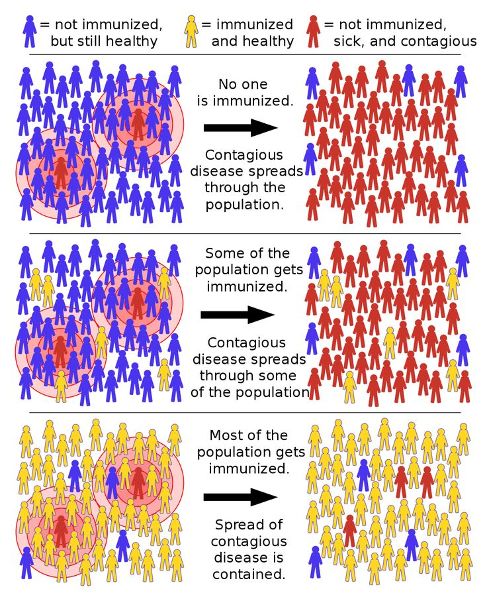
Booster dose is an extra administration of a vaccine after an earlier (primer) dose, to a re-exposure to the immunizing antigen, to increase the immunity and delivering to the protective levels.
Common vaccines in immunization schedule
1- BCG vaccine a suspension of an attenuated strain (Bacillus Calmette-Guérin) of Mycobacterium tuberculosis(bovine-strain tubercle bacilli (Mycobacterium bovis)), bovine type, which is inoculated into the skin for tuberculosis prophylaxis. It administered intracutaneously, or intradermally, and cannot be given when the patient is reactive to tuberculin.
2- cholera vaccine a preparation of killed Vibrio cholerae, administered intradermally, subcutaneously, or intramuscularly for immunization against cholera.
3- diphtheria and tetanus toxoids and pertussis vaccine DTP vaccine: a combination of diphtheria and tetanus toxoids and pertussis vaccine; administered intramuscularly for simultaneous immunization against diphtheria, tetanus, and whooping cough. When a pertussis vaccine is an acellular form, the combination may be abbreviated DTaP.
4- hepatitis A vaccine inactivated an inactivated whole virus vaccine derived from an attenuated strain of hepatitis A virus grown in cell culture; administered intramuscularly.
5- hepatitis B vaccine a preparation of hepatitis B surface antigen, derived either from human plasma of carriers of hepatitis B (hepatitis B vaccine inactivated) or from cloning in yeast cells (hepatitis B vaccine [recombinant]); administered intramuscularly.
6- influenza virus vaccine a killed virus vaccine used in immunization against influenza; it is trivalent, usually containing two influenza A virus strains and one influenza B virus strain.
7- measles, mumps, and rubella virus vaccine live (MMR) a combination of live attenuated measles, mumps, and rubella viruses, administered subcutaneously for simultaneous immunization against measles, mumps, and rubella.
8- poliovirus vaccine live oral (OPV) called also Sabin vaccine, an oral vaccine against poliomyelitis consisting of three types of live, attenuated polioviruses. It induces both humoral and intestinal immunity, so is useful for immunization and poliomyelitis eradication in areas where wild-type polioviruses have not been eradicated.
9- poliovirus vaccine inactivated (IPV) called also Salk vaccine, a preparation of killed polioviruses of three types, given in a series of intramuscular or subcutaneous injections to immunize against poliomyelitis. It does not induce intestinal immunity and so is not effective for poliovirus eradication in areas where wild-type polioviruses still exist in large numbers. However, it does not cause vaccine-associated paralytic poliomyelitis.
10- rabies vaccine is a vaccine used to prevent rabies. There are a number of rabies vaccines available that are both safe and effective. They can be used to prevent rabies before, and for a period of time after, exposure to the rabies virus, which is commonly caused by a dog bite or a bat bite.
Before exposure WHO recommends vaccinating those who are at high risk of the disease, Three doses of the vaccine are given over a one-month period on days zero, seven, and either twenty-one or twenty-eight.

After exposure to the individuals who have been potentially exposed to the virus, four doses over two weeks are recommended, as well as an injection of rabies immunoglobulin with the first dose. This is known as post-exposure vaccination. For people who have previously been vaccinated, only a single dose of the rabies vaccine is required.
However, vaccination after exposure is neither a treatment nor a cure for rabies; it can only prevent the development of rabies in a person if given before the virus reaches the brain. Because the rabies virus has a relatively long incubation period, post-exposure vaccinations are typically highly effective.

