Lecture 3- Serology and Vaccination for Biotechnology 4thstage2021
Prf. Dr. Rajwa Hasen Essa Prf.Dr. Alia Essam Mahmood
Antitoxin antibody, formed in the body by the introduction of a bacterial poison, or toxin, and capable of neutralizing the toxin.
For medical use in treating human infectious diseases, antitoxins are produced by injecting an animal with toxin; the animal, most commonly a horse, is given repeated small doses of toxin until a high concentration of the antitoxin builds up in the blood. The resulting highly concentrated preparation of antitoxins is called an antiserum.
When we inject the antisera intravenous we should be.
- Only purified antiserum can be used
- Sub cutaneous hypersensitivity test must be done
- The injection must be done slowly
- The patient must be observed for 1 hour.
How to make anti sera
Horses that were vaccinated three times with increasing sizes of the dose. The time between each vaccination varied from each horse and its health condition. Normally the horses needed a few weeks to produce the serum in the blood after the last vaccination.
In order to find the moment when most antitoxins in the blood cells of the horses are produced, frequent blood samples were taken from the horses. At the point when the highest amount of antibodies were produced, five litres of blood, a tenth of the blood volume of a horse, was taken through a cannula. The blood was collected and separated the serum varied from milky to brown. Concentration and sterility of the serum were checked carefully, and the serum was filtered many times. Protein content was decreased in order to use the serum for humans. Now they use procedure is called plasmapheresis a method of removing blood plasma from the body by withdrawing blood, separating it into plasma and cells, and transfusing the cells back into the bloodstream.
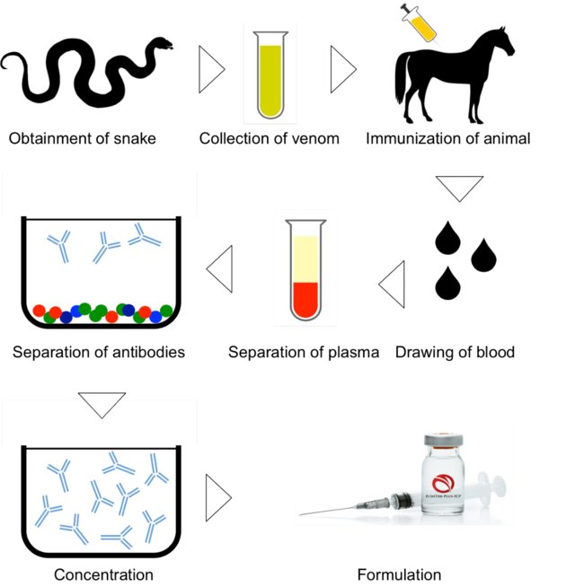
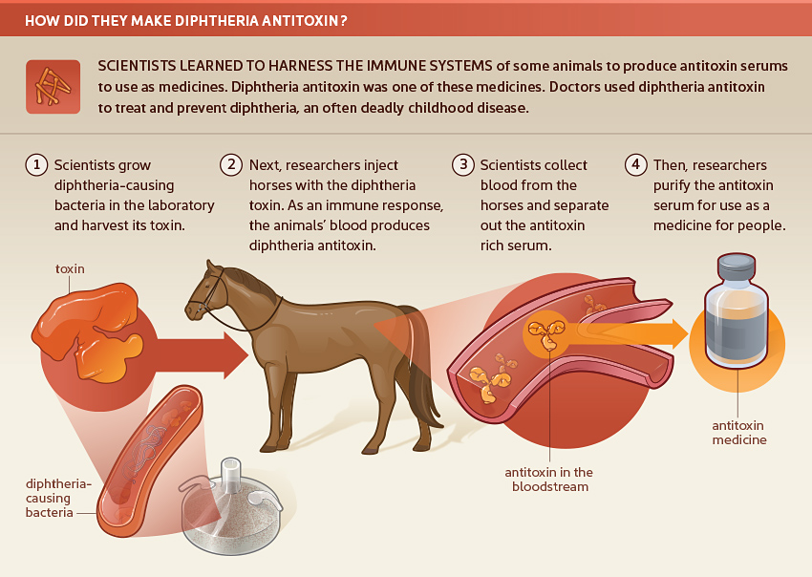
How did they make diphtheria antitoxin?
Scientists learned to harness the immune systems of some animals to produce antitoxin serums to use as medicines. Diphtheria antitoxin was one of these medicines. Doctors used diphtheria antitoxin to treat and prevent diphtheria, an often deadly childhood disease.
1. Scientists grow diphtheria-causing bacteria in the laboratory and harvest its toxin.
2. Next, researchers inject horses with the diphtheria toxin. As an immune response, the animal's blood produces diphtheria antitoxin.
3. Scientists collect blood from the horses and separate out the antitoxin rich serum.
4. Then, researchers purify the antitoxin serum for use as a medicine for people.

Vaccine a substance (contain weakened or inactive parts of a particular organism as an antigen)) used to stimulate the production of immune response (as the first reaction to the actual pathogen)and provide immunity against one or several diseases, prepared from the causative agent of a disease, its products, or a synthetic substitute, treated to act as an antigen without inducing the disease.
Some vaccines require multiple doses, given weeks or months apart, to allow for the production of long-lived antibodies and the development of memory cells
In this way, the body is trained to fight the specific disease-causing organism, building up the memory of the pathogen so as to rapidly fight it if and when exposed in the future.
Vaccines may also contain additional components:

An excipient an inactive substance that serves as the vehicle or medium for a drug or other active substance such as a vaccine, and confers a therapeutic enhancement on the active ingredient in the final dosage form, such as facilitating drug absorption, reducing viscosity, or enhancing solubility.

Preservatives are non-toxic substances in the amounts used and do not diminish the potency of vaccines, used to prevent contamination.

Adjuvants

Protective immune responses are directed against critical antigens in the pathogen's structure, or in its products (e.g. toxins, enzymes).

Antibodies that bind to critical antigens can neutralise or inhibit bacterial toxins and enzymes, immobilise pathogens, prevent them from binding to host cells and enhance their destruction by phagocytes and cytotoxic cells.
Antigen presentation partly determines whether a T helper-1 (Th1) or a T helper-2 (Th2) type of response is favoured.
1- Antigens presented to Th1 cells initiate the sequence of events culminating in cell-mediated immune responses.
2- Antigens presented to Th2 cells initiate antibody-mediated responses.
In practice, both types of response can occur simultaneously, but the route of administration can favour one or the other. It can also influence the class of antibodies that appear: antigens presented in the gut will tend to induce IgA production since large numbers of IgA-producing B cells are located there; by contrast, antigens injected into the skin will usually be transported to local lymph nodes, where IgM- and IgG-producing B cells predominate.
Effector Mechanisms Triggered by Vaccines
• Antibodies prevent or reduce infections by clearing extracellular pathogens through:
– Binding to the enzymatic active sites of toxins or preventing their diffusion
– Neutralizing viral replication (e.g., preventing viral binding and entry into cells)
– Promoting opsonophagocytosis of extracellular bacteria (i.e., enhancing their clearance by macrophages and neutrophils)
– Activating the complement cascade
• CD8 + T cells do not prevent infection but reduce, control, and clear intracellular pathogens by:
– Directly killing infected cells (release of perforin, granzyme, etc.)
– Indirectly killing infected cells through antimicrobial cytokine release
• CD4+ T cells do not prevent infection but participate in the reduction, control, and clearance of extracellular and intracellular pathogens by their homing and cytokine-production capacities. Their main subsets include:
– Follicular T-helper (Tfh) cells
– T-helper 1 (Th1) effector cells
– Th2 effector cells
– Th9 effector cells
– Th17 effector cells
The vaccine can be classified into:
Routine vaccines: are well tolerated provide adequate protection against dangerous and widespread infection e.g diphtheria, polio, measles, mumps Most people think of these as childhood vaccines that you get before starting school, but some vaccines are routinely recommended for adults, and some are recommended every year (a flu vaccine) or every 10 years (a tetanus booster).
Indicated vaccines: are performed only under certain conditions, tourist vaccines belong to this group
Heterologous vaccine is a type of live vaccine where one pathogen is introduced in order to provide protection against a different one. Examples: Jenner's administration of cowpox to protect against smallpox, and the administration of BCG vaccine made from Mycobacterium bovis to protect against human tuberculosis.
Homologous vaccine a type of vaccinefor the any pathogen that provide a protection against their same pathogen.
Most vaccines contain antigens of a single pathogen, Multiple vaccines there is a practice of multiple vaccines, which combine antigens of more than one pathogen. For example, diphtheria, tetanus and pertussis are administered together as DTP vaccination.
A monovalent vaccine contains a single strain of a single antigen (e.g. Measles vaccine).
Polyvalent vaccine contains two or more strains/serotypes of the same antigen (e.g. OPV oral polio vaccine)

