Lecture 1- Serology and Vaccination for Biotechnology 4th stage 2021
Prf. Dr. Rajwa Hasen Essa
Prf.Dr. Alia Essam Mahmood
Serology is the scientific study of serum and other body fluids with regard to the response of the immune system to pathogens or introduced substances, study of the antigen-antibody reaction of diagnosis of infectious diseases, autoimmune disorders immune allergies and neoplastic diseases.
Serum defined as blood plasma without fibrinogens, which includes all proteins not used in blood clotting; all electrolytes, antibodies, antigens, hormones; and any exogenous substances (microorganisms), and does not contain any type of cells.
Plasma the liquid part of the blood and lymphatic fluid, which makes up about half of the volume of blood. Plasma is free of cells and, unlike serum, has not clotted, that consists of water and its dissolved constituents including especially proteins (such as albumin, fibrinogen, and globulins).
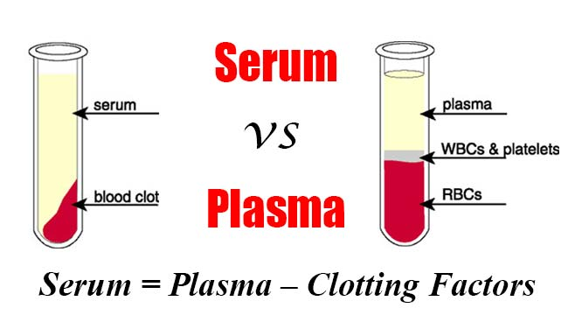
Immune Sera: a serum containing naturally or artificially produced antibodies to a given antigen either by immunization or infection, obtained from human or animal sources.
Antisera a blood serum containing antibodies against specific antigens injected to treat or protect against specific diseases, either in human or animal.
Immunization is the process whereby a person is made immune or resistant to an infectious disease or getting a vaccine that administrate against subsequent infection or disease.
Vaccination (getting a vaccine ) is a treatment with a vaccine to produce immunity against disease; inoculation (this term is often used interchangeably with vaccination). Vaccine, suspension of weakened, killed, or fragmented microorganisms or toxins or of antibodies or lymphocytes that is administered primarily to prevent disease.
Epitope: a part of a protein molecule that acts as an immunogenic/antigenic determinant, may contain many different epitopes each one capable of stimulating the production of specific antibodies, each one capable binding with a specific binding site.
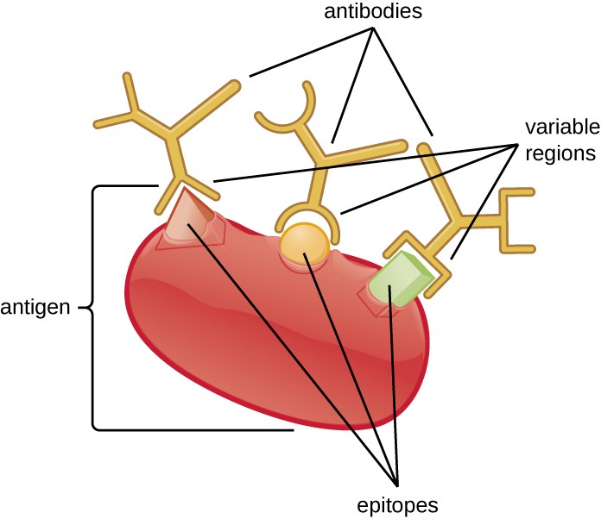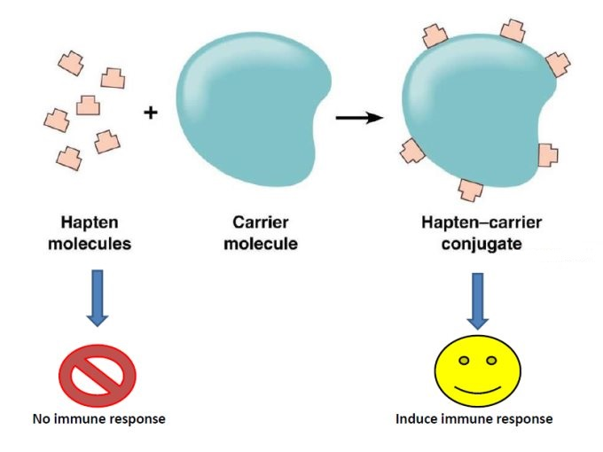
Immunogen: a substance usually a protein that produces an immune response.
Antigen and immunogen are two types of molecules that bind to the components of the immune system (including antibodies, B cells, and T cells).
Antigens can be either proteins, polysaccharides, lipids or nucleic acids (antigen refers to a molecule that is capable of binding to the product of that immune response), while immunogens are normally proteins and large polysaccharides. However, lipids and nucleic acids can also be immunogenic after binding to proteins or large polysaccharides. All immunogens are antigens, but all antigens may not be immunogens.
Hapten: a low-molecular-weight non-protein molecule which contains an antigenic determinant but which is not itself antigenic unless it complexes with an antigenic carrier, to be antigenic, the hapten must bind to an exogenous protein carrier.
Antigen-antibody interaction, or antigen-antibody reaction, is a specific chemical interaction between antibodies and antigens during immune reaction, either in the body during immune response or during diagnosis, the antigens are specifically and with high affinity bound by antibodies to form an antigen-antibody complex, in blood and then transported to cellular systems where it can be destroyed or deactivated.
The adjuvant is a pharmacological or immunological agent that modifies the effect of other agents, which is a material that helps stimulate and enhance the immune response against the antigen through the creation of a depot effect.
Directly immunizing most antigens will lead to poor immune response and rapid removal of the antigen from the body. To prevent this, the antigen is first combined with an adjuvant.
Adjuvants can act in various ways in presenting an antigen to the immune system. They can act as a depot for the antigen, presenting the antigen over a longer period of time, thus maximizing the immune response before the body clears the antigen.
Adjuvant immunobiological functions
- Improve the immunogenicity of highly purified or recombinant antigens (protein or peptide).
- Increase the innate immune response to antigen by interacting with pattern recognition receptors (PRRs) on or within accessory cells.
- Provide physical protection to antigens which grants the antigen a prolonged delivery.
- Increase the capacity to cause local reactions at the injection site (during vaccination), inducing the greater release of danger signals by chemokine releasing cells such as helper T cells and mast cells.
- Help in the translocation of antigens to the lymph nodes where they can be recognized by T cells.
Immunoassay a procedure for detecting or measuring specific proteins or other substances through their properties as antigens or antibodies, by measures the presence or concentration of a macromolecule or a small molecule in a solution through the use of an antibody (usually) or an antigen (sometimes).
Seroconversion: a change from a seronegative to a seropositive condition, to detect antibodies in the blood after a disease occurring or immunization.
Seroreversion spontaneous or induced conversion from a seropositive to a seronegative state.
Cutoff defines as a level or limit at which something stops, or cut-off is the unit of activity in a serodiagnostic test, the above values are classified as positive of the cutoff value and below values are considered negative of the cutoff value
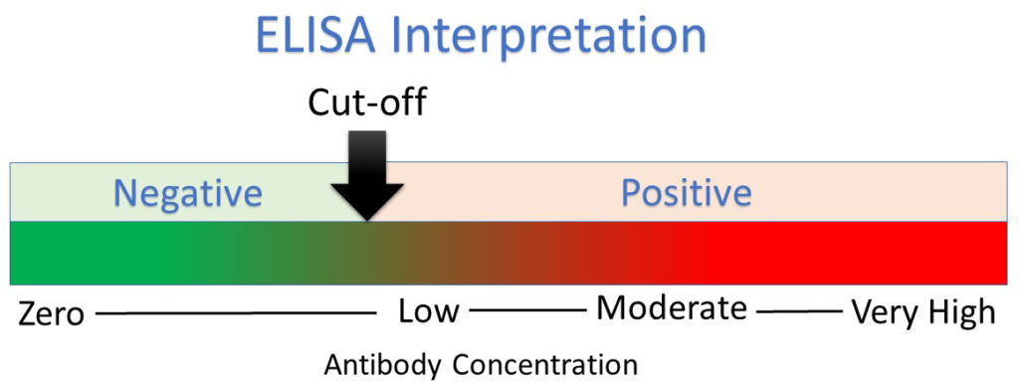
Specificity of a clinical test refers to the ability of the test to correctly identify those patients without the disease. (No false positive results) (Also called the true negative rate).
Sensitivity of a clinical test refers to the ability of the test to correctly identify those patients with the disease. (No false negative results) (Also called the true positive rate).
Validity: (or accuracy), A serological test should provide an indication of which individuals actually have the disease and which do not.
Cross-reactivity is the ability of an antigen to bind with an antibody that was raised to a different antigen. It may arise by one of two mechanisms: shared epitopes on multivalent antigens, or conformational similarity of epitopes.
Dilution is the act of making a weaker solution from a stronger solution, by adding water or saline, dilution is usually expressed as one unit of the original solution to the total number of units of the final solution. Serial dilution is decreasing the volume of serum progressively by maintaining a constant volume of fluid. Most commonly serial dilutions are two-fold or ten-fold range of dilutions, but finally, the total volume in each tube is the same.
A general rule for calculating the concentration of solutions
M1V1=M2V2
A titer is a way of expressing concentration, through employs serial dilution to obtain approximate quantitative information. The titer corresponds to the highest dilution factor that still yields a positive reading.
Antibody titer is a measurement of how much antibody an organism has produced that recognizes a particular epitope, expressed as the inverse of the greatest dilution (in a serial dilution) that still gives a positive result.
The endpoint titer is defined as the reciprocal of the highest analyte dilution that gives a reading above the cutoff, or the point in a titration at which a reaction is complete, often marked by a colour change.
This type of serologic testing employs known antiserum (serum containing specific known antibodies). The preparation of known antibodies is prepared in one of two ways: in animals or by hybridoma cells.
1. Polyclonal antibodies; preparation of known antisera in animals, involves inoculating animals with specific known antigens such as a specific strain of a bacterium. After the animal's immune responses have had time to produce antibodies against that antigen, the animal is bled and the blood is allowed to clot. The resulting liquid portion of the blood is the serum and it will contain antibodies specific for the injected antigen.
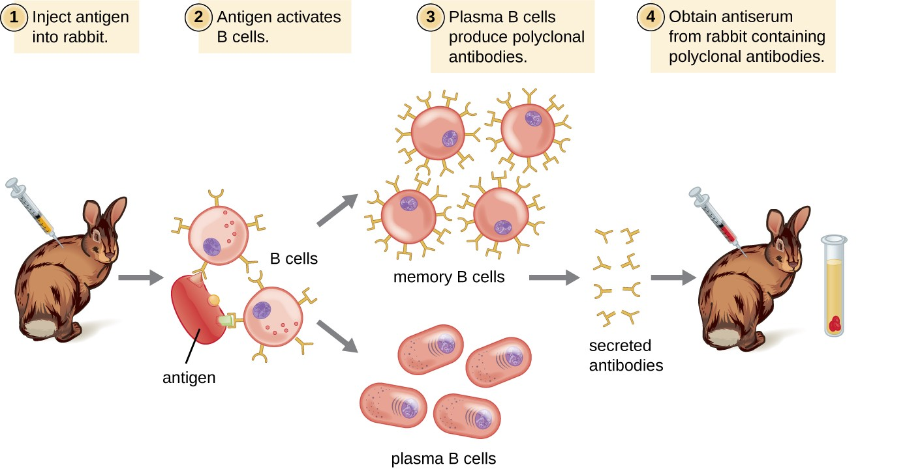
Because most antigens are complex structures with multiple epitopes, they result in the production of multiple antibodies in the lab animal. This so-called polyclonal antibody response is also typical of the response to infection by the human immune system. Antiserum drawn from an animal will thus contain antibodies from multiple clones of B cells, with each B cell responding to a specific epitope on the antigen.
Lab animals are usually injected at least twice with antigen when being used to produce antiserum. The second injection will activate memory cells that make class IgG antibodies against the antigen. The memory cells also undergo affinity maturation, resulting in a pool of antibodies with higher average affinity.
On re-exposure to the antigen, those B cells capable of producing an antibody with higher affinity antigen-binding sites will be stimulated to proliferate and produce more antibody than their lower-affinity peers. An adjuvant, which is a chemical that provokes a generalized activation of the immune system that stimulates greater antibody production, is often mixed with the antigen prior to injection.
Antiserum obtained from animals will not only contain antibodies against the antigen artificially introduced in the laboratory, but it will also contain antibodies to any other antigens to which the animal has been exposed during its lifetime. For this reason, antisera must first be “purified” to remove other antibodies before using the antibodies for research or diagnostic assays.
2. Monoclonal antibody technique, preparation of known antibodies
Monoclonal antibodies (mAb) are defined as the antibodies derived from a single clone of plasma cell; all having the same antigen specificity, produced against a single epitope of an antigen.
In this technique, an animal is injected with the specific antigen for the antibody required. After the appropriate time for antibody production, the animal's spleen is removed. The spleen is rich in plasma cells and each plasma cell produces only one specific type of antibody. However, plasma cells will not grow artificially in cell culture. Therefore, a plasma cell producing the required antibody is fused with a myeloma cell, a cancer cell from bone marrow which will grow rapidly in cell culture, to produce a hybridoma cell. The hybridoma cell has the characteristics of both parent cells. It will produce specific antibodies like the plasma cell and will also grow readily in cell culture like the myeloma cell. The hybridoma cells are grown artificially in huge vats where they produce large quantities of the specific antibody (Myeloma tumour cells used for hybridoma production are deficient in the enzyme hypoxanthine phosphoribosyltransferase. This defect leads to their inability to survive in a medium containing hypoxanthine, aminopterin, and thymidine (HAT medium). Antibody-producing spleen cells, however, contain the enzyme. Thus, fused hybridoma cells survive in the selective medium and can be recognized by their ability to grow indefinitely in the medium. Unfused antibody-producing lymphoid cells die after several multiplications in vitro because they are not immortal, and unfused myeloma cells die in the presence of the toxic enzyme substrates. The only surviving cells are true hybrids.
However, when only one clone of B cell is stimulated by a single epitope of an antigen and then is allowed to proliferate and produce antibodies; such antibodies are referred to as monoclonal antibodies (mAb).
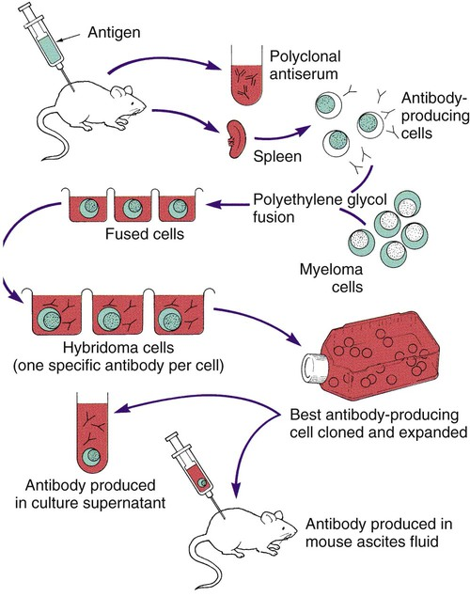
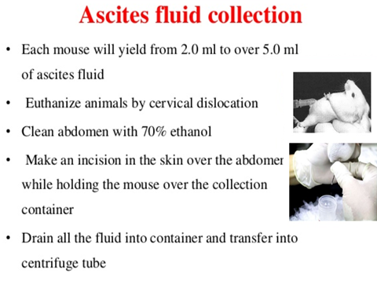

Monoclonal Antibodies produce in mouse ascites fluid
The ascites method is one of the quickest for producing large amounts of monoclonal antibodies. One mouse can produce 3-5 ml of ascites fluid after undergoing several extraction cycles after inoculation. Inoculating multiple mice simultaneously can produce large batches of a monoclonal antibody.
- Priming the Mouse
The mouse’s peritoneal cavity needs to be primed before hybridoma cells are injected. This promotes growth and antibody production in the hybridoma cells. Pristine is often used; it induces an immune reaction and prevents fluid from leaking out of the peritoneum. Priming is done by injecting 0.3mL of Freund’s Incomplete Adjuvant FIA, intra-peritoneally (IP), per mouse, using a 23G needle because of the viscosity of the FIA. The primer should be injected one to 10 days before the injection of hybridoma cells. 2-2- Injecting the Hybridoma Cells
Hybridoma cells are grown in tissue culture prior to injection into a mouse for ascites antibody production. The process is timed such that the cells are in the growth phase in tissue culture at the time during which they are injected. It is also important that the hybridoma is in the same genetic background as the host mouse to avoid host rejection. The number of cells that are injected ranges from hundreds of thousands to millions; with millions being on the high end of this procedure.
- Incubation Times Before First Tap
Ascites fluid is allowed to accumulate for about one to two weeks before any is taken out. Care is taken to observe the condition of the mice daily. The ascites fluid is removed from the peritoneal cavity, a process referred to as “tapping.”
- Isolation of Aqueous Ascites Component
After the ascites fluid is extracted from the mouse, it is spun down in a centrifuge. This process separates the lipid compartment from the cellular compartment to the bottom. In the middle is the aqueous compartment that is referred to as ascites fluid, and that contains the desired antibodies.
Monoclonal Antibodies | Polyclonal Antibodies
Expensive production | Inexpensive production
Long production time | Rapid production
Large quantities of specific antibodies | Large quantities of nonspecific antibodies
Recognize a single epitope on an antigen | Recognize multiple epitopes on an antigen
Production is continuous and uniform once the hybridoma is made | Different batches vary in composition

Applications
- Polyclonal antibodies are to detect unknown antigens, and used as a secondary antibody in immunoassays (e.g. ELISA, western blotting, microarray assays, immunohistochemistry, flow cytometry), their role is to bind to different epitopes and amplify the signal, leading to better detection. (sensitization and stronger). Polyclonal antibodies are used in general research applications.
- Monoclonal antibodies can be used for both the therapeutic treatment and clinical detection of disease.
-An example of therapeutic use involves the use of antibodies in the treatment of rabies, to recognise cancer cells
-An example of diagnostic use involves the use of antibodies in the detection of pregnancy
Human antibodies are classified into five isotypes (IgM, IgD, IgG, IgA, and IgE) according to their heavy chain (Mu, Delta, Gamma, Epsilon, or Alpha) which provide each isotype with distinct characteristics and roles.
Allotypes represent the genetically determined differences in antibodies between people. Allotypes are used for paternity testing.
Idiotypes are antibodies that recognize different specific epitopes.
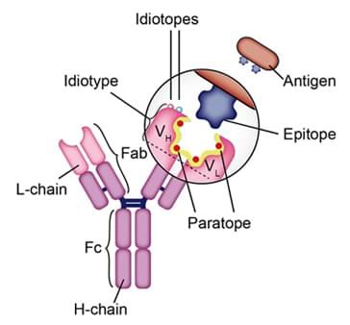
Through the end of the variable region; so it known as the set of genetic determinants of an individual; a set of antigen-binding sites which characterizes the antibodies produced by a particular clone of antibody-producing cells.
Nanobodies it’s a camelid (single-domain) antibodies, are composed of only heavy chains (no light chains). These antibodies are potential candidates to be used in antibody-based therapies because of some special characteristics, such as smaller size, good solubility, high thermostability, high affinity and specificity, low immunogenicity, and higher tissue penetration rate.
Paratope is a part of an antibody molecule composed of the variable regions of both the light and heavy chains that combine with the antigen.
Epitope ( antigenic determinant ) a site on the surface of an antigen molecule to which a single antibody molecule binds; generally an antigen has several or many different antigenic determinants and reacts with many different antibodies.
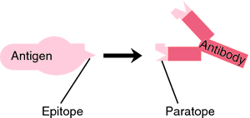
In a primary immune response, naive B cells are stimulated by antigen, become activated, and differentiate into antibody-secreting cells that produce antibodies specific for the eliciting antigen. A secondary immune response is elicited when the same antigen stimulates memory B cells, leading to the production of greater quantities of specific antibodies that are produced in the primary response.

S.N. | Characteristics | Primary Immune Response | Secondary Immune Response
1 | Definition | Primary Immune Response is the reaction of the immune system when it contacts an antigen for the first time. | Secondary Immune Response is the reaction of the immune system when it contacts an antigen for the second and subsequent times.
2 | Appearance | Appears mainly in the lymph nodes and spleen. | Appears mainly in the bone marrow and then, in the spleen and lymph nodes.
3 | Occurrence | This occurs in response to the primary contact of the antigen. | This occurs in response to the second and subsequent exposure to the same antigen.
4 | Antibody Peak | The antibody level reaches its peak in 7-10 days. | The antibody level reaches its peak in 3-5 days.
5 | Affinity of Antibody | Low affinity to their antigens. | High affinity to their antigens.
6 | Responding Cells | Naive B cells and T cells | Memory B cells
7 | Antibodies | Both thymus-dependent and thymus-independent antibodies are involved in the primary immune response. | Only thymus-dependent antibodies are involved in the secondary immune response.
8 | Lag Phase | Long (4-7 days) | Short (1-4 days)
9 | Types of Antibodies | A large amount of IgM and a small amount of IgG are produced during the primary immune response. | A large amount of IgG, a small amount of IgM, IgA, and IgE are produced during the secondary immune response.
10 | Amount of Antibody | Few antibodies are produced in the primary immune response. | 100-1000 times more antibodies are produced in the secondary immune response.
11 | Strength of the Response | The primary immune response is usually weaker than secondary immune response. | The secondary immune response is stronger.
12 | Antibody level | Antibody level declines to the point where it may be undetectable. | The antibody level tends to remain high for longer.
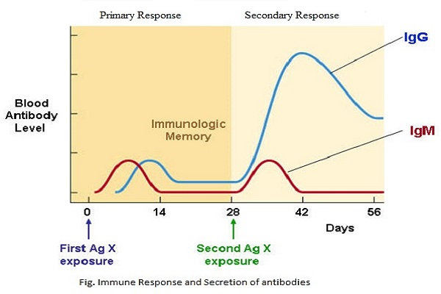
The first time the human body is exposed to some particular type of pathogen, the immune system responds in a specific way and this response is called the primary response. It consists of a relatively long latent phase during which our innate immunity is working but the adaptive immune system is still being mobilizedيتحشد. When our adaptive immunity is fully functional, plasma cells begin to produce antibodies and their concentration rises logarithmically. Eventually, as the pathogen is destroyed, the concentration of antibodies begins to drop and this is called the decline phase. During the primary response, memory cells that contain a copy of the antibody remain in our system. If we are ever reinfected with that same type of pathogen, our body will respond with a secondary immune response. This is a much quicker and more efficient response because our body now contains the memory cells with the antibodies that are specific to that reinvading antigen. The secondary response has a shorter latent phase and reaches a much higher peak antibody concentration. In addition, the dominant antibody produced during the secondary response is immunoglobulin G as compared to immunoglobulin M that is released during the primary phase.

