**Lec.5 Nanotechnology Dr.Neihaya Heikmat**

**Application of nanotechnology**

Nanotechnology is making significant improvements in technologies for protecting the environment. Nanoscale devices are being used for enhanced sensing, treating and remediation environmental contaminants.

**Nanoscale Developments in the Environment**

1.**Nanosensors** can be used to detect and track pathogens (germs), contaminants, nutrients, environmental characteristics (light/dark, hot/cold, wet/dry), heavy metals, particulates, and allergens.

**Nanotools** can track agricultural products and improve their quality by detecting pesticides, fertilizers, and biological events.

2.**Nanodevices** can be used to extract unwanted agricultural byproducts from soil and water.

3.**Nanocatalysts** will bioprocess waste into food, feed, industrial chemicals, biofuels and energy. (Catalysts are molecules that can quicken the speed of a chemical reactions by factors.

4.**Nano-filters** and **nano-bioreactor** can be used to study enzymes and microbes in compost systems.

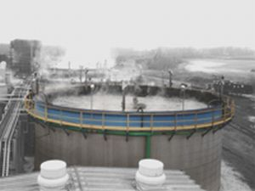

5.**Trends in nanotechnology** can be utilized to clean up toxic waste sites. Researchers have developed **sponge-like nanoporous** materials that will clean up pollutants in air and water, and break down toxic wastes therefore reducing greenhouse gases.

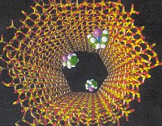

**Cleaner Water with Nanotechnology**

1-Nanotechnology can clean contaminated drinking water cheaply and simply enough to use in developing countries.

2-Researchers have developed nanocrystalline photocatalysts that purify water by accelerating a reaction that requires light.

3-Pipes might be coated with nanoparticles to weaken pollutants as they pass through.

**Applications-Treatment**

* Cleaning up waste streams of contaminants, particularly those substances that are highly toxic, persistent within the environment, or difficult to treat.

**Applications-Green Energy**

* Nano products such as Solar and fuel cells could lead to commercially viable alternative clean energy sources.

**Nanotechnology in Agriculture**

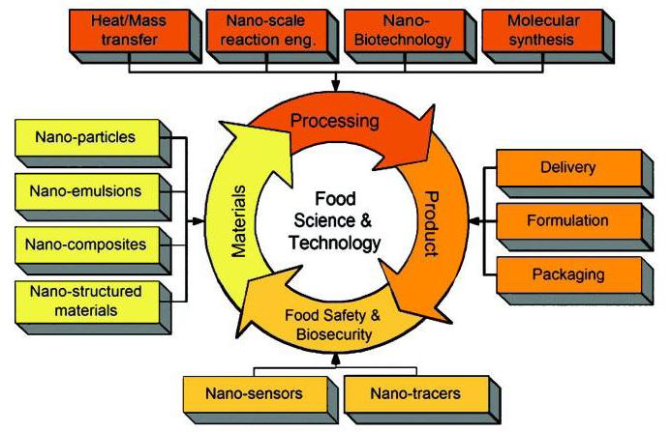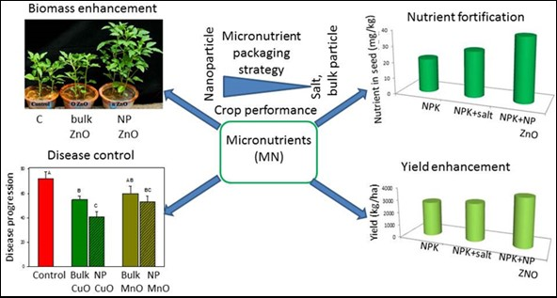

**Uses for nanotechnology in food**

-Nanotechnologies are being developed all the time. Here are some examples that are being used:

-**nanocarrier systems** for delivery of nutrients and supplements;

-**organic nano-sized additives** for food, supplements and animal feed;

-**food packaging** applications e.g. plastic polymers containing or coated with nanomaterials for improved mechanical or functional properties;

-**nanocoatings** on food contact surfaces for barrier or antimicrobial properties;

-**nano-sized agrochemicals** (a chemical used in agriculture, such as a pesticide or a fertilizer.);

-**nanosensors** for food labelling.

**Food examples**

-Nanoparticles are being used to **deliver vitamins or other nutrients** in food and drinks without affecting the taste or appearance.

-These nanoparticles **encapsulate the nutrients** and carry them through the stomach into the bloodstream.

-**Nanoparticle emulsions** are being used in ice cream and various spreads to improve the texture and uniformity.

-It **provides healthier foods** (e.g. lower fat, lower salt) with desirable sensory properties;

**Packaging examples**

-Researches have produced **smart packages** that can tell consumers about the freshness of milk or meat.

When oxidation occurs in the package, nanoparticles indicates the colour change and the consumer can see if the product is fresh or not.

Incorporation of nanoparticles in packaging can increase the barrier to oxygen and slow down the degradation of food during storage.

-Bottles made with **nanocomposites minimize the leakage** of carbon dioxide out of the bottle.

-**Food storage** bins have silver nanoparticles embedded in the plastic. The silver nanoparticles kill bacteria from any food previously stored in the bins, minimizing harmful bacteria.

**The future of nanotechnology**

Research is being carried out to develop **nanocapsules containing nutrients** that would be released when nanosensors detect a deficiency in your body.

Nanomaterials are being developed to **improve the taste, colour, and texture** of foods. For example, “interactive” foods are being developed that would allow you to choose which flavour and colour a food has.

**OPPORTUNITY FOR NANOTECHNOLOGY BASED TRADITIONAL MEDICINES**

**Curcumin**

widely accepted as traditional medicine in Southeast Asia. It is commonly used as spice and nutritional supplement, Used as **antioxidant, anti-inflammatory, antiviral, antibacterial, antifungal, anticancer** activities and potentially acts against various malignant diseases, diabetes, allergies, arthritis and Alzheimer's disease etc.

Major problems associated with its use are its low solubility, bioavailability and stability.

Curcumin is reported to be unstable in the gut, and little amounts of curcumin that pass through the GI tract are rapidly degraded. Nanotechnology has been successfully utilized here and has proven to be very effective in solving these problems.

*In vitro* therapeutic efficacy of nano formulated curcumin and free curcumin against a panel of human pancreatic cancer cell lines showed comparable results.

Novel polymeric amphiphile conjugates with hydrophilic and hydrophobic segments showed minimal toxicity on HeLa cells. **Nanocrystal** solid dispersion of curcumin, amorphous solid dispersion, and **nanoemulsion** exhibited marked improvement in the dissolution behavior when compared with crystalline curcumin with significant improvement in pharmacokinetic behavior.

***Ginkgo biloba***

Sources: Grape seed, hawthorn, milk thistle, green tea, and ginseng. **Active Component: Flavonoid and terpenoids.**

Drugs can be embedded or dissolved in nanoparticles and can also be adsorbed or coupled on the surface. **Encapsulating drugs within NPs** can improve the solubility and pharmacokinetics of drugs. The leaf extract of *Ginko biloba L*. has been widely used for brain cell activation properties. The nano sized *G. biloba* extract is expected to activate the brain cell and work on the treatment of Alzheimer's dimentia (like loss of memory, thinking, language, judgement and behaviour) better than pure extract.

The pharmacokinetic behavior and physicochemical factors related with **delivery systems** are considered to be primarily responsible for the improved targeting and therapeutic effectiveness; therefore, dealing with these factors during development of nano-herbal formulation can lead to more promising treatments for acute and chronic diseases.

Therefore, the nanoformulation can overcome the disadvantages of:

Poor aqueous solubility, physical instability, low drug absorption, lower bioavailability, slow pharmacological action, drug targeting, faster elimination, toxicity of many herbal drugs.

**Applications of novel drug delivery system for herbal formulations**

Great advances have been made on development of novel drug delivery systems (NDDS) for plant actives and extracts. Novel herbal formulations like:

* polymeric nanoparticles,
* nanocapsules,
* liposomes,
* phytosomes,
* nanoemulsions,
* microsphere, have been reported using bioactive and plant extracts.

Novel formulations are reported to have remarkable advantages over conventional formulations of

plant actives and extracts which include:

* enhancement of solubility,
* bioavailability,
* protection from toxicity,
* enhancement of pharmacological activity, enhancement of stability,
* improved tissue macrophages distribution, sustained delivery,
* and protection from physical and chemical degradation.

**LIPOSOMES FOR ANTIMICROBIAL DRUG DELIVERY**

* Liposomes are spherical lipid vesicles with a bilayered membrane structure consisting of amphiphilic lipid molecules.
* After extensive studies on their fundamental properties including lipid polymorphisms, lipidprotein and lipid-drug interactions,



**Biosensors**

* An alternative approach is to develop sensors so tiny that they can be semi permanently implanted inside the body, where they can continuously monitor their surroundings.
* New fields of nanotechnology are both components of the biosensor are excellent candidates for the application of nanotechnology.

**Nanorobotics**

* are the technology of creating machines of robots at or close to the nanometer scale.
* Using special bacterium-sized "assembler“ devices, nanotechnology would permit on a programmable basis exact control of molecular structures.

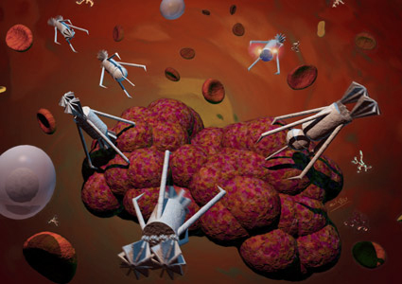

**Nanotechnology and Cancer**

* Nanotechnology has the potential to enable cancer research and
* improve molecular imaging,
* early detection,
* prevention,
* and treatment of cancer.

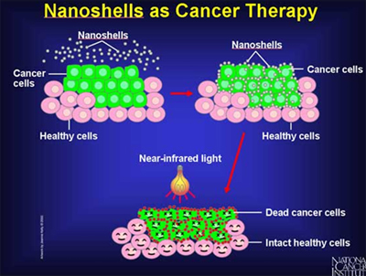

**Prostheses and implants**

* Nanotechnology also has applications in tissue engineering to help a person who needs new bones, teeth, or other tissues. That technique based on biological nanostructures is viable.
* Biomimetic nanostructures start with a predefined nanochemical or physical structure.