**Applications of biosynthesis nanoparticles Lec.5**

**Nanomedicine** is defined as the application of nanotechnology to health, and hence is virtually synonymous with **Nanobiotechnology**.

**Quantitative detection devices** for early diagnosis and for **therapy monitoring** will have a wide influence in patient management, in improving patient’s quality of life and in lowering mortality rates, in diseases like cancer and Alzheimer’s disease.

The following applications as being close to or on the market:

• **Sensors** for medical and environmental monitoring and for preparing pure chemicals and pharmaceuticals.

• **Light and strong materials** for defense, aerospace, automotive, and medical applications.

• **Lab-on-a-chip** diagnostic techniques.

• **Sunscreens** with ultraviolet-light absorbing nanoparticles.

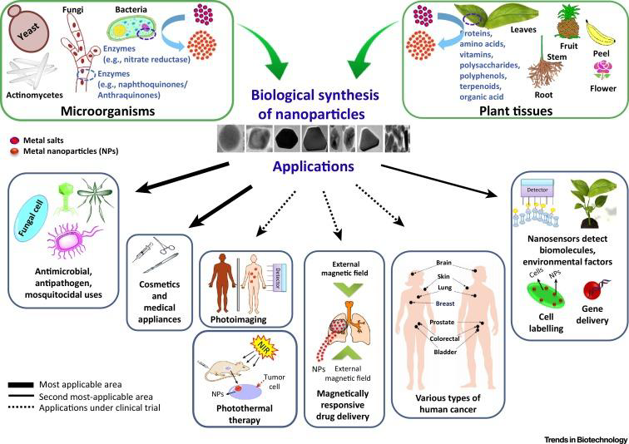

**Drug Delivery**

Over the last few decades, the applications of nanotechnology in medicine have been extensively explored in many medical areas, especially in drug delivery.

By loading drugs into nanoparticles through physical **encapsulation, adsorption, or chemical conjugation.**

The aim of drug delivery is to encapsulate a therapeutic agent to cover its properties until it reaches its target and is released. The encapsulation must therefore be able to respond to its environment.

**Applications of novel drug delivery system**

Great advances have been made on development of **novel drug delivery systems** (NDDS) like:

**Polymeric nanoparticles, nano capsules, liposomes, phytosomes, nanoemulsions, microsphere.**

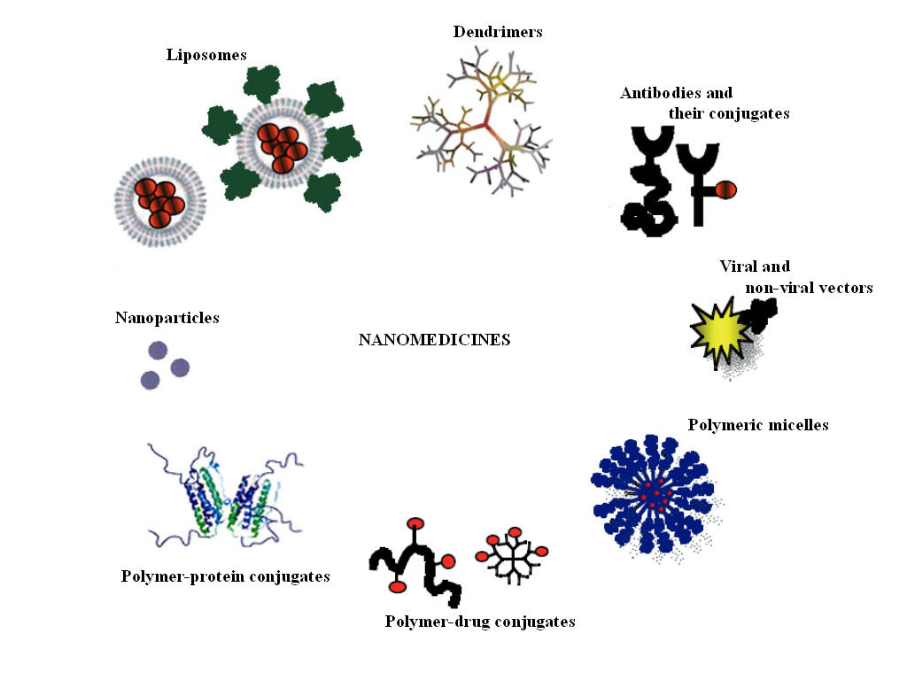

Novel formulations are reported to have **remarkable advantages** over conventional formulations

which include:

enhancement of solubility, bioavailability, protection from toxicity, enhancement of pharmacological activity, enhancement of stability, improved tissue macrophages distribution, sustained delivery, and protection from physical and chemical degradation.

**LIPOSOMES FOR ANTIMICROBIAL DRUG DELIVERY**

Liposomes are **spherical lipid vesicles with a bilayered membrane structure consisting of amphiphilic lipid molecules**.

After extensive studies on their fundamental properties including lipid polymorphisms, lipidprotein and lipid-drug interactions, and mechanisms of liposome disposition in **1980s,** the application potential of liposomes as a drug delivery vehicle was thoroughly recognized and started being transferred to practice.

In **1995, Doxil** (doxorubicin liposomes) became the first liposomal delivery system approved by the Food and Drug Administration (FDA) to treat AIDS. Liposomal drug delivery system can be made of either natural or synthetic lipids.



**Antimicrobial application of nanoparticles**

**-** Antifungul.

- Antiviral.

- Anti-itch Treatment, Eczema, Foot Treatment.

- Germ Free Products, Germicide Products.

**Biosensors**

An alternative approach is to develop sensors so tiny that they can be semi permanently implanted inside the body, where they can continuously monitor their surroundings.

New fields of nanotechnology are both components of the biosensor are excellent candidates for the application of nanotechnology.

The glucose sensor follows classic biosensing design: a recognition element to capture the analyte (glucose) mounted on a transducer that converts the presence of captured analyte into an electrical signal.

The recognition element is typically a **biological molecule**, the enzyme **glucose oxidase**, hence (if small enough) this device can be categorized as both nanobiotechnology and bionanotechnology.

**Automated diagnosis**

Diagnosis is essentially a problem of pattern recognition: an object (in this case, the disease) must be inferred from a collection of features.

the practical possibility depends on the availability of extremely powerful processors, based on chips having the very high degree of integration enabled by **nanoscale components on the chips.**

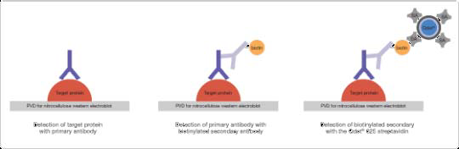

**Nano robotics**

It is the technology of **creating machines of robots** at or close to the nanometer scale. Using special bacterium-sized "**assembler“ devices,** nanotechnology would permit on a programmable basis exact control of molecular structures that are not readily manipulated by natural molecular machines.

With nanotechnology, atoms will be specifically placed and connected, all at very rapid rates, in a fashion similar to processes found in living organisms.

**Custom synthesis**

**Small modifications to a drug** would adapt its efficacy to other type variants. Different drugs will certainly be needed to treat different groups of patients suffering from what is clinically considered to be the same disease.

The development of **nanomixers** would represent a key step in making custom synthesis of drugs for groups of patients, or even for individual patients, economically viable.

**Nanotechnology and Cancer**

Nanotechnology has the potential to enable cancer research and improve molecular imaging, early detection, prevention, and treatment of cancer.

**1-Molecular imaging and early detection:** Nanotechnology can have a clear-changing impact on the ability of clinicians to spot cancer in its earliest stages.

**Detection of biomarkers** using nanotechnology may help researchers with molecular imaging of malignant lesions and allow doctors to see cells and molecules that are undetectable through conventional imaging.

Additionally, **photoluminescent nanoparticles** may allow oncologists to discriminate between cancerous and healthy cells.

**Nanomagnetics for Cancer Detection**

Earlier cancer detection, Development of nanomagnetic sensor, Use magnetic nanoparticles to ‘tag’ proteins indicative of cancer.

**2-Prevention and control**

**Proteomics and bioinformatics** will enable researchers to identify markers of cancer susceptibility and precancerous lesions.

Nanotechnology will then be used to develop devices that indicate when those markers appear in the body and deliver agents to reverse premalignant changes or kill those cells that have the potential to become malignant.

**3- Cancer treatment**

**Nanoscale devices** can contain both targeting agents and therapeutic payloads to produce high local levels of a given anticancer drug, particularly to tumors deep within the body that are difficult to access.

Nanoscale devices also develop new approaches to therapy, to combine a diagnostic or imaging agent with a drug, and to determine whether the drug acted on its target.

**“Smart” nanotherapeutics** may provide clinicians the ability to time the release of an anticancer drug or to deliver multiple drugs sequentially in a timed manner or at several locations in the body.

**Prostheses and implants**

Nanotechnology also has **applications in tissue engineering** to help a person who needs new bones, teeth, or other tissues. That technique based on **biological nanostructures** is viable.

**Biomimetic nanostructures** start with a predefined nanochemical or physical structure. A nanochemical structure may be an array of large reactive molecules attached to a surface, while a nanophysical structure may be a small crystal.

Other groups want to apply nanostructured materials in artificial sensory organs such as an electronic eye, ear, or nerve.

**Nanotechnology in Agriculture and Food Technology**

Areas of Nanoscience Research in Agriculture and Food Science were:

**1. Pathogen and contaminant detection.**

Imagine using nanotechnology to create self-healing materials or coatings that can modify agricultural materials or packaging to prevent microbial contamination; Or sensors which can slow decomposition and detect pathogens before your nose does.

**2.Tracking crops and products.**

Products Traceable nanotags and food quality sensors could improve food quality, taste and nutritional value. Preserve foods and extend nutritional stability.

**3.Nanodevices for molecular and cell biology.**

Nanotechnology is making revolutionary changes within cells which will improve agriculture and the food industry in amazing ways.

Develop better soil additives, fertilizers, pesticides, and **soil conditioners**. **Develop surfaces** that select, reject or bond to molecules based on nanotechnology.

**4.Environmental issues and agricultural waste.**

Agriculture is utilizing nanotechnology as it works toward the following solutions:

-Understanding the role of nanoparticles (inorganic and organic) in the movement and uptake of nutrients and pollutants; and the movement and toxicity of nanoparticles in agricultural pollution (dust, feedlot runoff);

-Reducing or converting animal or plant waste into useful products.

-Designing and developing reusable nanomaterials, such as nanocatalysts, that help reduce waste materials.

-Create ammonia needed in fertilizer.

-Create artificial iron in water.

-Clean soils using nanoparticles in water that clean the soil as they pass through it.