Cyto 5

4.2.4. Numerical sex chromosome aberrations
4.2.4.1. Turner syndrome
The Turner syndrome is characterized by 45,X0 karyotype. This is the only viable
monosomy. The explanation for this lies in the fact that while both homologues of the autosomes are necessary to the normal phenotype - so their monosomy is lethal – by contrast in females only one X chromosome is active (see the dose compensation in X inactivation), so a functional monosomy and Barr body negativity can be maintained. However, for the normal development of female sex characteristics both X chromosome is needed, as indicated by the symptoms of Turner syndrome. Although the frequency is 1:5000 in newborn female infants, the conception rate is much higher, but 99% of them spontaneously abort. This is in good agreement with the concepts of the viability of monosomies. 80% of these cases are due to paternal meiotic non-disjunctions, therefore in these patients only one maternal X chromosome is present.
While it is easy to understand the sexual development related characteristics of the syndrome, the low height is still not fully explained. It is assumed that a gene coding a protein of the small ribosome subunit (RPS4X) may also play a role. Because this gene has a Y chromosomal counterpart (RPS4Y) as well, both in normal females and males double dose of this ribosomal protein is produced. In Turner syndromic individuals less than sufficientamount is produced, and if the ribosome number is less than normal it will largely influence the production of other proteins, and thus indirectly the body height, too.
Although Turner syndrome is often characterized by normal intelligence there is a difference in verbal skills, social integration between patients inherited their X chromosome from father or the mother. Maternal X carriers, according to surveys are weaker in these features than the patients inherited paternal X. The phenomenon is explained by the different methylation of the two types X chromosome and the genomic imprinting.

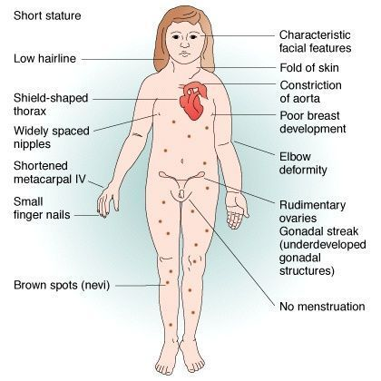

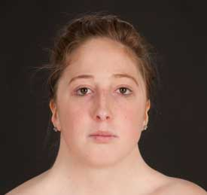

4.2.4.2.Klinefelter syndrome
Klinefelter syndrome is characterised by 47,XXY karyotype and male phenotype. The frequency is 1:1000. Nearly it is derived with the same probability from maternal (56%) and paternal (44%) non-disjunction. 36% of the maternal non-disjunctions take place in the first meiotic division. Since there are two X chromosomes, thus they are Barr body positive. Their sterility can also be attributed to presence of 2 X chromosomes, since certain X chromosomal gene products are in a higher dose than in normal fertile males.

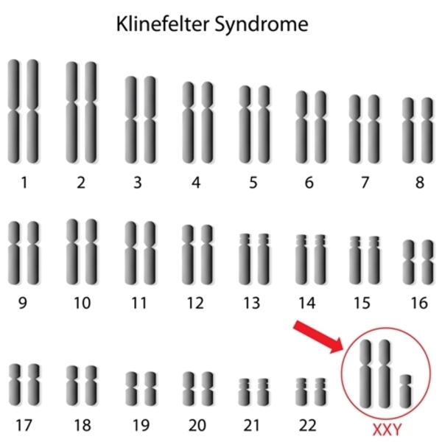

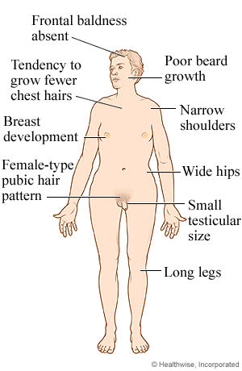

4.2.4.3. Triple X syndrome
Feminine phenotype and 47, XXX karyotype are present. 89% is of maternal, 8% is of paternal origin, and the remaining 3% is due to post-fertilization mitotic non- disjunction. Neonatal frequency is 1:1000. Two Barr bodies are typical.

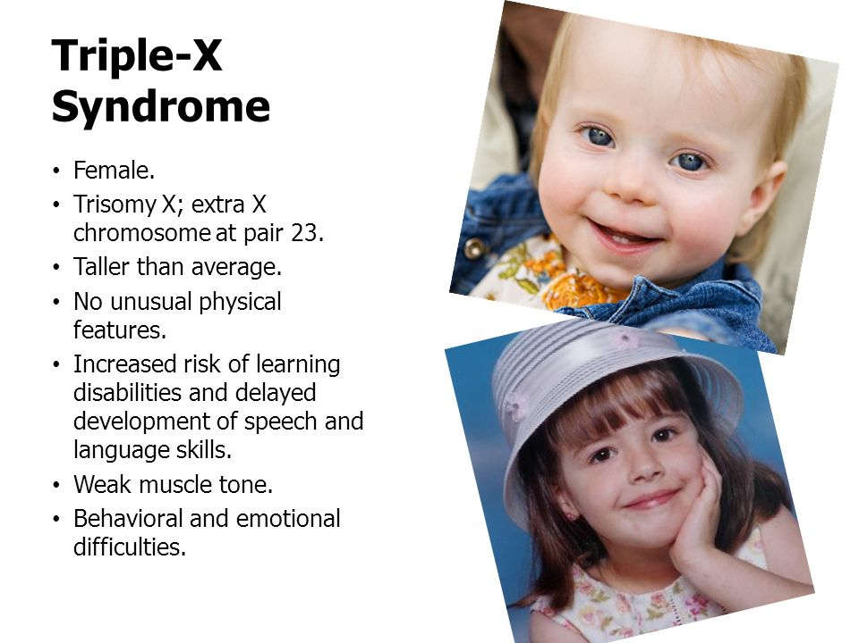

4.2.4.4.Double-Y syndrome, "superman" or Jacobs syndrome In this case normal, slightly taller than the average males have 47,XYY karyotype. The birth rate is 1:1000. They derived only from paternal second meiotic non-disjunction. In contrast to all meiotic non-disjunctions, the formation is not affected by age, as paternal gametogenesis is continuous from puberty, there are no aged sperms. They are also featured by poorly tolerated frustration and stronger aggressivity; perhaps that is why this chromosome abnormality is found in greater numbers amongst imprisoned men. The aggressiveness and the possible criminal tendency are strongly debated, and it would only be 100% decided if the entire male population would be karyotyped and comparative data about their aggressivity would have been available as well. Today many different aggressiveness associated genes and gene mutations are known, that is why the role of the Y chromosome in aggressiveness is questioned. Knowing the characteristics of meiotic division we could ask that the two aneuploidies
(47,XXX and 47,XYY) with normal fertility are characterized by greater prevalence of
similar disorders among offspring or not. For example, in the case of double Y syndrome the following karyotypes offspring are expected in the offspring: 2 XXY, 2 XY, 1 XX and 1 XYY. In contrast, birth of only normal offspring was reported so far, however its exact
explanation is still not known.

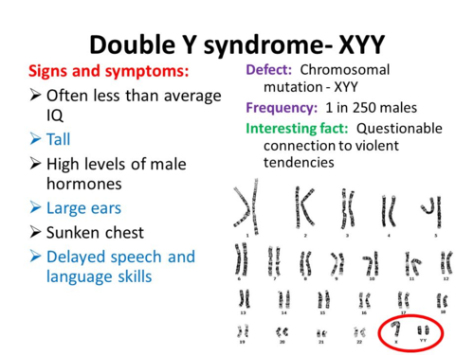

4.3. Uniparental disomy (UPD)
This abnormality which is not or hardly identifiable by cytogenetic methods were
recognized - due to molecular biological techniques - in the past decades. The UPD means that the person concerned has a normal chromosome number, but the homologues of a certain chromosome – in contrast to normal - are from the same parent, either from the father or from the mother.
As for the formation two consecutive numerical aberrations are in the background: a meiotic non-disjunction and an anaphase lag occurring during the early cleavage divisions. So in fact a trisomic zygote is formed first, and subsequently the 3 homologue is lost. Depending on whether first or second meiotic non-disjunction occurred, uniparental heterodisomy or uniparental isodisomy is present. The first case is when the
child inherits two different homologues from the parent (one grandmaternal and one
grandpaternal), that is non-disjunction occurred in the first meiosis. The latter is when the two homologues inherited are the same (either both are grandmaternal or grandpaternal) suggesting a second meiotic non-disjunction.

In UPD depending on the parental origin of the homologues, and due to genomic imprinting, different symptoms may be seen. The different symptoms in some of the Prader-Willi and Angelman syndrome cases are not due to the 15q deletion, but the UDP.

4.4. Mixoploid mutations
In mixoploidy or in mutations associated with mixed ploidity usually two (sometimes
more) cell lines with different chromosome numbers are found within an organism. There are two forms: mosaicism and chimerism.

4.4.1. Mosaicism
In genetics a mosaic is a living creature, where two cell lines of different chromosome
numbers, but of the same origin are present in the body. They are either aneuploid or
polyploid mosaics.
The former occurs as a result of mitotic non-disjunction or anaphase lag during cleavage, two cell lines of different chromosome number are formed, when one is normal and the other is aneuploid, generally trisomic. For example, assuming a two-cell embryo, if one cell is divided normally and the other is abnormally, then finally 2 normal and 1 trisomic and 1 monosomic cells are present. Since the monosomic cells are not viable eventually the ratio of the normal and the trisomic cells will be 2:1.

In the case of polyploid mosaicism a normal and a polyploid (generally triploid /
tetraploid) cell line are present. In this case, however mitotic spindle error leads to the
formation of the aberration. Again, assuming a two-cell embryo, if one divides normally, the other not, ultimately there will be 3 cells instead of four, and two are normal and one is tetraploid. Depending on the time the aberration occurs (during cleavage or in organogenesis or even later in development), the symptoms become more or less severe. So the proportion of normal and defective cells is crucial. Mosaicisms involving sex chromosomes are relatively common. In the case of gonadal mosaicism only the cells in the germ line have abnormal chromosome number, thus the risk of numerical aberrations in the offspring is high. Unfortunately, the detection of such defects is still not possible routinely, but the birth of an abnormal offspring of the patient can indicate this. Mosaicism in a broader sense is a somatic mutation, when different mutants (alleles) of a given gene are located in different organs or in different cells of the same organ (for example eyes with different colors: one is blue and the other is brown or a blue eye with brown spots).

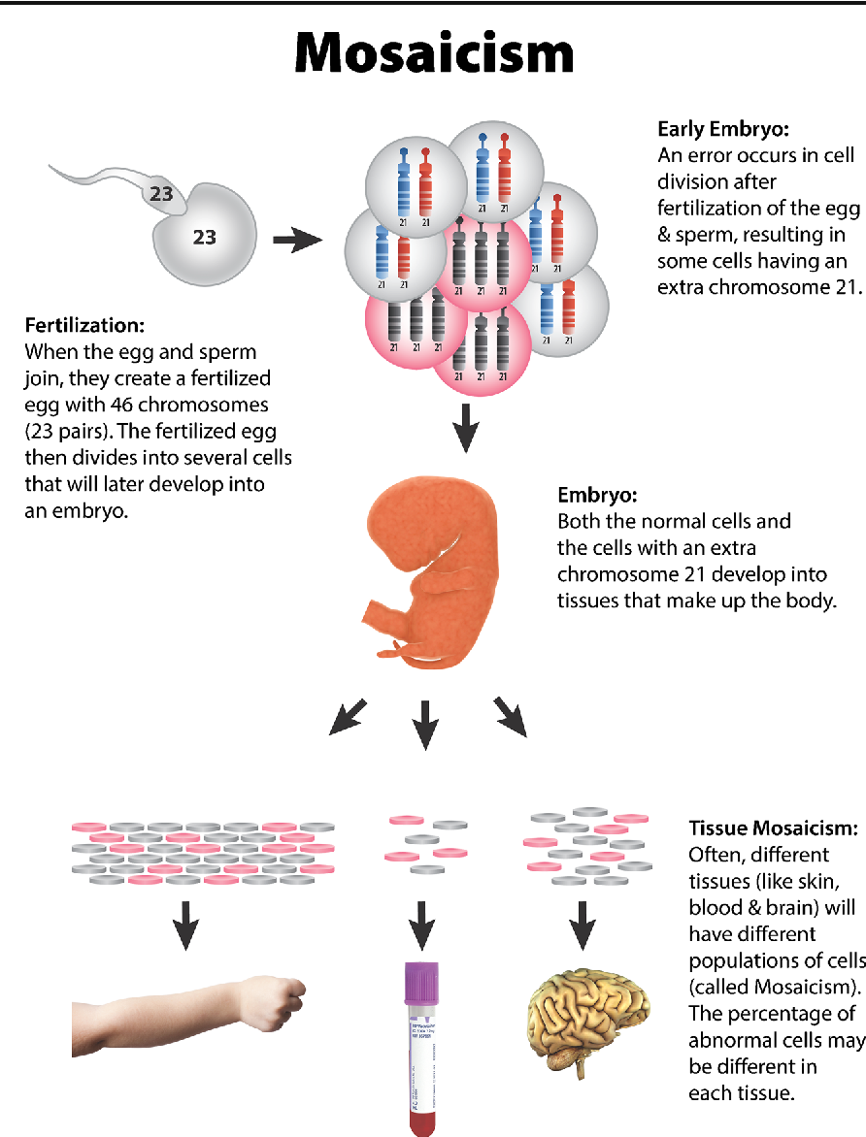

4.4.2. Chimerism
After the lion-headed, bird-legged, snake-tailed monster of Greek mythology the creature that has two cell lines of different origin - derived from different zygotes - is called chimera. A chimera is derived either from fusion of fraternal twins, or from double fertilization of an egg and a polar body (polocyte), or from transplacental haematopoietic stem cells exchange between fraternal twins (blood group chimerism).
Recently, the chimera referred to as transgenic animals / plants, which contain cells of
different origin, derived from either the fusion of few-cell-embryos, or via the microinjection of foreign genes into fertilized oocytes.

