Biological Synthesis of Nanoparticles from Plants Lec. 4
Approaches in Metal nanoparticles synthesis- Nanomaterials fabrication methods can be classified according to whether their assembly followed either:
1- Bottom to up
where smaller components of atomic or molecular dimensions self-assemble together, according to a natural physical principle or an externally applied driving force, to give rise to larger and more organized systems;
Methods like: Chemical/electrochemical: Precipitation, Vapor deposition. Atomic/molecular condensation, sol-gel process, Spray pyrolysis.
Self-assembly
Self-assembly is the ‘fabrication tool’ of nature: all-natural materials, organic and inorganic, are produced through a self-assembly route to create complex structures with nanoscale precision.
Examples are the formation of the DNA double helix or the formation of the membrane cell from phospholipids.
In self-assembly, sub-units spontaneously organize and aggregate into stable, well-defined structures through non-covalent interaction.
2- Top to Dawn
The top-down approach, a process that starts from a large piece and subsequently uses finer and finer tools for creating correspondingly smaller structures.
Mechanical/Ball milling, Diffusion flame, Thermal/ Laser ablation, Microwave, Ultra films, Lithography.

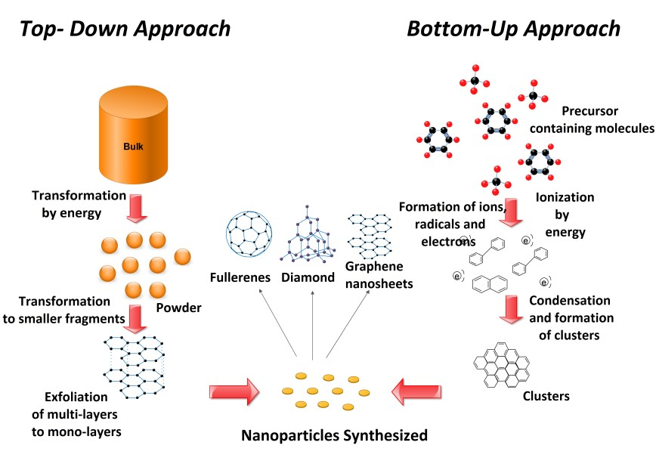
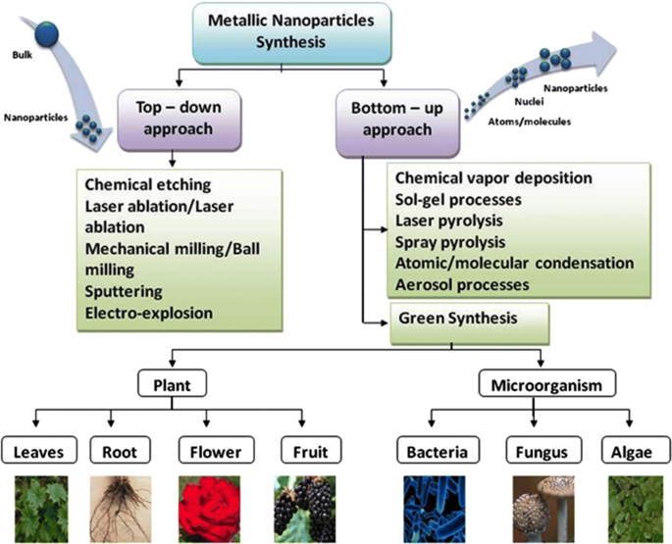
PHYSICAL AND CHEMICAL METHODS
Various physical and chemical processes have been exploited in the synthesis of several organic metal nanoparticles.
-The high energy requirement in physical methods of nanoparticle synthesis.
-the waste disposal problems in chemical synthesis,
-so both methods are costly.
-and generate toxic by product are major demerits of the conventional nanoparticle synthesis.
Biosynthesis of nanoparticles
Accordingly, there is a necessary need to extend for environmentally benign procedures for synthesis of nanoparticles.
A promising move towards to reach this objective is to develop the array of biological resources in nature.
Such drawbacks demand the development of clean, biocompatible, nonhazardous, inexpensive, energy-efficient, and eco-friendly methods for nanoparticles synthesis.
Biological (Green) synthesis:
Microscopic: Bacteria, Actinomycetes, Fungi
Macroscopic: Algae, Seaweeds, Plant Extracts (Leaves, Bark, Stem, Shoots, Seeds, Latex, Secondary metabolites, Roots, Twigs, peel, fruit, seedlings, essential oils, Tissue cultures, Gum)
Phytonanotechnology
Phytonanotechnology has provided new avenues for the synthesis of nanoparticles and is an ecofriendly, simple, rapid, stable, and cost-effective method.
Phytonanotechnology has advantages, including: biocompatibility, Scalability, and the medical applicability of synthesizing nanoparticles using the universal solvent, water, as a reducing medium.
Mechanism of Biosynthesis
Reports also suggest that different mechanisms for synthesizing nanoparticles exist in different plant species.
The exact mechanism and the components responsible for plant-mediated synthetic nanoparticles remain to be elucidated.
It has been proposed that proteins, amino acids, organic acid, vitamins, as well as secondary metabolites, such as flavonoids, alkaloids, polyphenols, terpenoids, heterocyclic compounds, and polysaccharides, have significant roles in metal salt reduction and, furthermore, act as capping and stabilizing agents for synthesized nanoparticles.
Additionally, various plant parts, including leaves, fruits, stems, roots, and their extracts, have been used for the synthesis of metal nanoparticles.

Plant extracts
The reduction method using plant extracts is one step, low cost and eco-friendly, hence considered as the most preferred way for the synthesis of metal nanoparticles. Thus, this method may be included in the class of green technology.
Among various nanometals explored so far, nanoparticles of silver, gold, copper, zinc, palladium, titanium, nickel, indium etc. have been prepared by using a wide variety of plant extracts.
Leaf extracts
The leaves of plants like Mentha, Ocimum, and Eucalyptus were reported for the synthesis of gold nanoparticles.
Ocimum leaf provided finer particles compared with other plant leaves used. The gold nanoparticles were polymorphic, stable, size 30–130 nm in non-agglomerated form.
Seed extracts
The synthesis of silver nanoparticles through seeds of the plant Elaeocarpus granitrus was reported. The nanoparticles were involved for development of bionanocomposite with chitosan matrix and antimicrobial assay was done.
The synthesis of silver nanoparticles was reported using aqueous seed extract of Jatropha curcas. The stable silver nanoparticles at different concentration of AgNO3 were spherical in shape with diameter ranging from 15 to 50 nm.
Essential oils
The synthesis of gold nanoparticles with essential oils extracted from the fresh leaves of Anacardium occidentale was reported.
The NPs synthesized at room temperature were hexagonal in shape while at higher temperature were a mixture of anisotropic particles.
Peel extract
The biosynthesis of silver nanoparticles (AgNPs) from Citrus sinensis peel extract was reported. The synthesized AgNPs were an effective antibacterial agent against Escherichia coli, Pseudomonas aeruginosa and Staphylococcus aureus.
The aqueous extracts from the peels of Citrus fruits (orange, grapefruit, tangelo, lemon and lime) were used for the synthesis of AgNPs using microwave technology; the synthesis was successful for the orange peel extract.
Secondary metabolites
The plant broth of Phyllanthus amarus containing secondary metabolites was used for the formation of silver nanoparticles (AgNPs). The coconut water was used for synthesis of gold nanoparticles through microwave irradiation.
The nanoparticles were tested for cytotoxicity on two human cancer cell lines, HeLa (human cervical cancer) and MCF-7 (human breast cancer). The nanoparticles found to be nontoxic.
Stem extracts
The stem extract of Breynia rhamnoides was used for synthesis of gold and silver nanoparticles was reported.
The nanoparticles showed antibacterial property against multi-drug resistant bacteria such as Streptococcus pyogens, Pseudomonas aeruginosa, Escherichia coli, Bacillus subtilis and Staphylococcus aureus.
Fruit extracts
Tribulus terrestris L. fruit bodies were used for synthesis of silver nanoparticles. The nanoparticles were spherical shaped with 16-28 nm of size.
Latex extracts
The latex of Jatropha curcas was used in silver nanoparticles synthesis. The particles radius was 10–20 nm and stabilized by the cyclic peptides.
The latex of Euphorbia milii was used in silver nanoparticles synthesis. The silver nanoparticles sizes were of 10–50 nm.
Tissue culture extracts
The extracts from tissue culture-derived callus and leaf of the salt marsh plant (Sesuvium portulacastrum L.) used in the synthesis of silver nanoparticles.
The callus extract was able to produce antimicrobial silver nanoparticles than leaf extract.
The silver nanoparticles synthesized were spherical in shape with size 5 to 20 nm. The silver nanoparticles inhibited clinical test strains of bacteria and fungi.
Phyconanotechnology (Nanosynthesis by Microalgae)
- Microalgae are microorganisms of choice in biotechnology due to their wide range of potential bio-applications, such as:
- over-expression of pigments.
- Bioremediation.
- biofuel production.
- Nanomaterial production. and toxicity studies.
Different methodologies devised for the exploitation of microalgae in the biosynthesis of nanomaterials.

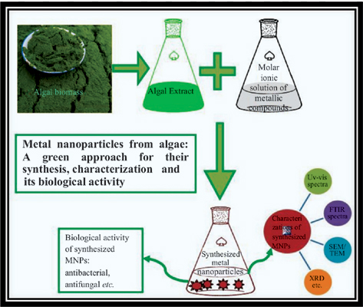

- NPs of the different parameters such as dispersion, surface properties, agglomeration and de-agglomeration can be controlled using:
- ultrasonication, ionic strength and pH of aqueous solutions, physiological buffers, and cell culture media.

Characterization of Nanoparticles
1-UV-vis, DLS, XRD, EDS, and FTIR, are considered indirect methods of determining data related to:
- Composition, structure, crystal phase, and properties of nanoparticles.

2-The surface morphology and surface area of NPs can be analyzed using scanning electron microscope (SEM).
3-To get a higher resolution of approximately 0.2 nm, atomic force microscopy (AFM) can be used. It provides real topographical images of sample surfaces.
4-X-ray diffraction (XRD) is the most essential tool used to characterize crystal structures.

