Chromatography

Chromatography
Chromatography is a general term that is applied for a wide variety of separation techniques based on the partitioning or distribution of a sample (solute) between a moving or mobile phase and a fixed or stationary phase.

Stationary Phase
It is characterized by a high surface area and get the separation of the result physiological interaction for the Material to be estimated Material to be estimated and portable by the mobile phase and this phase either solid or liquid.

Mobile Phase
Is the phase that carries the material to be separated and passes from the top of the stationary phase and this phase is either liquid or gas.
There are a large number of chromatography methods and for accurate study , chromatography methods should be classified.

Chromatography classification
The chromatographic procedures can be subdivided according to the various techniques applied, or to the physicochemical principles play role in the separation.

A-The chromatographic procedures according to the various mobile phases can be divided into three parts:
1-Gas chromatography (GC).
2- Supercritical fluid chromatography (SFC) .
3- Liquid chromatography (LC).

B- The liquid chromatography can be divided into :
1- Paper chromatography (PC).
2- Column chromatography .
3- Thin layer chromatography (TLC).

lon - Exchange Chromatography
The term "ion exchange" means the exchange between ions have the same charged between a solution and a solid material that contact with the solution but does not dissolve in it. It is called an (Ion - Exchanger).
The ion-exchanger is characterized by its own charge, and have a porous molecular structure that allows the movement of ions and solvent molecules through it in and out freely.
There are many materials that are suitable for this purpose, such as natural materials, including some types of clay and soil where the phenomenon of ion exchange was discovered for the first time in clay and soil, where it was noted that the dissolved salts ions in the water are exchange with the ions associated with soil, The clay usually contains in its crystalline structure an increase of the positive or negative charge, This charge is equivalent with the ions that have the opposite charge that are can change able with ions have the same charge soluble in the solution and in contact with the clay particles

2R - Na⁺ + Ca⁺² (R) ₂ Ca⁺² + 2Na⁺ On the exchanger in solution on the exchanger in solution

R⁻ : Is the body of the exchanger that carries a negative charge in the case of the cation exchanger which is always equated with a positive ion charge such as Na⁺ an ion exchange component R_ Na⁺ .
The stationary phase in ion-exchanger chromatography is Polymer particles (polystyrene) which is linked by side with (Divinyl benzene) , that called (Resin).The vinyl group in the ring can be easily exchanged when added an active acidic groups.

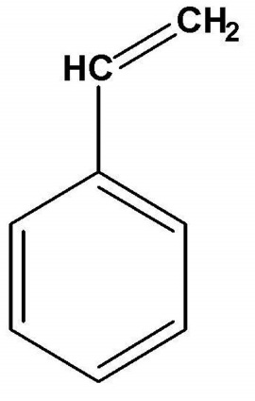

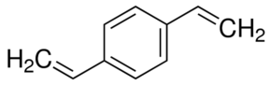
Styrene Divinyl benzene

There are four main types of ion exchanger resins used in analytical chemistry:
Exchanger Type | Effective functional groups
- Cation exchanger

- Strong acid | Sulfonic acid SO₃H⁺
- Weak acid | Carboxylic acid COOH⁺
- Anion exchanger

- Strong base | Quaternary ammonium groups  R-CH₂N⁺(CH₃)₃
- Weak base | Poly amine  R-NH₃

preparation of ion exchange column
The column is prepared by filling the solid material (resin) inside the column by adding it to a column filled with solvent and left until it precipitates. The column can be mechanically shaken or the solvent is crushed by a long piston during filling. The air bubbles formed in the column should be expelled and made less efficient.
A glass wool or perforated glass disc is placed in the bottom of the column to support the stationary phase and we can be use the burette as a column.

The dimensions of column depend on:
1- Separation efficiency required .
2- The size of the sample
3- The type of the chromatography separation method.
The dimensions of the ion exchanger column are range from a few millimeters in diameter and a few centimeters in length to a few centimeters in diameter and several tens of centimeters in length.

Eluting solvent added
Sample (Mobil phase)
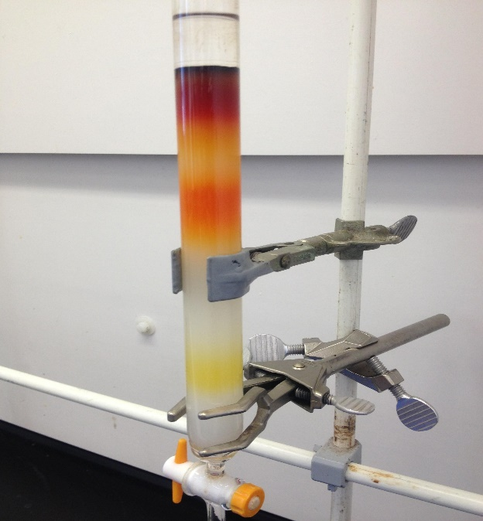Solid material(Stationary phase)

Glass wool plug

Cation exchanger resins
These resins contain acid groups linked to the aromatic ring, The positive ions exchangers (strong acid ) are sulfonic acid groups (SO₃H⁺)and it's a very strong acid similar to sulfuric acid while The positive ion exchangers (weak acid) are carboxylic groups (COOH⁺ ) , They partially ionize so that protons of these groups can be exchanged with other cations.

n Rr_ SO₃H⁺ + M ⁺ ( Rr_ SO₃⁻ )_{n} M^{+n} + nH⁺ (strong acid)

n Rr _ COOH⁺ + M⁺ ( Rr _COO⁻)_{n} M^{+n} + nH⁺ (weak acid)

Note
Rr the resin
n the number of moles
M⁺ the positive ions

Anion Exchanger Resins
These resins contain basic groups (hydroxyl ions OH- ) can be exchanged with the other anions. The ( Quaternary ammonium groups) are very strong base while the Amine groups are a weak base groups.

n Rr_NR₃ OH⁻ + A^{-n} (Rr_NR₃)_{n} A^{-n} + n OH⁻ (Strong base )

n Rr_ NH₃ OH⁻ + A^{-n} (Rr _NH₃)_{n} A^{-n} + n OH⁻ (Weak base)

Note
Rr the resin
n the number of moles
A^{-n} the negative ions

Properties of Exchangers
Ion exchangers must have certain properties in order to be use several times. Some of these properties that must be known and controlled are :
1- The size of the exchanger granules must be large.
2- Degree of branching .
- Degree of inflation .
- Capacity .
Capacity
It is the number of the (M.eq) of ( H⁺ or OH⁻ ) per gram of solid resin.
Or It is the number of the ( M.eq) of ( H⁺ or OH⁻ ) In the one ml volume of the wet resin .

The ion- exchanger activated
To converting the resin (exchanger) to the desired shape depends on the type of exchanger (cationic or anionic) and it depends on the purpose of the experiment. In the process of water desalination (deionized water, removing the ions from the water), the cationic exchanger is converted into (H⁺- form) by adding a suitable dilute acid to the column containing the cation resin.
The anionic exchanger is converted into (OH⁻- Form) by adding a suitble dilute base to the column containing the anionic resin and then wash the column with the distilled water to remove the trace of acid or base. The washing process is done by adding distilled water to the column with the opening of the column faucet and maintaining the flowing speed. The cation exchanger activates by added an acid like HCl (3M) , then added of distilled water as a few batches, for example (10 ml) and then we get rid of the solution in the column to the conical flask and then check it by using silver nitrate (AgNO₃) .
If the solution is turbid ,that is mean the solution is contain salts that is formed by the reaction of the added acid with the ions in the resin, then we remove of the solution and washing the resin by distilled water . The solution must be remove from column again and check the solution by silver nitrate , if solution are not turbidity this refer of the absence of salts and complete the check by adding a drop of the methyl orange indicator. when the color of the solution is pink that is mean the presence of the acid in the column while if the solution is yellow color that is mean no more acid in the column.

The separation by the ion exchanger
Is one of the types of chromatography (liquid - solid) which are separated all similar ions in the charge .

Types of ion exchangers
- Natural exchangers such as zeolite , soil
- Structural exchangers: can be divided into :

- Non-organic ion exchangers
These exchangers are divided into two parts :

- Aluminum silicate
It is a cation exchange consist from the mixing of aluminum sulphate and sodium silicate to produce a gel containing aluminum ions that can be replaced with calcium ions or ammonium or other ions. Although these exchanges have a high exchange capacity but it's easily decomposed by acids and base. The most important use of these exchanges in the estimation of ammonium ion.

- Hydroxyl Oxides
The precipitate ( iron oxide or aluminum oxide) which have a positive charge ( as a cationic exchanger) and their ability to ions exchange are small, While the hydroxyl oxides of quaternary metals (Sn, Tn) are more useful in the ion exchange.

- Organic exchangers
are industrial resin have a high molecular weight containing an effective group of organic polymers that are insoluble in water and can combine with a large number of electrically charged groups and are used in analytical chemistry and are available in the granules form ranging from
( 0.02 - 0.04 mm )

Experiment (1)

NaOH calibration using positive ion exchanger

The theoretical part
The cation exchanger contains effective sites that are rich with positive ions which are usually of the (H^{+_} form). The positive ion can be changed by another positive ion such as ( Na⁺ or K⁺⁾, The hydrogen proton will replace by the ions (Na⁺ and K⁺) when added saline solution such as (NaCl , KCl.)

R_SO₃ H⁺ + NaCl R_SO₃Na⁺ + HCl

R_ COO⁻ H⁺ + NaCl R_ COO⁻ Na⁺ + HCl

When a sodium chloride ( NaCl) or potassium chloride (KCl) solution is passed on cation exchanger (H⁺ Form) , the exchange will be between sodium ions (Na⁺) and hydrogen ions (H⁺) as follows:

R_H⁺ + NaCl R_ Na⁺ + HCl

The flow solution from the column is acid (HCl) and the calibration this acid with sodium hydroxide we can be known the number of the Meq. of the acid or hydrogen.
we can calculate the normality of the base (NaOH).

Materials
1. HCl hydrochloric acid (3N)
2. AgNO₃ silver nitrate (0.1 N)
3 – NaCl sodium chloride
4 – Methyl orange
5 - NaOH

Procedure
- Carefully weigh (0.1) g of sodium chloride ( NaCl ) and dissolve it with a little amount of the distilled water,Then add it to the activated column and leave ( 2 ) ml of distilled water above the resin.

- Collect the first amount of washing water from the column and check it by adding of the methyl orange indicator. when a pink color appear , Add another amount of the distilled water to the column and collect it in the conical flask, then also check it by use the methyl orange indicator and repeat this process until the pink color disappearance.

- Titrate the solution in the conical flask with the sodium hydroxide solution in the burette.

Calculation
Meq.NaCl = Meq.HCl = Meq.NaOH

N×V (NaCl) = N×V (HCl) = N× V(NaOH)
الحجم النازل من السحاحة الحجم النازل من عمود المبادل

Wt of NaCl × 1000 × V = N (NaOH) × V (NaOH)
الحجم النازل من السحاحة ?
Eq.wt of NaCl V

EXP: (60 Ml) is the volume of the potassium chloride that was passed through the cationic column weight (0.5 gm) ,This column was washed by D.W then (50 ml) of the eluent solution was collected , IF the capacity was ( 9 mmole/g) ,Calculated :
- Write the equation for this question ?
- The initial weight of potassium chloride that was added ?
- The PH of the eluent solution ?
If you know the atomic weight of K= 39 , Cl = 35.5

R_H⁺ + KCl R_K⁺ + HCl
المحلول النازل من المبادل في المبادل محلول مضاف مبادل كاتيوني
الى العمود

Meq. KCl = Meq.HCl = Meq.NaOH

N×V (KCl) = N×V(HCl) = N× V(NaOH)

Wt of KCl (?) × 1000 × V = N (HCl) × V (HCl)
الحجم النازل من المبادل
Eq.wt of KCl V

Capacity = No. of Meq of H⁺ / Wt of solid Resin
9 = ? / 0.5 gm

No. of Meq of H⁺ = 4.5

Wt of KCl (?) / 74.5 ×1000 = 4.5

Wt of KCl = 0.3 gm

PH= - log [H⁺]

No.of Meq of H⁺ = N (HCl) × V (HCl)
4.5 = N × 50 N(HCl) = 0.09

PH = - log [0.09]

PH= 1

Discussion questions

- What is the purpose of activating the ion exchanger column?

- Why we use silver nitrate as indicator for the collect solution from the column in the process of the activating for the ion exchanger column?

- What is the color of the methyl orange indicator when use it to check the acidic media and neutral media

- What is the type of resins in the both of the cationic and anionic ion exchange columns ?

- Why we can not use litmus paper to check the solution that come down from the column through the activation process ?

Experiment (2)

- Determination of the number of total equivalents of salts
B- Determination the ratio of the NaCl and KCl salts using positive ion exchanger

Materials
- HCl (3M)
- AgNO₃ (0.1 M)
- NaCl
- KCl
- Methyl orange
- NaOH

Procedure
- Reactivate the ion exchanger column using hydrochloric acid (HCl) (3M).

- Wash the column with distilled water until it becomes neutral.

- Carefully weigh (0.2 g) from the sample contain (NaCl and KCl).

- Dissolve the salt with a little amount of the distilled water in the beaker, then transfer it to the ion exchanger column.

- Collect the solution from the bottom of the column in the conical flask and then wash the beaker with a little distilled water and transfer it to the ion exchanger column.

- Collect the first amount of washing water from the column and check it by adding of the methyl orange indicator. when a pink color appear , Add another amount of the distilled water to the column and collect it in the conical flask, then also check it by use the methyl orange indicator and repeat this process until the pink color disappearance.

- Titrate the solution that collected in the conical flask with the sodium hydroxide (0.1N) .

- Calculate the volume for the titration and calculate the number of equivalents in the sample.

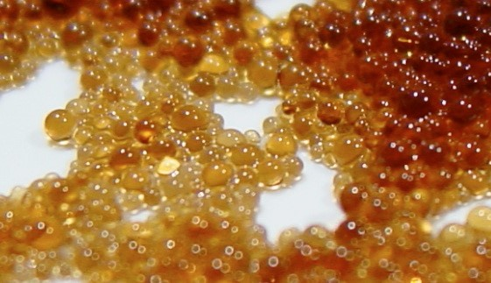
Figure (1) Ion exchange column resin

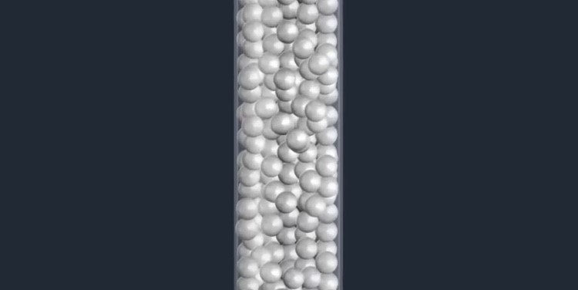
Figure (2) Method of compacting the resin granules into the ion exchange column
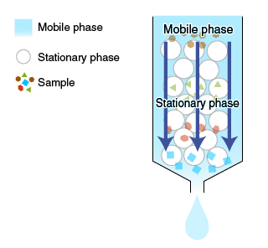
Figure (3) components of the ion exchange column

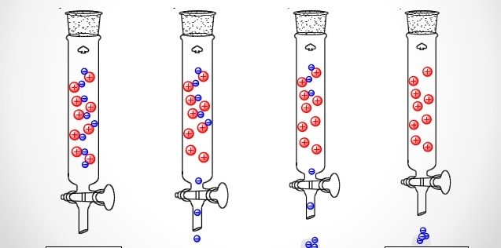
Figure (4) activation of the ion exchanger (cation) by adding hydrochloric acid

Figure No. (4) as:
The red balls represent the active centers after the activation process and they are H +
The blue balls represent all negative ions that will be associated with impurities or unwanted ions that are present in the column before activation and that will come out of the column in the form of salts such as NaCl, KCl, CaCl2 and others that are detected using the silver nitrate AgNO3

Below is how to work with pictures

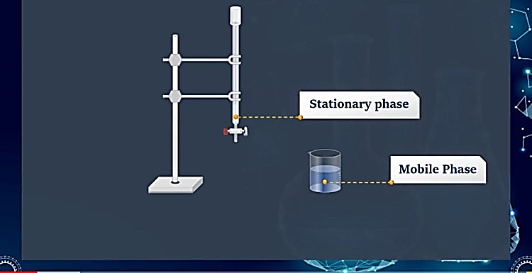
Figure (1) represents preparation and activation of the column containing the stationary phase
And prepare the mobile phase in Beaker, which is done by dissolving 0.2 g of salt mixture (NaCl + KCl) in the least possible quantity of distilled water.

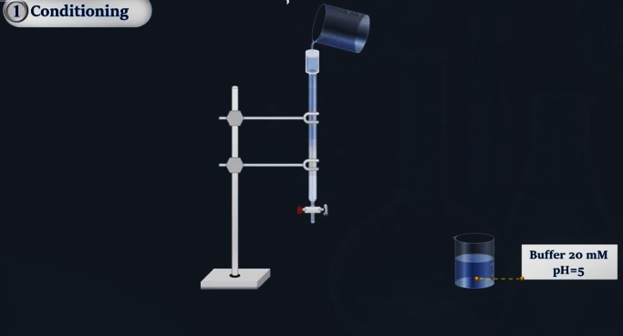

Figure (2) represents the addition of the mobile phase that was prepared with the first step and contains (NaCl + KCl) mixture to the previously activated ion exchange column.

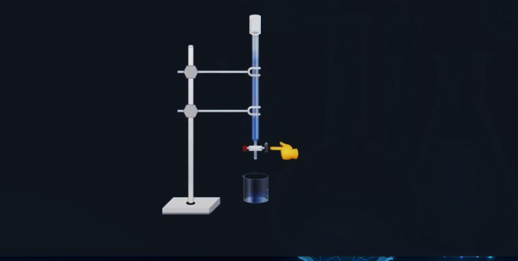

Figure (3) We collect the solution coming down from the column, after adding several small batches of distilled water to the column. Each time we add two drops of methyl orange to the solution coming out from column. When a pink color appears, that is means there is an acid. If appesrs yellow or orange color after add drop of methyl orange to the solution coming out from column that is mean the medium is neutral and there is no acid in the column
Then we take the pink solution that we collected during the times of washing with distilled water and tetration it against the base of the known standard sodium hydroxide (0.1) normally, and we calculate the volume coming from the burette at the disappearance of the pink color.

Calculation
No. of Meq. of cation = No. of Meq. NaOH

No. of Meq. of NaCl + No.of Meq. of KCl = No. of Meq. Of NaOH

X 0.2 - X N (NaOH) × V (NaOH)
+ =
58.5 74.5 1000

Wt of NaCl = X
Wt of KCl = 0.2 – X

X
% NaCl = × 100
0.2

0.2 - X
% KCl = × 100
0.2

Exp: (3 gm) of sample contain ( 70% sodium chloride and 30% calcium chloride ) was dissolved by (50 ml) of D.W then this solution passed through cationic resin and the eluent collected was titrated with (0.2N) of sodium hydroxide, Calculated:
- Write the equation for this question ?
- The volume of sodium hydroxide that will be need for titration ?
- The PH of eluent solution?
the atomic weight of Ca = 40 , Na = 23, Cl = 35.5

R_H ⁺ + ( NaCl + CaCl₂) R_ (Na⁺ ) + HCl

2R_H⁺ + CaCl₂ ( R)₂Ca⁺² + 2HCl

Eq.Wt of NaCl = 23+35.5 /1 = 58.5
Eq.Wt of CaCl₂ = 40 + 35.5 × 2 / 2 = 55.5

%NaCl = Wt of NaCl × 100
Wt of sampl

70/100 = Wt of NaCl / 3gm Wt = 2.1 gm

Wt of CaCl₂ = 3gm – 2.1 gm = 0.9 gm or another solution
% CaCl₂ = 30/100 = Wt of CaCl₂ /3gm Wt of CaCl₂ = 0.9 gm

NO.of Meq for NaCl + NO.of Meq for CaCl₂ = NO.of Meq HCl = NO.of Meq NaOH

N×V (NaCl) + N×V (CaCl₂) = N×V (NaOH)

Wt NaCl / Eq.Wt × 1000 + Wt CaCl₂ / Eq.Wt × 1000 = 0.2 × V (NaOH)
2.1/58.5 + 0.9/55.5 = 0.2 × V (NaOH) / 1000
0.05 = 0.2 × V (NaOH) / 1000
V of (NaOH) = 250 Ml

NO. of Meq of HCl = NO.of Meq NaOH
OR
N (HCl) × 50 ml = 0.2 × 250 ml N (HCl) = 1

NO.of Meq HCl = NO.of Meq NaCl + NO.of Meq CaCl₂
PH of HCl = - log [H] PH= - log 1 = ZERO

Discussion questions
1- How do we know that the column has become neutral ?
2- What will happen to the column after we transfer the solution sample to it and what the type of the groups that the column will be carry ?

Experiment (3)

Water turbidity Determination by Cation Exchanger

The theoretical part
In the beginning we need to know what water turbidity, it is formed in the water by the presence of the calcium and magnesium salts dissolved in water and sometimes in the presence of the iron salts in water.
Two kinds of the water turbidity can be distinguished depending on the nature of the dissolved salts in water:

- Temporary turbidity
It is formed in the water as a result of the containing this water on Ca (HCO₃)₂, Mg (HCO₃)₂ or both of them , these salts are decomposed when heating the water turbidity to the boiling point so it cause to form CaCO₃ and MgCO₃, At a result of that the temporary turbidity will be gone that known as a carbonate turbidity.

- Permanent turbidity
This is produced by the presence of the sulfate, calcium chloride and magnesium chloride dissolved in water. This turbidity can not be removed by boiling, When the water for example, (tap water) is passed on a cation exchanger as a (H⁺ - Form), the dissolved cations in the water turbidity that containing (calcium and magnesium ions) will be exchange with the hydrogen ions in the exchanger. the solution will be acids of the anions dissolved in the water .The amount of the exchange hydrogen ions can be calculated by titration the acid with a standard solution of NaOH using the methyl orange indicator.

Turbidity removal methods
- Temporary turbidity removal

- Heating to the boiling degree

∆
2Ca (HCO3)₂ 2Ca CO₃ + 2H₂O + 2CO₂
∆
2Mg (HCO3)₂ 2Mg CO₃ +2 H₂O + 2CO₂

- The addition of sodium carbonate

The soluble( calcium bicarbonate and magnesium) are converted into insoluble carbonate, that precipitated from the solution according to the following equations :

Ca (HCO3) ₂+ Na₂CO₃ CaCO₃ +2 NaHCO₃

Mg (HCO3)₂ + Na₂CO3 MgCO3 + 2 NaHCO₃

- Permanent turbidity removal
We can remove this turbidity by addition of sodium carbonate ,That react with soluble (sulfate, calcium chloride and magnesium chloride) are converted into insoluble carbonate, that precipitated from the solution according to the following equations :

CaCl₂ + Na₂CO₃ CaCO3 + 2NaCl

MgCl₂ + Na₂CO₃ MgCO₃ + 2NaCl

Industrial Applications
The ion exchange columns are widely used in the industry for the purpose of obtaining deionized water. The method is to passes the ordinary water in a strong cation column (H⁺ - Form), The water exited from this column is free from cations but it contains anions and hydrogen ion( acid). Then, acidic water should be passes through another separated strong anionic column as a ( OH⁻ - Form), When water passes in this column, an exchange between the anions and the hydroxyl group (OH) will occur. The anions remain on the column resin and the hydroxyl group goes to the water, Water now contains hydrogen ion and hydroxyl ion and is free of cations and anions .
The amount of cations and anions in the prepared water in this method is much less than the amount of ions contained in the water prepared by water evaporation and condensation using regular fumigants. The resin which used in this method can be reused after activated in the normal method.
2R_H⁺ + CaCl₂ ( R_)₂Ca⁺² +2 HCl
2R_H⁺ + MgSO4 (R_)₂Mg⁺² + H₂SO₄
2 R_H⁺ + Ca(HCO₃)₂ (R_)₂Ca⁺² + H₂CO3 ₊ CO₃⁻²
The equations represent turbidity water passing through a strong cation exchanger
R_OH⁻ + HCl R_Cl + H⁺_OH⁻ deionized water
R_OH- + H₂SO₄ (R_)₂SO₄⁻² + H⁺_OH⁻ + H⁺
R_OH⁻ + H₂CO₃ (R_)₂ CO₃⁻² + H⁺_OH⁻ + H⁺
The equations represent turbidity water passing through a strong anionic exchanger
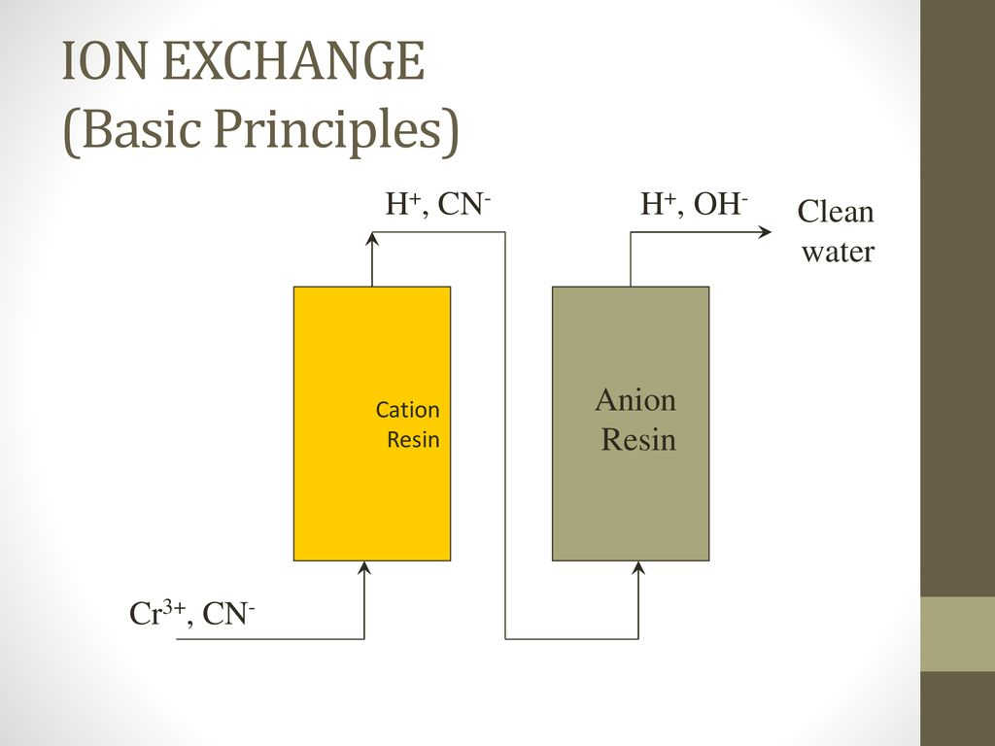
Figure (1) shows the process of obtaining deionized water

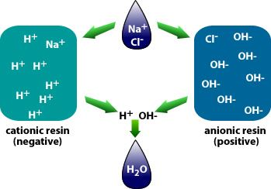
Figure 2 shows the method for ion exchange in cationic and ionic exchanges to obtain deionized water
Materials
1. HCl hydrochloric acid (3N)
2. AgNO3 silver nitrate (0.1 N)
3– Methyl orange
4 – NaOH
- Turbidity water

Procedure
1. Reactive the column by HCl .
2. Wash the column with distilled water until it becomes neutral.
3. Take from the turbidity water measured by the pipette in a clean beaker.
4. Step by step , transfer this water quantitatively to the ion exchanger column.
5. Wash the beaker several times with distilled water and pass the wash water to the ion exchanger column.
6. Collect the water from the column in a conical flask and will be pink color after being detected by the methyl orange indicator and then titrate it with the standard solution of sodium hydroxide.

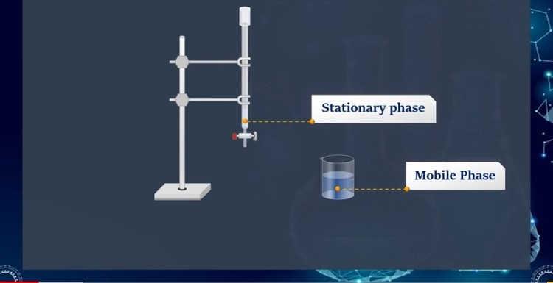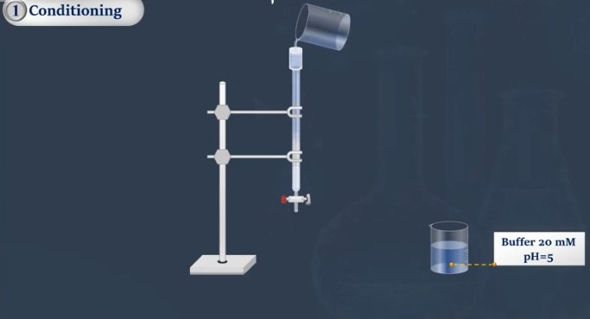
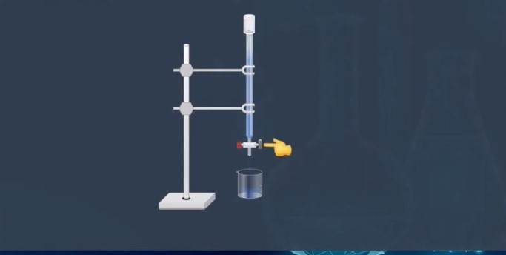
The figures above illustrate how the experiment works

Calculation
1- Calculate number of M.eq of salt
No. of Meq. for cation = No. of Meq .for NaOH
No. of Meq.of NaOH = No. of Meq. CaCO3

N (NaOH) × V (NaOH) = Wt CaCO3
1000 Eq.Wt CaCO3

2- Calculate weight of calcium carbonate in (25ml) turbidity water?
3- Calculate ppm CaCO₃
4- Calculate concentration molar [M] of CaCO₃ ?
5- Calculate PH?

EXP: (4 gm) of sample contain (Magnesium sulfate) was dissolved by (60 ml) of D.W then this solution passed through cationic resin and the eluent collected was titrated with (0.5N) of sodium hydroxide, Calculated:
- Write the equation for this question ?
- The volume of sodium hydroxide that will be need for titration ?
- The PH of eluent solution?
the atomic weight of Mg= 24 , S=32, O = 16
2R_H⁺ + MgSO₄ (R_)₂Mg⁺² + H₂SO₄

NO.of Meq for MgSO₄ = NO.of Meq H₂SO₄ = NO.of Meq NaOH

NO.of Meq for MgSO₄ = NO.of Meq NaOH

N×V (MgSO4) = N×V (NaOH)

Wt of MgSO4/ Eq.wt = 0.5 × V (NaOH)/1000

4 / 88 = 0.5× V(NaOH)/1000 V(NaOH)= 90.9 ml

PH= - Log[H⁺]
NO.of Meq for MgSO₄ = NO.of Meq H₂SO₄
N× V(MgSO4) = N×V(H₂SO₄)
4/88 ×1000 = N × 60 N= 0.75 /2
PH= - log[0.75] = 0.12
Another Way
NO.of Meq H₂SO₄ = NO.of Meq NaOH
N × 60 = 0.5 × 90.9 N= 0.75
PH = 0.12

Discussion questions
1 – What are other methods to remove the turbidity ? compare between them
2- What is water turbidity ?
3 – What is the reason of presence of the turbidity and what is the types of it?
4 - What are the most phenomenans of turbidity water ?
5 – How we can obtain deionized water from the turbidity water ?

Experiment (4)

The theoretical part
Plate chromatography
In this method, the stationary phase is either a liquid carried on a sheet of paper or cellulose on a glass plate or an effective solid material coated with a glass or cellulose plate. Because the stationary phase is carried on a plate so this technical called plate chromatography.
Plate chromatography can be divided into :

- Thin Layer Chromatography
The method is defined as one of the methods of separation. Thin-layer chromatography (TLC) has been largely replaced paper chromatography because it is faster,and more sensitive. The resolution in TLC is greater because the particles on the plate are smaller and more regular than paper fibres. The advantages of thin layer chromatography are the high sample throughput, the low cost, the possibility to analyze several samples and standards simultaneously, minimal sample preparation is necessary, and the plate may be stored for later identification and quantification

- Chromatographic Paper
At paper chromatography (partition chromatography) the stationary phase and the mobile phase are both liquid. The paper generally serves as a support for the liquid stationary phase. The sample is applied as a small spot or streak one and the half, two cm from the edge of a strip or square of filter paper, which then is allowed to dry. The dry strip is suspended in a closed container in which the atmosphere is saturated with the developing solvent (mobile phase), and the paper chromatogram that is developed. When the front solvent travel the length of the paper, the strip is removed from the developing chamber and the separated zones are detected. The stationary phase in paper partition chromatography is in most cases is water. After the chromatographic procedure, the components of the analysed material are characterized by their relative mobility (Rf-value)

Distance traveled by separated material (a)
R_{F} =
The distance traveled by the solvent (b)

Materials
- Filter paper
- Diluted ammonia
- Sample (orange methyl , red methyl , blue methyl )

Procedure
1. Put in the cylinder (1) ml of NH₃.
2. Draw a line by pen on the sheet 2 cm from the edge of the sheet.
3. Put a spot of the sample in the middle of the line.
4 - Put the sheet in the cylinder for 1/4 hr , until the components of the sample are separated
5. Extract the sheet from the cylinder until it dries ,and then calculate the R_{f} value for each them.

Discussion Questions
1 – What are the advantages of the value of R_{F} ?
2. Has the experiment been used for qualitative or quantitative detection purposes?
3. What is the stationary phase and the mobile phase used in the experiment ?

Experiment (5)
Calibration of hydrochloric acid using anion exchanger
The theoretical part
The anion exchanger contains the hydroxyl groups which have negative charge where ion exchange occurs between (OH⁻) group and ions that have negative charge found in the solution (mobile phase)
When a sodium chloride or potassium chloride solution is transferred to an OH-Form anion exchanger, the exchange between chloride ions and hydroxyl ions will be as follows :
Activation Anionic resin equation
R_ Cl- , Br- , I- + NaOH R_OH- + NaCl
In resin activation base in resin eluent solution

R _ OH⁻ + NaCl R_ Cl⁻ + NaOH

The solution that flow from the column is NaOH and by the calibration of the base (NaOH) with the hydrochloric acid (HCl) we can know the concentration of the used acid.

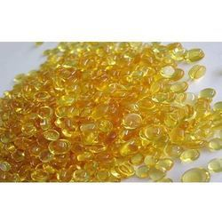
Anionic resin
Anionic exchange

Materials
1 - AgNO3 Silver Nitrate (0.1 m) .
2- NaCl Sodium Chloride .
3- Phenol Naphthaline indicator .
4- NaOH Sodium Hydroxide (3M).
5 - HCl Hydrochloric acid .

Procedure
1. Reactivation the ion exchanger column by using the NaOH ( 3M)
2 - Wash the column several times with distilled water and then check it by silver nitrate detector, and we continue to wash the column until it becomes neutral.
3- Carefully weigh (0.1g) from the sample (NaCl)
4- Dissolve the salt in a small amount of distilled water and then transfer to the ion exchange column
5- Collect the solution from the bottom of the column into a conical flask.
6- Collect the first batch of the water from the column and check it by adding a drop of the phenol naphthaline indicator when the appearance of pink - purple add another batch of distilled water to the column and also check it by use the indicator and repeat this process until the disappearance of pink - violet.
- Transfer The collected solution to the conical flask and calibrate it with the hydrochloric acid in the burette.

Calculation
- No. of Meq.of NaCl = No. of Meq.of NaOH = No. of Meq.of HCl
- Calculate PH?

EXP: (60 Ml) is the volume of the potassium chloride that was passed through the Anionic column weight (0.5 gm) ,This column was washed by D.W then (50 ml) of the eluent solution was collected , IF the capacity was ( 9 mmole/g) ,Calculated :
- Write the equation for this question ?
- The initial weight of potassium chloride that was added ?
- The POH of the eluent solution ?
If you know the atomic weight of K= 39 , Cl = 35.5

R_OH⁻ + KCl R_Cl⁻ + KOH⁻
In resin Elution solution

Meq. KCl = Meq. KOH = Meq.HCl

N×V (KCl) = N×V(KOH) = N× V(HCl)

Wt of KCl (?) × 1000 × V = N (KOH ) × V (KOH)
الحجم النازل من المبادل
Eq.wt of KCl V

Capacity = No. of Meq of OH⁻ / Wt of solid Resin
9 = ? / 0.5 gm

No. of Meq of OH⁻ = 4.5

Wt of KCl (?) / 74.5 ×1000 = 4.5

Wt of KCl = 0.3 gm

POH= - log [OH⁻ ]

No.of Meq of OH⁻ = N (OH⁻ ) × V (OH⁻ )
4.5 = N × 50 N(OH-) = 0.09

POH = - log [0.09]

POH= 1

Discussion Questions
1 - How do you know the resin is cationic or anionic ?
2- Why we calibrate the elution solution collected from anionic column with hydrochloric acid

Experiment (6)
Adsorption chromatography

The theoretical part
Adsorption is a collection of atoms, molecules or ions on the surface of the absorbent material, a phenomenon of surface phenomena including the retention or retention of liquid or gases material on the surface of a solid material.

The most important factors affecting on the process of adsorption
1-Temperature
2 - Concentration of colored material
3 - Surface area of ​​the adsorbent surface
4 - PH media

The substance that suffers from the adsorption process is called the adsorbent substance, While the surface obtained by the adsorption process is called the absorbent surface.

Types of adsorption
1. Physical adsorption: weak bonds (vandervals force)
2. Chemical adsorption: chemical bonds

Required in the adsorption process
1- Absorbent surface such as polymer-clay, animal charcoal
2- Contaminant material such as Chrome Palladium Mercury

Adsorption applications
1-Treatment of poisoning
2- Industry
3- Motivation
4- Pollution
5- Medicine and Pharmacy

Materials
- Poly aniline or charcoal
- Methylene Blue
- HCl (1:1)
- Litmus paper

Procedure

- Take (10) ml of (10) ppm methelen blue measure its absorbance (before adsorption) is considered contaminant .

- Control of the PH (2-3) by Litmus paper through add (6) drops of HCl 1:1 for solution

- Weigh absorbent surface 0.05 g poly aniline or (charcoal) and add it to the solution

- Put the solution in the shaking device for (30min) at ( 25 °C)

- After filtration , take the filtrate solution where the absorbance is measured at the maximum wavelength at (660 nm) after the device be zero on the distillate water and represent absorbance adsorption

- Calculate the Removal ratio Quantity and absorbent material ?

Calculation
- Calculate the amount of pollutant absorbed per gram of surface (q) mg/g
- Removal percentage (%R)
- Initial concentration before adsorption C_{i} = 10 ppm mg/L
- Concentration at given after adsorption C_{t} = ? ppm mg/L

ppm C_{i} = 10 C_{t} =?
Step (1) …… A₁ A₂ …… Step (5)

10 × A₂
C_{t} =
A₁

Remaining concentration after adsorption C_{e} = C_{i} - C_{t} = mg/L

V ( C_{i} - C_{t} )
q = = mg/g
m

m = weight of adsorbent surface (g)
V = total volume of the solution

C_{e}
% R = × 100
C_{i}

Discussion Questions

1- Define adsorption and its types?
2- What are the factors that effect on the adsorption process ?
3- What type of blank is used ?and why?

